Messy Church – 21st September 2024
Creation and harvest

The activities are:

- Chaos – what there was in the beginning: Genesis chapter 1, verses 1and 2 – splat pattern butterflies
- Dry land: Genesis chapter 1, verses 9 and 10 – Lemon Pudding
- Plants and flowers: Genesis chapter 1, verses 11 and 12
  - Doily flowers
  - Paper flower picture
  - Leaf picture – with leaf stamps
- Sun, moon and stars of light: Gensis chapter 1,verses 14 to 19
  - Starry pictures on black paper (in the Celebration)
  - Rainbow sun (in the Celebration)
- Fish and birds: Genesis chapter 1, verses 20 to 23 – playdoh modelling
- Animals and people: Genesis chapter 1, verses 24 to 31
  - Pompom sheep and rabbits
  - Tube animals
  - Fold over sheep
Our activities this month are all based on the beginning of the Bible, and God’s creation of the world. Of course, we don’t know how God created the world really, and this story was written by people who knew even less than we do. We don’t think it really happened in 6 days, which is what the Bible says, but it must have happened in the order the Bible says – there has to have been light, dark, warmth and water before there could be plants, and plants have to have come before animals. And we don’t know what was there before creation. Scientists say that there was a big bang – but they don’t know what caused the big bang, or how it created the universe!
Stories and Activities
1. Chaos – what there was in the beginning: Genesis chapter 1, verses 1 and 2 – splat pattern butterflies
The bible says that before God started to make the universe, there was Chaos – just a muddle of darkness and water, but God was there.
You will need: a piece of paper, paint, scissors and two straws, or twigs, or garden canes – not long ones! If you want, you can also use the template which comes with this file. The paint should be thick, not thin.
Fold the piece of paper in half, and draw half a butterfly against the fold – you can use the half butterfly template if you prefer.
Leaving the paper folded, cut out the butterfly (through both layers of paper – don’t worry about the antennae, you won’t need them.) Cut two slits across the fold, about where they are on the template – at the bottom of where the body and the wings join, and at the top. The slits don’t need to be very long.
Unfold the paper, and splodge paint onto one half of the butterfly. When you have done this, fold the paper back in half, with the painty part inside. Press down carefully, unfold and leave to dry.
When the paint is dry, slip the two straws, or whatever you are using, through the slits, so that they make the body and the antennae at the top of the body (if you use bendy straws, you can bend them outwards).
Talk about: what chaos might look like – do your parents ever complain that their lives are chaotic, or your bedroom is chaos because you haven’t tidied it?

2. Dry land: Genesis chapter 1, verses 9 and 10
On the third day, the bible says, God created dry land – he got all the water together, and land appeared – like the tide going out, so that you can see all the beach.
You will need: the recipe supplied, the ingredients and the tools, and access to a cooker – you will need some help from adults, as the lemon will need a sharp knife to cut it.
Follow the instructions to make the lemon pudding – notice how liquid the mixture is when it goes into the cooker, and remember that when it comes out of the cooker.
Talk about: how the pudding has changed – what was liquid is now solid. When you cut into the pudding, you will discover that the base of the pudding is more liquid than the top. Think about a beach – how the wet sand dries on the top, but it is still much wetter underneath.
3. Plants and flowers: Genesis chapter 1, verses 11 and 12
This is the second part of the third day. God, having made dry land, decided to have plants of all kinds. At the end of the day, God looks at his new dry land and its plants, and is pleased with what he has achieved.
We have three different activities in this section.
3a. Doily flowers
You will need: a paper doily, a pipe-cleaner and some ribbon, scissors and some glue handy in case. The instructions for the flower is part of the pack.
Follow the instructions to make your flower. If you make more than one, you can tie them together with ribbon, but you could have a ribbon bow even if you have only one flower.
3b. Paper flower picture
You will need: a piece of paper or a paper doily, paper flowers (we will provide these at the church, but you can cut your own out of coloured paper – you will need scissors and a pencil to draw them with), glue.
Stick paper flowers onto your paper or doily, to make a picture or pattern.
3c. Leaf picture
You will need: a piece of paper, leaf stamps and some paint, paper towel to clean the stamp when changing colour
Dip the leaf stamp of your choice in some paint, and print it on paper – change the stamp, or change the paint colour (wipe the stamp clean before putting a different colour on).
Talk about: what plants need to survive – soil, water, warmth. Think about the order of things in the creation story – before the plants come, there is soil, water and warmth – we may not know how God created the world, but we can see that it works, so it must have been done right.

4. Sun, moon and stars of light: Genesis chapter 1, verses 14 to 19
These verses tell how God made the sun, moon and stars. Scientists tell us that up to this point – the development of plants – it would have been difficult to see the sky, because of mist and cloud. We know that although it gets light when it is cloudy, we cannot see the sun, the moon or the stars.
We have two activities in this section.
4a. Starry pictures on black paper (in the Celebration)
You will need: black paper, stick on stars, moon and sun (you can make the sun and moon from paper, but silver and gold stars are easy to buy), glue, scissors
Glue stars, sun and moon on your paper, to make a picture of the sky. Remember that if you are in space, the sky isn’t blue, it’s black!
4b. Rainbow sun (in the Celebration)
You will need: the instructions sent with the pack, yellow and orange card, and paper in red, orange, yellow, green and blue, scissors, glue. In the pack, there is also a picture of what (approximately) your sun should look like.
Follow the instructions to make your rainbow sun.
Talk about: looking at the sky at night, and what you can see there. Ask a grown up whether they have seen things like: a solar eclipse, or a comet. Ask them if they haven’t seen them because it was cloudy?!

5. Fish and birds: Genesis chapter 1, verses 20 to 23 – playdoh modelling
On day five, God made fish and birds. When he had finished the day, he said that what he had made was good.
You will need: playdoh, and a paper plate to put your creations on
Use the playdoh to make birds and fish. Put them on the plate, so you can show them to each other.
Talk about: the parts birds and fish play in the environment of the world – how they clean up the sea and the land
If you want, you can make other animals with the playdoh.

6 Animals and people: Genesis chapter 1, verses 24 to 31
On the sixth day, God, the bible says made animals and people. When he had finished making them, he told the people to look after the animals and the world he had made, he looked at all he had done, and as he had said on the other days, he said it was very good. On the seventh day, the bible says, God rested – which is why Jews and Christians have a rest day every week. We all start the week with Sunday, which we call the first day of the week, so the seventh day is Saturday, and that is the day Jews call the Sabbath, and have their rest day then. Christians celebrate the first day of the week for their rest day, because Jesus came back to life on the first day of the week.
We have three activities for this day – and none of them are people.
6a. Pompom sheep and rabbits
You will need: for each animal, two pompom makers of different sizes, sheep or rabbit coloured yarn, and wiggly eyes. For the sheep, two short pieces of pipe-cleaner; for the rabbit, paper or card for the feet and paper or card for ears.
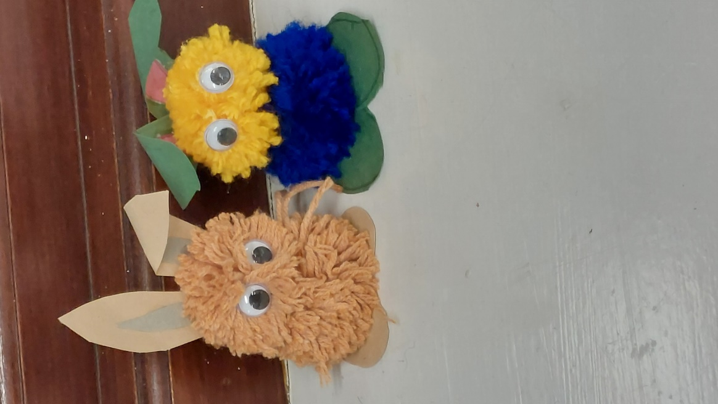
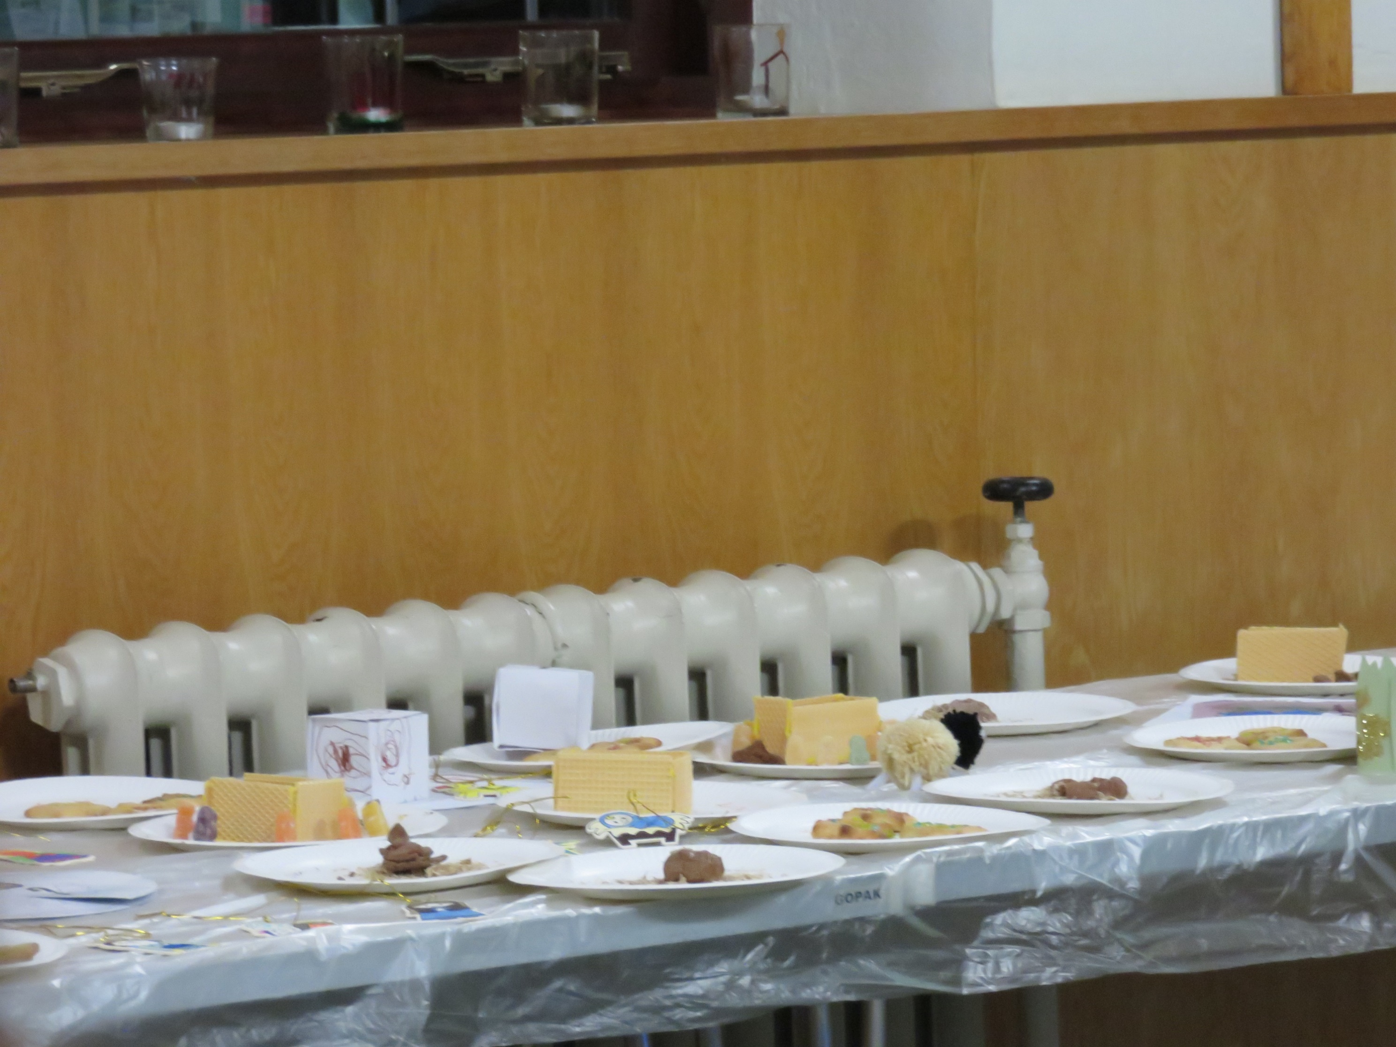
Make two pompoms, one of each size, leaving the ends of the tie long. If you are making the sheep, put the pipe-cleaners across the middle of the larger pompom before you cut round the maker. Tie the two pompoms together tightly, so that head and body are close together. For the sheep, bend the pipe-cleaners down, so that the sheep stands up, with the head level with the ground – look at the picture. For the rabbit, make card feet, and stick them to the bottom of the larger pompom – so the smaller pompom is at the top – see the picture. Give the rabbit ears, and both animals wiggly eyes at the front of the head.
6b. Tube animals
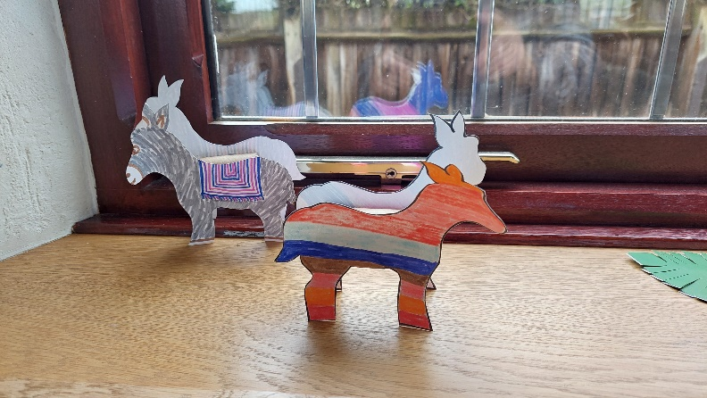
You will need: print outs of the animal(s) you want to do (this would be best done on card, but if you don’t have printer card, print them on paper and stick them to thin card – cereal boxes are really good for this), colouring pencils, or felt tip pens, scissors, and lengths of tube – the inner tubes of tin foil rolls, or paper towel rolls are fine, glue
Choose the animal you want to do, and colour both pieces in. If you cut it out after you have coloured it in, it won’t matter if you go over the lines! Cut the animal out, and then cut a length of tube which is the same length as the body of the animal. Put glue in a line down the inner sides of both bodies, and carefully stick them either side of the tube – make sure both sets of feet touch the ground!
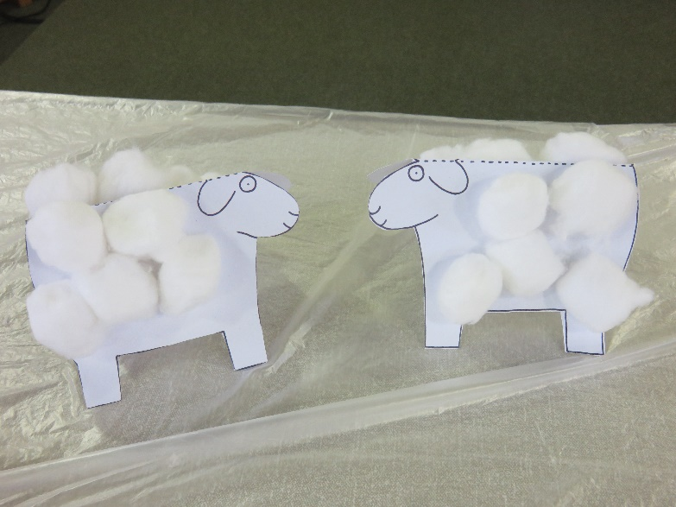
6c. Fold over sheep
You will need: a print out of the sheep (again, best done on card, but printing on paper and sticking it to thin card works), cotton wool, scissors, glue
Cut out the sheep round the solid lines, and fold it in Fish half on the dotted line, so that it stands up. Glue cotton wool to both sides, for the sheep’s fleece.
Talk about: the importance of animals – for food, for helping to manage the countryside, for the balance of the environment.

Celebration

Autumn is the time when we think about harvest. If you have looked at the fields, you will have seen that the wheat and barley have been harvested, you may even have seen a combine harvester at work. Fruit has been picked from the trees, apples and pears and plums around Harlington. You may also have picked blackberries.

Cauliflowers fluffy https://youtu.be/PukdaXUzgOU?si=vQljKfUygxuC2ssB

When we think about harvest, we may also remember the story in the Bible when we learn that God created everything. The people who wrote the story weren’t actually there, of course, so they wrote it as a kind of poem, and it gives the order of creation very well. I always think that the most important part is the very first bit, where it starts, “In the beginning God created….”

Who put the colours in the rainbow https://youtu.be/l9GsKFIaRo0?si=fKYsCTvgTbekMkGg

We are thinking about light most in the things we’re making in the Celebration. We’re going to start with the Rainbow Sun.

The list of the days of Creation is like this

Day 1
The first thing that had to be created was day itself. God made light, separated from darkness and the first day happened.

Day 2
God separated out the world from space. This is expressed as separating waters above from those below.

Day 3
Dry land appears and plants grow on it

Day 4
The sun, moon and stars can be seen in the sky

Day 5
Fish and birds are created

Day 6
Animals and people are created

Day 7
God rests

We’ll make a sky picture.

Our God is a great big God https://youtu.be/8Hi8jW1qYsw?si=OyBP6hF6HdYMp6Sm

Let’s pray.

Dear God,
Thank you for our wonderful world. Thank you that it is full of so many things. Thank you for the harvest that gives us the food we eat. Help us to take care of the world, help us to learn to look after it properly.

Amen

Next Messy Church is 19th October. See you then.

Enjoy our celebration on the Harlington Methodist Church YouTube channel at https://www.youtube.com/channel/UCTMWR_QCxujkh1zHjTFcoJw

Then have tea or a treat if it isn’t tea time!

If you send me pictures of anything you do, I will share them on the Church Facebook page (if you want to send pictures that you don’t want shared, just tell me. I’ll only share the one’s you’re happy to share.)

Harlington Messy Church Team

We’ll have a Zoom meeting open for those who can’t come to the church. Our end of Zoom will go on YouTube during the celebration, but we won’t put pictures from your end on. Contact me if you want the link for Zoom. Look out for the broadcast on the Harlington Methodist Church YouTube Channel. https://www.youtube.com/channel/UCTMWR_QCxujkh1zHjTFcoJw/videos

