Grapes and Olives
Grapes were grown in vineyards, walled to keep out thieves, goats and wild animals. Vineyards were usually owned by rich men, and worked in by many other people.
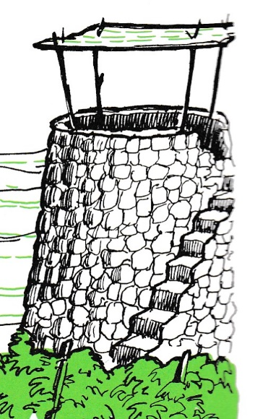
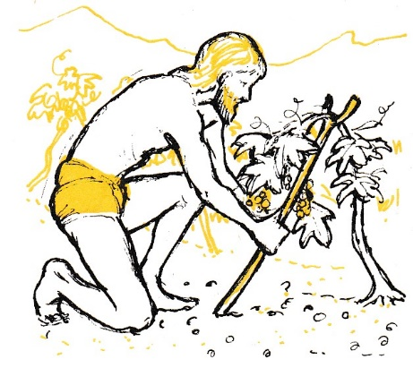
Vineyards usually had at least one watchtower, where someone would be on duty all day and night, especially as the grapes ripened and were nearly ready for harvesting.

Grape vines are trailing plants. These days they are trained along wires, but in 1st century Palestine, they grew along the ground until the grapes formed, and then they were lifted up on forked sticks, so the bunches of grapes hung down to ripe. If there were olive or fig trees in the vineyard, they might be used to support the vines.
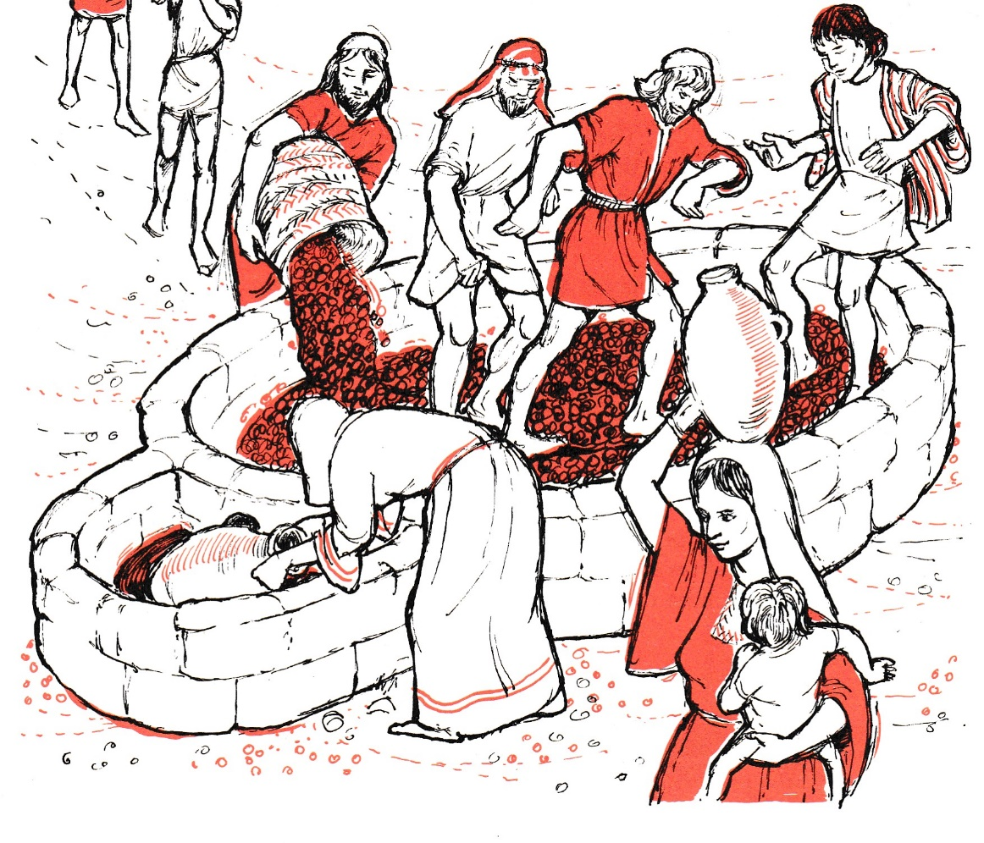
When the grapes were picked, they were taken in baskets to the winepress, which was often inside the vineyard as well, so the grapes did not have to be carried far.

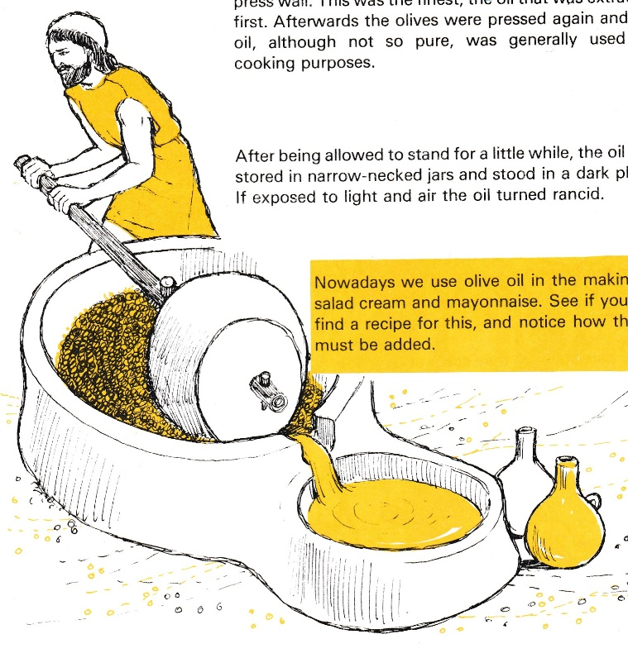
Men would wash their feet and legs, and then tread the grapes, to break the skins, so the juice flowed out – can you see the hole in the wall of the main section, so that the wine could be put in jars without getting the skins of the grapes in as well?

Olives have much tougher skins than grapes, and so a weighted roller was used to crush them. You can see that the press is a different shape, but it works the same way.

