**Doily Flowers**

You can make this pretty flower from just a paper doily and a pipe cleaner. A fun simple craft that anyone will enjoy.

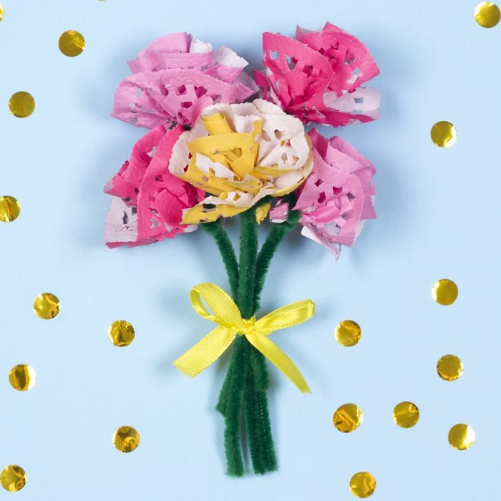

**Step 1**

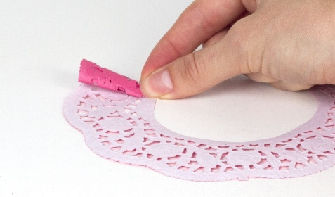

1. Take a paper doily and cut out the middle circle to create a ring.
2. Cut a slit in the ring and start to roll up the doily from one end. Gather the doily as you roll it up, pinching it at the bottom, to create the petals.
3. Wrap a pipe cleaner around the bottom of the doily flower, and twist it tightly to hold it in place.
4. If the pipe cleaner doesn't feel tight enough around the flower, add a small amount of glue to hold it in place.
5. Tie a ribbon bow around the stem of the flower.