Torch – pictures of the finished article
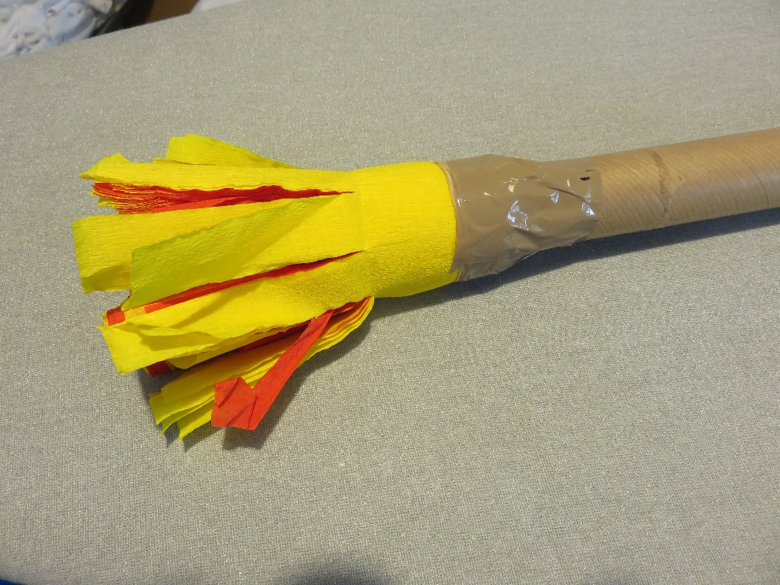
Card tube from kitchen towel or cooking foil

Parcel tape or wide sticky tape

Elastic band

Red and yellow crepe paper, alternately layered

Cut the strips after the crepe paper is glued, cutting through all the layers, to just short of the top of the tube. So the torch looks as though the flames come out of the tube, tuck a few of the strands of crepe paper into the end of the tube, so you can’t see the hole.
