Messy Church – 15^{h} February 2025
Joseph as an adult

The activities are:

- Egyptian dress – two items:
  - Headdress
  - Collar
- Pharoah’s dreams – Genesis, chapter 41, verses 1 to 32
  - Fat cows
  - Thin cows – in the Celebration
  - Iced biscuits (with cows or grain)
- Joseph’s new job – Genesis, chapter 41, verses 33 to 57
  - Ice cream wafer barns
  - Origami grain bags – in the Celebration
  - “stamped grain” pictures
- Joseph and his brothers – Genesis, chapters 42 to 45
  - Joseph’s family – Picture or mobile
  - Wine cup

Stories and Activities
Last month we looked at the stories of Joseph as a child, and as a young man. We stopped at the point where he was in prison, but hoping for something to happen, because he had explained the dreams of two of Pharoah’s employees – the butler (or wine steward), and the baker. Joseph hoped that the wine steward would talk to Pharoah about him, and he might be freed from prison. But the wine steward forgot, in his excitement at being freed, who had told him that he would be.

- Egyptian dress
Nowhere in the Bible is there a description of what people in general wore – there are descriptions of special dress for the Jewish priests, much later than Genesis, but not what people usually wore. There is also no description of what people wore for special occasions, except that it was usually made of linen. But we do know what important Egyptians wore, because it was carved on their monuments, and painted on their coffins. So we thought that we could make a headdress or a collar (or both), just as we made a pyramid last time.
- headdress
You will need: at least two pieces of paper, a pencil and colouring pencils or felt tip pens, scissors, and sticky tape.
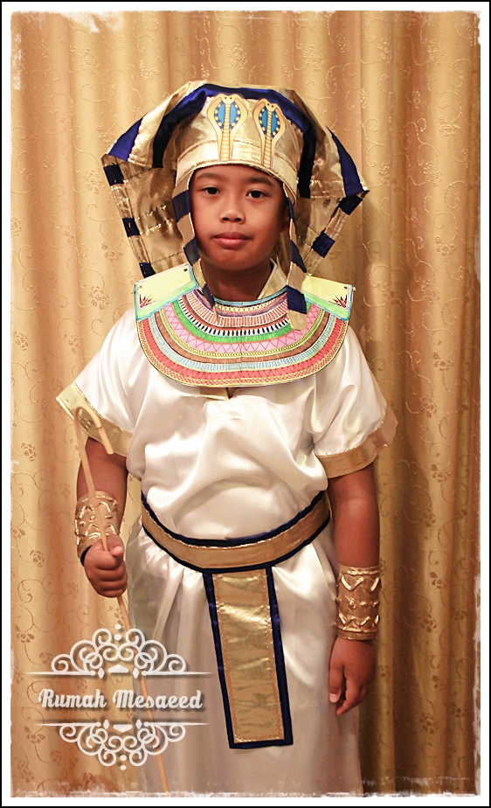
You may need to stick pieces of paper together to make a headdress big enough for yourself. As you can see from the picture, it needs to be wide enough to spread out on both sides of your face, and long enough to reach the back of your neck. If you don’t want to wear it, just use a single piece of A4 lengthwise, and cut the band to go across the front and round the head from another piece.
Colour the back and top of the headdress in stripes, and decorate the front vertically – look at the picture. Stick a band on the front, to go across the forehead and round the back of the head, under the main piece.
- collar
You will need: at least two pieces of paper, a pencil and colouring pencils or felt tip pens, scissors, and sticky tape.
The collar should go right around the neck, so again, you may need to stick pieces together. Cut both edges to make it lie down, and then colour it in stripes.
Talk about: dressing up for special occasions. Do you think clothes like this would be practical for daily wear? Would you like to wear them ever? (Imagine them made of fabric, rather than paper.) Do you have clothes for special occasions?

2. Pharoah’s dreams – Genesis, chapter 41, verses 1 to 32
Two years after Joseph told the wine steward and the baker the meanings of their dreams, Pharoah started having odd dreams. He told his usual advisers, but they didn’t know what the dreams meant. Then the wine steward remembered Joseph, and told Pharoah about him. Pharoah sent for Joseph – who had to wash, and shave, and put clean clothes on – and then Pharoah explained his dreams to Joseph.
Pharoah had dreamed he was on the river bank, when he saw 7 fat cows come out of the Nile. They grazed in the fields by the river, and then 7 thin cows came out of the river after them – they ate the fat cows, but they got no fatter. Pharoah woke up, but fell asleep again. This time he dreamed that there were 7 ears of grain on one stalk, good, healthy, nearly ready to cut. And there were 7 thin, meagre ears. The thin ears ate the fat ears, but were no fatter.
Joseph said that God had sent Pharoah a message: both dreams meant the same thing – there would be 7 good years, when the harvest would be plentiful, more than enough to feed the people in the country, and then there would be 7 years when there would be famine – the crops would die in the fields, and there would not be enough to feed the people, never mind the animals. Joseph said that what Pharoah needed was a good manager, who would make sure that during the 7 good years, a fifth of the grain would be stored, and not eaten, so that when the 7 years of famine came, there would be grain to sell back to the people, and the nation would survive.
Pharoah said that in that case, Joseph could be the manager, and he gave Joesph a signet ring, as proof that he was doing the work that Pharoah wanted done.
- Fat cows
You will need: print outs of the cow (this would be best done on card, but if you don’t have printer card, print them on paper and stick them to thin card – cereal boxes are really good for this), colouring pencils, or felt tip pens, scissors, and a length of tube – the inner tubes of tin foil rolls, or paper towel rolls are fine, glue.
Colour in and cut out both sides of the cow, and then cut a length of tube which is the same length as the body of the animal. Put glue in a line down the inner sides of both bodies, and carefully stick them either side of the tube – make sure both sets of feet touch the ground!.
- Thin cows – in the Celebration
You will need: two long pipe-cleaners, tin snips, small wiggly eyes (optional)
Cut one of the pipe-cleaners in half – each half makes a pair of legs. Fold the other pipe-cleaner in half, and using the folded end as the head, shape the length of the body, twisting the ends together for the tail. Twist the cut pipe-cleaners around the body, one about a third of the length from the head, and the other about 2 thirds of the length. (Make sure the legs are the same length on each side of the body.) If you want, you can stick wiggly eyes either side of the head.
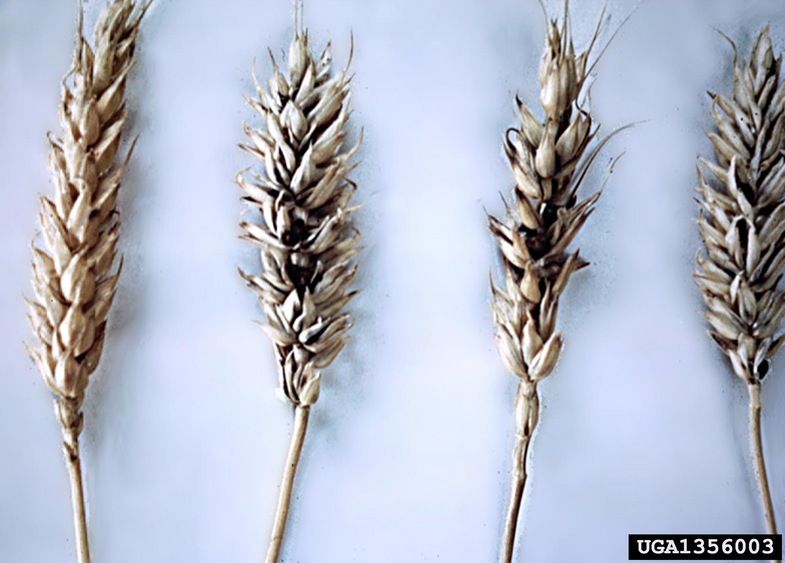
- Iced biscuits
You will need: either shop-bought plain biscuits, or home made biscuits (there is a recipe with this booklet), and some squirty icing.
If you are making your own biscuits, leave them to cool before icing them.
On the biscuit, use the squirty icing to make a cow, or to make a head of grain (see the picture)
Talk about: think about knowing in advance what is going to happen – would this be a good thing? Imagine what it would be like to know exactly what the weather was going to be like on your summer holiday – would it change what clothes you packed, or what activities you planned.

3. Joseph’s new job – Genesis, chapter 41, verses 33 to 57
For the next 7 years, Joseph travelled up and down Egypt, (he was given the use of Pharoah’s second-best chariot), making sure that one fifth of all the produce that the Egyptians’ farms produced was stored carefully. He might have had to organise the building of barns, to store the grain, or space to store other crops, so they kept well. The Bible says that every city had storehouses, which were filled from the farms around them, so that, when the famine came, food could be provided locally, without having to transport it long distances. Joseph also got married, and he and his wife had two sons, Manasseh and Ephraim.
- Ice cream wafer barns
You will need: ice cream wafers (at least three for each child, depending on how big you want to make them) squirty icing, a paper plate to stand the barn on, some shredded wheat (optional)
Use the squirty icing to stick ice cream wafers together to make the walls and roof of a barn – remember you need to have a doorway to go in and out! If you want, you can pull some shredded wheat apart to fill the barn – do it carefully – you might want to fill the barn first, and then put the roof on!
- Origami grain bags – in the Celebration
You will need: a square piece of paper (if you are using a piece of A4, fold one top corner over, so that the top edge lies along the side edge, and then cut the bottom (which is a single layer) off.), scissors, sight of the instructions, supplied with this booklet
Follow the pattern to make a bag the farmers might have used to transport grain to the barn, to be used when there was none in the fields, during the famine.
- “stamped grain” pictures
You will need: a piece of paper, a “head of wheat” stamp (we have made one, but you could draw a head of wheat – see the picture above – so you would need colouring pencils or felt tip pens).
Make a picture of a field of wheat.
Talk about: planning the food you might want to take if you go on a self catering holiday – or a picnic. Think about buying food that has to keep for some time – how would you store it? Perhaps you have an apple tree in your garden – how long can you keep the apples for?

4. Joseph and his brothers – Genesis, chapters 42 to 45
The famine was not confined to Egypt – it affected the surrounding countries as well. We have no stories from the countries to the west of Egypt, but the Bible says that “all the world” came to buy grain in Egypt, and that the country where Jacob and his family still lived was also suffering from the famine. (This is not surprising – famine is often caused by the weather, and Palestine is next door to Egypt and still shares the weather patterns.)
When Jacob heard that there was grain for sale in Egypt, he sent 10 of his sons to buy some. He didn’t send Benjamin, Joseph’s full brother, because he was, Jacob believed, the only surviving son of his favourite wife. Joseph was in charge of selling the grain, just as he had been in charge of collecting it, so when his brothers arrived, and bowed to him, he recognised them, and remembered his dream of his brothers bowing to him. They didn’t recognise him – Joseph was now 30 years old, and he had been only a teenager when they sold him.
Joseph behaved as though his brothers were complete strangers – he even accused them of being spies for Egypt’s enemies, taking advantage of the famine to see the state of Egypt, whether it would be worth attacking. The brothers denied that they were spies, and told Joseph about the family – how they had been 12 brothers, but one was dead, and the 12th had stayed at home, but Joseph put them in prison for three days anyway. Then he told them that 9 of the brothers could go home, with grain for their families, but one would have to stay in prison, until the others brought the 12th brother, to prove their story. Reuben, who hadn’t wanted to kill – or sell – Joseph, told the others that this was all their fault. It was Simeon who stayed in prison and the others went home. On the way home, they discovered that the money they had paid for the grain had been put back in the tops of their grain sacks! Jacob was cross with them for telling “the man in charge” about their one remaining brother.
- Joseph’s family – picture or mobile
Some people did this activity in January – but if you would like to do it now, or do it again, remember that everyone is at least 10 years older!
You will need: a piece of paper, a pencil and colouring pencils or felt tip pens. If you want to make a mobile, you will need scissors, string and hole punch or needle and thread, and at least two small garden canes.
Draw round the top joint of your thumb, to make an oval (and do it at least 12 times – one for each brother – if you want to do Jacob and his wives, do 5 more!) Use each oval for a person – draw a face on the oval, and if you want, put a body underneath.
To make the mobile, cut out the figures as you have drawn them, and either use a hole punch and string, or a needle and thread, (this might be best used with small children, as their thumbs are quite small – and they will need help!)
Talk about: being part of a family – imagine that you have not seen the rest of the family for years – how would you feel when you saw them again?
- Wine cup
Again, if you did this activity last time, you don’t have to do it again. This is a different story!
When Jacob and his family had eaten all the grain the brothers had bought in Egypt (although they had got their money back), Jacob wanted his sons to go and buy more, but they refused to go unless Benjamin came with them, because “the man in charge” would not see them, or let Simeon go, unless Benjamin came too. After a long time, Jacob gave in, and said they could take Benjamin as well. He told them to take all the money they had brought home, and more money, to pay for the extra grain, and gifts from the produce they had in store from before the famine – honey, nuts, and resin, all of which will keep for some years. When they all reached Egypt, and Joseph saw them in the queue, with Benjamin, he ordered his steward (house manager) to make a special meal, and to take the brothers to his house.
Joseph’s brothers were afraid, because such an important person had had them taken to his house. They thought they would be imprisoned, or sold as slaves, because they had had the first lot of money returned, so they told the steward about it, and he said that he had received the money the first time, no problem, so not to worry. When Joseph came home, they bowed to him, again, and gave him the gifts they had brought, and introduced him to Benjamin. This all made Joseph cry, but he went away to a different room, so they couldn’t see. The brothers ate the special meal in a separate room from Joseph, because that was the custom – people of different nationalities didn’t eat together, and Joseph was behaving like the Egyptian they thought he was.
Joseph ordered his steward to fill his brothers’ grain sacks, and again to put the money in the top of each one, but also to put his, Joseph’s, best silver cut in Benjamin’s grain sack. When the brothers left in the morning, Joseph sent his steward after them, to look for the cup he had hidden the night before! The brothers were indignant, and said they were not thieves, and if the cup was found in their belongings, then Joseph could kill the one who had taken it, and the others would be his slaves. They were horrified when the cup was found in Benjamin’s sack, and the whole group went back to Joseph’s house before he left for work.
All the brothers bowed to Joseph again, and Judah spoke for them all. He said they would all be slaves to Joseph, because of the cup. Joseph said that wasn’t necessary – the innocent ones could go back to their father, only the guilty one would stay as his slave. Joseph wanted to know whether they had changed in the years he had been away, or whether they would still do what seemed to be best for them.
Judah had been the brother who persuaded the others not to kill Joseph 12 years earlier, just to sell him to the Ishmaelite traders, and now it is Judah who tells Joseph that he had promised Jacob, their father, to bring Benjamin home, or else be sold into slavery himself, rather than come back without him, or Jacob would die of sorrow, losing the 2nd child of his favourite wife.
At this point, Joseph cannot control himself any longer. He sends all the Egyptians out of the room, and he tells his brothers who he is. They have real difficulty in believing it. The whole group becomes so noisy that Pharoah asks his servants to find out what is going on, and when he learns that Joseph’s brothers have come, he says they should go back and fetch their father, and all their families. The famine, he says, is only in it’s second year, there are five more years to go. Jacob’s family should all come and live in Egypt, and be safe.
So that is what happened.
You will need: a yogurt pot (or something similar), some cooking foil, stick on jewels if you have them.
Cover the pot with cooking foil, to make it look like a posh cup that a king might use. If you are careful, you could screw up the foil and then carefully unfold it again to cover the pot – the crinkles make it look as if the silver cup has been decorated. Add jewels.
Talk about: what would you do if someone stole something of yours? Could you forgive them, even if they had a good reason? How would you feel if someone tricked you the way Joseph tricked his brothers?

Celebration

Song Tell me who made all of creation? https://youtu.be/2Od_qFJ2g50?si=r6KvKXhXue6Mu9SP

Do you remember where we left things last time? Joseph was his father’s favourite son, and it showed. He also had dreams in which his brothers bowed down to him. He told his brothers so, and they didn’t like it, or him. One day they decided to kill him, but changed their minds and sold him to be a slave instead. They still told their father, Jacob, that he was dead.
Joseph was taken to Egypt, and sold to a man called Potiphar. He worked hard, but Potiphar’s wife got him put in prison. While he was in prison he interpreted the dreams of two other prisoners, one of whom was Pharoah’s cup bearer. He was set free and went back to work for Pharoah.

Pharoah was having sleepless nights. Whenever he went to sleep he had strange dreams. He was sure they meant something, but he didn’t know what. He called all the wisest people in the land and all the people who were supposed to understand dreams, but they couldn’t help. Then the cup bearer remembered Joseph. So he told Pharoah what had happened two years before.

Pharoah was anxious to understand the dreams, so he told his guards to bring Joseph to him. Of course, this meant that Joseph had to have a wash and brush-up, and get clean clothes. So Joseph was brought before Pharoah to interpret Pharoah’s dreams. The first dream was about fat cows, seven of them, that came out from the river Nile. But they were followed by seven scrawny thin cows. The thin cows ate the fat cows, but they didn’t get any fatter.

You may have made fat cows. We’re going to make the thin cows from pipe cleaners.

Pharoah then told his second dream. In it he saw a stalk of corn that had seven really good fat ears of grain on it. Then another seven grew, but these were shrivelled up as if they had been dried by a hot easterly wind. Then the seven thin ears ate the seven fat ones, but didn’t get any fatter.

After all this time Joseph was less arrogant, and he told Pharoah that although he couldn’t say what the dream meant God would know and would tell him. And this is what it meant.

There would be seven good years when there would be abundant harvests and a surplus of everything. But then there would be seven bad years when there would be famine. If nothing was done the good years would be wasted but if Pharoah stored up grain in the good years then they could get through the famine. Joseph said to Pharoah that he should find a good man to put in charge of looking after grain. Pharoah asked all his wise men where he could find such a person, and decided that it should be Joseph.

So Joseph went from being a slave, and in prison, to being the second most important person in Egypt.

Sing Up times, down times https://youtu.be/FVJ9mRML5DI?si=RBIh20DpzgeN6P6A

Thing happened just as Joseph had said, but grain had been stored in Egypt and was sold during the famine. (This made Pharoah very rich and he became the main landowner in Egypt.) The famine didn’t only strike Egypt, surrounding countries also suffered, and people came to Egypt to buy grain.

In Canaan Jacob, Joseph’s father, heard there was food in Egypt and sent the ten oldest brothers there to buy grain. While they were waiting, Joseph saw them and recognised them, but they didn’t recognise him. They bowed down to him, and asked for grain. Joseph played a game on them, and suggested they were spies, so they told him their story and that their father and another brother were still at home. He sold them grain, but told his servants to put their money back in the grain sacks. He sent the brothers away, all but one, and told them that next time they came they had to bring the youngest brother with them as well.

We’re going to make origami containers to hold grain,

When the brothers got back home they found the money. They were afraid to go back for more grain, but eventually they had to. They still didn’t recognise Joseph, but they explained about the money. This time Joseph had his cup hidden in Benjemin’s sack. When they set out to go home, Joseph had his guards chase after them and bring them back. When the cup was found in Benjemin’s sack Joseph said he had to stay in Egypt in prison. At this the brother each asked to take his place, and Joseph saw that they had changed. He said who he was, and Pharoah invited the whole family, Jacob included, to come to Egypt to live.

We’ll sing One more step along the world I go. https://youtu.be/7PXV3dwaeNU?si=CM2sp7hrxJ2XXCfc

Let’s pray.

Lord God, sometimes, when people have done wrong things to us, we just want to get our own back. Help us to learn to put those ideas aside and to do good things instead.
Amen

Next Messy Church is 15th March. See you then.

Enjoy our celebration on the Harlington Methodist Church YouTube channel at https://www.youtube.com/channel/UCTMWR_QCxujkh1zHjTFcoJw

Then have tea or a treat if it isn’t tea time!

If you send me pictures of anything you do, I can share them on the Church Facebook page or in the Church Monthly (if you want to send pictures that you don’t want shared, just tell me. I’ll only share the one’s you’re happy to share.)

Harlington Messy Church Team

We’ll have a Zoom meeting open for those who can’t come to the church. Our end of Zoom will go on YouTube during the celebration, but we won’t put pictures from your end on. Contact me if you want the link for Zoom. Look out for the broadcast on the Harlington Methodist Church YouTube Channel. https://www.youtube.com/channel/UCTMWR_QCxujkh1zHjTFcoJw/videos

