Fabric purses
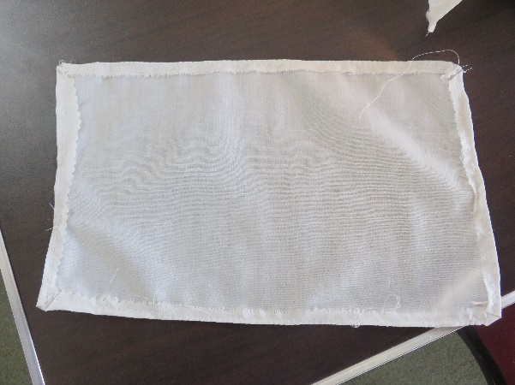
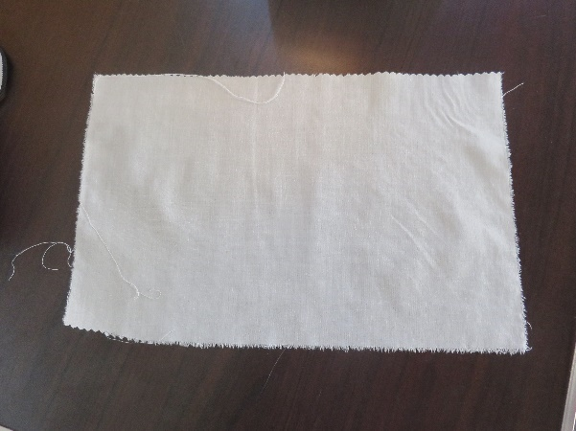
- Start with a piece of fabric more than twice the size of the purse you want to make. I used an old shirt of Clive’s, cut up into pieces.

- If it is likely to fray, hem it all round the edge – I used a zig-zag stitch so that the fabric would not pull.
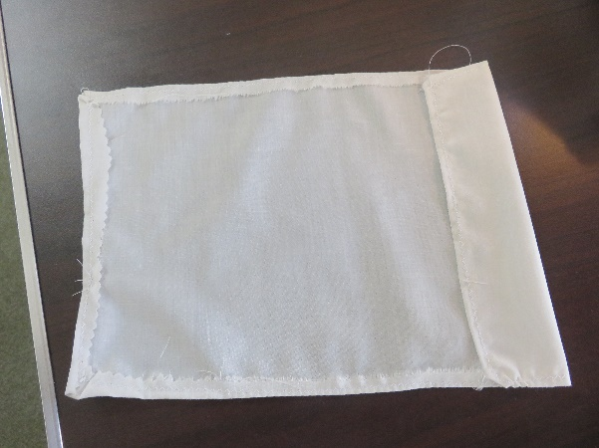
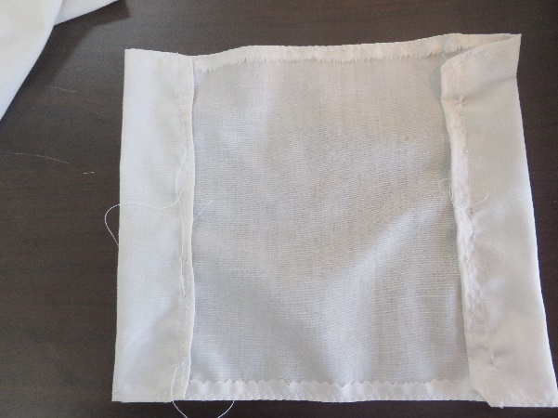
- Turn over one end to the inside, to make a channel wide enough to thread through.

- Repeat at the other end.

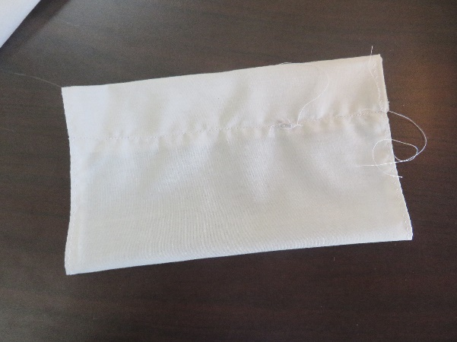
- Turn the purse over, so that the outside is showing, and fold it in half.
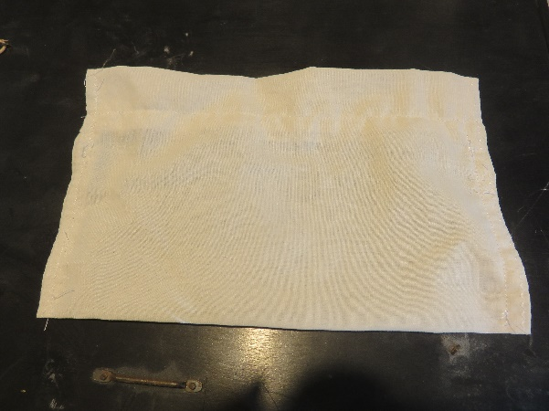
- Stitch both sides down, from the fold at the bottom, to the bottom edge of the turn over at the top.

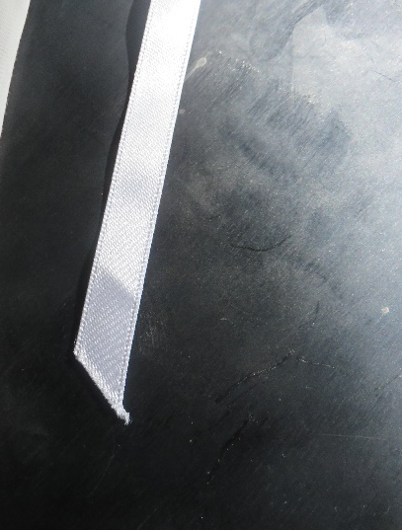
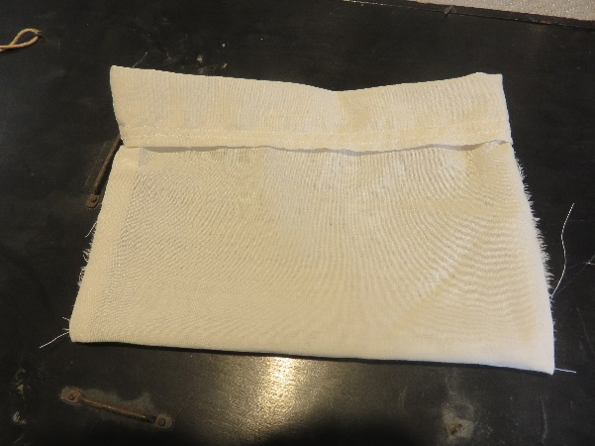
- This is what it will look like on the inside, if you turn it inside out.

- If you are using, ribbon for the fastening, cut the ends on a diagonal – it stops them fraying too badly.

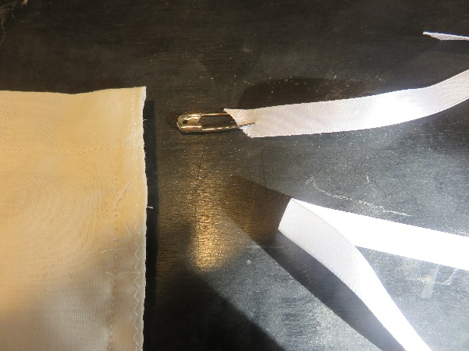
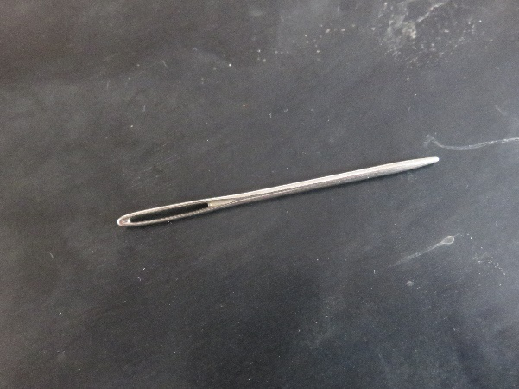
- With ribbon, use a safety pin, with yarn or string, use a blunt needle with a big eye.

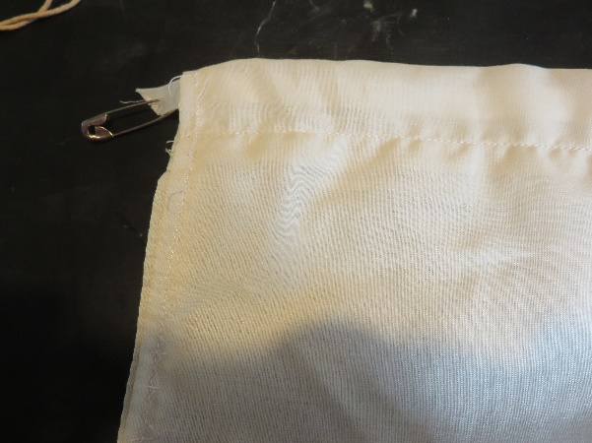
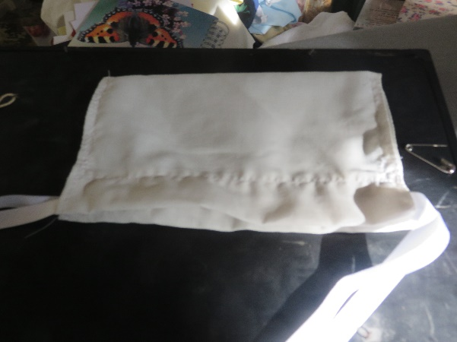
- Thread your fastening through the channels at the top of the purse.

- I had some lengths of ribbon already cut, so I used two – one on each side. If you are cutting ribbon or string or yarn for yourself, you can use just one piece. Make sure the string is long enough for the purse to lie flat when the string is tied together
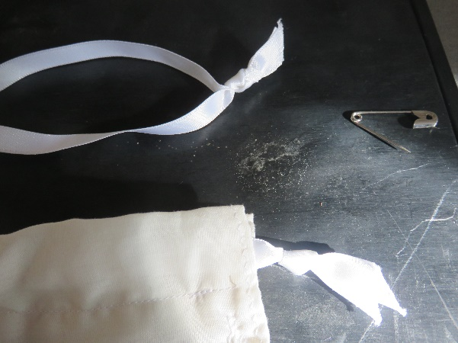

- When you have threaded both sides, tie the ends together – you can see in the picture that I have a knot each end.

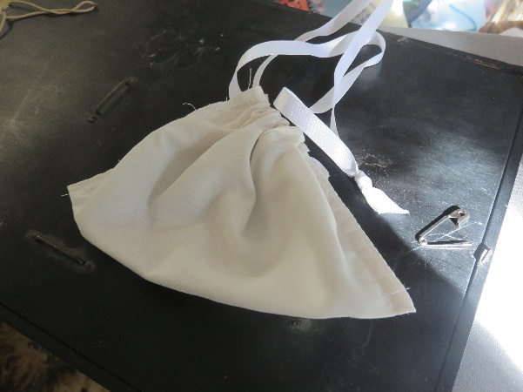

- A purse like this would be gathered, and the end of the string or ribbon would be tied around the owner’s belt, so that it could not easily be stolen.

