[HOW TO MAKE AN ORIGAMI BOWL](https://www.gatheringbeauty.com/blog/2019/9/how-to-make-an-easy-origami-bowl)

You will need

* A square of paper

(if you have a piece of A4 paper, you can make a square by folding a diagonal from one corner so that the two sides are together. There will be part of the paper that is not inside the fold. Cut this part off, and the rest will be square)

* 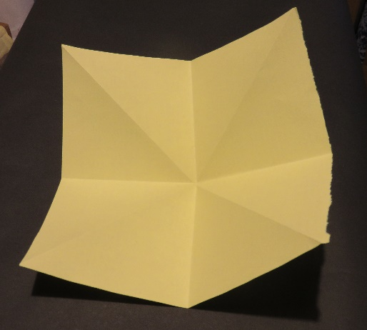Scissors

1. Start by lying your paper flat. If you’re using double-sided paper make sure the side you want to see on the inside of the finished bowl is facing up.

1

1. Fold in half from left to right, unfold and fold in half again this time from top to bottom.
2. Open back out and flip over so the outside is facing down.
3. Fold it in half again, this time across both diagonals.
4. A picture containing envelope, stationary

   Description automatically generatedUnfold and flip back over.
5. Your first two folds (from side to side and top to bottom) should show as folded away from you, and the diagonal folds look as if they are coming towards you. (first picture).

2

1. Rotate the paper so that a corner is pointing towards you.

3

1. Fold the two outside corners into the middle (look at the second picture).
2. Press flat, so that you have a square (picture 3).
3. Rotate the paper so the open end is at the top.

4

1. Fold the top point down to meet the bottom point. (picture 4)
2. A close-up of a book

   Description automatically generated with medium confidenceOpen back out and fold the top point back down but this time bring it down to meet the crease you made in the previous step. Leave folded and fold back down along the same crease with the point tucked under.

5

1. Flip over and repeat steps 11 and 12 with the point on the other side. (picture 5)
2. Text, letter

   Description automatically generatedLift the flap on the right and turn it to the left like a page. (picture 6)

6

1. Take the right-hand side and fold it into the middle.
2. Fold the left-hand side in to match. (picture 7)

7

1. Flip the whole model over and repeat steps 14, 15 and 16 on the other side.

1. Take the top point and fold it down to meet the bottom of your model. (picture 8)

1. Unfold it again and fold the point down to the crease you have just made. (picture 9)

8

9

1. Tuck the point under the folded over sides and press flat. (picture 10)

10

1. Flip over and repeat on the other side.

11

12

1. Gently open out the bowl into a square, pulling the bottom until it flattens, and the bowl stands up. (picture 12)