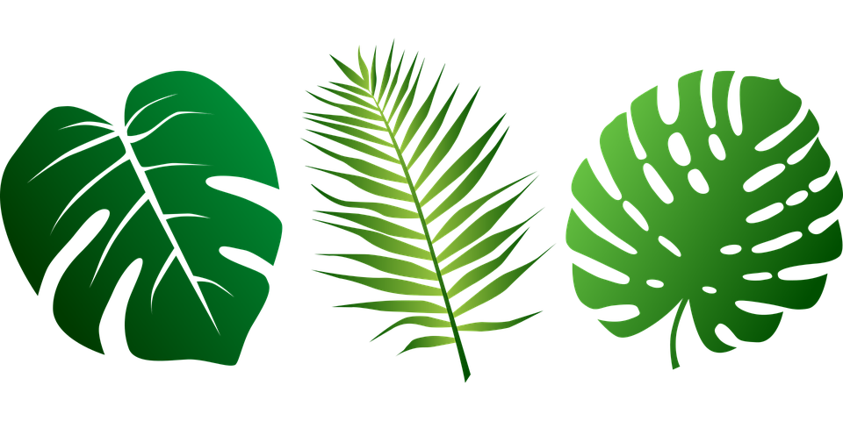

These are all palm leaves of various types. The middle one is the one where the leaflets, the individual strands, are used to make palm crosses for churches to give out on Palm Sunday. It is the easiest to make from paper, because you don’t have to cut all round the leaflet shapes, you can just cut straight towards the centre stem. If you want to try making the other shapes, you can.