626 quiz for 24th April 2020

Just a few questions: things you can look for, or look up, prompted by our walks around the village. You can email us the answers if you want.

- We walked past this tree on a footpath within easy reach of the village centre – have you seen it, can you tell me where it is?
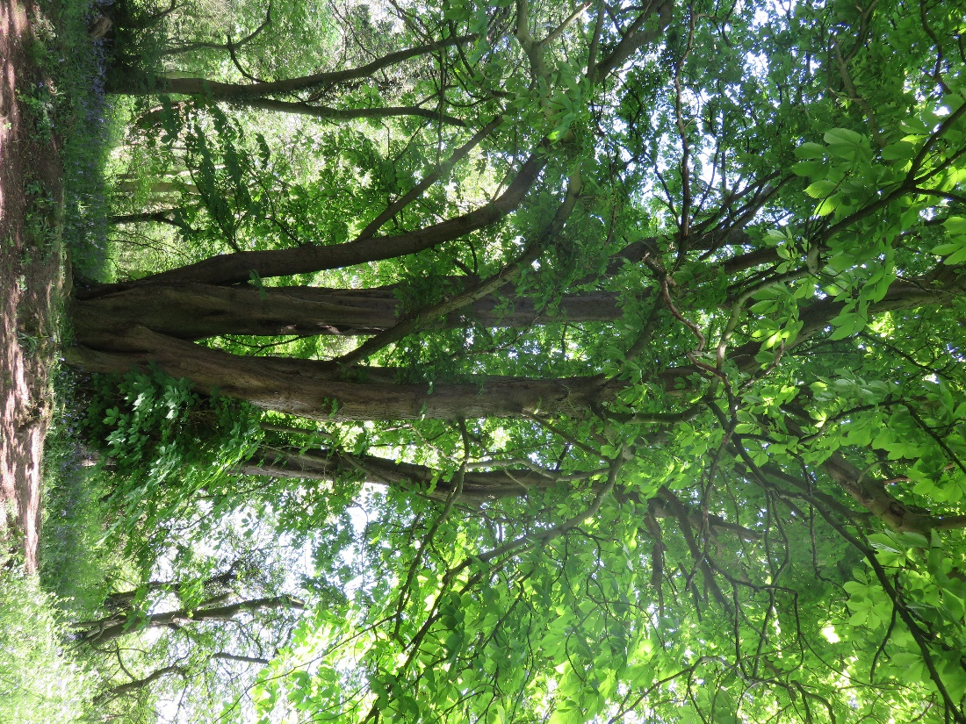
- There are two types of bluebells growing around the village. Do you know what they are?
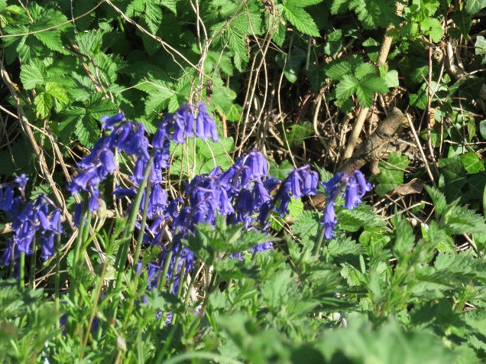
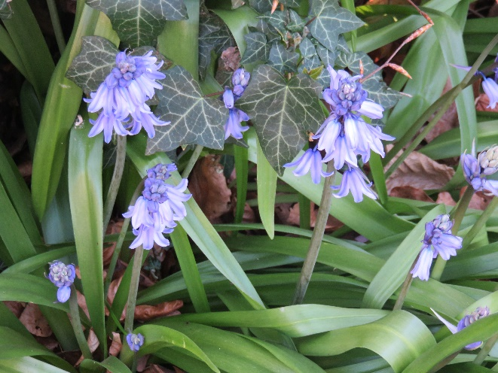

- From which direction was this view of the village taken?
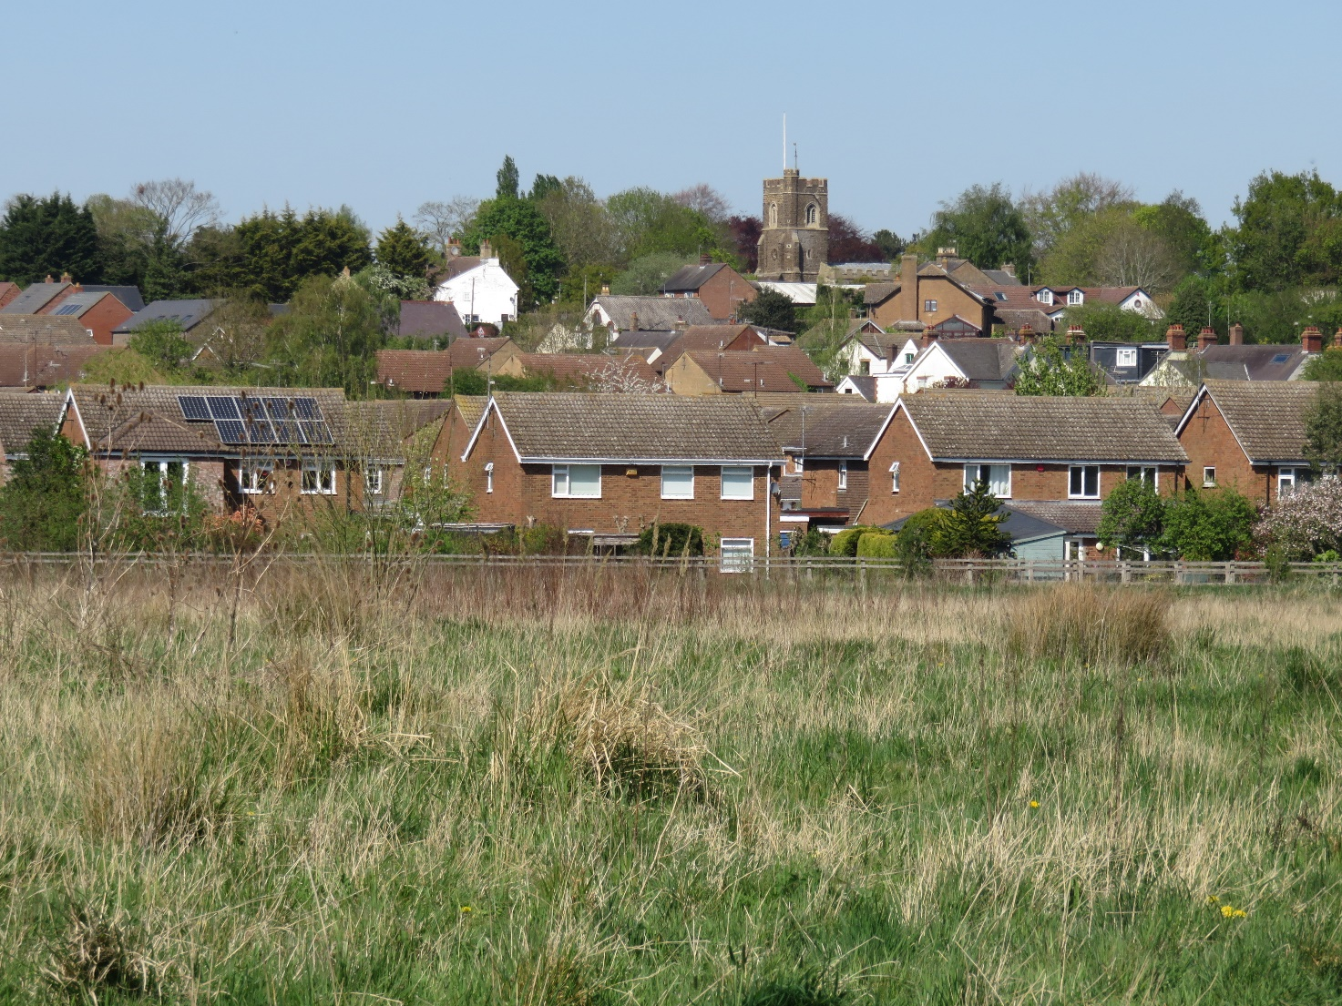

- What are these flowers?
  - 

   