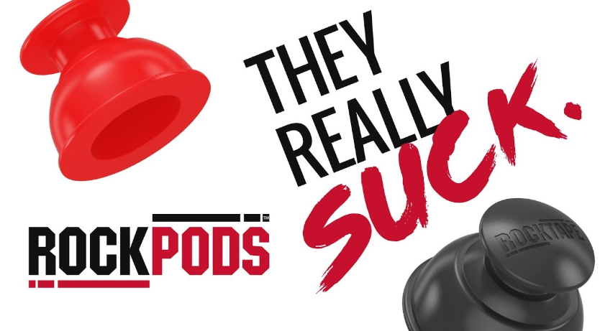

Rockpods™ consent and liability release form

By signing below, you acknowledge that you have no known conditions that would contraindicate receiving Cupping Therapy with silicone RockPods™ and thereby release any and all liability of and by Summit Massage Therapy, LLC and its Therapists/Staff.

“RockPods™ use decompressive technology to loosen and lift connective tissue, and increase blood and lymph flow to the skin and the muscles, stimulating the body’s natural healing process to treat chronic pain, relieve tension and sedate the nervous system.”

~RockTape™

Print name: _____________________________________________

Sign name: ______________________________________________ Date: _________________

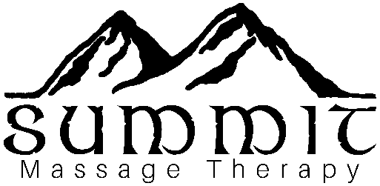Therapist Init.: ___________________________ Date: _________________