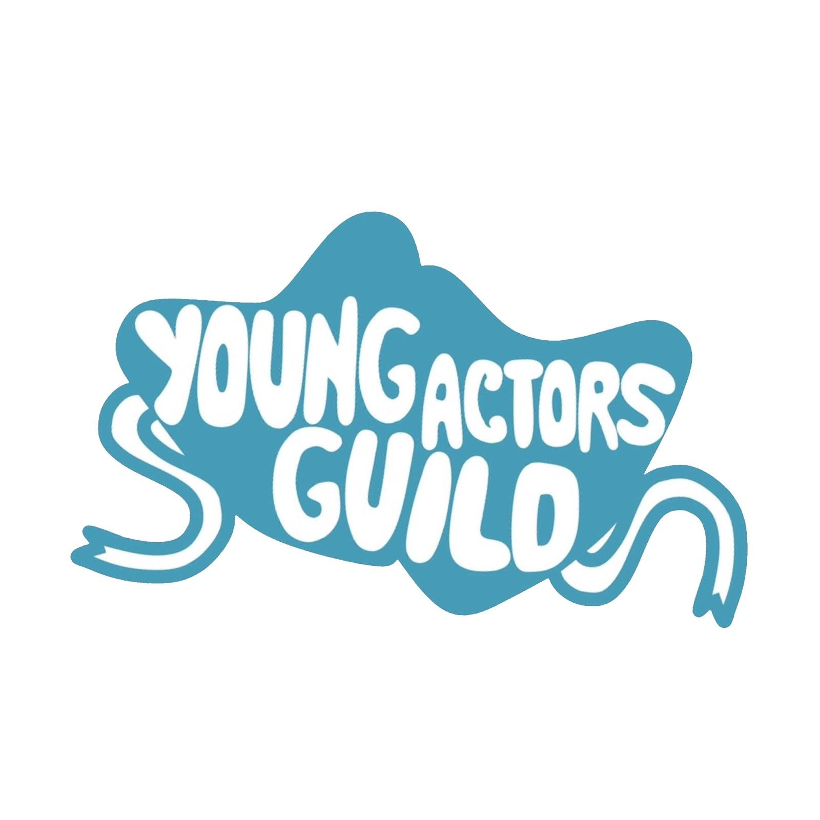
Young Actors Guild Health and Safety Guidelines

During all in person activities with the Young Actors Guild, for health and safety reasons, all members, and attendees must agree to obey the following precautions. If by chance a member or attendee cannot obey the precautions, they will be asked to leave, as health and safety if everyone else at the event is the number one priority of the Young Actors Guild. These rules are in place as a response to COVID-19 and the CDC’s recommendations regarding COVID-19.

In effect as of December 1st 2022

Precautions you must follow:

- Masks are not mandatory at any YAG events

- A Covid Compliance Officer provided by YAG will attend every event

- Temperature checks will be administered at the beginning of each rehearsal.

- If a temperature is above 99.9, the participant will be sent home.

- These protocols are subject to change at any time by the YAG Youth Board if situations change.

As the parent of ________________________ I acknowledge that the following rules and guidelines are in place to keep my child safe. And I have made my child fully aware and helped them to fully understand the following rules and guidelines so they can keep themselves; and others safe.

Parent Signature ________________________

