FM 4 Challenge Ride

Farm to Market Road 4 (FM 4) is a farm-to-market road that runs between the cities of Grandview and Jacksboro. The road traverses four counties (Johnson, Hood, Palo Pinto and Jack) and passes through several small and medium size towns. The route was designated in March 1942. FM 4 is one of the longest farm-to-market roads (116.2 miles) in the state of Texas.

The object of the challenge is to ride the entire length of FM4. There is no time limit on completing the challenge. You can do it in a single ride or break the ride into the segments described below. As proof of participation, you must collect a photograph of you and your bike at the designated location. The photographs should be submitted via email to fwhog.membership@gmail.com. Once you have completed all segments and submitted the required photographs, the photographs will be validated, and you will be awarded the FM 4 Challenge patch at the next HOG Chapter meeting.

Collecting Pictures
If you do the ride as a single ride, you must get the photograph associated with each stop along the ride. If you break the ride into segments, you must get the designated photograph at the start and end of the segment(s) you ride as well as any interim stops that you may pass through. For example, if you start the ride in Palo Pinto and ride to Granbury, you will need the photographs for Palo Pinto, Santo, Lipan and Granbury to get credit for those segments of the ride. If you ride the Granbury to Grandview segment later, you must get another Granbury picture as proof of start/exit point.

Locations and Associated Pictures

Grandview Mural located on the north side of Rowlett’s Hardware Store, Grandview Texas
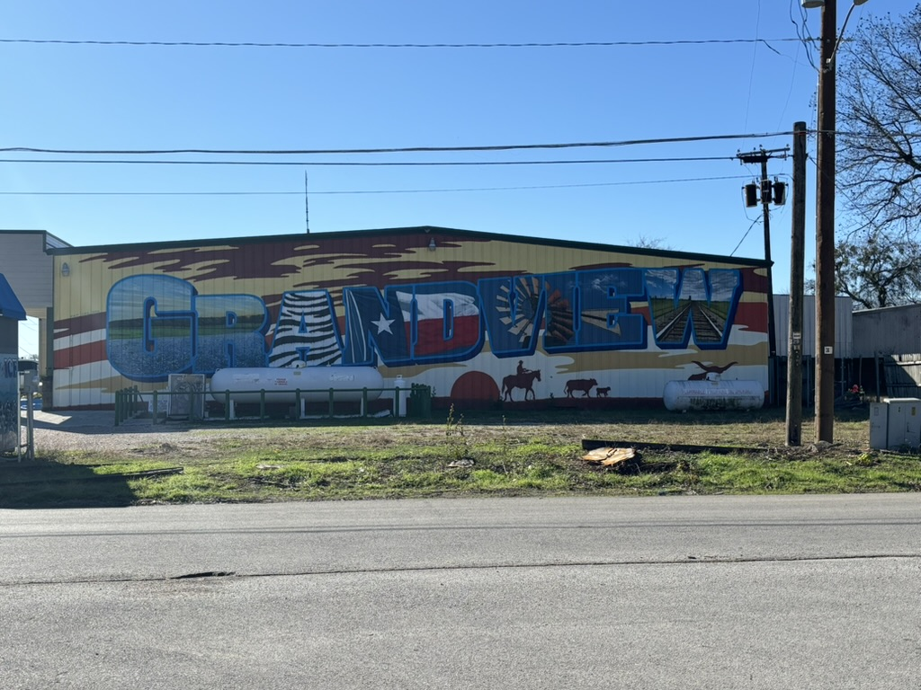

Gone With The Wind Museum, Cleburne Texas
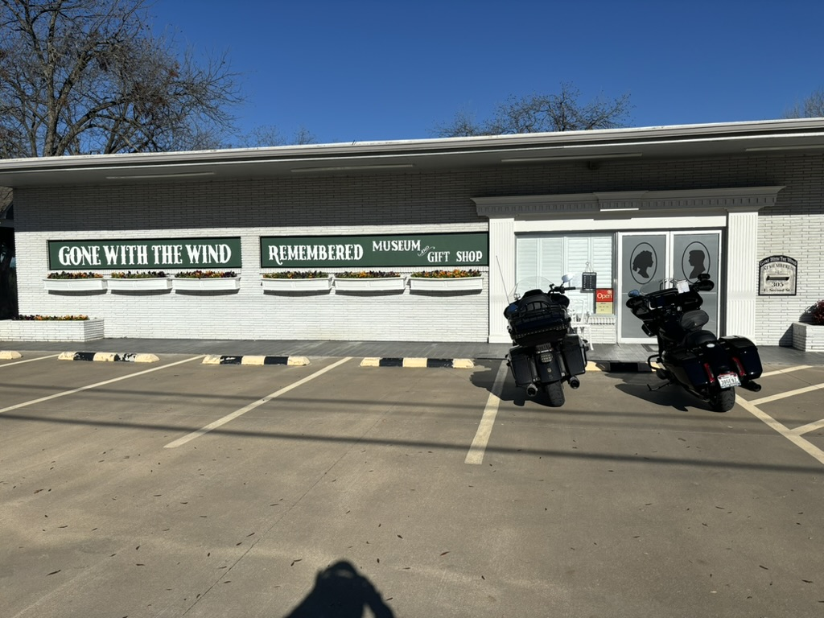

Hood County Court House, Granbury Texas
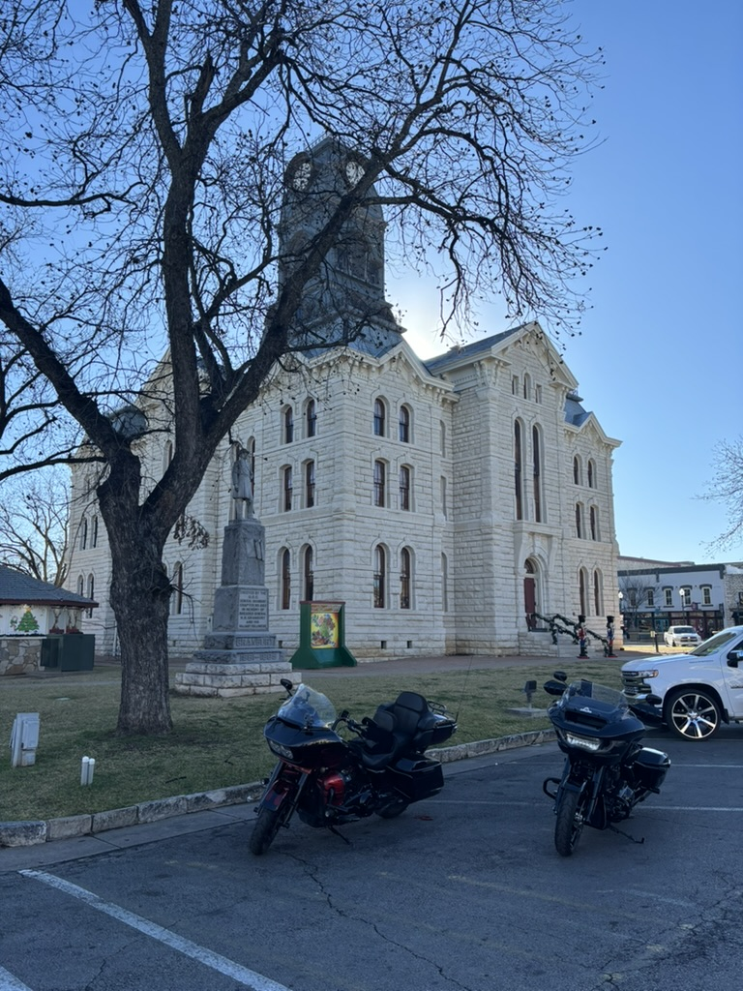

Circle H2 Convivence Store, Lipan Texas

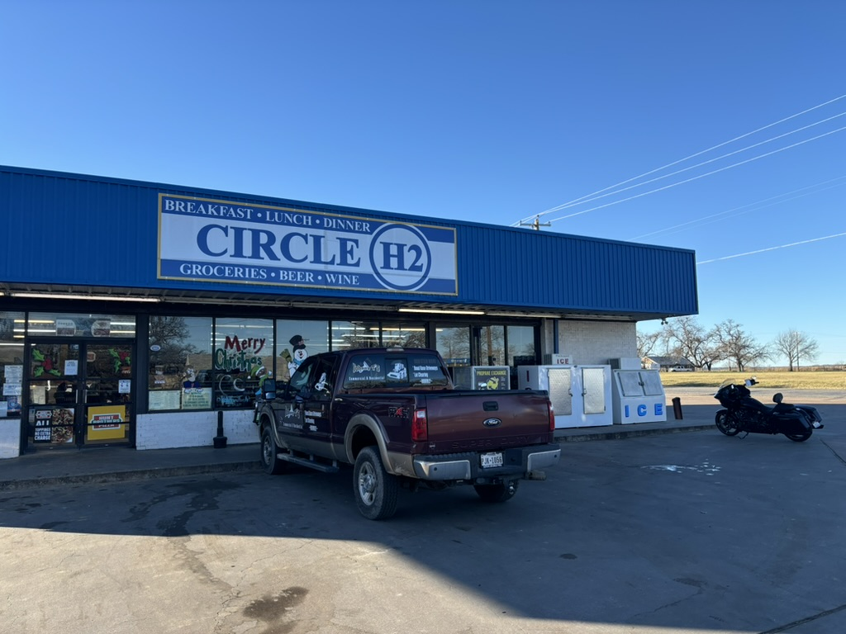

Tommy’s Conoco, Santo Texas

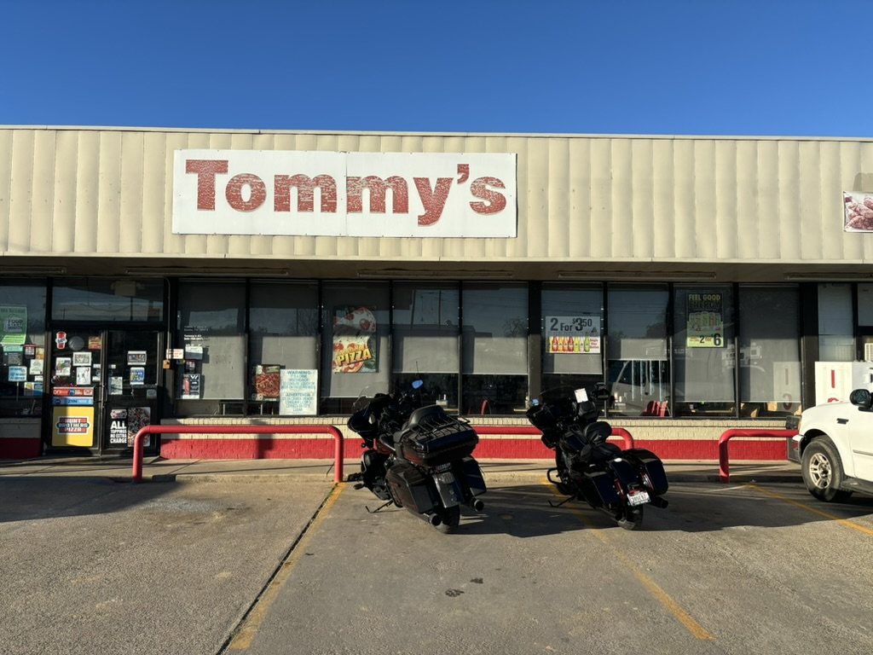

Old Jail Museum, Palo Pinto Texas
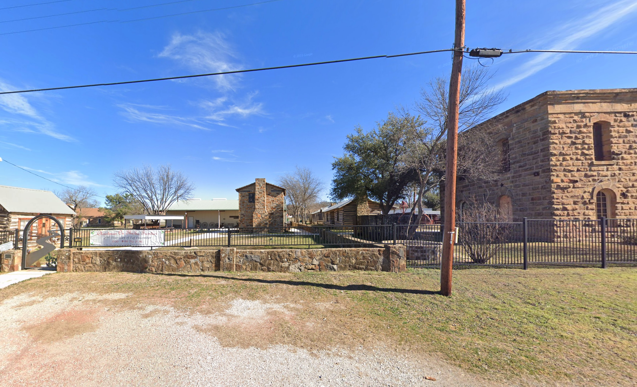

The Café, Graford Texas
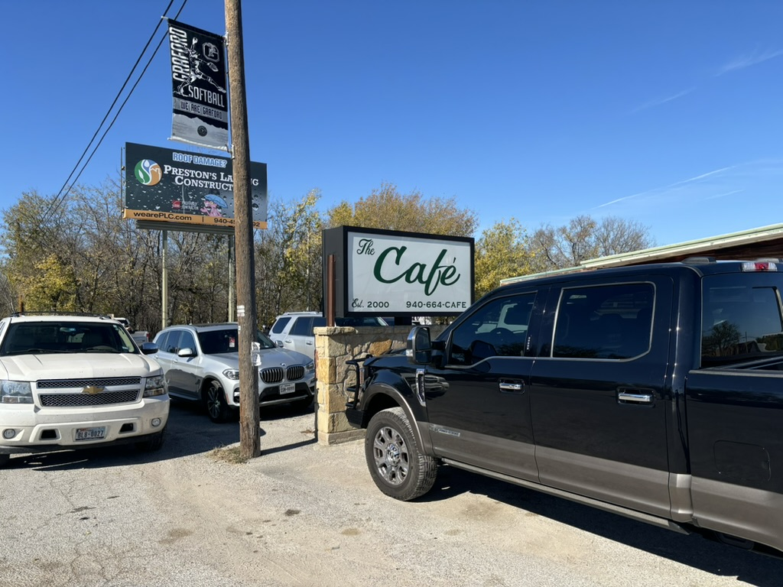

Jacksboro ISD Building, Jacksboro Texas
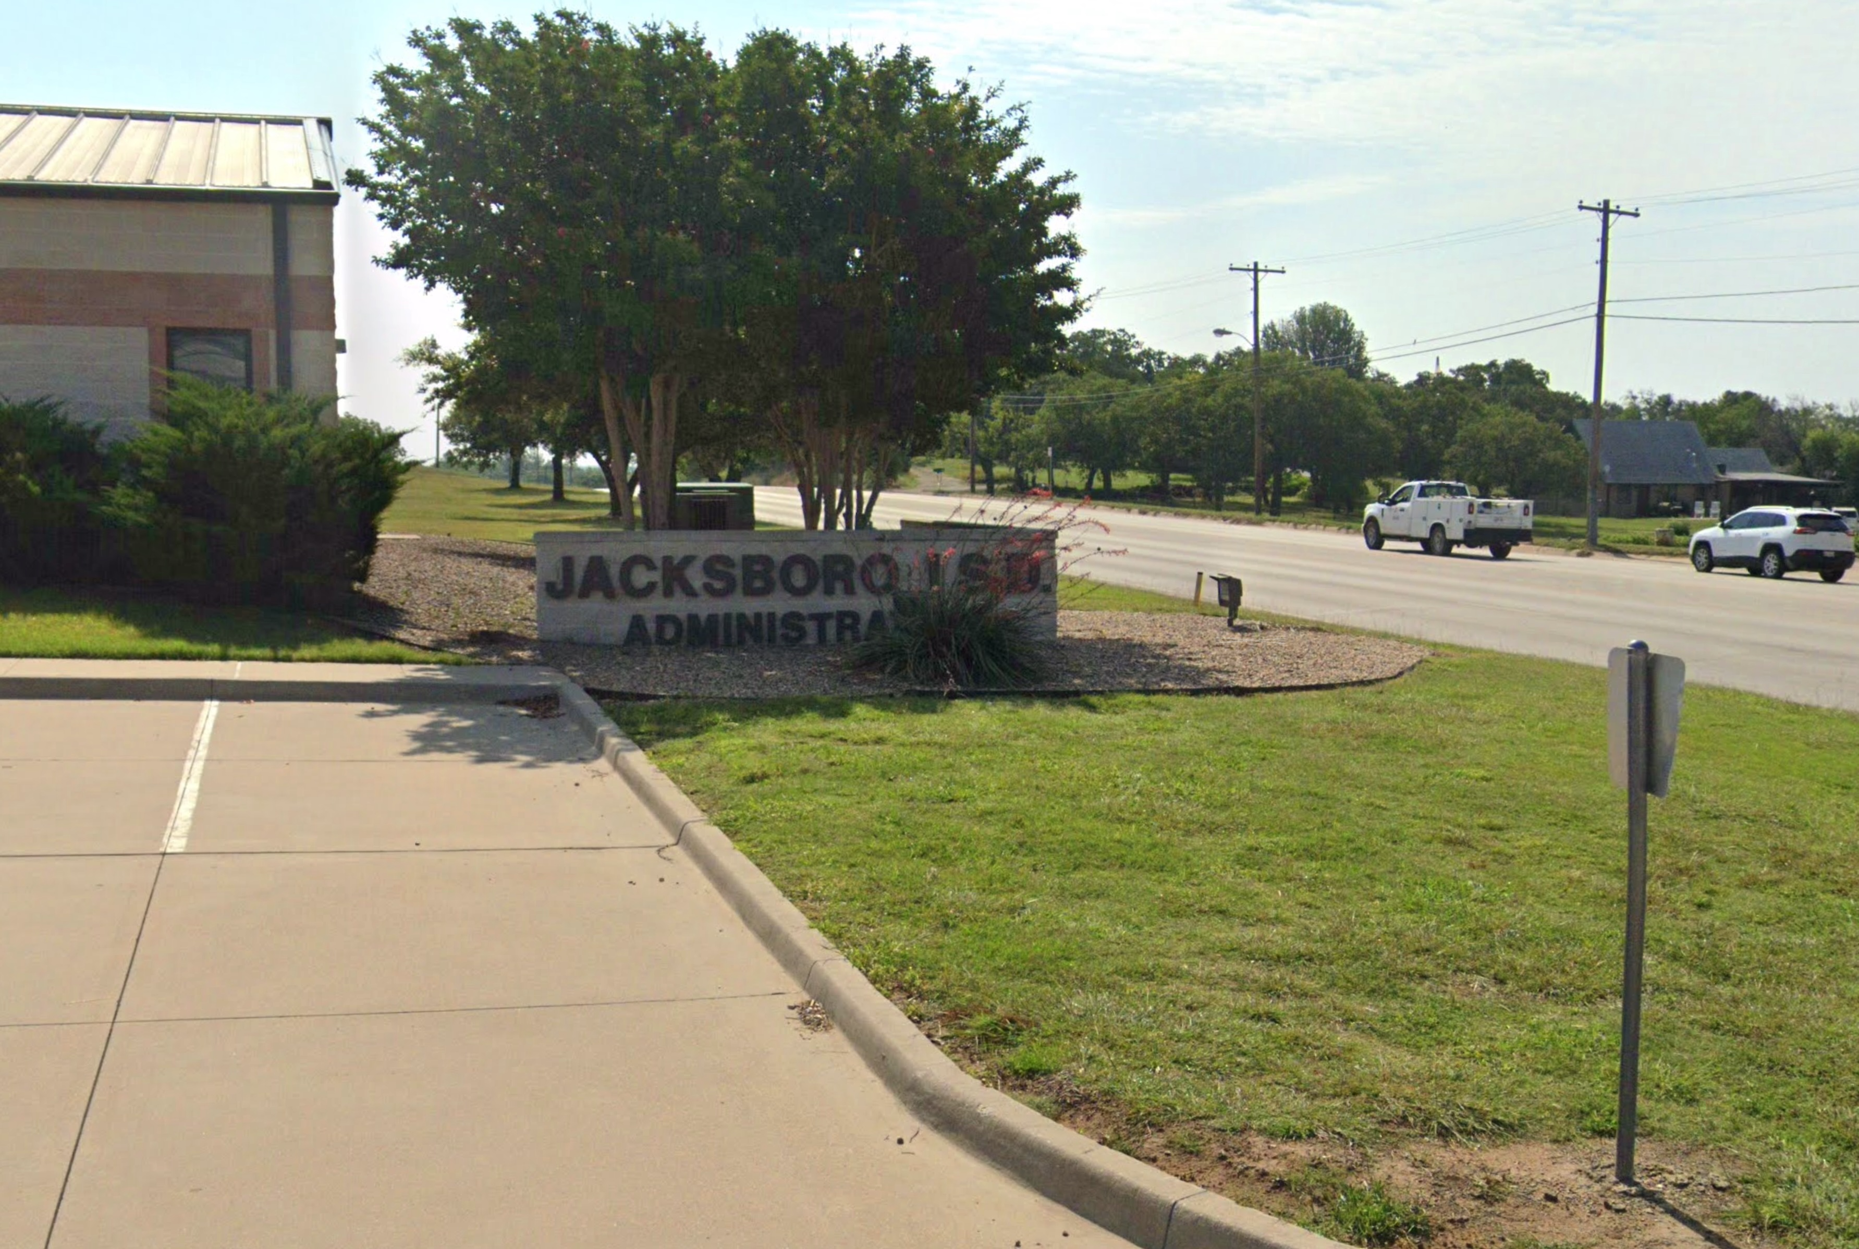

Distance Table
Location | Total Distance N to S (mi) | Leg Distance  N to S (mi) | Total Distance S to N (mi) | Leg Distance  N to S (mi)
Grandview Mural | 124.8 | 13.4 | 0 | 0
Gone With the Wind Museum, Cleburne | 111.4 | 29.3 | 13.4 | 13.4
Hood County Court House, Granbury | 82.1 | 18.5 | 42.7 | 29.3
Circle H2 Store, Lipan | 63.6 | 14 | 61.2 | 18.5
Tommy's, Santo | 49.6 | 14.4 | 75.2 | 14
Old Jail Museum Complex, Palo Pinto | 35.2 | 14.6 | 89.6 | 14.4
The Café, Graford | 20.6 | 20.6 | 104.2 | 14.6
Jacksboro ISD Building | 0 | 0 | 124.8 | 20.6

