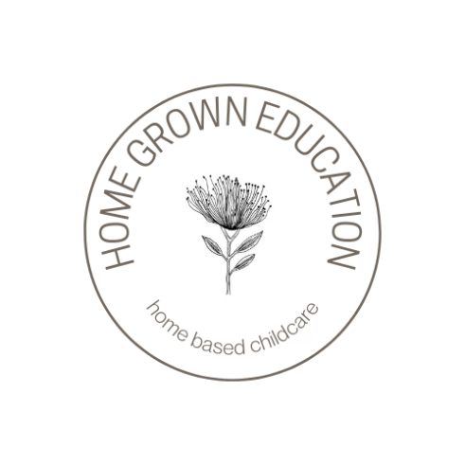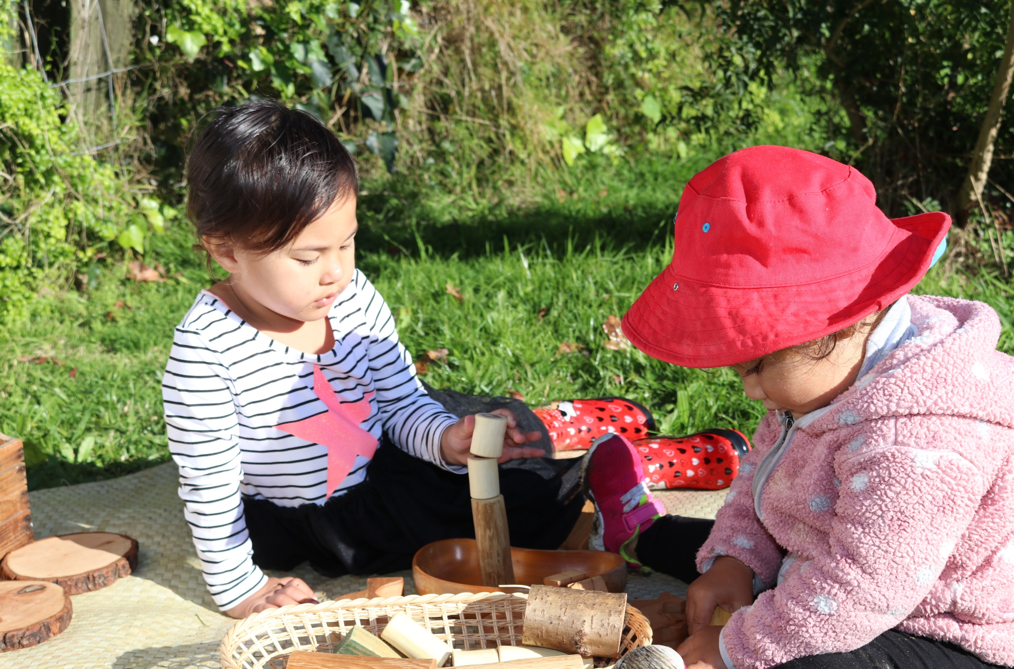

**PARENT HANDBOOK**

**HOME GROWN EDUCATION**

**Home Grown Education**

**Ho**

**WELCOME TO**

Home Grown Education is a home based early childhood provider which basically means we operate within selected homes. We are licensed by the Ministry of Education to deliver childcare and education for children in collaboration with their families and community.

At Home Grown Education, we believe the home based service is a wonderful option for parents and families to have their child learn and develop just as they would in a childcare center, but with the unique benefits of lower adult to child ratios which promotes quality interaction between children and their educator.

Children can settle faster and thrive in a home environment that is what they will already be familiar with, this means they can get straight into learning without the stress of settling in.

What we love about home based services is that every child has the opportunity to explore a real world environment and gain valuable experiences they would if they were at home with their families. We believe these experiences are important for children to grow into competent and confident learners of society.

We are founded on the philosophy of Reggio Emilia and implement the values of respect, honesty and love as guiding principles of practice.

Every child that joins our service, brings with them their identity, culture, family connections and ancestral links that we use to inform our teaching. Children have the opportunity to learn their heritage language as we have homes that are full emergent or bi-lingual in a specific language.

Home Grown Education is an extended family that continues to grow, and we welcome you to our family.

Yours in Education and Care,

Casey Smith + The Home Grown Education Team

Casey Smith



**Managing Director**

**Home Grown Education**

**Our Environments**

**Ho**

Home Grown Education Home Base services exist within homes of our wonderful educators. All these homes are screened to meet safety and compliance standards set out by the Ministry of Education.

Home Grown Education select specific resources that enhance the learning environment in each home. We aim to inspire young minds through setting up of vibrant resources, creating environments that invite children to explore.

We maintain consistency in all our services, and you will find similar resources, quality equipment, and natural tones that keep the feel and comfort of a home, still maintaining a space that creates opportunities for quality learning experiences.

One of our standards we value in each service is hygiene. Our policies ensure that each service maintains a good standard of hygiene and follows processes to ensure learning spaces are clean and safe for children.

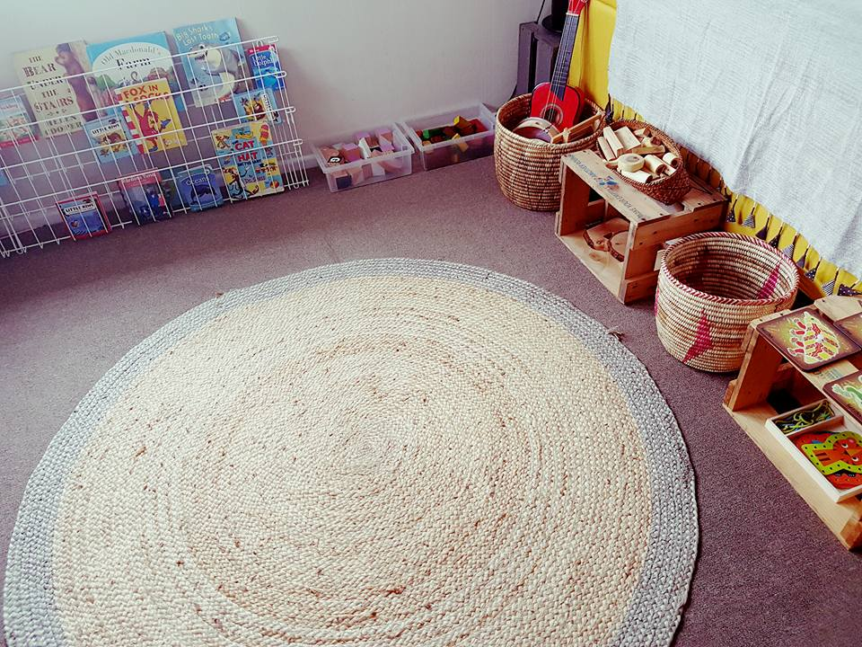

**Sustainability**

**Ho**

**Resources + Equipment**

Home Grown Education has an extensive list of resources and equipment that we ensure are used when educators are choosing resources for their service. This ensures that quality is maintained and kept. Home Grown Education purchases most of the resources and equipment in each service to help maintain the quality and vibrancy of each learning space. Natural resources are a common feature in every service, which contributes to the Reggio philosophy we implement in our curriculum. Home Grown Education has some custom-made resources to assist educators in their teaching, these are featured in each home to promote the curriculum. We make it our responsibility to be sustainable in our home services by purchasing recycled resources, materials and equipment that already exist within our communities before we seek to purchase new resources.

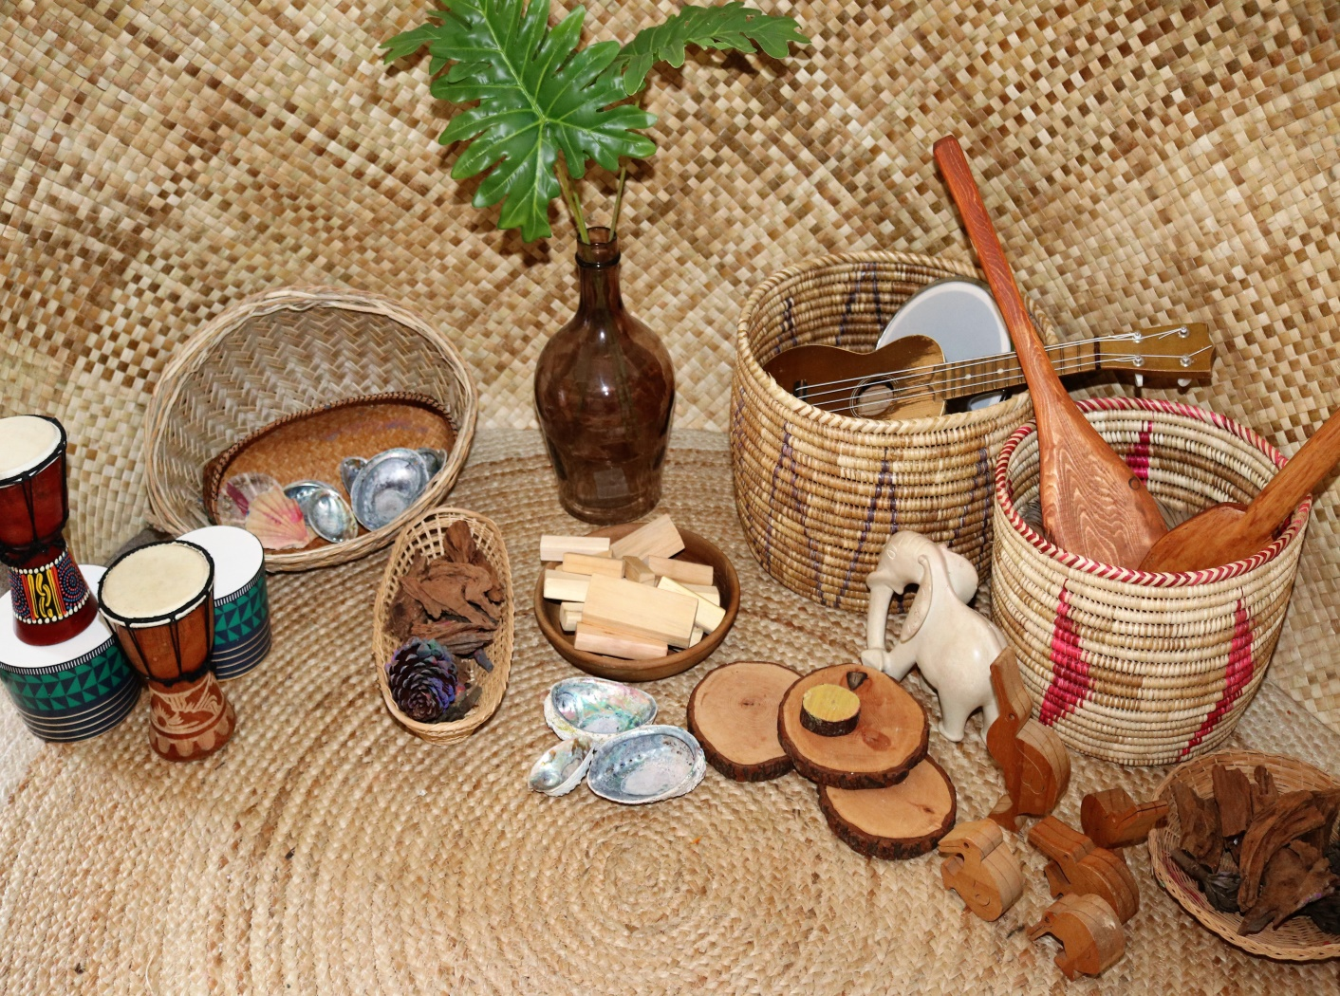

**Vetting**

**Ho**

Home Grown Educators are all police vetted prior to them operating as an official Home Grown service. This is to ensure safety of all our tamariki (children) and their whanau. Any adult that is home during the operating hours of home based services are all police vetted to ensure children are not in any possible danger, high risk environment and are kept safe at all times. Our coordinator frequently visits each service to ensure these measures are kept.

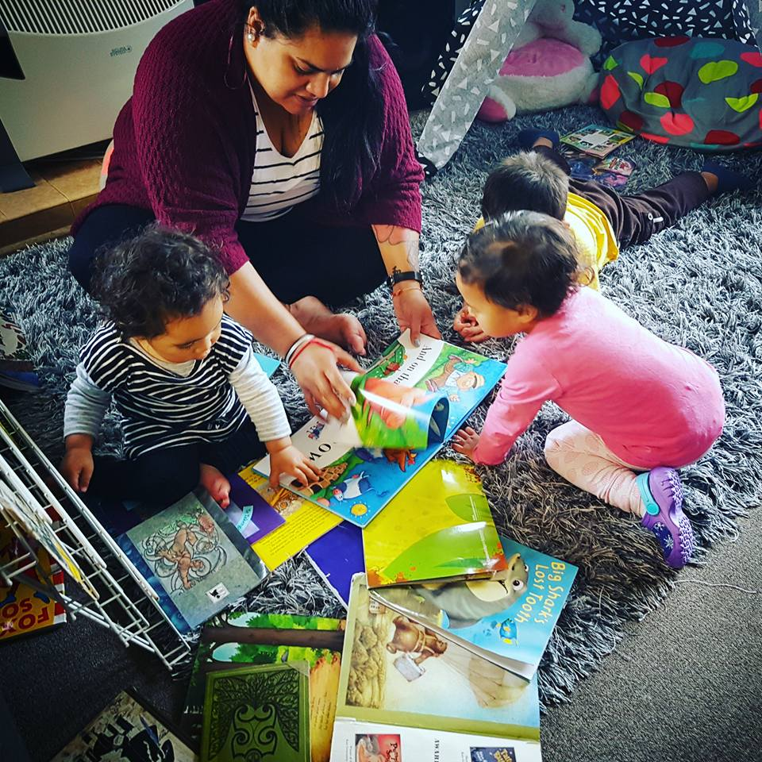

**Group Sizes**

**Ho**

Each home can only have up to 4 children at any operating time. This also counts the children of an educator who is home during operating hours. Out of these 4 children, only two of them can be under the age of 2yrs. This is to ensure the safety and supervision of children in our care. Having small group sizes where the ratio of 1:4 is consistently maintained, this allows children to have the quality time and attention with educators so that they can develop at a rate that is natural to them, and are not held back because they are not stimulated in their learning.

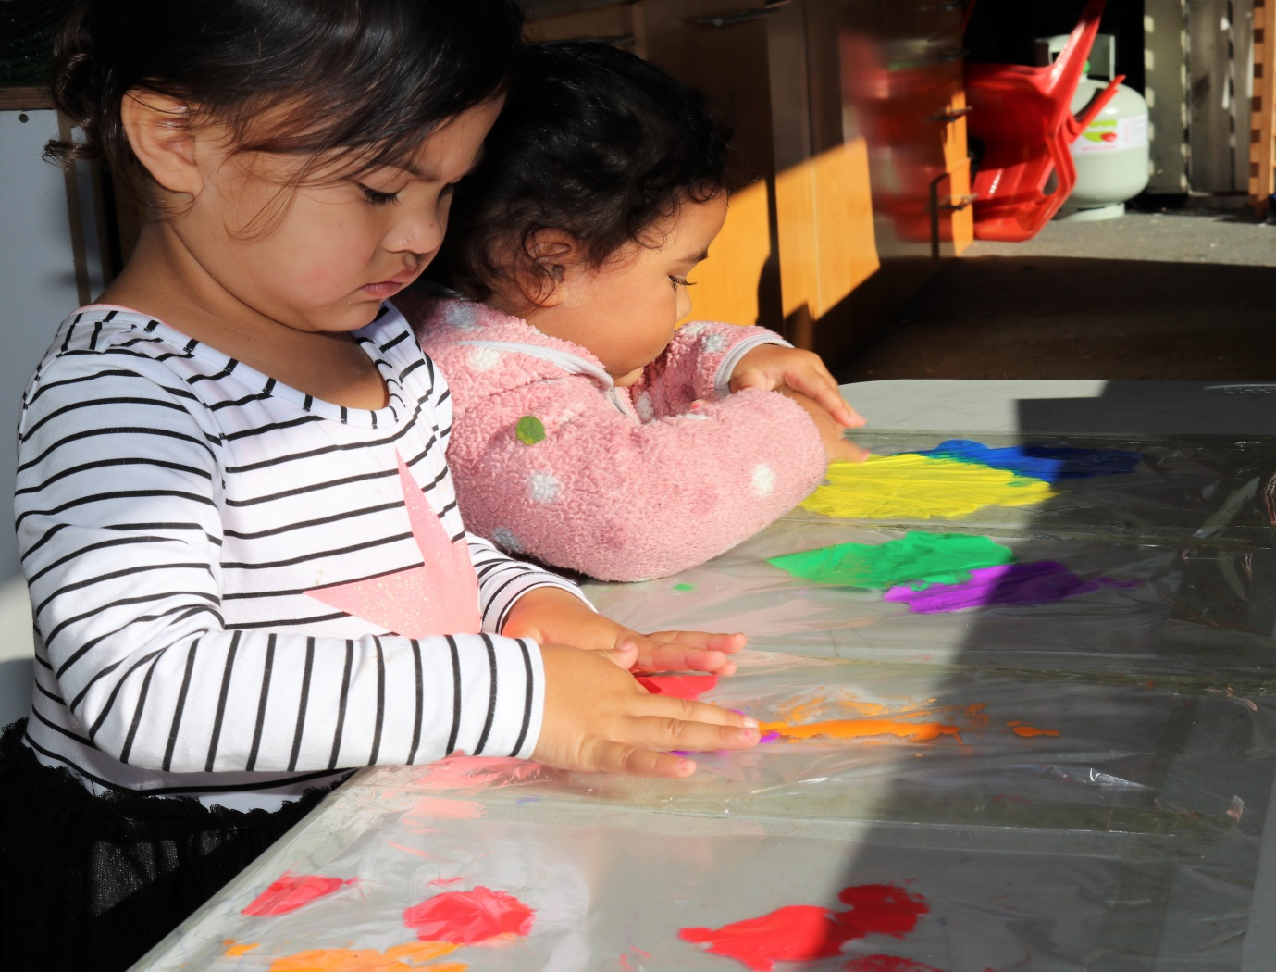

**Settling In**

**Ho**

At Home Grown Education home based services, we have experienced that children settle faster in a home environment because of the nature of the service. Being in a home setting allows children to feel a sense of belonging and familiarity. When children settle faster, they are ready for learning and can focus on development, parents can leave their child with piece of mind that their child is happy and are content in a safe environment. Parents can log into storypark via an app that can be downloaded onto their phone to receive updates on their child’s development and activities throughout the day. Educators can contact parents and caregivers throughout the settling in process when appropriate to keep them informed and ease their minds throughout this hard time.

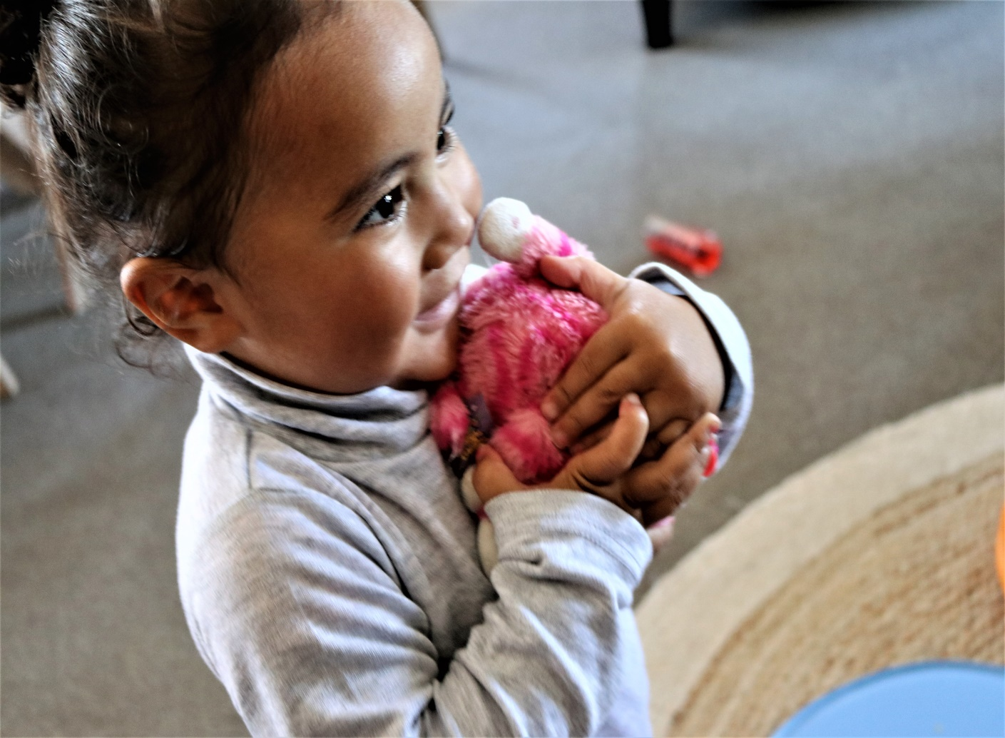

**Food + Nutrition**

**Ho**

Home Grown children are encouraged to bring their own lunches from home to each service. This is to help parents and families maintain their children’s nutritional needs they are used to in their home. However, there may be instances that educators provide food for children and when this does occur, food charts are filed and kept so whanau can see what their child has eaten. Children with specific dietary requirements are displayed in each service. Home Grown Education have a healthy eating policy that eliminates any junk food and meals that are not nutritious for children.

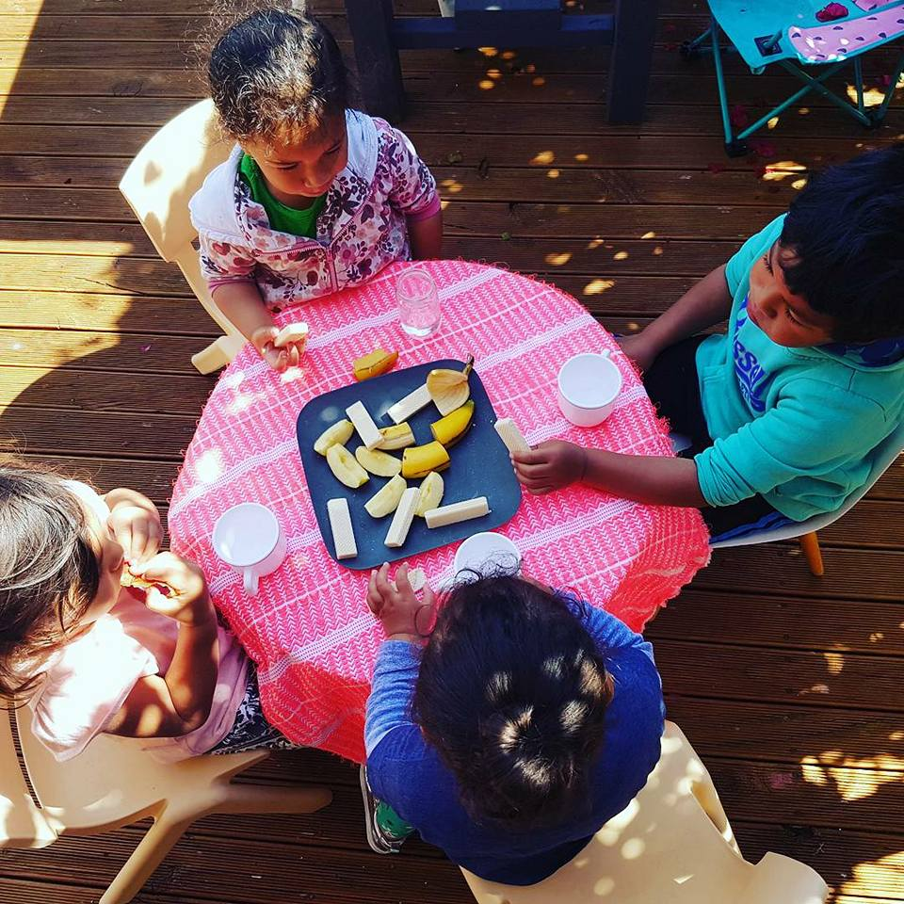

**Our Curriculum**

**Ho**

To learn and develop, a child must be in a secure and happy environment. At Home Grown Education, we value the home environment as a major tool for children to feel comfortable and a sense of familiarity and stability. A quality environment reflects the nature of learning through play, and is a reciprocal process between children and kaiako.

Quality kaiako are another factor that contributes to a well-founded curriculum. Selecting educators that are supportive, caring and well-trained help to enhance children’s learning within the curriculum.

Smaller ratios between educator and children 1:4 allows for higher quality in curriculum delivery, children have more attention and can focus on their learning and development in a family oriented space.

We know that children are developing faster in a home based environment because of these factors, and our curriculum helps to achieve learning milestones, provide opportunities for children to explore, and experience real world learning so they can develop a working theory in their journey to understanding the world they live in.

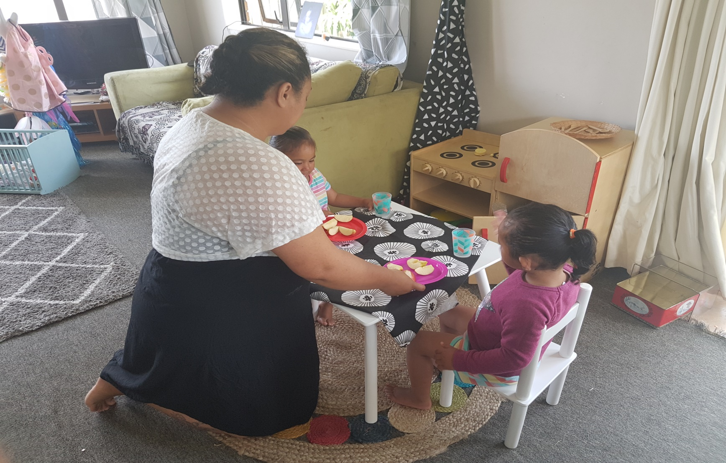

**The Reggio Approach   
in our Curriculum**

**The Reggio Emilia Approach is an innovative and inspiring approach to early childhood education** which values the child as strong, capable and resilient; rich with wonder and knowledge. Every child brings with them deep curiosity and potential and this innate curiosity drives their interest to understand their world and their place within it.

Children

Children are capable of constructing their own learning. They are [driven by their interests](http://www.aneverydaystory.com/2013/12/04/exploring-electricity/) to understand and know more. Children form an understanding of themselves and their place in the world through their interactions with others. There is a strong focus on social collaboration, working in groups, where each child is an equal participant, having their thoughts and questions valued. The adult is not the giver of knowledge. [Children search out the knowledge through their own investigations.](http://aneverydaystory.wordpress.com/2012/10/03/reggio-project-based-homeschooling-a-big-learning-curve/) Children are communicators. Communication is a process, a way of discovering things, asking questions, using language as *play. Playing*with sounds and rhythm and rhyme; delighting in the process of communicating. [Children are encouraged to use language to investigate and explore](http://aneverydaystory.wordpress.com/2012/09/18/reggio-emilia-projects-for-preschoolers-studying-bugs-and-ants/), to reflect on their experiences. They are listened to with respect, believing that their questions and observations are an opportunity to learn and search together. It is a process; a continual process. A collaborative process. Rather than the child asking a question and the adult offering the answers, [the search is undertaken together](http://www.aneverydaystory.com/2014/03/20/human-body-build-skeleton/).

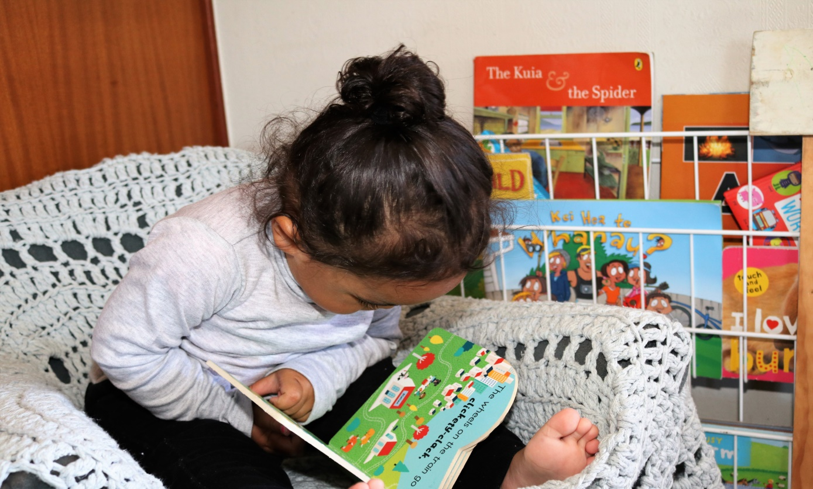

Whanau

The family and community surrounding the child is what makes up the child’s identity. The cultural heritage of each child is unique and used in Home Grown Education to support children’s learning and development. We aspire to create confident learners that believe they are capable and this is done through including their identity in their learning. It is an expectation for every child to leave Home Grown Education having learnt their whakapapa and cultural identity through reciting their pepeha and learning about their cultures within the curriculum.

Kaiako

The adult is a mentor and guide. [Our role as adults](http://www.aneverydaystory.com/2014/06/18/reggio-emilia-role-of-adult/) is to observe (our) children, listen to their questions and their stories, find what interests them and then provide them with opportunities to explore these interests further. The Reggio Emilia Approach takes a child-led project approach. The projects aren’t planned in advanced, they emerge based on the child’s interests.

An emphasis on documenting children’s thoughts**.** You’ll notice in Reggio and Reggio-inspired settings that there is an emphasis on carefully displaying and documenting children’s thoughts and progression of thinking; [making their thoughts visible](http://www.aneverydaystory.com/2014/04/09/30-days-to-transform-your-play-day-9/) in many different ways: photographs, transcripts of children’s thoughts and explanations, visual representations ([drawings](http://www.aneverydaystory.com/2013/07/09/studying-native-birds/), sculptures etc.), all designed to show the child’s learning process.

Environment

The environment is the third teacher. [The environment is recognised for its potential to inspire children](http://www.aneverydaystory.com/2014/04/03/30-days-to-transform-your-play-day-3/). An environment filled with*natural light, order and beauty*. Open spaces[free from clutter](http://www.aneverydaystory.com/2014/04/02/30-days-to-transform-your-play-day-2/), where every material is considered for its purpose, every corner is ever-evolving to encourage children to delve deeper and deeper into their interests. The space encourages collaboration, communication and exploration. The space respects children as capable by providing them with [authentic materials & tools](http://www.aneverydaystory.com/2014/04/10/transform-your-play-selecting-materials/). The space is cared for by the children and the adults.

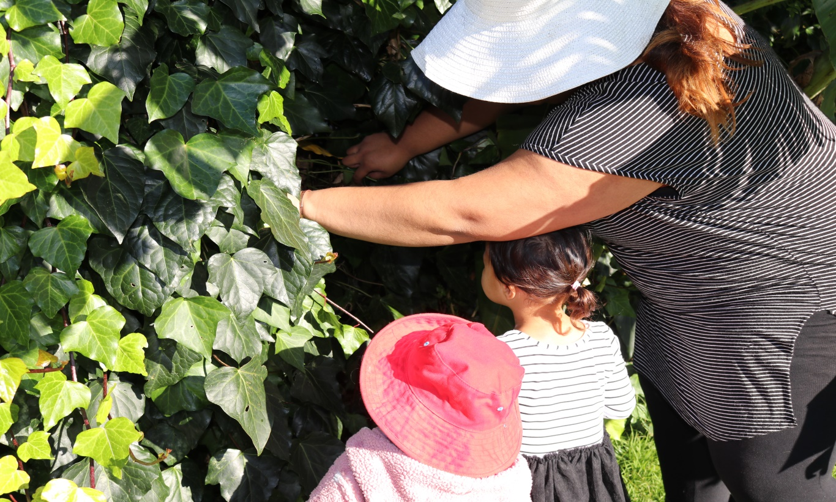

**The Importance of Play**

**Ho**

At Home Grown Education play is central for our children to develop positive life long learning experiences. We view play as children’s work.

We value play as an opportunity for children to prepare for life. We focus on developing skills and habits of learning that will support and impact the child’s life in the long term.

We can do this by creating learning experiences that help children develop ways of thinking, problem solving, risk taking, communicate and to explore. These are skills that they will need for life.

The social behaviours that children learn among their peers will allow them to learn turn taking, patience, compassion and care for others which are values that when paired with respect, honesty and love we believe will contribute to growing competent, good members of society.

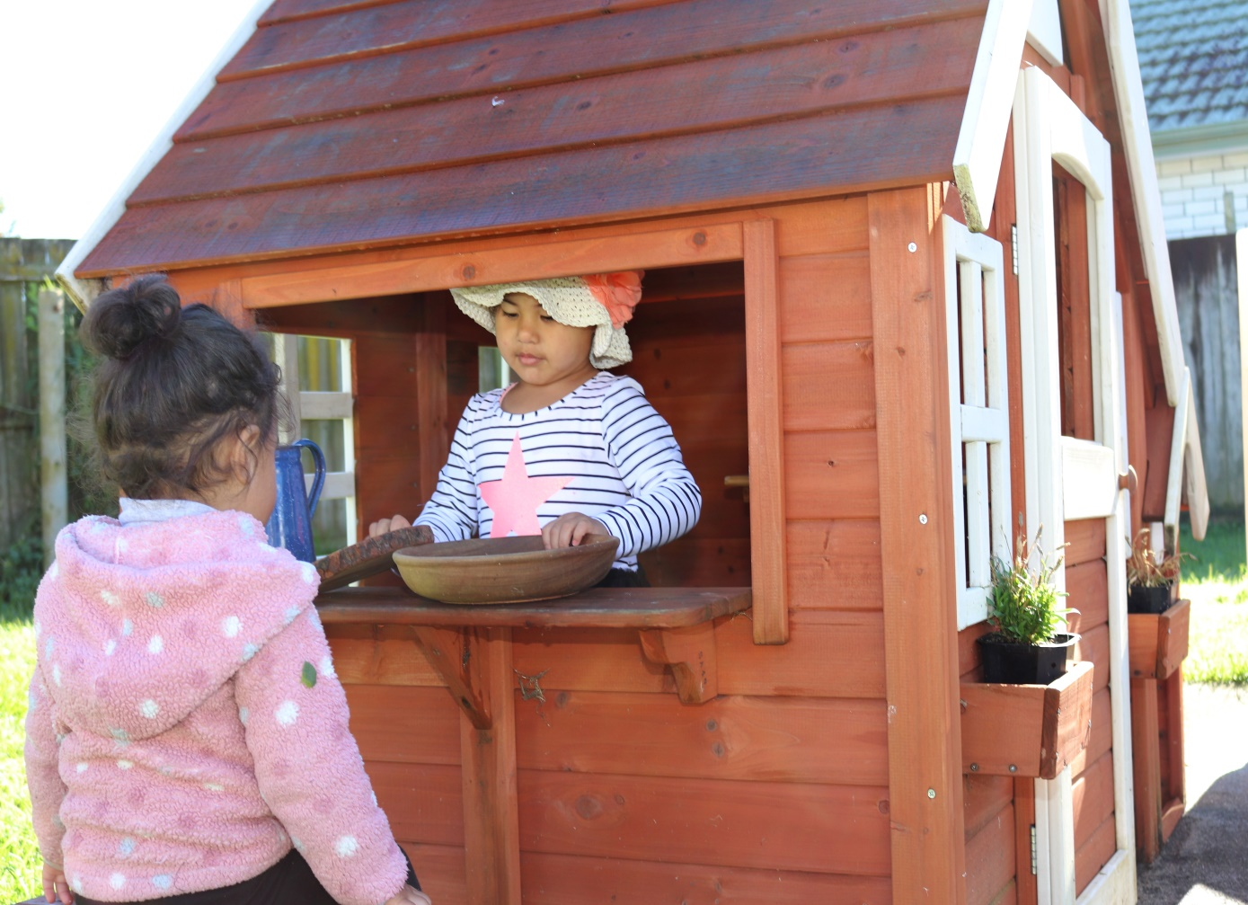

**Having Your Say**

**Ho**

We value the voice of parents and whanau in all areas of our service. From planning for your child’s learning and development, ideas for excursions, ways to improve we would love to hear from you.

We plan for each child as a unique being and can only do this with the contributions made by parents and whanau. Home Grown Education has found a new way to make this easy for our whanau through downloading the Storypark app on any device so you can receive instant messages, media, and learning assessments for your child from a click of a screen!

We encourage whanau to upload pictures, videos or thoughts that they might experience outside of our service hours, this can help kaiako plan for activities that are based on the interest of the child.

Whether it is a comment, idea or photo we would love to hear from you.

Download the storypark app via google play store or the app store to be in touch soon.

Alternatively you can contact us via email, phone or contact us online.

If you would like to make a complaint about our service being non-compliant you can contact the Ministry of Education on

12-18 Normanby Road,

Mt Eden, Auckland 1024

Ph: +64 9 632 9400

or if you wish to view a copy of:

* Our latest ERO report
* Policies & Procedures
* Our operational documents (philosophy, daily plans….etc)
* The Education (early childhood services regulations 2008, and the licensing criteria for home based education and care services 2008)
* The services current licence
* The amount and details of any funding received by the Ministry of Education

you can request it by emailing us at [admin@homegrowned.co.nz](mailto:admin@homegrowned.co.nz).

If you would like to contact the coordinators who are qualified and registered teachers, you can contact the following:

Casey Smith

0212476975

[casey@homegrowned.co.nz](mailto:casey@homegrowned.co.nz)

Rosalie Leuluai

Home Grown Education

Tel (09) 216 6767

Mob (021) 247 6975

Email: [admin@homegrowned.co.nz](mailto:admin@homegrowned.co.nz)

www.homegrowned.co.nz