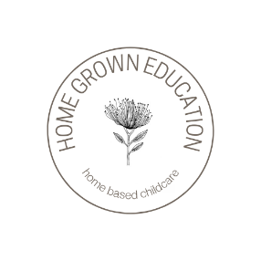
Home Grown Education
Philosophy

At Home Grown Education we will provide a holistic learning environment based on the following principles and values:

Aroha (Love) – Being kind and caring to all people, places, and things.
Whakapono (Honesty) – Showing Integrity in all we do, even when it is hard.
Whakaute (Respect) – Being mindful of all people, places, and things.

Our curriculum is based on the principles and learning strands of Te Whāriki, the early childhood curriculum document unique to Aotearoa NZ, and will reflect the diversity of the teachers, children and families that make up Home Grown Education.
Young children develop and learn in the context of authentic, respectful relationships. With Home Grown Education each child will experience a warm, respectful relationship with their educator and will be supported to build respectful relationships with their peers and the world around them. These relationships will form the secure foundation from which meaningful learning and exploration can occur. A key role of the educator is to reflect on each child a positive self-image and sense of worth, acknowledging and respecting the culture, language and ‘basket’ of knowledge and understanding that each child brings with them.

