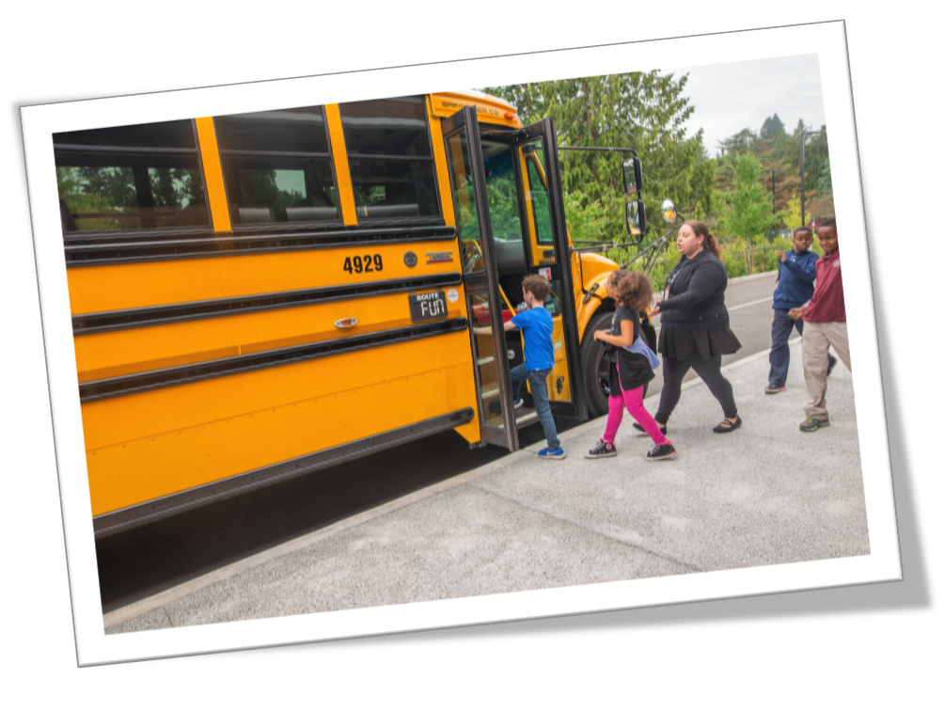Seattle Public Schools logo in white


2020.21 |Re-entry School-based Guidebook



Magnolia Elementary

## Purpose and Use of this Guide for Students, Families, and Staff

This In-Person Re-entry Guide (the Guide) has been developed to assist schools in contextualizing their re-entry plans to their school sites, and for schools to share re-entry plans, including site-based details, with staff, students, and families. In the Guide, you will find what to expect as your learning community prepares for a return to in-person learning.

The Guide communicates protocols and processes foundational to re-entry: health, safety, operations, instruction, and community-based partnerships. These protocols and processes have been developed in coordination with multiple Central Office Departments and anchored to guidance from OSPI, the CDC, and Washington State. In the Guide you will see internal links for District staff and school leaders to access expanded details related to some protocols or processes. Protocols and processes can be accessed by families and other members of the learning community on [the In-Person Learning Plan](https://www.seattleschools.org/resources) site on The Seattle Schools website.

Seattle Public Schools is committed to providing high-quality learning, no matter the circumstances. Throughout the district’s response to COVID-19, the health and safety of our community has been our top priority. Following the recommendations of public health experts, most SPS students began the 2020-21 school year remotely. Since then, public health and the global medical community have learned a lot about the transmission of COVID-19. We are confident that while in-person learning will look different than in past years, the strong health and safety protocols we are successfully using have prepared us to return more students to our school buildings this spring.

Content Hyperlinks ***Click on each topic to navigate to the protocol***

School Name and Logo 1

Purpose and Use of this Guide for Students, Families, and Staff 1

**In Person Learning: Health, Safety, and Operations** 3

Cleaning Procedures and Schedules 4

Cohort Guidance 5

COVID Legal Agreement and Family Instructions 6

Daily Health Screening for Students and Staff 6

Drop-off/Pick-up Procedures 8

Daily Health Screening Kiosks 9

Entry, Exit, Traffic Flow 10

Meal Procedures 12

[This protocol is under review. Please check back on 3/30 for updated information. 12](https://seattleschools.sharepoint.com/sites/SPSRemoteLearningPlayBook-O365/Shared%20Documents/Re-entry/SPS%20School%20Re-Entry%20Guide%20.docx#_Toc67492150)

Physical Distancing Protocols and Classroom Adjustments 13

Physical Distancing Classroom Checklists 14

Playground and Recess Protocol 15

PPE: Face Coverings 16

PPE: Inventory and Ordering 18

Enhanced PPE: Evaluation and Training 19

Protected Health Care Room 20

Restrooms 22

Signage 23

Student/Staff Health Alert and Contact Tracing 24

Transportation 25

Water Fountains 26

**Curricular and Instructional Practices** 28

CAI Educator Orientation 29

Learning Materials – Education Kit Management 30

Student Summary Guidance 31

Technology to Support In-Person Learning 32

**In Person Learning: Community Based Organization Partnerships** 33

Childcare 34

Appendices and Resources 35

# **In Person Learning: Health, Safety, and Operations**

# Cleaning Procedures and Schedules

Daily Cleaning

Seattle Public Schools follows the Washington Department of Health, Public Health, and CDC Cleaning and Disinfecting guidelines.

Daily cleaning schedule:

* High touch surfaces/points cleaning and disinfectant occurs at least three times a day and includes but is not limited to the following: doorknobs, door hardware, drinking fountains, stair rails, common areas, desks, tables, light switches, elevator buttons, and any other touchpoints in high traffic/common spaces.
* All restrooms are serviced and disinfected three times per day, with at least 2 hours between servicing. Common spaces used by childcare (hallways, gyms, cafeterias, etc.) are cleaned and disinfected daily.
* If there is a suspected or confirmed case of COVID-19, Seattle Public Schools will follow the CDC Cleaning and Disinfecting guidelines and communication plan for staff, families, and students.

[For SPS staff and school leaders, use this link to access detailed cleaning and disinfecting guidance.](https://seattleschools.sharepoint.com/:b:/s/SchoolsandContinuousImprovement/EWAquXwIsoFGsVU8tM5QcIMBvRevy4xM4gUTMQJrZrziqA?e=Q6ldWe)

Back to top

# Cohort Guidance

Creating cohorts or small groups of students and staff that remain together throughout the school day, so that there is minimal mixing between groups, is a key principle for limiting the spread of COVID-19. This practice helps to reduce opportunities for exposure or transmission of COVID-19 at school, facilitates contact tracing in the event of a positive case, and simplifies testing, quarantine, and/or isolation to a single cohort rather than school-wide measures.

Protocol:

Small groups (cohorts) of students will remain with dedicated staff throughout the school day, including lunch time and recess. Cohorts, consisting of 15 or fewer students and their educator(s), will remain consistent from day to day.

Staff, students, and families will receive orientation to the cohort model. Staff will receive building-specific training to support the implementation of the cohort model.

Procedures and training include considerations for:

* Drop-off/pick-up
* Building entry/exit assigned locations
* Hallway traffic patterns
* Assigned classroom seating
* Staggered classroom entrance/release times
* Restroom use (individual and classroom)
* Recess
  + Zones will be used to maintain separation between groups

Back to top

# COVID Legal Agreement and Family Instructions

Prior to beginning in-person services, schools will need to obtain a signed agreement from each student’s parent or guardian. Agreements have been translated into the top 5 languages.

**For SPS Staff and School Leaders:**

* [Use this link to access the COVID Legal Agreement – Purpose and Staff Instructions](https://seattleschools.sharepoint.com/:b:/s/SchoolsandContinuousImprovement/EdYf9H6q1iJEqi4oE4fxY74BTw0s4VQNInQjA6BUzMEUXw?e=Ci4lgd)
* [Use this link to access the COVID Legal Agreement and Family Instructions (English)](https://seattleschools.sharepoint.com/:b:/s/SchoolsandContinuousImprovement/EYVpDTOIq6pIkdk3n7oM3B0BMvEovhIEfSfR_M0xrsGFxg?e=Cuq03k)
* [Use this link to access the Translated COVID Legal Agreements and Family Instructions](https://seattleschools.sharepoint.com/:f:/s/SchoolsandContinuousImprovement/EpSjvnG5Un5Jlv1JJYAE-3sB8oX6QP4CMiBlHCzayDAzCg?e=totqzZ)

# Daily Health Screening for Students and Staff

Daily health screening of both students and staff ***before arrival / entry to school or work site*** is done to reduce the transmission risk of COVID-19 and to confirm that staff and students entering the school/site are not experiencing any COVID-19 symptoms or have had any known exposure to the virus. Students and staff with any symptoms, known exposure, or who are ill must stay home or return home.

Daily Health Screening Process

**The Daily Health Screening process is completed electronically:**

* Student /staff receive, daily, an initial and follow-up notification (email/text) to complete the screening.
* After completion, instructions are given for *Approved* or *Not Approved* school/site entry.
* An *Approved* message gives a green indicator to proceed and enter.
* A *Not Approved* message gives a red indicator to stop, stay home and if indicated contact a health care provider.
* Note: Daily Health Screening notification is “live” for one time, or 24 hours, when another notification is emailed/texted.

**Student Daily Health Screening Process**

* Family of students PreK – grade 5 and students grades 6-12 complete the Daily Health Screening before departure for/arrival to school.
* If *Approved* message is received, students arrive to school with face coverings on and are instructed to line up 6 feet apart from non-household members.
* School staff will view the health screening dashboard and print classroom status reports to be given to designated staff greeting students. The reports identify the status of each student.
  + Students *Approved* to enter school will be escorted for school entry.
  + Students with a *Not Approved* message will:
    - Be escorted to the Protected Health Care Room
    - Have family notified to confirm the *Not Approved* result
    - Receive health screening to determine next steps

*Continued on Next Page*

* + - * Students without symptoms or having had NO known exposure will be escorted to the classroom.
      * Students exhibiting symptoms or having had known exposure will be sent home with notification to family.
        1. Designated staff will email Health Information noting STUDENT HEALTH ALERT in the subject line.
  + Students without a completed screening entry who:
    - Arrive with a family member present, or students in grade 6-12, will complete the health screening on site. If *Approved*, student will proceed to class.
    - Arrive without a family member will be escorted to a designated location to determine next steps.  Family will be contacted to complete the health screening.
* If during the daily health screening, students are told to stay home, parent/guardian is still expected to contact the schools to notify them that their student will stay home.

**Staff Daily Health Screening Process**

* Staff complete the Daily Health Screening before departure for/arrival to school or building site.
* If *Approved* message received, staff travel to/arrive at school/site with mask on, remaining 6 feet apart from others whenever possible from non-household members.
* COVID Site Supervisor will view the health screening dashboard to determine staff approval to enter the worksite.
* COVID Site Supervisor will follow up with staff to determine next steps.
  + Staff who did not complete the screening, will complete it on site before going to work location.
  + Staff exhibiting symptoms or having known exposure to the virus will be asked to go directly home.
    - The staff’s Supervisor will email Health Information noting HEALTH ALERT in the subject line.
* If during the daily health screening, staff are told to stay home, they are still expected to contact their direct supervisor and notify them of their absence.

Back to top

# Drop-off/Pick-up Procedures

Drop-Off/Pick-Up Safety Protocols

* The time and location used for students regarding drop-off/pick-up should support state and local physical distancing requirements as described in the SPS COVID-19 Health and Safety Protocols.
* Schools should work to create a plan that either staggers times of drop-offs/pick-ups for different transportation modes and/or separate for example, bus and family drop-off/pick-up.
* Drop off and pick up locations should be clearly identified with signage.
* School staff should be identified to support supervision of the family, alternative transportation provider, and yellow bus drop-off/pick-up locations.
* Students/family members will receive an e-mail or text message each day with a link to complete the daily health screening.  This should be completed prior to arriving at school.
* If a student/family member is unable to use e-mail or text messaging to complete the daily health screening, they may use the kiosk at the school entry with staff member support.
  + More detailed information can be found in the Daily Health Screening section.

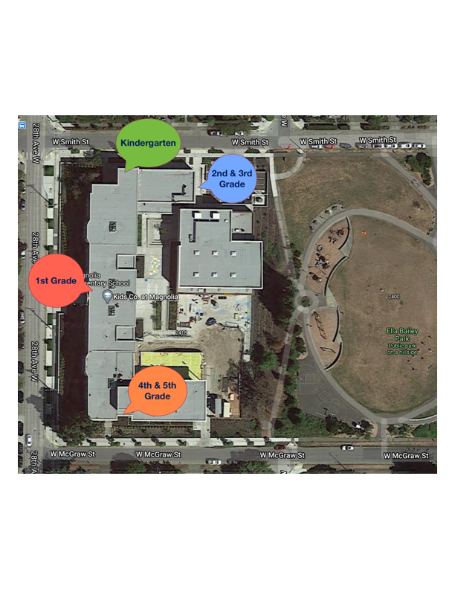

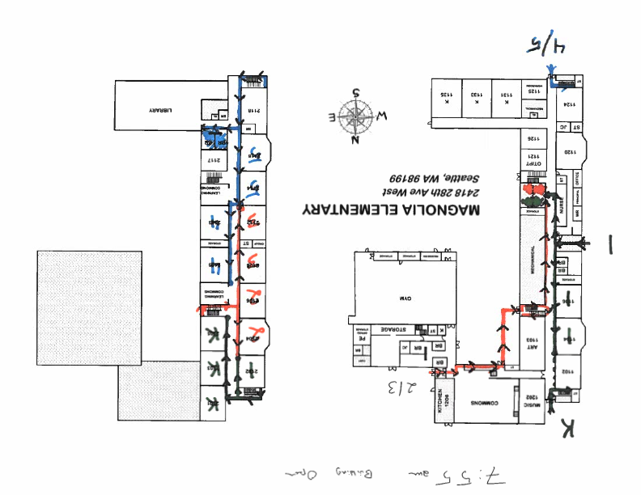

**Kindergarten**

* **Kindergarten students assigned to Cohort A** will line up on dots leading up to the side door on Smith Street at 7:55 am. K Teachers will be at this entrance to greet students and confirm that adult family members have submitted an attestation. They will walk their cohorts into the building and up the staircase just in the door to their classrooms on the 2nd floor. (photos of door, stairway and classroom. At 10:40, K Teachers will walk their students back out to these dots to hand students off to their adult family members for pick up.
* Kindergarten students assigned to Cohort B will line up on dots leading up to the side door on Smith Street at 11:40 am. K Teachers will be at this entrance to greet students and confirm that adult family members have submitted an attestation. They will walk their cohorts into the building and up the staircase just in the door to their classrooms on the 2nd floor. (photos of door, stairway and classroom. At 2:25 pm, K Teachers will walk their students back out to these dots to hand students off to their adult family members for pick up.

1st Grade

* **1st grade students in Cohort A** will line up on dots leading up to the front door on 28th Street at 7:55 am. 1st Grade Teac hers will be at this entrance to greet students and confirm that adult family members have submitted an attestation. They will walk their cohorts into the building and up the staircase just in the door to their classrooms on the 2nd floor. (photos of door, stairway and classrooms). At 10:40, 1st Grade Teachers will walk their students back out to these dots to hand students off to their adult family members for pick up.
* **1st grade students in Cohort B** will line up on dots leading up to the front door on 28th Street at 11:40 am. 1st Grade Teac hers will be at this entrance to greet students and confirm that adult family members have submitted an attestation. They will walk their cohorts into the building and up the staircase just in the door to their classrooms on the 2nd floor. (photos of door, stairway and classrooms). At 2:25 pm, 1st Grade Teachers will walk their students back out to these dots to hand students off to their adult family members for pick up.

* **2nd and 3rd Graders assigned to Cohort A** will line up on dots leading up to the back door entering the Commons (off the loading dock on Smith Street) at 8:00 am*.* 2nd & 3rd Grade Teachers will be at this entrance to greet students and confirm that adult family members have submitted an attestation. They will walk their cohorts into the building and upstairs to their classrooms on the 2nd floor. At 10:45 am, 2nd and 3rd Grade Teachers will walk their students back out to these dots to hand students off to their adult family members for pick up.
* **2nd and 3rd Graders assigned to Cohort B** will line up on dots leading up to the back door entering the Commons (off the loading dock on Smith Street) at 11:45 am*.* 2nd & 3rd Grade Teachers will be at this entrance to greet students and confirm that adult family members have submitted an attestation. They will walk their cohorts into the building and upstairs to their classrooms on the 2nd floor.   
  At 2:30 pm, 2nd and 3rd Grade Teachers will walk their students back out to these dots to hand students off to their adult family members for pick up.

* **4th and 5th Graders assigned to Cohort A** will line up on dots leading up to the side door on McGraw Street at 8:00 am. 4th and 5th Grade Teachers will be at this entrance to greet students and confirm that adult family members have submitted an attestation. They will walk their cohorts into the building and up the staircase just in the door to their classrooms on the 2nd floor. (photos of door, stairway and classrooms). At 10:45 am, 4th and 5th Grade Teachers will walk their students back out to these dots to hand students off to their adult family members for pick up.
* **4th and 5th Graders assigned to Cohort B** will line up on dots leading up to the side door on McGraw Street at 11:45 am. 4th and 5th Grade Teachers will be at this entrance to greet students and confirm that adult family members have submitted an attestation. They will walk their cohorts into the building and up the staircase just in the door to their classrooms on the 2nd floor. At 2:30 pm, 4th and 5th Grade Teachers will walk their students back out to these dots to hand students off to their adult family members for pick up.

Back to top

# Daily Health Screening Kiosks

Daily health screenings are an important element to reducing the transmission of COVID-19 at school. A kiosk will be provided at each school building to provide a back-up method for students and families to complete their daily health screening on site. The kiosk should be used only when a student/family member has been unable to complete their daily health screening prior to arrival. For staff members, it is recommended that they provide the daily health screening via their phone, laptop and/or district device. If staff are unable to complete using these methods, staff may use the kiosk. Getting daily health screening information prior to arrival on-site and in electronic form helps speed up both the oversight process and, in the event it is needed, contact tracing.

For SPS Staff and School Leaders:

[Use this link to access the Daily Health Screening Kiosk Set-Up and Management Instructions](https://seattleschools.sharepoint.com/:b:/s/SchoolsandContinuousImprovement/ESWpCTSMlzxOlcjqqqsick4BU4HeQc3c7QaDN8TNeICybQ?e=O0W7aP)

Back to top

# Entry, Exit, Traffic Flow

Maintaining appropriate physical distancing and limiting the exposure to other cohorts throughout the school day, are done to reduce the risk of transmission of COVID-19 in shared areas, including building entry and exit.

Building Main Entrance Set-Up

The main entrance of every SPS building should be set up with COVID-19 signage, Daily Health Screening poster, Quick Response (QR) code for staff, and a table with COVID-19 health and safety items.  The check-in station provides:

* A location for visitors to sign in and attest to the required daily health screening.
* Health supplies such as masks and hand sanitizer.
* Visual reminders of COVID-19 requirements such as physical distancing, face coverings, and hand washing.
* A location for staff to document their presence in the building, in the event that contact tracing is needed.  The method for taking attendance is flexible (does not have to be a sign in sheet).

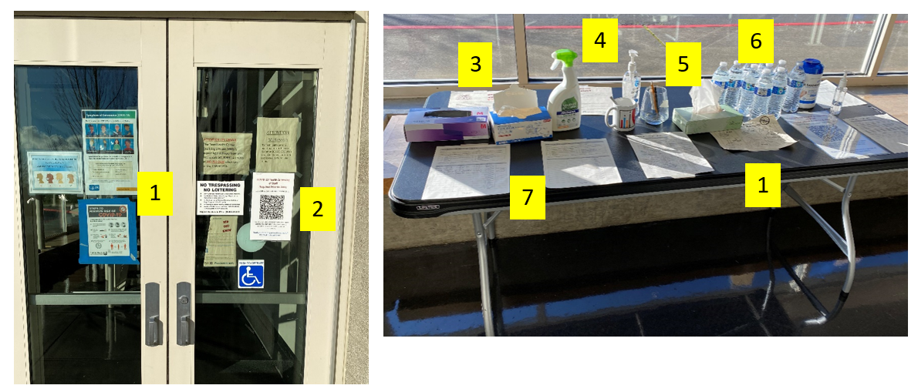

Key:

1. COVID-19 signage (Minimize Risk, Face Coverings, Physical Distancing, Hand Washing)

2. Daily Health Screening Poster

3. Masks

4. Hand sanitizer

5. Separate containers for clean and dirty pens

6. Bottled water

7. Health screening sign-in sheet

Student Entry and Exit

* Student cohorts will have a designated entrance and exit. (see Drop Off and Pick Up Procedures)
* At each entrance markers will be placed 6 ft apart for students to line up for building entry.

*Continued on Next Page*

* Each classroom cohort will have a different set of markers (possibly different colors)
* Staff will greet students at the entrance ensuring that the daily health screening has been completed for each student.
* Staff will walk with the students to the classroom ensuring students follow directional signage.

Traffic Flow

* Cohort boundaries will be marked with either tape on the floor or candlesticks to indicate the edge of the cohort.
* Classroom entry and exit times will be staggered to prevent mixing of cohorts.
* To the extent possible, 6 ft of space will be maintained when cohorts walk in the hall.
* Students will follow directional signage.  Please see Required Signage section for more information.

Students stay to the left in the hallways during transition times, spaced apart from one another in line. Schedules and site maps build in space between classes, to minimize interaction between classes in the hallways.

Example:

**School Photos coming soon!**

Back to top

# Meal Procedures

**For SPS Staff and School Leaders:** [Use this link to access meal ordering and delivery instructions for school sites.](https://seattleschools.sharepoint.com/:b:/s/SchoolsandContinuousImprovement/EZIiyHIJGzJLn1SxbFiXuskBVwOWY94quPWRwJvXsEYzLw?e=VPx98G)

**Protocol For K-5 Meal Services for In Person Learning**

**Updated: 3/23/2021**

During our re-entry phases into in person learning, it is intended for students to have meals offsite. The following guidance provides schools the procedures for ensuring that students have access to meals. Schools should plan to communicate to all families the importance of eating meals at home before arriving at school.

Students not coming to buildings for in person instruction can continue to access meals at the 40 open meal sites across the district.

General information:

* If a child requests to eat breakfast or lunch on site, the meal must be made available. Schools should plan for this contingency including how to access a meal and where meals can be eaten with supervision.
* Please see **page 5** of the [Preschool Re Entry Guide Addendum linked here](https://seattleschools.sharepoint.com/sites/SPSRemoteLearningPlayBook-O365/Shared%20Documents/Forms/AllItems.aspx?id=%2Fsites%2FSPSRemoteLearningPlayBook%2DO365%2FShared%20Documents%2FEarly%20Learning%2FSPS%20School%20Re%2DEntry%20Guide%20%5FPRESCHOOL%20Addendum%5FMarch%2029%20FINAL%2Epdf&parent=%2Fsites%2FSPSRemoteLearningPlayBook%2DO365%2FShared%20Documents%2FEarly%20Learning&p=true&originalPath=aHR0cHM6Ly9zZWF0dGxlc2Nob29scy5zaGFyZXBvaW50LmNvbS86Yjovcy9TUFNSZW1vdGVMZWFybmluZ1BsYXlCb29rLU8zNjUvRWNBbUJqTkpKeVJOdXU5bF9vak1meklCR3ZCQjhGVHB0ajlPRDZubThKQkpZUT9ydGltZT1vT18tZWpUdTJFZw) for specific information and guidance regarding preschool snacks and meals for in-person learning.

Grab and Go Meal Procedures and Strategies:

* Nutrition services will deliver grab-and-go meals to one location in each school; Facilities will identify the drop off location and communicate with the school leader

For AM cohorts: Each bag will include a lunch for the day and a breakfast for the following morning

For PM cohorts:  Each bag will include a breakfast and lunch for the follow day.

Tuesdays: Each bag will contain 2 breakfasts and 2 lunches

Fridays: Each bag will contain 3 breakfasts and 3 lunches

School leadership will identify a process for delivery of grab and go meals to students

* Picked up: for example - outside, near a cohort exit point, et. al.
* Space identified and a staggered schedule is developed for picking up meals

Grab-and-go Lunch

Protocol Implementation Notes:

* School safety teams to review entry and exit plans to determine how many stations near exits to set up for grab-and-go pickup.
* Station for pick up must be set up and social distancing markers in place during pickup.

Full day in person meals

In some circumstances, students will be eating meals onsite including students whose IEP requires in person services all day and/or students who request a meal upon arriving at school. The following guidelines will apply:

* Schools must identify a space and supervision schedule for eating meals onsite for these students only.
* Meal spaces must meet the following criteria:
* Space must be outside of the classroom; outdoor spaces would be an option when available.
* Students and staff should remain at least 6 ft apart in areas that can become crowded (eg. Standing in line) and while eating by providing physical guidance such as tape or graphics on the floors or walls
* Mark 6 ft of distance indicating seating
* Students seated will face the same direction and not towards each other
* Dedicated and consistent supervision must be provided by school staff based on building capacity including classroom teachers
* If possible, create on site meal space on a tile or hard surface (for ease in cleaning).

For more information and support:

Contact Sara Mirabueno, Director of School-based Operations.

# Physical Distancing Protocols and Classroom Adjustments

Physical distancing is a key principle for reducing the transmission of COVID-19. Physical distancing is defined as creating at least six feet of distance between individuals which may include distance between defined groups or cohorts.

Protocol:

Physical distancing recommendations will be followed in accordance with Washington State Department of Health (DOH) [K-12 Schools Fall 2020-21 Guidance](https://www.doh.wa.gov/Portals/1/Documents/1600/coronavirus/FallGuidanceK-12.pdf).

Strategies that will be used to support at least 6 feet of physical distancing include the following:

* Student desks/tables will be spaced 6 feet apart
* Desks/tables will face the same direction
* Students will have assigned seating
* Teacher workstations will be arranged to provide at least 8-10 feet of distance from the first row of students
* Staggered classroom entry and release times
* Signage will be posted in classrooms and commonly used areas (hallways, meeting rooms, locker rooms, bathrooms, etc.)
* Additional prevention measures, such as barriers or additional PPE, may be required in certain situations when strict physical distancing is not feasible
* Designated point(s) of entry at each site
* Physical distance markers will be displayed outside to reinforce physical distancing
* Directional signage will mark traffic patterns throughout sites
* Create schedules for use of any shared spaces

*Continued on next page*

## Physical Distancing Classroom Checklists

[General Education Classrooms](https://seattleschools.sharepoint.com/:b:/s/SchoolsandContinuousImprovement/EZ5pF2s4IGBNrjs1W2EIF-MBQ3-hKsNPMHM3oLP4yzenOg?e=TIG2Lu)

[Special Education Classrooms](https://seattleschools.sharepoint.com/:b:/s/SchoolsandContinuousImprovement/EZCOBVUpzhdEvZILtmlNw8wBUOEr0d8BjkOEt1etoSkGhA?e=acIJYX)

Back to top

Students are spaced 6 feet from one another at desks.

# Playground and Recess Protocol

Outdoor Recess and Playground Protocol

* Students will use cohort designated exit and entrance
* Recess times will be staggered and follow physical distancing protocols
* Cohorts will be assigned specific areas of the playfield/blacktop
* Multiple cohorts using the playground at the same time will be separated by visual markers such as cones to create space between them.  Only one cohort per day should be using play structures unless they are sanitized between uses.
* Playground structures will be cleaned daily by custodian
* Ensure adequate supplies to minimize sharing of high touch materials to the extent possible (e.g., assigning each student their own equipment) or limit use of supplies and equipment by one group of children at a time. Students should wash hands or use hand sanitizer before and after use.
* Supervision must be provided by school staff based on building capacity.
* Students should wash hands before and after recess.
* Childcare programs may use playground equipment provided they sanitize the equipment before and after use and coordinate schedules with the school leader.

Use of indoor spaces when weather requires:

* Cohort guidance should still be maintained.  If a gym space is large enough to accommodate two cohorts, this can be done using visual markers, such as cones to maintain six feet of distance.
* Ensure adequate supplies to minimize sharing of high touch materials to the extent possible (e.g., assigning each student their own equipment) or limit use of supplies and equipment by one group of children at a time. Students should wash hands or use hand sanitizer before and after use.
* If students need to have recess indoors in their classrooms due to weather restrictions, then social distancing guidelines should still be followed.



**More school photos of Recess Zones (in gym and on playcourt) coming soon**

Back to top

# PPE: Face Coverings

Wearing a face covering can significantly reduce the transmission of COVID-19. Cloth face coverings act as a barrier to preventing the spread of droplets that are released in the air when we breathe, speak. To work effectively, face coverings must be worn correctly and used in combination with other mitigating measures like physical distancing and staying home when ill.

Face covering requirements follow [Department of Health](https://www.doh.wa.gov/Portals/1/Documents/1600/coronavirus/FallGuidanceK-12.pdf), [Public Health – Seattle & King County](https://kingcounty.gov/depts/health/covid-19/care/masks.aspx), and [Labor & Industries](https://www.k12.wa.us/sites/default/files/public/communications/Employer-Health-and-Safety-Requirements-for-School-Scenarios.pdf) recommendations and guidelines.

Protocol:

* Students and building volunteers or guests must wear a cloth face covering or an acceptable alternative at school and work locations
  + Specific exceptions may apply based on age, development or disability
* Staff must wear a cloth face covering unless working alone in a room with 4 walls and a door when there is no likelihood that another person will enter.  Face covering must be kept close by to put on if necessary.
* Staff with a disability or other medical issue that prevents from wearing a face covering should contact [Human Resources](mailto:504ada@seattleschools.org) to discuss accommodations.
* Staff performing tasks that require higher levels of protection will be provided personal protective equipment (PPE) in accordance with [Labor & Industries](https://www.k12.wa.us/sites/default/files/public/communications/Employer-Health-and-Safety-Requirements-for-School-Scenarios.pdf) guidelines.
* Cloth face coverings will be provided to students and staff who need them.
* Cloth face coverings must not be worn by:
  + Those under 2 years of age.
  + Those with a disability that prevents them from comfortably wearing or removing a face covering.
  + Those with certain respiratory conditions or trouble breathing.
  + Those who are deaf or hard of hearing, and those who provide instruction to such people, and use facial and mouth movements as part of communication.
  + Those advised by a medical, legal, or behavioral health professional that wearing a face covering may pose a risk to that person.
* In rare circumstances when a cloth face covering cannot be worn, students and staff may use a clear face covering or a face shield with a drape or wrap as an alternative to a cloth face covering. If used, face shields should extend below the chin, to the ears, and have no gap at the forehead.
* Younger students are supervised when wearing a face covering or face shield. These students may need help with their face covering and getting used to wearing them.
* Continue physical distancing when possible while wearing cloth face coverings.
* Students may remove face coverings to eat and drink and when they can be physically distanced outside. If students need a “mask break” they will be escorted outside or to a large, well ventilated room where there is sufficient space to ensure more than six feet of physical distance between people.

*Continued on Next Page*

Essential Information and Procedure:

**A face covering that is correctly worn includes the following:**

* Fits snugly against the sides of the face and under the chin
* Fully covers the mouth and nose
* Can easily breath
* Able to wear without continually having to touch and adjust the face covering
* Made of multiple layers

**Face coverings may be removed:**

* When eating or drinking
* During scheduled times, outdoors, keeping six feet apart, and in their defined cohort zoned area

**Care for individual cloth face coverings include:**

* Labeling with the student’s name
* Storing in a labeled paper bag, or alternately in a sealed bag if paper bag is unavailable, when not in use
* Replacing lost, wet, or damaged face coverings with new face coverings that are readily available at school

Education:

**How to remove your face covering for a mask break**

* Sanitize hands using hand sanitizer
* Grab face covering by the loops behind your ears to remove from face.
* Do not touch the outside of the face covering
* Hold by the ear loops, place in paper bag if storing
* Sanitize hands after removing

**To reapply your mask after a mask break**

* Sanitize hands using hand sanitizer
* Grab face covering by the loops
* Place face covering on face ensuring nose and mouth are completely covered and under chin
* 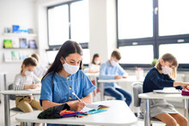Press at nose to make a seal
* Sanitize/wash hands

Back to top

# PPE: Inventory and Ordering

[For SPS Staff and School Leaders: Use this link to access full protocol for inventory and ordering procedures.](https://seattleschools.sharepoint.com/:b:/s/SchoolsandContinuousImprovement/EW1MhU9e2G1Ona4Hk3MA7DkBf3g39YQOvM1akm3DPq6Cqg?e=5MN2Ir)

The District has an internal process for reviewing Personal Protective Equipment (PPE) inventory and re-ordering supplies as needed. PPE supplies are maintained in the warehouse and schools should contact their custodian and request reordering of needed supplies. Central office will support schools to determine what a 30 school-day supply of general PPE would be for their building, and that is the amount of PPE that would be maintained onsite, in a designated location.

**Enhanced Personal Protective Equipment:** Certain tasks may require higher levels of protection to help mitigate the transmission of COVID-19. Enhanced PPE will be determined following Labor & Industries (L&I) guidelines. Health Services will provide education and training for staff on usage of enhanced PPE.

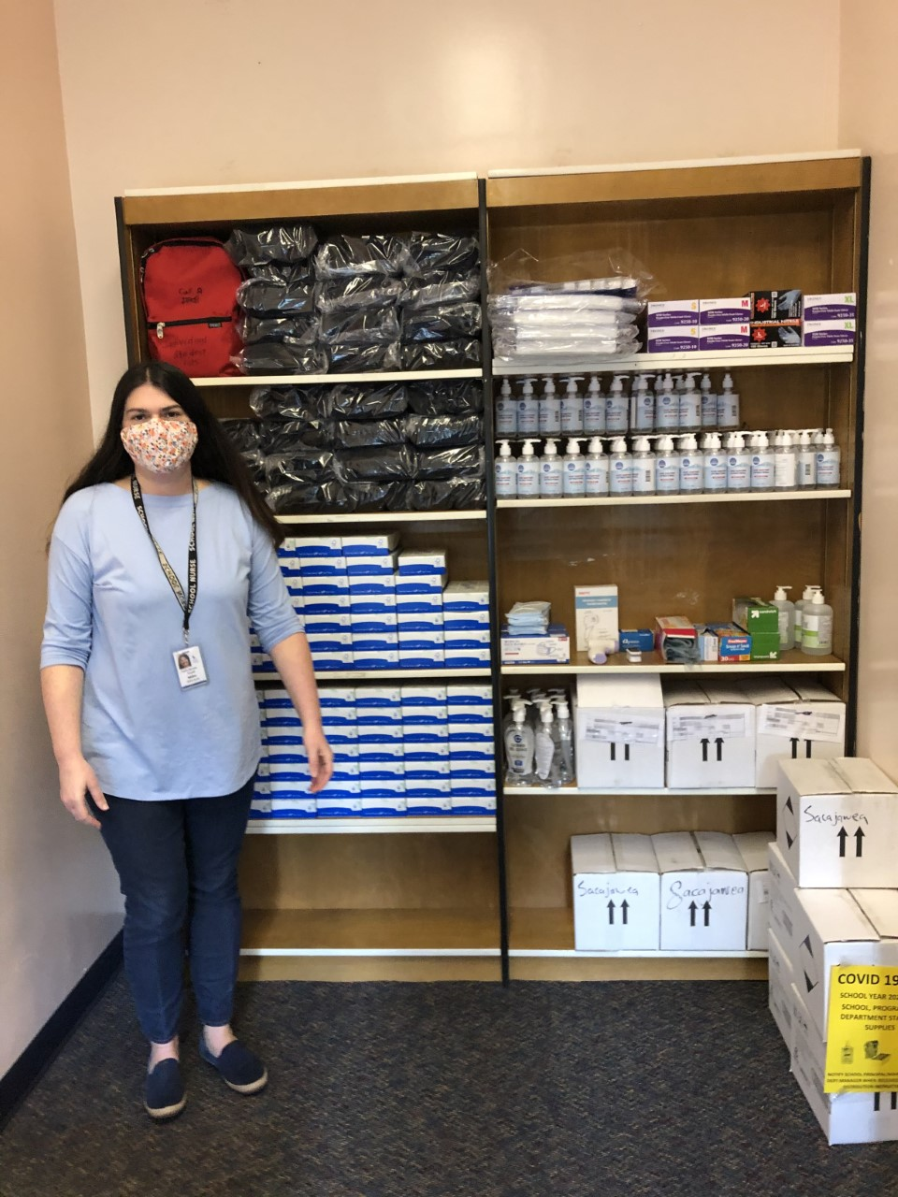

Back to top

# Enhanced PPE: Evaluation and Training

Certain tasks may require higher levels of protection to help mitigate the transmission of COVID-19. Enhanced PPE will be determined following Labor & Industries (L&I) guidelines. Health Services will provide evaluation, education and training for staff on usage of enhanced PPE.

[For SPS Staff and School Leaders: Use this link to view the full PPE Evaluation and Training Protocol.](https://seattleschools.sharepoint.com/:b:/s/SchoolsandContinuousImprovement/Ed23tiphJj9CnkqECwt-oqYB7Smya42vLS7g1YKhHeY-4Q?e=Z4jaTS)

Back to top

# Protected Health Care Room

[For SPS Staff and School Leaders: Use this link for details for Protected Health Care Room protocol.](https://seattleschools.sharepoint.com/:b:/s/SchoolsandContinuousImprovement/Ec8YyaiZgf1NkBALoFJRFOsB8Dvppz-fBDKlgUTF5J_GRg?e=vaV58k)

Each school site will have a designated space/room to temporarily isolate any student or staff with symptoms of COVID-19 until they can be sent home.

Protected Health Care Room Protocol

If a student presents or exhibits COVID-19 symptoms in a school setting,

Staff will:

* Accompany the student to designated protected health care room (not nurse’s room)
* Provide/ensure face covering is worn
* Ensure student monitoring and a staff person is within the line of sight of the student
* Should student exhibit breathing difficulty or distress, staff are trained to call 9-1-1 immediately

Teacher or designee will:

* Notify school COVID site supervisor
* Provide parent/guardian contact information

COVID Site Supervisor will:

* Identify student close contacts (any person who was within 6 feet of an infected individual for a total of 15 minutes or more, over a 24-hour period) and inform of their possible exposure to COVID-19 in the school building while maintaining confidentiality.

**Cleaning and Disinfecting:**

Cleaning and disinfecting protocols will be implemented after departure of ill person. Protocols to cordon off area include using the provided[Protected Health Care Room Signage](https://mysps.seattleschools.org/wp-content/uploads/2021/02/Protected-Health-Care-Room-Signage.pdf).

**Personal Protective Equipment (PPE):**

Staff in the roles described above will be provided PPE as outlined by [L & I](https://www.k12.wa.us/sites/default/files/public/communications/Employer-Health-and-Safety-Requirements-for-School-Scenarios.pdf).

**Training**:

Staff in the roles described above will complete the mandated health & safety trainings.

* SPS COVID-19 Health & Safety training
* Health Services training on proper use and fitting of PPE

**Other Resources:**

* [Department of Health (DOH) K-12 2020-21 Guidance](https://www.doh.wa.gov/Portals/1/Documents/1600/coronavirus/FallGuidanceK-12.pdf%22%20/)
* [Public Health – Seattle & King County Toolkit](https://www.kingcounty.gov/depts/health/covid-19/schools-childcare/~/media/depts/health/communicable-diseases/documents/C19/schools-toolkit/sept-3/kc-schools-covid-19-response-toolkit.ashx)

*Continued on Next Page*

**Signage for Protected Health Care Room:**

|  |  |
| --- | --- |
|  |  |

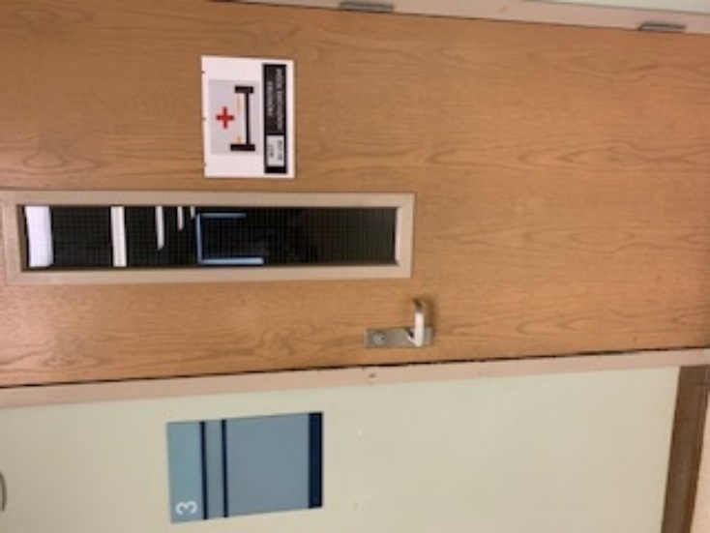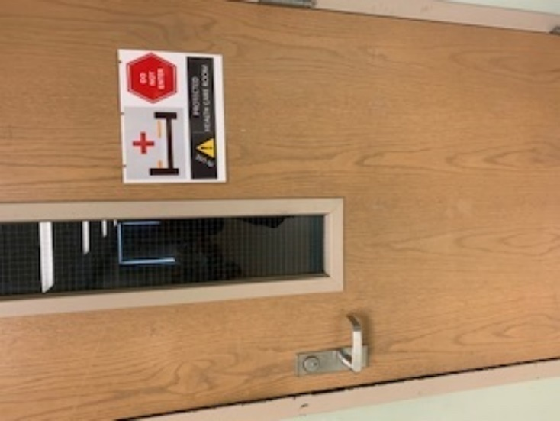

# 

Back to top

# Restrooms

Procedure:

* Restrooms will be assigned to specific cohorts, when possible.
* Restrooms will have maximum occupancy signage.
* Alternate sinks and stalls for student use, when possible.
  + In buildings where restrooms are used for multiple cohorts, consider assigning specific stalls and sinks to each cohort.
* Determine the need to schedule restroom use by cohorts.
* Create standing points 6 ft apart for students waiting outside the restroom.
* Ensure handwashing after restroom use
* Restrooms will be cleaned three times daily.

Students separated by 6 ft or more while washing hands, during handwashing breaks and after using the restroom.

|  |  |
| --- | --- |
|  | more school photos coming soon |

Students are separated by 6 feet or more when using restroom.

Back to top

# Signage

[For SPS Staff and School Leaders: Use this link to access protocols for building signage](https://seattleschools.sharepoint.com/:b:/s/SchoolsandContinuousImprovement/EatpfkqYOLFErqHd7w39Q-YBD73xsHf6RNp5uSNfd2l-kQ?e=LzkQzQ)  
[Link for Protected Health Care Room Signage](https://seattleschools.sharepoint.com/:b:/s/SchoolsandContinuousImprovement/EUSu1p7BRwlOt0luQC_uhyQBQLmMGWspfRZ381ktWvn6YQ?e=akKxit)

Schools will use signage to support the implementation of health, safety, and operations protocols and the directional flow of cohorts. The following places will have signage indicating processes, procedures, and movement of staff and students:

* At Main Entry
* Hallways
* Front office
* Entry/exit
* Bus load zones
* Pick up and drop off zones
* Staff shared spaces (copy rooms, kitchens etc.)
* Restrooms
* Classroom sinks
* Kitchen
* Signage to indicate rooms that are closed
* Signage to block off closed seating
* Signage to indicate dedicated space for the Protected Health Care Room
* Offices
* Shared work and common spaces (gyms, cafeteria, locker rooms, library, labs)
* General health room

Access to Approved Signage and Ordering

A walk through of each school will be completed by facilities to identify what floor markers and initial signage is required for maintaining cohorts and to indicate the Protected Health Care Room.  These will be delivered to each building.

Other approved signage may be found in the [Health, Wellness and Safety Section of the playbook](https://mysps.seattleschools.org/playbook/health-safety-and-wellness/). Schools may print replacement or additional signage for buildings.

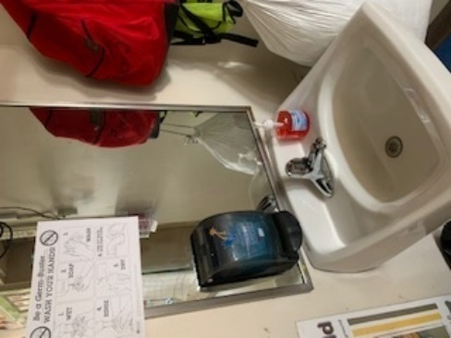

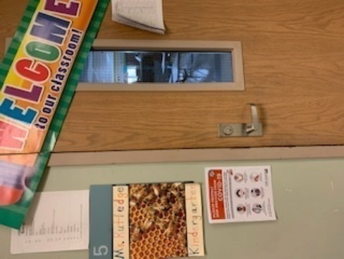

Required Signage Examples

Back to top

# Student/Staff Health Alert and Contact Tracing

COVID-19 Case at School

The DOH guidance for a COVID-19 outbreak in schools when grouping or cohorting students is, to dismiss the entire classroom for home quarantined for 14 days if two or more laboratory positive COVID-19 cases occur within the group or cohort within a 14-day period.

Prior to entering any school facility, employees and students self-screen for COVID-19 in accordance with Public Health – Seattle & King County (PHSKC) health guidelines. Health screening includes attestation, when to stay home/seek medical attention, and temperature.

If a student presents or exhibits COVID-19 symptoms in a school setting:

Staff will:

* Accompany the student to designated protected health care room (not nurse’s room)
* Provide/ensure face covering is worn
* Ensure student monitoring and a staff person is within the line of sight of the student
* Should student exhibit breathing difficulty or distress, staff are trained to call 9-1-1 immediately

Teacher or designee will:

* Notify school COVID site supervisor
* Provide parent/guardian contact information

COVID Site Supervisor will:

* Identify student close contacts (any person who was within 6 feet of an infected individual for a total of 15 minutes or more, over a 24-hour period) and inform of their possible exposure to COVID-19 in the school building while maintaining confidentiality.
* Notify Health Information using STUDENT HEALTH ALERT in the subject line and await further instructions.

Contact Tracing

If a parent or guardian suspects or needs to confirm a COVID-19 illness with the school, they will follow the absence notification process by calling or emailing the school. Front office staff will note any calls or emails related to suspected or confirmed COVID-19 symptoms/illness and will notify the COVID Response Team, who will do contact tracing. Please see the [Seattle Public Schools COVID-19 Health and Safety Protocols](https://www.seattleschools.org/UserFiles/Servers/Server_543/File/District/SPS-COVID-19HealthSafetyProtocolOverview.pdf) for additional details.

Cleaning and Disinfection

If there is a suspected or confirmed case of COVID-19, Seattle Public Schools will follow the Department of Health (DOH), Public Health, and CDC cleaning and disinfecting guidelines and communication plan for staff, families, and students.

If room or building closure is required, the Facilities Operation Center (FOC) will:

* Notify the COVID ALERT distribution group and school leader, if applicable
* Confirm area(s) of exposure to Determine HVAC programming shutdown/return to service

*Continued on Next Page*

* Post room/building closure signage
* Disinfecting of high frequency touch areas in the building will be performed 3 times a day by custodial and classrooms will be cleaned once per day.
* In alignment with the guidance from the Department of Health; custodial staff will be cleaning high touch point surfaces (i.e. railings, grab bars) on plastic and metal play structures once per day using a green-certified neutral cleaner. This once per day cleaning will take place after the school day has ended.

Back to top

# Transportation

The following guidelines are designed to mitigate risk factors associated with the transmission of COVID-19 and will apply to all transportation providers, staff, students and their families.

* Staff: This includes the Driver, Bus Monitor, and District Employees
* All Vehicles:  This includes all district arranged transportation by school bus, alternative service provider (ZUM, Hop, Skip, Drive & ALC), or district employees.

Procedures

**On All Vehicles**

* All staff will complete a daily health screening to confirm they are symptom free prior to each service.
* Staff will wear appropriate PPE.
* Disinfecting procedures will be completed after each service. (Practices may vary from carrier to carrier).
* A Health and Safety checklist will be filled out after each service.
* All riders will wear an appropriate mask.
* All rider(s) remain seated until a school representative comes to the load/unload zone to receive rider(s).

**On Alternative Service Providers or District Vehicles**

* Plexiglass or a clear plastic barrier will be placed between the front and back seats.
* Students will be seated in the back seat only, to allow as much distancing as possible between the rider and the driver.
* Students who reside in the same household, attending the same school, may be allowed to ride together.

**On Yellow School Bus**

* Seating assignments will conform to social distancing guidelines.  Seating will be assigned by load order; coming into school, riders getting on first will be seated farthest from the front of the bus.
* One rider per seat with the exception of family units from the same household.  Type A Buses: 10 Riders; Type C Buses: 24 riders.
* Rider(s) are required to disembark vehicle in an orderly manner, one at a time, from the front of the bus working backwards, while maintaining proper social distance.

*Continued on Next Page*

**Additional Protocols for Special Education Transportation**

* Curb-to-curb service will be provided for Special Education riders, even those who would normally require a less restrictive level of service, as a health precaution. (No community pick up locations).
* Students are required to use a face mask.
  + *If a rider is unable to wear a face mask, appropriate accommodations will be made.*
* At schools, rider(s) will be escorted to the load/unload zone by a school representative following proper social distance guidelines.
* Bus routes with assigned bus monitors will assist rider(s) boarding the bus, one at a time, by stop order; the last stop gets on first and the first stop gets on last.

**School Staff Expectations**

* School staff should be available to meet all vehicles at the designated load/unload zone at their scheduled arrival time.  Students may arrive/depart by either bus, van or car.  Buses will load/unload in the designated bus zone.  All other vehicles will load/unload in the parent zone.
* School staff should be available to assist with the unloading/loading of all students.

**Parent/Guardian Expectations**

* Ensure their student wears appropriate PPE!
* Daily health screening completed before their student heads to school!
* IMPORTANT MES SPECIFIC INFORMATION! Please arrange for a family connected adult to walk your student(s) to their cohort line & teacher at the designated time. If driving, please park somewhere way from the school block and walk your student to the school sidewalk area designated for their cohort.

# Water Fountains

Back to top

In an abundance of caution, all water fountains are to remain blocked off for use by students and staff. Bottle filling stations may be used.

* Students and staff may bring bottles of water to school for their own personal use but cannot refill water bottles at the water fountains.  Bottle filling stations may be used, however.
* The district will continue to supply each building with disposable bottles of water as needed.
* Packages of disposable bottles of water will be delivered to buildings weekly by nutrition services.
* Additional packages can be ordered through the warehouse by the custodian.

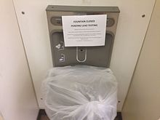

Back to top

# **Curricular and Instructional Practices**

Procedures, Protocols, Processes, and Information

# CAI Educator Orientation

The Curriculum, Assessment, and Instruction (CAI) team has developed [guidance for preschool through fifth grade educators, linked here](https://seattleschools.sharepoint.com/:w:/s/SchoolsandContinuousImprovement/EVQ3YF2kNxZHmhQFLIS38m8BmegC9Bon8nXXmGkRUCm5uQ?e=gJhdhw). Educators can find information in the linked document by grade level about content-specific curricular resources, developmental consideration, orientation training, consumables, technology and learning management system supports. Follow the links provided in the document, by content area in each grade level to access instructional support materials, including the identified power standards, guidance on scope and sequence, and other instructional support in our learning management systems. Orientation training listed is optional and shared to help orient you to the content area grade-level essential information.

Back to top

# Learning Materials – Education Kit Management

Classroom instruction will be different when students return to in-person learning. To comply with health protocols and social distancing, access to student learning materials will need to be adapted.

Procedures

* Schools will work with their staff to redistribute educator and student materials.
* Some student materials were sent home to support remote learning needs, remote teachers and in-person teachers should collaborate to determine how to best allocate these resources.
* Appropriate health protocols for disinfection need to be followed for all materials returning to schools. Each student should have a designated area at their desk or elsewhere in their classroom to keep their individual learning materials, such as writing tools, school supplies, textbooks, consumables, and technology devices.
* Teachers may need to adapt instructional practices and leverage available classroom technology (document cameras, presentation stations, etc.) to follow health protocols in lieu of standard practices around in-class student material use. Some educator materials are provided online. In these instances, Curriculum, Assessment, and Instruction (CAI) content managers will provide access codes to online resources. Additional printed educator manuals will not be available. However, many educator manuals can be accessed online (consult individual content guidelines).
* Students will need to bring their devices and necessary learning materials to and from school daily. Health protocols may prohibit the use of a classroom charging carts for devices. It is expected that students bring their devices to school fully charged and bring with them the necessary charging equipment every day when possible. This will allow for students who may not have the ability to charge their device away from school to access the limited classroom charging points.

Example:

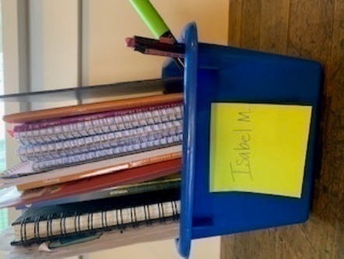

At this school, students will keep their materials in tubs at their desks, including notebooks and writing utensils.

Back to top

# Student Summary Guidance

As some PK-1 students transition from remote learning to in-person learning, a student’s teacher may change because of the student’s or teacher’s selected instructional model. To help provide a seamless transition, it will be important for teachers to communicate, share, and receive student information (Whole child, academic and portfolio samples) for all PK-5 students who will be assigned a new teacher.

Process

Providing the new teacher with information on each student’s story, strength, and need is one opportunity to maintain consistency and continue to provide a supportive environment for both students and the new classroom teacher. New teachers should also have access to information about incoming students.

This information could include:

* Family Connection and/or Strong Start Information (All About Me)
* Teaching Strategies Gold (Preschool) and WaKIDS (Kindergarten) Data
* ELA Being a Reader Student Level and independent reading level
* Math universal number sense screener results, units/standards taught, curriculum used, level of mastery.
* Science units the student has engaged with this year
* Collaboration with Specialists (PE, Music, Visual Arts etc.) and lessons taught that year
* Any tiered academic and/or SEL supports the student is receiving
* Individualized Education Programs (Students receiving Special Education Services)
* Student’s story, strengths and needs (including any ongoing technology supports)
* SEL student and family self-reflection; progress report comments and supports
* Sharing the evidence of student learning you have collected throughout the year

Information could be shared in the form of a written template, spreadsheet, or through a collaborative discussion. Curriculum, Assessment, and Instruction may provide sample templates, as needed.

Data points collected by the previous teacher will be accessible in their respective SPS software (e.g. PowerSchool, Homeroom, SeeSaw).

Back to top

# Technology to Support In-Person Learning

During remote instruction, educators have continued to build practice around the use of technology to support student engagement and learning. Technology will be an important component of in-person learning as well. [The document linked here](https://seattleschools.sharepoint.com/:w:/s/SchoolsandContinuousImprovement/EXafPYlKwepCkhF3-moWT9oBUELv9-RSTJ3g3b31AlSkDw?e=RrdWvk) has examples and guidance about the use of technology tools to support in-person learning for each curricular area.

Back to top

# **In Person Learning: Community Based Organization Partnerships**

Procedures, Protocols, Processes, and Information

# Childcare

For SPS Staff and School Leaders: [Use this link to access protocols and procedures for childcare and community-based partnerships.](https://seattleschools.sharepoint.com/:b:/s/SchoolsandContinuousImprovement/EfwEweLW-DFMnybNzMILrNQBAtF2UI0SP_-UYn3FIEEUHQ?e=foYoVM)

We have dedicated childcare at forty school sites that will be maintained with the increase of PreK-1 and students enrolled in Special Education Intensive Service Pathways. We will work to bring back additional childcare operations in our buildings. An increase will need to be evaluated on a case by case basis for each school building and provider. We are working to balance space availability and ensure health and safety protocols can be met.

Childcare sites will follow Public Health, Seattle and King County guidance, [detailed here](https://www.kingcounty.gov/depts/health/covid-19/schools-childcare/~/media/depts/health/communicable-diseases/documents/C19/guidance-covid-19-in-childcare.ashx), when there is a suspected or confirmed case of COVID-19 among any staff or students at their site/s.

Schools and childcare sites will follow district protocols for communication and transferring students.

Back to top

|  |
| --- |
| Re-entry Guide |
| Process, Protocols, Information, Contacts Appendices and Resources [SPS COVID Health and Safety Protocols](https://www.seattleschools.org/UserFiles/Servers/Server_543/File/District/SPS-COVID-19HealthSafetyProtocolOverview.pdf)  [2020 – 2021 Health and Safety Training](https://seattleschools.sharepoint.com/:p:/s/SPSRemoteLearningPlayBook-O365/EZUuj59cduZMm0gLtCh6e_0BSwCWsPXoet0p2otry3j9xA?e=uxI9Q7) |