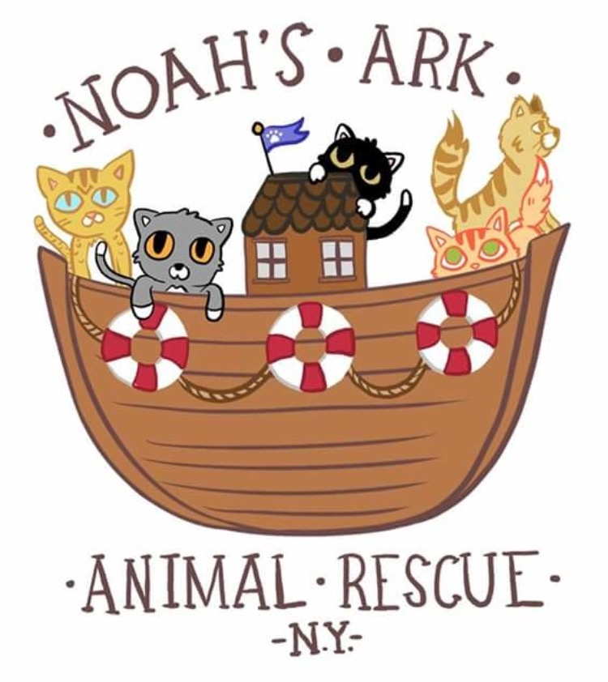

Noah’s Ark Animal Rescue NY, Inc.
NoahsArkNY@Gmail.com
Facebook.com/NoahsArkNY
(917) 536-3063

Adoption Application

Thank you for your interest in adopting a new furry family member from Noah’s Ark Animal Rescue! Please fill out all information as requested in this application so that we can help introduce you to the perfect new addition to your family.

We want to ensure that each and every one of our rescued pets is placed in their FOREVER home. In the interest of making this a successful adoption, please note that we do require that you permit an in-home visit by one of our representatives prior to adoption. Your personal references and previous veterinary care provider(s) will also be contacted before the adoption is final.

Adoption fees:

Single adoptions:
Adult cat (2+ years) = $100
Young cat (0-2 years) = $150

Double adoptions:
Momma + kitten = $200 ($50 discount)
Kitten + kitten = $250 ($50 discount)

The adoption fee for each of our pets helps us to offset the cost of food, supplies, and the veterinary care for each pet during their time in foster care prior to adoption.

We rely 100% on your donations to continue helping homeless pets in the Rockaway Beach area. Please consider donating generously, as the adoption fee does not even closely cover the full cost of rescuing, vetting and providing shelter and care for the pet you are looking to adopt.

Please remember a new pet is an adjustment in any home, especially homes with pets already. The introduction is a slow process and takes not only time but patience.
Adopter’s Personal Information:

Full Name:

Birthdate (mm/dd/yy):

Home address:
Street:
City, State, Zip:

Home Phone #:
Cell Phone #:

Email address:

Place of employment:
Work telephone #:

Spouse or partner’s name:
Spouse or partner’s phone #:

About Your Home:

- Type of residence (mark with “x”):
  - House [ ]
  - Condo [ ]
  - Apartment [ ]
  - Other (please specify):
- Do you:
  - Own [ ]
  - Rent [ ]
  - Live with family [ ]
  - Other (please specify):
- If you are a renter or live in a condo, does your landlord/condo association allow pets?
  - Landlord or Condo Association contact name:
  - Phone #:
- How long have you lived at this address?
- Do you plan to move in the next few years?
- What would you do if you were moving to a residence where pets weren’t permitted?

About Your Family:

- How many adults are living in the household?
- How many children live in this household?
- Ages of children in the house:
- For whom would you be adopting this new pet?
- Who will be the primary caregiver for this animal?
- Who will be financially responsible for this animal?
- Do any members of your household have allergies to animals?
  - If yes, who?
  - Has anyone been tested to confirm no allergies?
- Describe your household activity/noise level:
- What attracted you to the specific cat or dog who you’d like to adopt?
- How often do you travel?
- How will you have your pet(s) cared for while you’re away from home?
- In the event of an emergency, who would care for your pet(s)?
- How many hours per day will your new pet(s) be alone?
- Will he/she/they be confined in a certain area, or will they have free roam of the house while no one is home?

About Your Current Pet(s):

1. Please list all current pets’ info below:

Pet #1:
Name:
Species/Breed:
Age:
Gender:
Spayed/Neutered?
How long have you had him/her?
How did you acquire him/her?
Up to date on vaccines?

Pet #2:
Name:
Species/Breed:
Age:
Gender:
Spayed/Neutered?
How long have you had him/her?
How did you acquire him/her?
Up to date on vaccines?

Pet #3:
Name:
Species/Breed:
Age:
Gender:
Spayed/Neutered?
How long have you had him/her?
How did you acquire him/her?
Up to date on vaccines?

Pet #4:
Name:
Species/Breed:
Age:
Gender:
Spayed/Neutered?
How long have you had him/her?
How did you acquire him/her?
Up to date on vaccines?

2. Do your pet(s) get along with other animals (cats/dogs)?
3. Please list your most recent veterinarian or animal hospital:

(***Please note: Vaccinations for your existing pets must be current prior to adopting a new pet.***):

Name of animal hospital/clinic:
City/State:
Phone #:

4. Do you have any existing behavioral issues with any of the current pets in your household? Please explain.

Pet History
- Did you have pets growing up?
- Have you ever been the primary caregiver for a pet of this kind?
- Have you ever given a pet away, relinquished a pet to a shelter or animal control facility?
- Have you ever had a pet lost or stolen?
- Have you ever had to retrieve one of your pets from a pound, shelter, or animal control facility?
- Please list the following info for any of your past pets:
Pet #1
  - Name
  - Species/breed
  - Spayed/neutered?
  - Owned how long?
  - What happened to this pet?

Pet #2
  - Name
  - Species/breed
  - Spayed/neutered?
  - Owned how long?
  - What happened to this pet?

Pet #3
  - Name
  - Species/breed
  - Spayed/neutered?
  - Owned how long?
  - What happened to this pet?

Plans for Your New Pet

- Will your new pet live:
  - Indoors only [ ]
  - Indoors and outdoors [ ]
  - Outdoors only [ ]
- Do you plan to declaw (if you’re adopting a cat)?
- If you are not applying for adopting a specific pet, what type of pet are you looking for?
- Desired temperament / personality?
- Are you aware that all adopted pets require a period of adjustment in their new homes? Sometimes as long as a month or more?
- Are you willing to bring your pet to a veterinarian for yearly examinations and vaccinations according to your veterinarian’s recommendations?
- Are you willing and able to pay for emergency veterinary care, which could cost upwards of $1000?
- Are you prepared to pay for regular pet expenses including supplies, food, toys, boarding/pet sitting, grooming, etc.?
- Adopting a new pet is a 15-20 year commitment. Are you and all of your family members prepared for making that commitment?
- Please use this space to write down any questions you have about caring for your new pet:

Personal References (list 3 please):

**References must be successfully contacted by our representatives in order to process the adoption application**
NO FRIENDS OR FAMILY MEMBERS PLEASE

- Name:
Phone #:
Relationship:

2. Name:
Phone #:
Relationship:

3. Name:
Phone #:
Relationship:

By signing this adoption application, I certify that:
- The information I have provided is accurate.
- I understand that all adoption applications are thoroughly reviewed, and home checks are required prior to finalizing adoptions.
- I give permission for veterinary and personal references to be called by a representative of the rescue group.

Signature:
Initials (if signing online):
Date:

Application modified 01/01/2019

