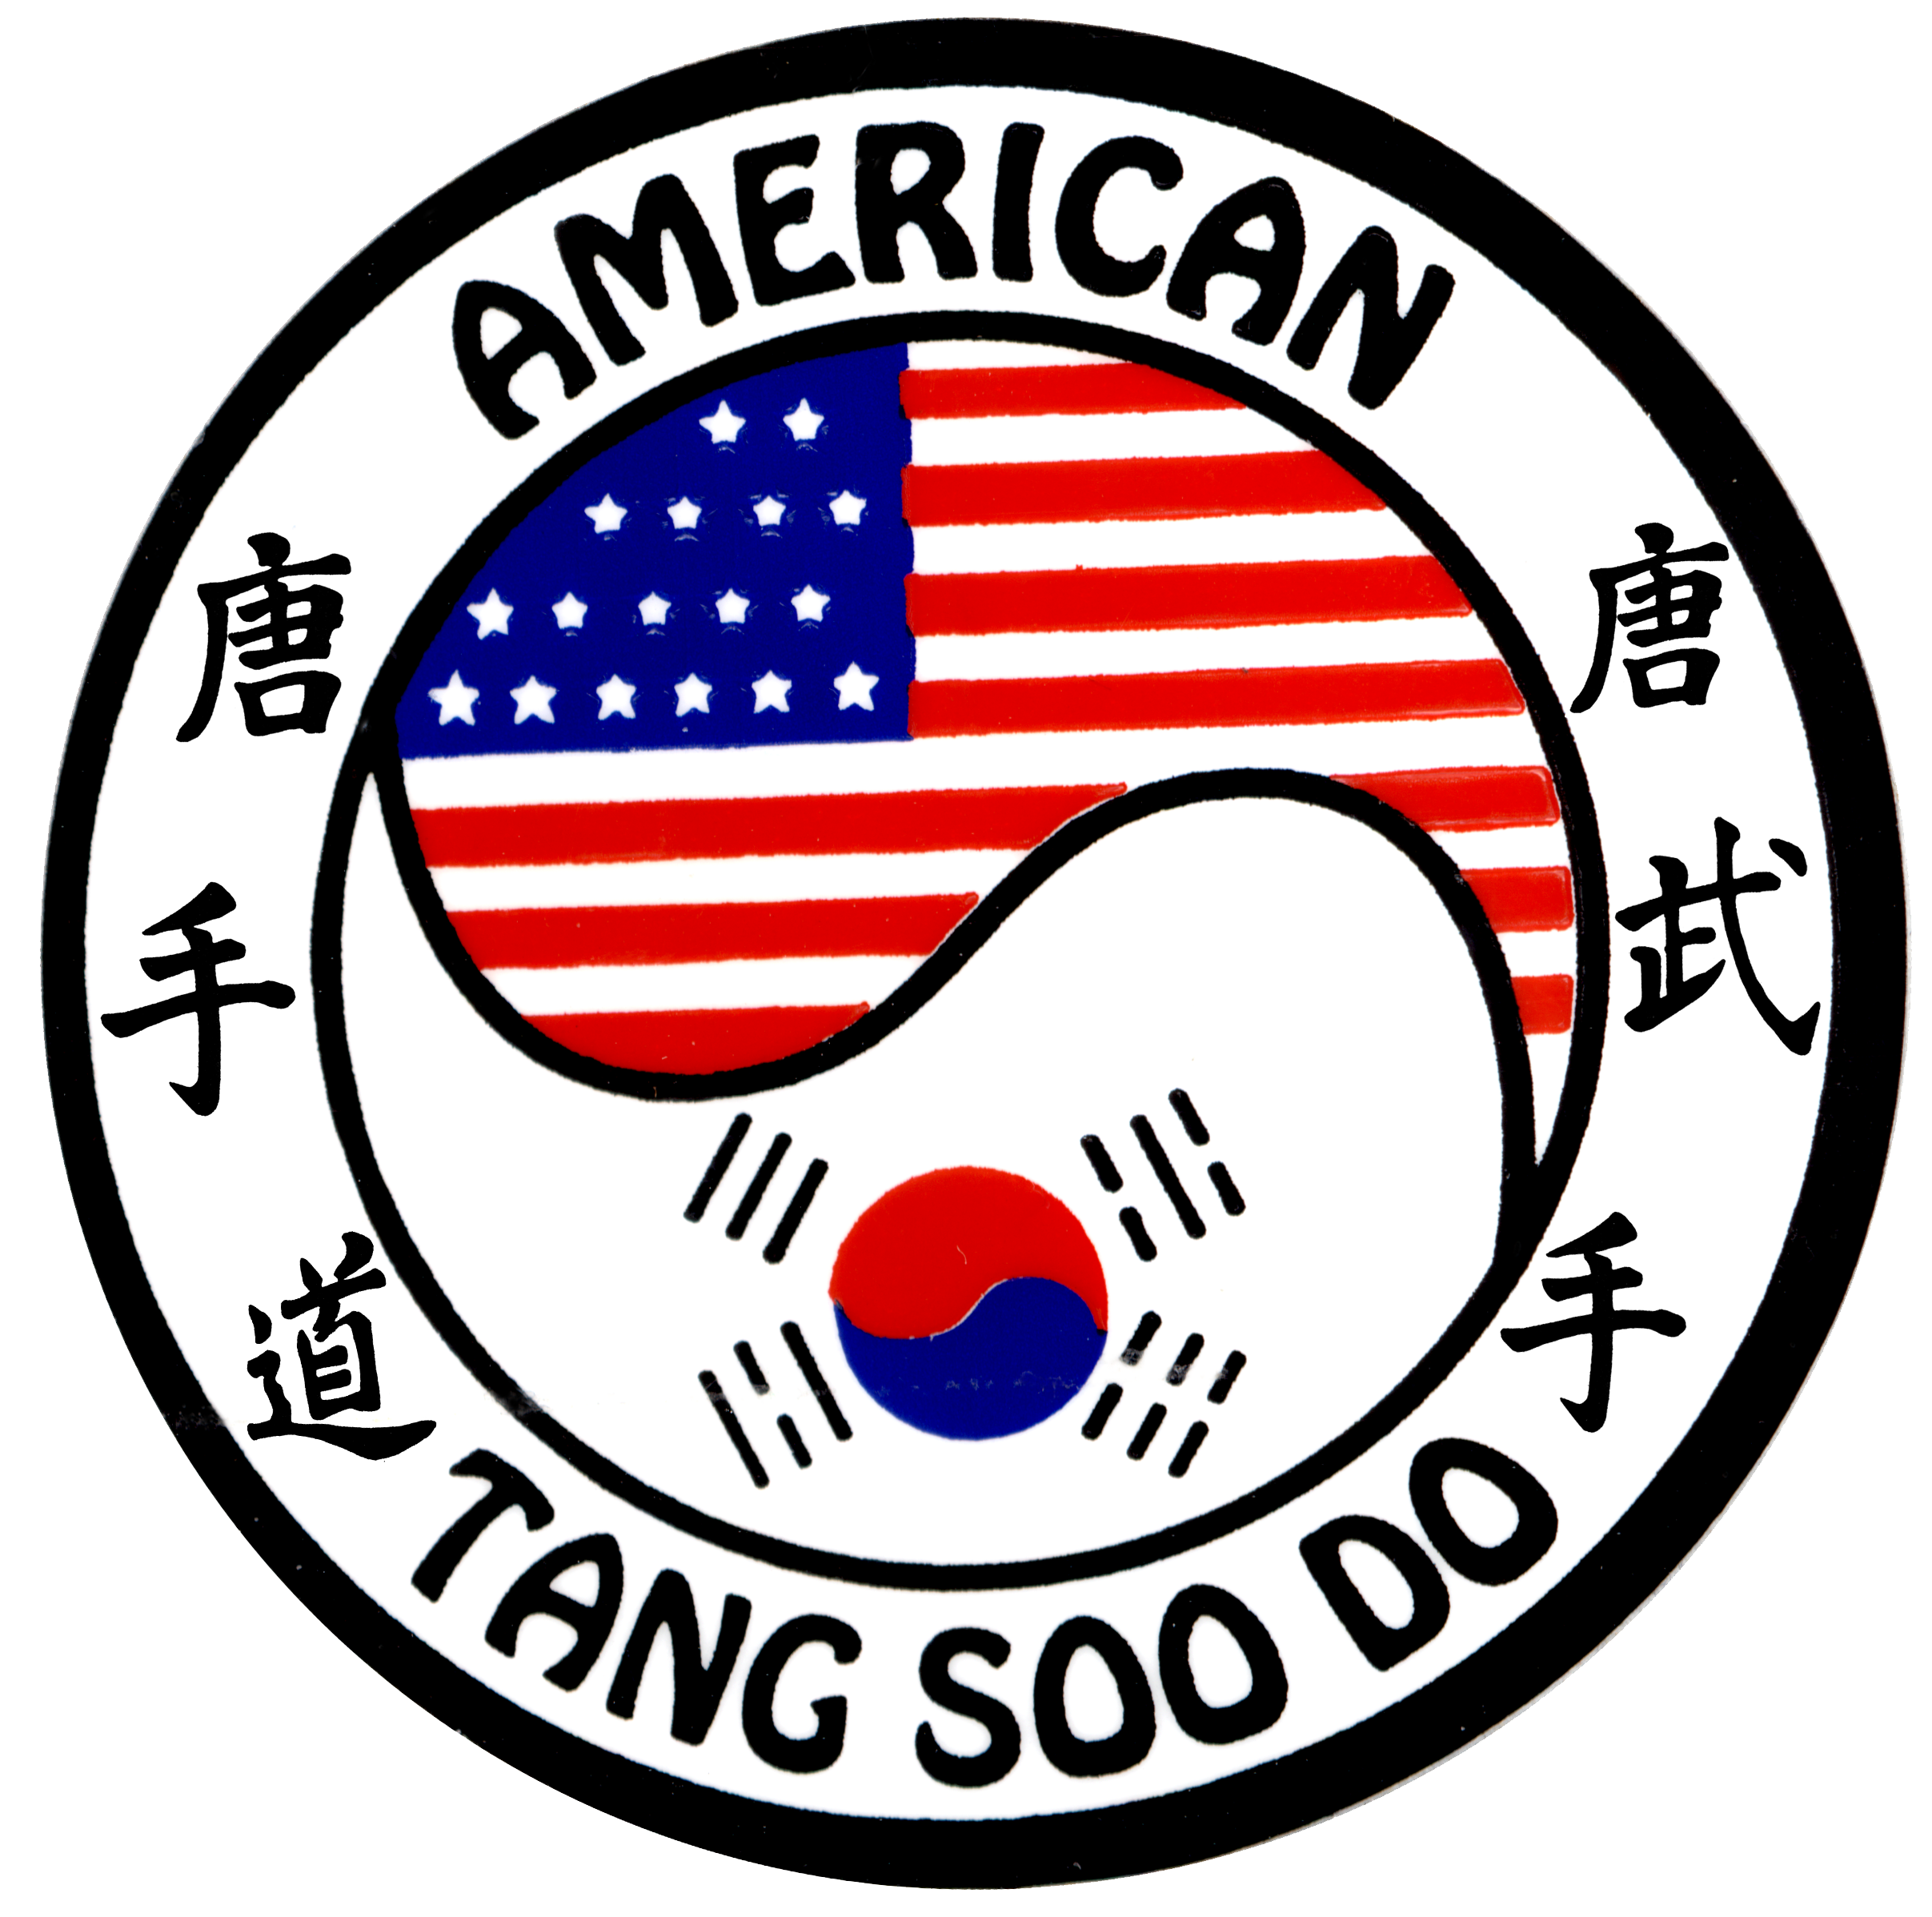

Tournament Rules

Form

Forms are judged by either 3 or 5 judges. If 3 judges all scores are counted, if there are 5 judges the highest score and the lowest score will be cut to come up with the final score. In the event of a tie the lowest score is factored back in for both competitors and if still tied the highest scores are added back in to get final score. If the competitors are still tied the competitors will do their form again together and the judges will pick the winner of the 2 competitors by hand getures either by pointing left or right. Forms are also judged on correctness (variations as to school or style are acceptable), speed, power, focus, transition, and sportsmanship.

Fighting

Fighting will be two minutes total time. All techniques are 1 point. Legal techniques are any kick or puch that is thrown with focus, power and correct technique. The technique must come close enough to a competitors target area as to be evident that the competitor throwing the technique could’ve easily scored if they decided they wanted to do so, or if a technique is close but no block is attempted, a point may also be awarded. Red belts and blackbelts will be allowed light contact with no face contact in any division. Legal hand techniques will include reverse punch, backfist if delivered correctly, ridge hand. Multiple puching, (The Rush) will be counted as one point and the opponent must be overwhelmed by the flurry of techniques, with at least one of the techniques thrown and landed correctly. Kicking techniques standing and jumping will be only one point. All techniques must be above the belt, landing at the side seam line in some way, sides of the helmet, and front band on the front top of the head gear. There will be no techniques to the top of the head, back of the head, the throat, or anywhere below the belt.
Sweeping is allowed in blackbelt dividions to the front foot boot high only, with the intent being balance disruption, and must be immediately followed by a correct scoring technique. All scores must be verified by a majority of judges.
If one competitors is ahead by 5 points the match will be called using the mercy rule.
If tied at the end of 2 minutes we will fight to sudden death. First CLEAN point wins.

Special Consideration

While we always welcome many styles and their traditional philosophies at our events over the years, we have always stressed the development of traditional technique and skills at our tournaments. This being said certain popular Sport Karate techniques will not be recognized and scored at our event. We will not be scoring any technique that is a lunging, feet off the ground ,tag type, technique. We are of the opinion that this type of technique is of marginal value in the development of traditional offensive and defensive technique. These are not clean or powerful techniques, and tend to degrade good technique into bad. Sport Karate tag type strikes do not align with our philosophy of correct and powerful technique, delivered in a controlled manner. Quite often these techniques end up tagging or hitting the top of the head in a wild and uncontrolled manner. While we respect the athleticism of these types of techniques, we stress the development of traditional martial arts technique and philosophy.

Dress Appropriately

Please wear the traditional uniform of your art, no T-shirts, wild outfits or other fashion statements, will be allowed. Please refrain from wearing any jewelry, rings, necklaces, earrings etc.

