**Half Post Method:**

1. While pulling the ear gently upright, press the post (wrapped with sticky-side out zonas tape) against the ear flap starting at the knob of cartilage.

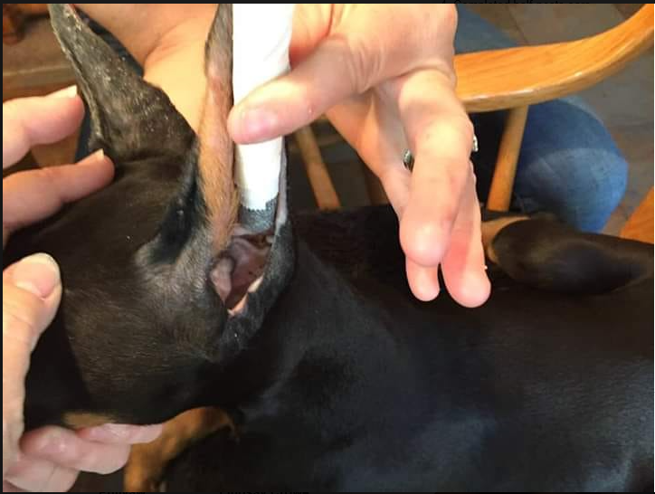

2. Keeping the ear pulled up, gently wrap tape around It making sure the flap at front is folded back.

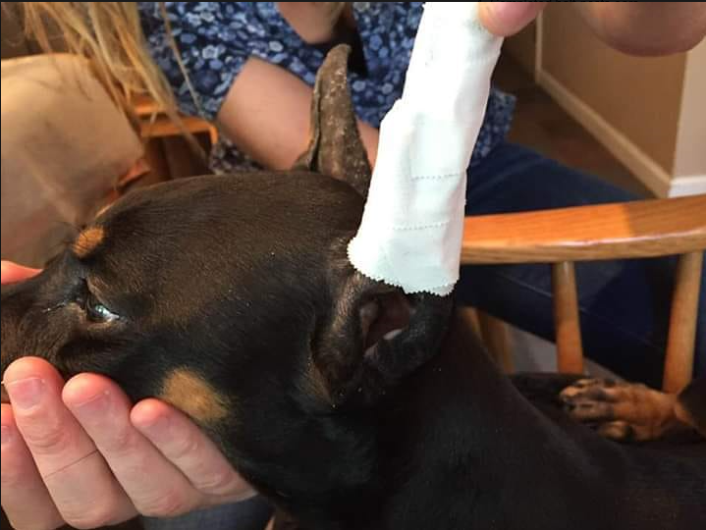

3. Make a solid bridge of the backer rod and wrap it with tape, sticky-side in. Then attach between the ears with tape going from bridge to post in a figure-eight. It’s very important that the bridge is attached while ears are pulled upright and that it sets directly on top of the skull - that’s what keeps the ears from falling or forming pockets.

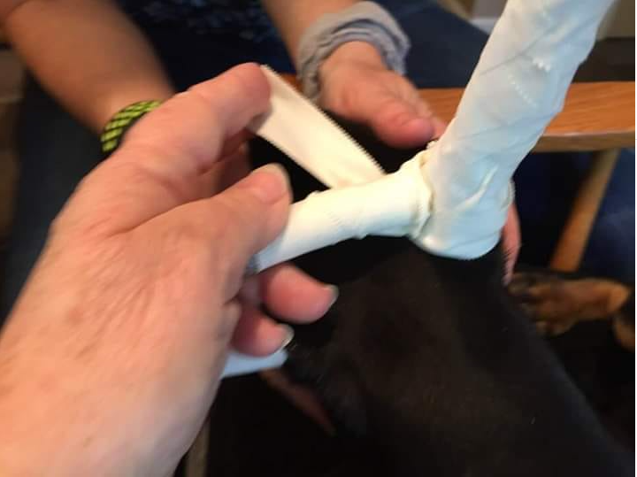

4. Completed half-posts ears.

