Meetings are open to ALL addicts and are non-smoking unless otherwise noted.

MEETING CODES
(C) - Closed meeting - For addicts only
(BS) - Book study
(H) -Handicap Accessible
(ASL) American Sign Language

NA is not affiliated with, nor does it endorse any related facility or outside enterprises.

ANY ADDICT CAN ATTEND ANY MEETING AT ANYTIME!

SUNDAY
Salem
5:00 – 6:00 PM – Wanted For – NA Meeting
1797 Center St NE - SOS Club (H) (Route 5, 5A, 10

6:00 – 7:30 PM – Claggett Creek Recovery Group
Keizer Senior Center - 930 Plymouth Dr
(Bus Route 9)

MONDAY
Salem
9:00 – 10:00 AM – Rendezvous (Route 1, 9)
555 Gaines St NE - Salem Alliance Annex

6:30 – 7:30 PM – A Desire to Stay Clean
1699 Court St - Court Street Christion Church, park on North side parking lot. (BS)

Dallas
7:00 – 8:00 PM – Dallas Recovery
783 SW Church St. - Dallas Evangelical

TUESDAY
Salem
9:00 – 10:00 AM – Rendezvous (Route 1, 9)
555 Gaines St NE - Salem Alliance Annex

6:00 – 7:00 PM – The Do It Hard Group
4787 Skyline Rd S - Skyline Baptist Church
Rotating format (H)

7:00 – 8:15 PM – West Salem Recovery
Welcomaaa Club 3825 D St NE
(H, BS- Living Clean)

7:00 – 8:00 PM – How Ya Livin’
1797 Center St NE - SOS Club
(C-Men’s, H, BS) (Route 5, 5A, 10)

7:00 – 8:00 PM – Girls Night Out
1797 Center St NE - SOS Club
(H, BS, Women’s) (Route 5, 5A, 10)

Silverton
6:00 – 7:00 PM – NA Fuels Recovery
302 N Water St. Silverton, OR

WEDNESDAY
Salem
9:00 – 10:00 AM – Rendezvous (Route 1, 9)
555 Gaines St NE - Salem Alliance Annex

12:00 – 1:00 PM – Felony Flats Afternoon Fix
410 19th St SE - Capital Park Community Center. Please enter around back through orange door.

5:30 – 6:30 PM – Basic Step Meeting
Woodland Chapel - 582 High St SE

7:30 – 8:45 PM – No Excuses
1797 Center St NE - SOS Club (H)
(Route 5, 5A, 10)

Dallas
7:00 – 8:00 PM – Dallas Recovery
783 SW Church St. - Dallas Evangelical

THURSDAY
Salem
9:00 – 10:00 AM – Rendezvous (Route 1, 9)
555 Gaines St NE - Salem Alliance Annex

12:00 – 1:00 PM – Basic Text Study
Welcomaaa Club - 3825 D St NE

7:00 – 8:15 PM – West Salem Recovery
Welcomaaa Club - 3825 D St NE

7:30 – 8:30 PM – No Matter What
1797 Center St NE - SOS Club (H) (Route 5, 5A, 10)

Dallas
7:00 – 8:30 PM – Climbing Out
Dallas Alliance - 775 E Ellendale Ave

FRIDAY
Salem
9:00 - 10:00 AM – Rendezvous (Route 1, 9)
555 Gaines ST Ne - Salem Alliance Annex

7:00 – 8:00 PM – Welcome Home
1797 Center St NE - SOS Club (H)

7:30 – 9:00 PM – Friday Night Fireside
3825 D St NE - Welcomaaa Club (H) (Route 11)

Stayton
7:00 – 8:30 PM – Friday Night Variety Group
975 Fern Ridge Rd SE - Foothills Church

Dallas
9:00 – 10:00 PM – Dallas Recovery
783 SW Church St. - Dallas Evangelical

SATURDAY
Salem
10:30 am – 12:00 pm – The Morning After
1155 Glen Creek Rd NW -
West Salem Christian Church

7:00 – 8:00 PM – Life on Life’s Terms
1797 Center St NE - SOS Club (H)

10:00 – 11:00 PM – Candlelight Meeting
3825 D St NE - Welcomaaa Club (H)

Dallas
7:00 – 8:30 PM – Climbing Out
Dallas Alliance - 775 E Ellendale Ave

ZOOM MEETINGS

THURSDAY

7:00 – 8:15 PM – West Salem Recovery Hybrid
Zoom ID: 896 067 835 PW: 1234

9:00 – 10:15 PM – Unity Through Uncertainty
Zoom ID: 642 419 8521 PW: Unity

SERVICE MEETINGS

Mid-Willamette Valley Area Service Committee
10:00 AM - 2nd Sunday of each month
SOS Club - 1797 Center St (H) &
Zoom ID: 235 459 8816 PW: recover

Hospitals and Institutions
1:00 PM - 2nd Sunday of each month
SOS Club - 1797 Center St (H) &
Zoom ID: 235 459 8816 PW: recover

Alt H&I – 4th Wednesday
6:00PM – ZOOM ONLY
ID: 597 602 9006 PW:0522

Activities
8:30 PM – 2nd Tuesday of each month
SOS Club - 1797 Center St (H)
8:30 PM – 4th Tuesday of each month
ZOOM 642 419 8521 PW: Unity

Helpline
6:30 PM – 2nd Thursday of each month
Zoom 235 459 8816 PW: recover

For the most current and up to date information & upcoming activities please visit our web page at WWW.MWVANA.ORG

PHONE LIST
Welcome to NA!
Use this list, we are here to help.

__________________________________________________________________________________________________________________________________________________________________________________________________________________________________________________________________________________________________________________________________________________________________________________________________________________________________________________________________________________________________________________________________________________________________________________________________________________________________________________________________________________________
_______________________________________________________________________________________________________________
Permission granted to copy this literature if not sold for profit.

NARCOTICS ANONYMOUS
MID-WILLAMETTE VALLEY
MEETING SCHEDULE

December 2022
January 2023

24 HOUR HELP LINE
503-990-0861

Narcotics Anonymous
PO BOX 17525
Salem OR 97305

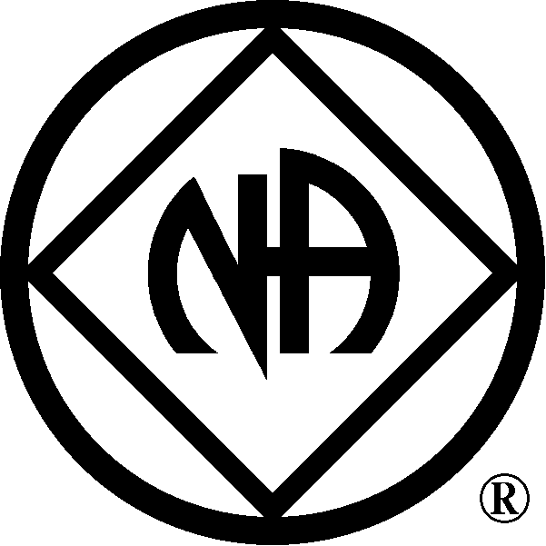

www.mwvana.org

