Allison Jordan – Legacy Leader.
Storyteller. Visionary.

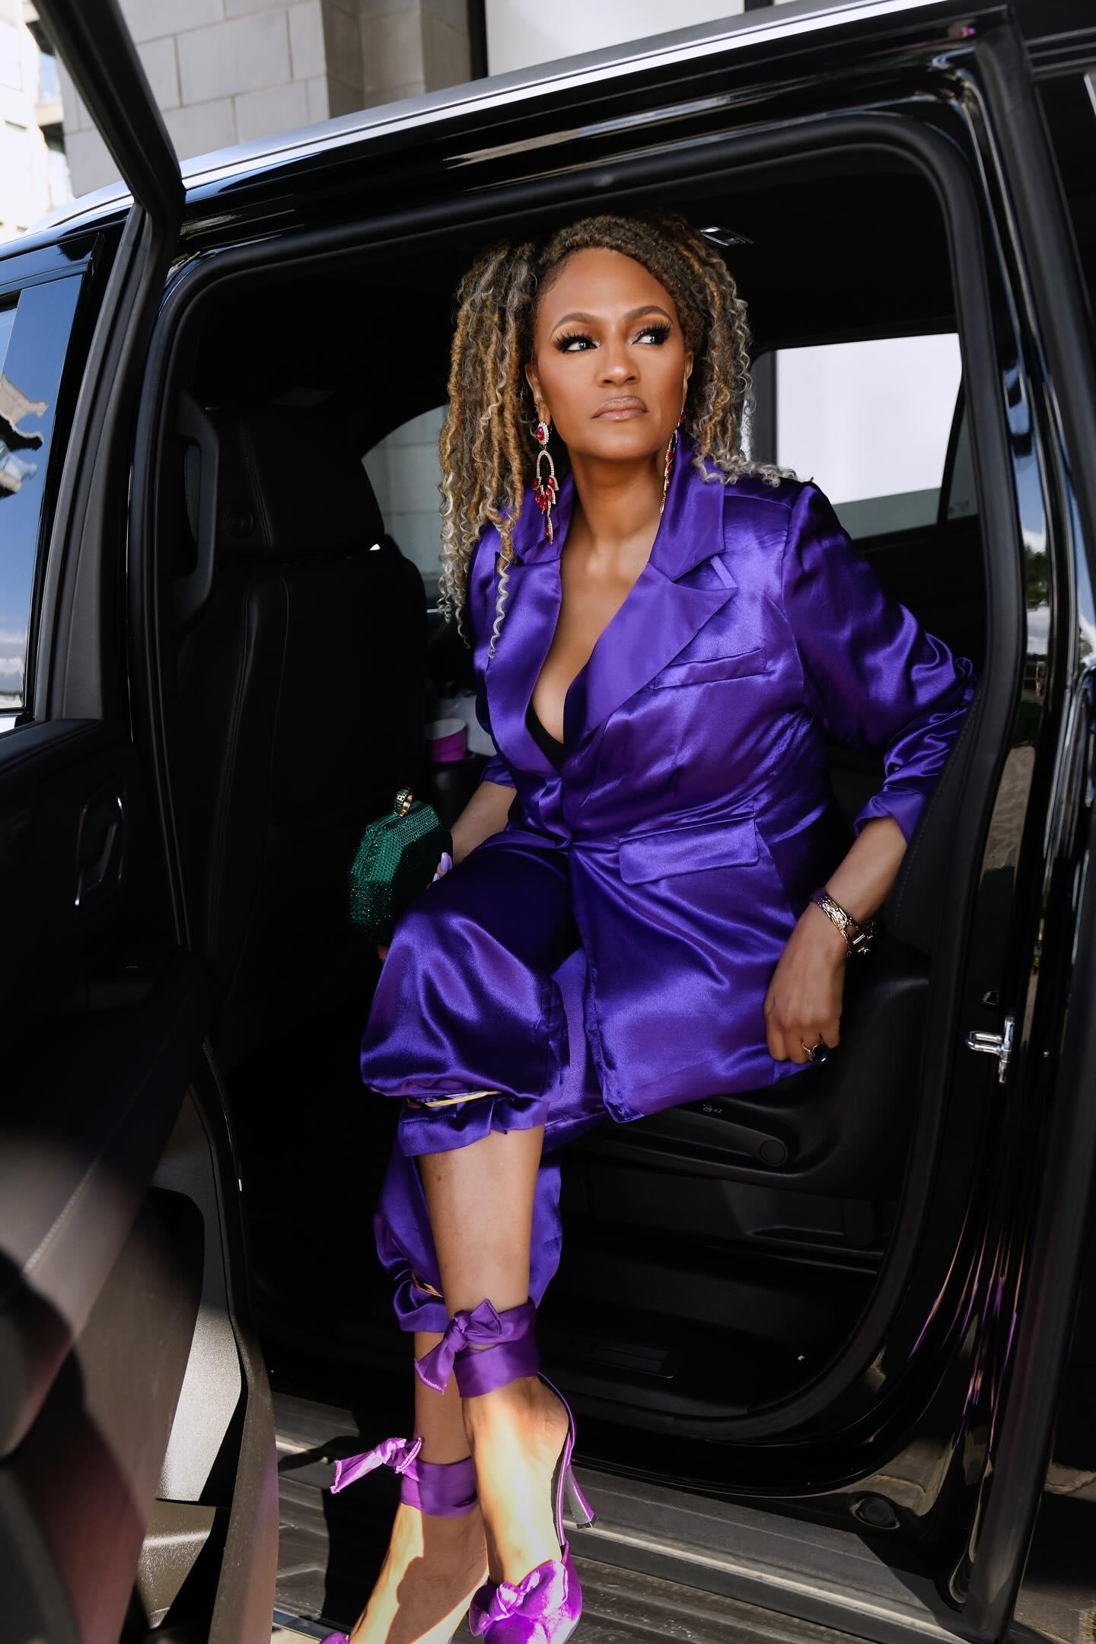
Allison Jordan is a powerhouse entertainment executive, producer, educator, mental health influencer, and cultural curator whose groundbreaking career spans over four decades. From Hollywood to City Hall, Broadway to Bravo, Allison has been a force behind some of the most culturally impactful productions, artists, festivals, and initiatives in American entertainment and civic life.
Before she left for Hollywood at age 23, Allison was already shaping culture in her hometown of Chicago. While attending Columbia College Chicago in 1989, she became one of the youngest editors at the South Shore Scene newspaper, where she reported on arts, culture, and community empowerment from a distinctly Black perspective. She also worked for the Chicago Sun-Times in marketing and customer relations, winning the Chicago Sun-Times Minority Journalism Scholarship, and was inducted into the Library of Congress as one of the top journalism students in the country.
She began working for the Mayor’s Office of Special Events under mentor Sasha Daltonn, a cultural icon and author who featured Allison in her book. There, Allison helped produce major city events including the Chicago Blues Fest, Taste of Chicago, and the first Martin Luther King, Jr. Breakfast, now in its 40th+ year. She helped coordinate the musical tributes for Mayor Harold Washington as he lay in state, and also worked at City Hall TV under the late Michael Scott. She was also a producer with WCTW and CHTV, known for civic and cultural programming connected to the city’s political and artistic evolution.
After these roles, Allison worked closely with Edward Gardner, founder of Soft Sheen, who mentored her like one of his own children. Gardner, a pioneering legend in Black entrepreneurship, philanthropy, and cultural preservation, also owned the New Regal Theater, where he hand-appointed Allison as one of his entertainment leads. He took many under his wing and empowered them—Allison being one of the few women leaders he personally appointed. Under his guidance, she learned the value of legacy, ownership, and purpose. At the Regal, she helped produce Sarafina, the Sinbad Pepsi Comedy Special, and the Multicultural Children’s Festival. She was instrumental in booking shows across the country for R. Kelly and MGM, working alongside his first manager Eric Payton, after meeting them during rehearsals at the Regal.
She played a pivotal role in helping bring a newly emerging playwright and director, Tyler Perry, to the Avalon Regal Theatre, where his character Madea made its debut in I Can Do Bad All by Myself. Allison worked at the Regal Theatre and helped bring this production to the stage. She was part of the team that helped launch Madea’s live stage breakthrough into a national success. That moment was the genesis of one of the most iconic entertainment empires in history.
She also produced the Hip Hop Festival at the Regal, where she met her best friend, rap icon Kool Moe Dee. They have collaborated on numerous creative ventures from the 1990s to the present day and continue working together in 2025.
Allison worked with internationally acclaimed jazz icon Kahil El’Zabar, one of the greatest jazz percussionists and composers in the world. She produced the Underground Jazz Festival and Bastille Day celebrations in Chicago’s Lincoln Park, further establishing herself as a cultural architect.

At age 23, Allison moved to California and began working with Johnny Carson Productions, located on the Universal Studios lot. The production company was affiliated with NBC, where she worked as a writer’s assistant on the show Amen. She later became a staff writer and would have continued into Season 6 had the show not ended after Season 5.
After Amen ended, Beverly Cashen, one of the first Black female TV producers, recommended Allison for a new show. That introduction led her to Stan Daniels—legendary writer and producer of The Mary Tyler Moore Show, Taxi, and The Bob Newhart Show—who was recovering from hip surgery and developing a new project from his bedroom. Allison worked alongside Daniels and other writers from Good Times. Together, they helped curate the pilot of what would later become one of television’s best shows: ROC. Allison worked on ROC, created by Charles S. Dutton and Stan Daniels, where she met Jamie Foxx, who was originally cast in the pilot but replaced, returning in the final season—during which they met. Jamie lived with Allison as a mentoree. She helped launch his career—introducing him to the Wayans family, taking him to comedy clubs to work out material, and shaping his comedic voice. She also helped Eddie Griffin and Angela Means, supporting Eddie’s first HBO special and producing Angela’s first showcase.
She served as the first female judge of the Bay Area Comedy Explosion, which was often regarded as the American Idol of comedy. On that stage were future comedy stars including Eddie Griffin, Chris Tucker, D.L. Hughley, Mike Epps, Sommore, Sheryl Underwood, Cedric the Entertainer, Steve Harvey, and Bernie Mac. This show became a launching pad for a new generation of Black comedic talent.
At the William Morris Agency, she worked under Jim Crabbe in the Motion Picture Literary Department, collaborating with some of the most powerful writers and directors in the industry, including Kevin Jarre, John Fusco, Desmond Nakano, Nelson George, Pam Gibson, Phil Joanou, and Renny Harlin. She transitioned between the music, TV, and literary packaging departments—becoming one of the first Black women to do so. Following WMA’s acquisition, she also worked at Triad Artists in TV and music packaging.
After her tenure at William Morris and Triad Artists, Allison launched her own management company in Hollywood. She founded The Hooks Players, which held residency at the Richard Pryor Theater, where she developed talent and collaborated with Broadway legend Sharon Brown (Dreamgirls, Joseph and the Amazing Technicolor Dreamcoat) and Rain Pryor, daughter of the late Richard Pryor.

In 1997, Allison became President of Operations for Mamisi, Wesley Snipes’ cutting-edge e-commerce company and a partner to his film production company, Amen Ra. At a time when the internet was still known as the “superhighway,” Mamisi stood at the forefront of digital innovation—before the rise of Yelp, Facebook, or Myspace. Under Allison’s leadership, the company scaled to a staff of over 300 internationally. Mamisi pioneered 360-degree camera technology, built one of the first editing hubs for independent filmmakers, launched the world’s first online gallery openings—where collectors could walk through exhibitions in real time and purchase art globally—and developed online casting systems, managed by Emmy-winning casting director Robi Reed. Their visionary tech allowed for early consumer-to-creator interfacing and community-building—concepts now ubiquitous in modern platforms. Wesley Snipes and Allison Jordan’s visionary work at Mamisi laid the foundation for much of today’s digital engagement and online content ecosystems.
In 2005, she co-owned Kingpin Eatery, along with Corliss King, her late husband Terrance Hale, and the late Deon Price—a beloved restaurant on the South Side of Chicago located directly across from the iconic 50 Yard Line. Known throughout the Chicagoland area, Kingpin Eatery was celebrated for its scratch-made, soulful culinary offerings—most notably their signature grilled chicken sandwich topped with homemade chipotle mayo. Everything was crafted from stock, including emulsified dressings, with a strong commitment to authentic, homemade flavor. They proudly partnered with Duerson Foods, owned by the late NFL great Dave Duerson. Allison, a trained chef who attended culinary school, also won the national “Name That Sauce” competition out of over 5,000 chefs that same year, leading to her induction into the prestigious International Chef Federation.
In 2018, Allison founded Epic Arts & Entertainment, an 8,000 sq. ft. performing arts studio located in River Oaks Mall. The center was a haven for creativity, teaching acting, modeling, boxing, martial arts, self-defense, line dancing, stepping, sign language, creative writing, piano, vocal lessons, personal fitness, nutrition, and more. The studio also served as a vibrant event space—hosting job fairs, bridal showers, baby showers, birthday parties, and civic town halls in partnership with the local mayor’s office. Through a special mall partnership, local businesses offered discounts to parents and guardians of students, boosting community commerce and foot traffic. With more than 300 students enrolled monthly and signature productions like Annie and The Wizard of Oz during summer camps, Epic Arts became a cultural and community hub. Despite closing its physical location in 2023 after COVID, Allison continues to teach monthly online acting classes, drawing on her Uta Hagen training under the mentorship of legendary educator Edilah Barnes.
Returning to Chicago, she married NBA World Champion and Three-Point Shootout winner Craig Hodges, and together they co-founded 3 Point INC. Allison went on to serve as General Manager of the Chicago Condors, a professional women's basketball team in the American Basketball League (ABL). She was the first Black woman to run a professional basketball team. Under her leadership, the Condors led the league in ticket sales and merchandise revenue out of 13 teams nationally.

During this time, Allison and Craig also co-created Hoops for Fitness, a groundbreaking basketball-based fitness program designed specifically for women. The program gained widespread attention across news outlets as one of the first of its kind—teaching basketball fundamentals through exercise. Many participants expressed how learning the game not only improved their health, but also brought them closer to their partners, children, or loved ones who played sports. From teaching the legendary triangle offense developed by Tex Winter—used by the Chicago Bulls during their championship dynasty—to empowering women through sport, Hoops for Fitness fostered physical wellness, family connection, and a deeper appreciation for the game. It was this venture that inspired the formation of 3 Point INC, a broader initiative committed to merging sports, education, and community empowerment.
She became a co-host on the AC Green Show on 106.3 FM, broadcast from Crawford Media Group, where she interviewed emerging entrepreneurs, community leaders, and musical artists. The show was known for playing great inspirational music and sharing stories of transformation and purpose. It was during this time that she also became one of the first Black female boxing promoters in the State of Indiana, acquiring the Universal Boxing Organization All-American Championship Belt. Her work in the male-dominated world of boxing allowed her to collaborate with four professional champions and proved that women can lead in any arena—literally and figuratively.
She has also served on numerous boards and has worked tirelessly with an incalculable number of nonprofits and outreach organizations—donating her time, expertise, and resources to causes close to her heart. As a passionate community advocate, she has worked with legislators, mentored youth, supported families, and stood boldly for the indigent and underserved. Whether through policy, programs, or presence, Allison’s mission has always been rooted in service.
Allison is also the creator and host of the hit podcast The Brain Truth (www.thebraintruth.com), a trailblazing platform at the intersection of brain health, mental wellness, and spiritual empowerment. Her work as a mental health advocate includes certifications in Mental Health First Aid and QPR suicide prevention, and a deep partnership with NAMI (National Alliance on Mental Illness). In one of her most personal full-circle achievements, she now partners with Riveredge Hospital—the very hospital where she once received care—to help secure inpatient beds for those in urgent need of mental health services. As a survivor and now a certified peer in the field, Allison turns her lived experience into a mission of restoration for others.
Currently, Allison is in pre-production for her highly anticipated talk show, The Brain Truth, a powerful multimedia platform exploring brain health, transformation, and authenticity. She is also developing her Blissed Balance brand, a luxury wellness and beauty line inspired by her personal healing journey, and is launching The ReStory, a retreat-based space that redefines rest and recovery. Each of these ventures reflects her commitment to legacy, healing, and service in the next season of her life.

Through every season, Allison has remained a fiercely loyal sister, daughter, mother, and grandmother—as well as a spiritual warrior and truth-teller. Her voice has echoed across boardrooms, stages, sanctuaries, and rallies. She is a survivor of grief, betrayal, abuse, chronic illness, and spiritual warfare. And through it all, she has remained obedient to her divine calling and committed to completing the work she was put here to do.
Her memoir, FINALLY, was recently signed to a major publisher and is set for release in February 2026. It chronicles her powerful and unpredictable journey, filled with incredible wins and devastating losses—grounded in resilience and unwavering faith. She is living proof that every chapter matters, and that no story is too broken to be rewritten.
#

