

I was sitting with a friend at work a few months ago, and they asked me why I would want to be a part of a neighborhood board. I thought about this (not very long though), and explained that I wanted to do everything I could for my neighbors, and to make my community the best it could be. They began to relate to me a few horror stories about their HOA, and I had to explain to them that we are not an HOA, and that we were made up of residents of our wonderful neighborhood that volunteered to help fundraise, and hold events to bring our neighborhood closer. We hold events like the annual Block Party, the Pancake Breakfast, and the Ice Cream Social. We fundraise to do things like pay for lights in our alleyways, to put up signs for the neighborhood, and publish things like this newsletter, and the community website (Stgregoryinfo.org) that help keep people informed of neighborhood business and happenings. We hold events like the annual Holiday Light Contest, and host block watch parties for people to get to know their neighbors. We talk to City officials and fight for issues that will keep the community safer. Anything we can do to promote a sense of community and to also help bring everyone that lives in our borders closer together. We talked a bit longer, with him expressing that this was what he thought he would get in an HOA, but never saw. He asked more questions later, but now they were things like: “What is the average cost of a house in your neighborhood?” and “Will you let me know if anything comes up in my price range?”

I have been lucky enough to meet a few of the families that have moved to our neighborhood in the past year or so, and every one of them have stated how much it felt less like a neighborhood than an actual community. They love that they have been welcomed with open arms by their neighbors and made to feel at home almost immediately. Some have asked how to get more involved. We had two new couples help us at the Pancake Breakfast, and another new family that opened up their home to host two Association meetings!

Giving and helping doesn’t take much and its pretty painless we promise! If you want to help but don’t know how to start, feel free to contact a board member and get the location of the next meeting. Stop in for a bit and let us know what you would like to do or ask what roles we have. We will never ask anyone to do more than they are comfortable with, but honestly, if all you want to do is stop in and say hello, or bring a new issue to our attention so we can fight for you, we welcome you!

On behalf of the entire Board, we look forward to meeting more of our neighbors, and doing everything we can to make this wonderful neighborhood even better in the future!

Getting Involved is Easy….

Summer 2019

Stgregoryinfo.org

Ice Cream Social is right around the corner!!

July 27th

1947 – 2019.

Celebrating over 70 years as a neighborhood!

Free Motion Lights for Residents!

 

A limited amount of outdoor motion lights are available at no cost to St. Gregory residents courtesy of the St. Gregory Neighborhood Association. These lights are completely free of charge for residents to help light up those back yards to help with home security as it pertains to the alley lighting efforts. If you have questions, please reach out to a board member for more details.

**Girl Scout Troop 7133 Needs Donations!**

You may have seen the girls around the neighborhood selling cookies or working on one of their many community service projects.

The current project is looking for sunblock, hats, ball caps, gently used t-shirts, and sunglasses to distribute to the homeless and less fortunate in our city. Please bring any donations to the Ice Cream Social, or contact Dr. Kristy Osgood at [osgoodinphoenix@gmail.com](mailto:osgoodinphoenix@gmail.com)

They are always on the lookout for graffiti as well! These girls love to paint a wall at no cost, so if you have graffiti, and you want it cleaned up by a dedicated group of young ladies (with a serious cute factor…) reach out and let them know!

Summer is here!

Summer means the dreaded return of those summer temps, but we have the cure!

The SGNA Ice Cream Social is right around the corner!

This year the event will again be held in the Phoenix Christian Elementary School cafeteria, as it has in years past. Be on the lookout for the signs and save the date!

Saturday July 27th.

1:30 pm to 3:00 pm

Come join your friends and neighbors for a sundae or cone, along with fun and games.

As always, this event is free for everyone!

Donations are always accepted to help with the Alley Light Fund, but not expected.

Would you like to host a meet up for your neighbors? Part of the push for safe streets is encouraging neighbors to get to know one another. Some of your neighbors are signing up as we speak to host small gatherings at their homes to get to know you! These get-togethers can be a great way to strengthen the neighborhood and make it safer. Your neighbors are often the first to notice something that isn’t quite right at your home. The more we look out for each other, the safer our homes become.

If you feel like you may be up for hosting one of these small gatherings, please call or send an email to Bob Wieser at 602-489-4179 or [rwwieser66@gmail.com](mailto:rwwieser66@gmail.com%20)  The St. Gregory Neighborhood Association will place the signs in your yard on the date you prefer, and help you out with some flyers to put on your neighbors’ doors to let them know where and when they can stop by!

Meet up!

Celebrating more than 70 years in the neighborhood.

2018 v: 1

Things You Need to Know!

A very well deserved round of applause is owed to Kay Abramsohn and everyone that has reached out to donate their recycling items to her. Through her efforts, a total of **almost $1200** has been raised this fiscal year! Please, please, please send Kay an email and donate your empty water bottles and aluminum cans to help keep the lights on! Her contact info is on the back cover of the newsletter, and if you happen to see Kay, make sure to thank her for all she does for our community. She truly is one of the angels of St. Gregory!



**@ $5200 of the $6000 needed for this year has been raised so far. Keep the Alley Lights On!**

The St. Gregory Neighborhood Association Progress for 501c3!

Another exciting development is that the SGNA has significantly moved forward in the process for 501c3 designation!

Now begins the next step, in which board members will amend past taxes and complete the application process to become official with the IRS.

If you would like to donate, or have a business that would like to make a donation, you may soon enjoy the tax deduction benefit!

Would you like to help with a fundraiser?

Have any other interesting ideas for using the designation? Please let a board member know. We are always trying to think of new ways to raise the needed funds each year to keep the alley lights on and also to help us host the events that so many of us love to attend, and which help us to form and keep the friendships with our neighbors that so many of us cherish, and that make our neighborhood so special to live in.



**Curb Check!**

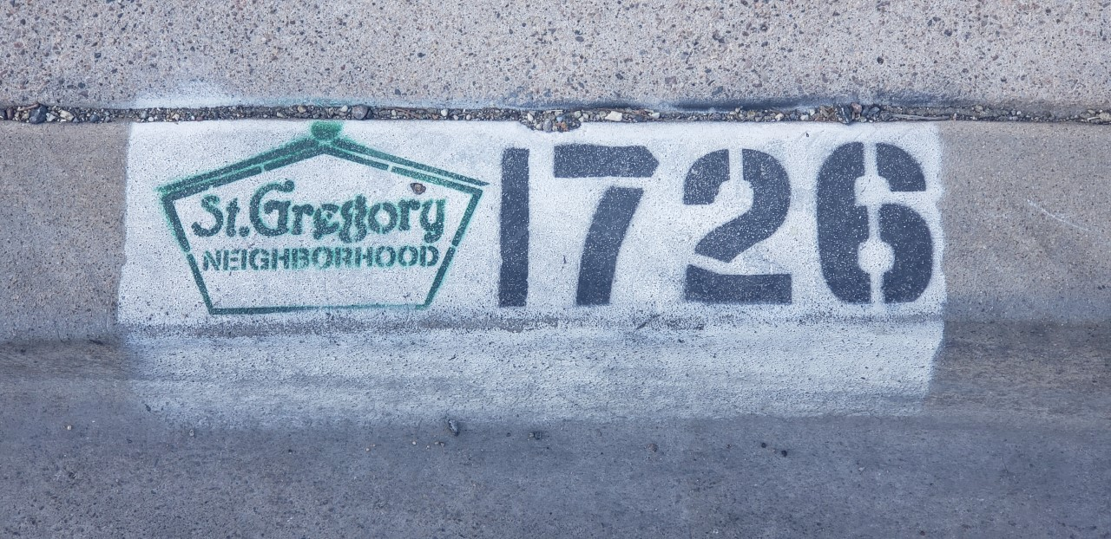

If you have gone on a walk lately, or for a drive around St. Gregory, you may have noticed some fancy new numbers on some of the curbs… Ninety homes in the southern and western sections of the neighborhood saw new street numbers painted on their curbs in 2018. The service was paid for by the Neighborhood Association, and in the next few years, every home will get new numbers throughout all of St. Gregory!

We truly hope that everyone enjoys this service and we want to give a big thanks to Eric Carpenter at AZ Curb Striping and Sealcoat for making the stencil with the St. Gregory logo, and doing the work for us at a great rate! This is what allows us to provide the service at no cost to residents. If you just can’t wait for your turn on the schedule, and want to pay for your numbers early and help out the SGNA, or would like to contact Eric for work of your own, you can reach him at 602-489-0225. The next round of 90 addresses should be started soon!

Make sure to thank him for all of us!

**An Argument for Art.**

[Peter Bond](mailto:bjspurlock@gmail.com)pbond1@cox.net

[Elaine Colantro  
Elaine@stgregoryinfo.org](mailto:Ethan%20Rutkoffwhiskers@shadowcats3.com602-277-2815)

[Kay Abramsohn, Secretary  
aljkay@netscape.net  
602-230-7219](mailto:Kay%20Abramsohn,%20Secretaryaljkay@netscape.net602-230-7219)

Do you have an idea for an article? Want to spotlight or recognize a fellow resident? Would you like to help with some aspect of the newsletter? Articles and ideas are always welcomed!

Contact Jonathan Wade @ Stgregstories@gmail com

I know that we spend a lot of time and space in these newsletters talking about the alleys and the Alley Light Project to keep them lit throughout the nights. This is because we care about deterring crime, and keeping our neighbors and our neighborhood safe. But what if there were more options? While St. Gregory already enjoys one of the lowest crime rates in all of the urban core of Phoenix, we must continue to grow and look for ways to keep our homes as safe as possible. One such option to consider is public art. My family recently partnered with the Phoenix Mural Project to sponsor an artist and design a mural for our alley wall. Studies have shown time and again, that art cuts down on crime. Phoenix as a whole has embraced this philosophy lately and murals are popping up all over the downtown, and midtown areas. Art promotes an influx of culture, and has been shown to increase property values in many areas that embrace mural projects and other public art projects. Yes, even crime (and graffiti) has been seen to decrease when these projects take root. Art encourages people to walk among it to enjoy it. The Coronado Neighborhood in Downtown Phoenix embraced murals and public art years ago, and has enjoyed the benefits that came with it. Overall crime rates have dropped substantially, and graffiti is almost non existent in their alleys, even the ones without murals! On a recent trip for inspiration, we saw several other couples out walking the streets and alleyways. What criminal element would want to deal with the constant threat of someone catching them in the act? This is one of the questions that was asked by residents there when they made the choice to begin embracing art as their method to combat unsavory elements, and it has worked wonderfully to transform their neighborhood to a vibrant and safe space for young families. If you are interested there are several organizations that are helping residents find an artist to pair with. Phoenixmuralproject.org is a good place to start, along with looking up the Phoenix Mural Festival online. A quick search online provides a multitude of artists that are ready to work on mural projects!

**Important Numbers:**

Phx. PD Main: 602-262-6011

Crime Stop: 602-262-6151

Silent Witness: 480-948-6377

Animal Control: 602-506-7387

Graffiti Busters: 602-495-7014

City Water Emer.:602-261-8000

Southwest Gas: 877-860-6020

AZ Public Service: 602-371-7171

Public Works: 602-262-7251

City Council Dist4: 602-262-7447

City Of Phoenix Neighborhood Services: 602-534-4444 or email [nsd@phoenix.gov](https://www.phoenix.gov/nsd/contact).

**St. Gregory Neighborhood Association Contacts:**

Board Officers:

[Evelyn Billings, Treasurer  
stgregoryneighborhood@gmail.com  
602-274-4159](mailto:rsvp@stgregoryinfo.org)

Board Members at Large:

[Bob Wieser  
rwwieser66@gmail.com  
(602) 489-4179](mailto:Robert.Wieser@aps.com)

Jonathan Wade  
[jonno23@live.com](mailto:jonno23@live.com)  
602-410-5914