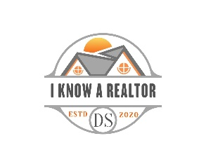

Guide to Selling Your Home in The Villages, Florida
Ask me about the following topics for a smooth, profitable sale.
Realtor Representation in Florida
- Single Agent Representation
- Transaction Broker (most common in Florida)
- No Brokerage Relationship
- What sellers should expect from each
- Why choosing the right representation matters

Contract Types: AS-IS vs. FAR/BAR
- AS-IS Contract
  - Buyer inspections
  - Seller not obligated to make repairs
  - Most common in The Villages
- FAR/BAR Standard Contract
  - Repair limits
  - More obligations for sellers
- Which contract is typically used and why

Pre-Listing Preparation
- Decluttering and depersonalizing
- Minor repairs that boost value
- Staging tips tailored to Villages buyers
- Importance of curb appeal (golf cart visibility, landscaping, exterior paint)
- Pre-listing inspections (optional but powerful)

Marketing Your Home
- Professional photography
- Virtual tours
- Drone imagery (especially for golf-front or water-view homes)
- Open houses vs. private showings
- Highlighting lifestyle features, not just the home

The Listing Process
- Comparative Market Analysis (CMA)
- Pricing strategy
- Listing paperwork
- Showing instructions
- Feedback and adjustments

The Showing Agreement & Representation Agreement
- What sellers sign and why
- How showings are scheduled
- Safety and security considerations
- What to expect during buyer visits

The Purchase Contract & Negotiation
- Reviewing offers
- Understanding contingencies
- Negotiating price, terms, and closing timeline
- Handling multiple-offer situations

From Contract to Closing
- Inspections
- Appraisal
- Title work
- HOA/CDD estoppel
- Final walkthrough
- Closing day expectations

Moving On
- Utility transfers
- Mail forwarding
- Homestead removal
- Tips for a smooth transition

