Multi-Scale Data Center room for Computing and storage

Vishal Nandigana
nandiga@iitm.ac.in
¹Indian Institute of Technology Madras (IITM)

Keywords | Abstract
Data center, | In this paper, a list of multi-scale data center system computers and data Storage devices for cloud computing and transfer of cloud computing data and storage and computations in a square 100 meters room is worked for AIDesign software for cloud computing data storage using the devices and computing using the same storage requirements and performing the transfer of data storage and data transfer and computations for AIDesign software to perform the operations, computing, storage and data transfer to enable milliseconds computing of design and analysis in the cloud computing storage facility room. AIDesign software is patented, and industries approved and commercially available over https://aidesign.today.

- Introdutction

The age of data storage, computing, transfer of data, within a cloud room of small space with large transfer of data, computing and storage and transfer with small time scales of milliseconds over a small room of few 100 meter square size, with volumes of data of TBs is the information security and storage and risk management free access over cloud computing of new form that is possible in the new age of AI[1-4] with large volume of data centers, data storage, data, transfer of data, computing of big data and big land [5-7] being a failure till date owing to the issue of heating and electronic unsolvable till date on the cooling of circuits over any of the computing, storage, data handling, transfer and cloud room space or big data centers for decades and almost a centuring from IBM to Intel to NVIDIA to D-Waveto QualComm to LamResearch to Radioshack, to Wireless staions to music and entertainment industries [8-11].

Here, we show using AIDesign PVT LTD GSTIIN legally approved software business industry AIDesign PVT LTD https://aidesign.today offering and offered the solution of multiscale data storage, transfer, computing and cloud room size of 100 square meter with TBs of data storage and millisecond of data transfer, handling, computing in this cloud room for the first time de-necessiating the big data center idea and storage and big computing with big room and land idea [1-4].

Multi-Scale Data Center system computers and Data Storage devices, cloud room list

Data Storage

1. 3 HD 2 TB Hard Drives (HDD, SanDisk, WD)

2. 5 HD 16 GB Hard Drives (5 USB port i Ball, SanDisk)

Data Computing devices

PC/Workstation/Laptop/MiniLaptop/WorkstationLaptop/BusinessLaptop

PC: Monitor of 42” PC monitor
Workstation: PC + APC Back-UPS Pro 1500 + BlueTooth Station compatible with Workstation + Sony AV System RMT-AH412U with 1000 W 5.1 Ch with surround 2 Head Stand speakers with HDMI ARC Bluetooth USB + Sony BlueTooth of Sony AV System RMT-AH412U with 1000 W 5.1 Ch with surround 2 Head Stand speakers with HDMI ARC Bluetooth USB Sony BlueTooth (Bose Equivalent size) Sony BlueTooth Headphones with (hole-hole wired jack, BlueTooth Station compatible with Workstation jacks compatible with Sony Blue Tooth Headphones)

Laptop: HP 8 GB RAM, 512 GB HardDisk, or Dell, Lenovo etc etc Laptop 8GB RAM, 512 GB HardDisk

MiniLaptop: Laptop or Dell XPS with Dell XPS highest latest Dell XPS release in 2021.

WorkstationLaptop: Dell XPS with Dell XPS highest latest Dell XPS release in 2021.

BusinessLaptop: Dell touchscreen MiniLaptop or Laptop latest Dell release in 2021.

Cloud Computing room

An AC with 100 square meter space.

An example using current AI Technology on engineering comparison of stress visualization on solid brick and existing Ansys commercial engineering software

Figure 1 (a-e) shows an example using current AI Technology AIDesign commercial software on engineering comparison of stress on solid brick with Ansys commercial software. The file size of the complete AIDesign commercial software solver code is few MBs and the file size of the complete AIDesign visualization software solver code is few KBs. The file size of (a-d) visualization of stress on solid brick using AIDesign commercial software is ~60 KB each for visualization (a to d) .jpeg images while the file size of existing Ansys commercial software is ~ 100 KB per .jpeg as shown in Figure 1 (e).

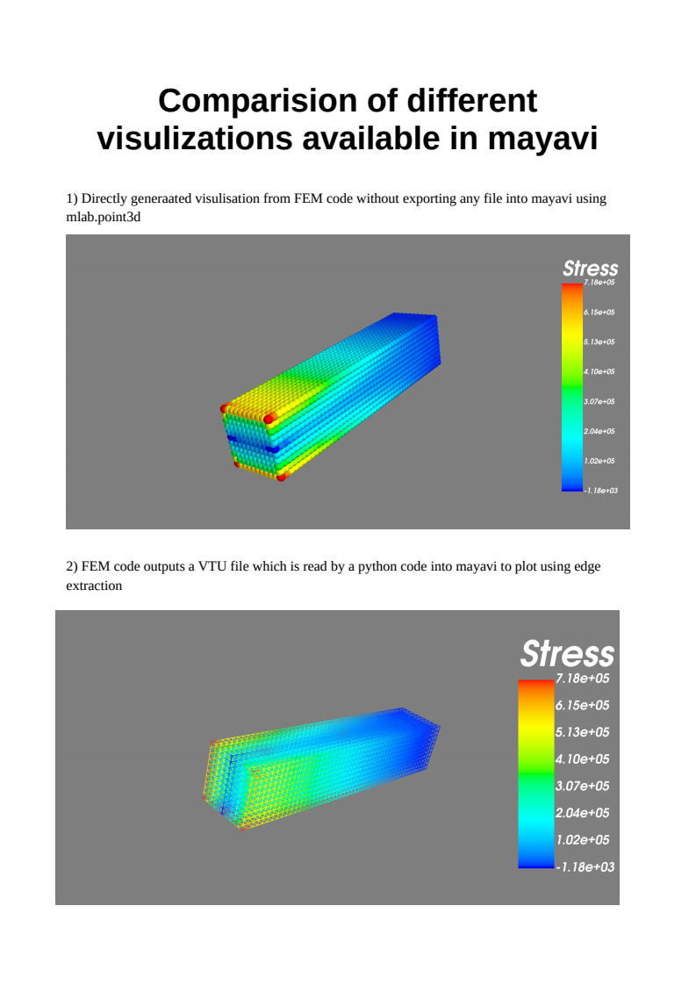

(a) AIDesign analysis visualization with option (1) that has solid atom size around 1 nm code in the visualization atom view

(b) AIDesign analysis visualization with option (2) that has solid and colorless atom of size around 1 nm code in the visualization atom view

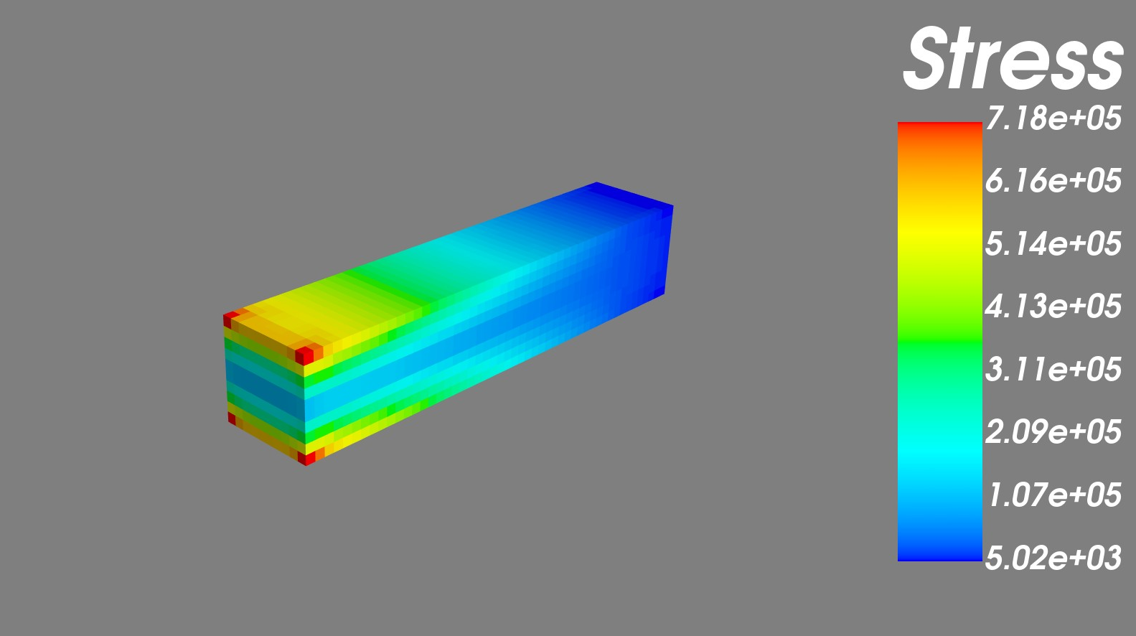

(c) AIDesign analysis visualization with option (3) that has fluroscent dye image view code in the visualization view

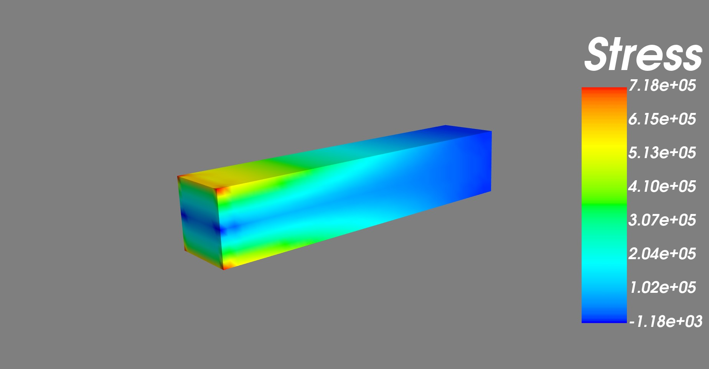

(d) AIDesign analysis visualization with option (4) that has hot map image view code in the visualization view

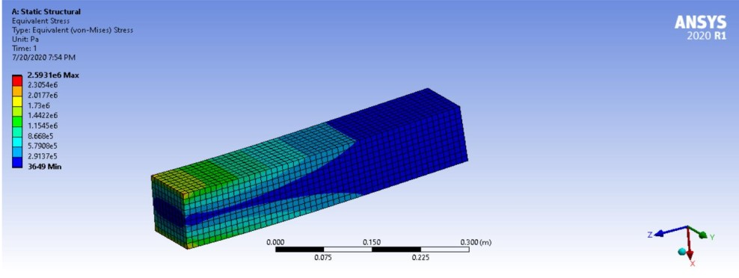

(e) Visualization view select option in commercial Ansys Software

Fig. 1 (a-e). An example using current AI Technology AIDesign commercial software on engineering comparison of stress visualization image view of solid bricks with Ansys commercial software.

Conclusions

Here, A multi-scale Data center system computers and Data Storage devices for cloud computing and transfer of cloud computing data and storage and computations in a square 100 meters room is shown for the first time that worked for the first time using AIDesign software to perform the operations, computing, storage, and data transfer in milliseconds computing of design and analysis in the cloud computing storage facility room.

Acknowledgements

The authors like to acknowledge our funding sources, MHRD STARS research grant [STARS/APR2019/NS/148/FS], SERB CRG-Exponential technology grant CRG/2020/001684, Support for enterpreneurial and managerial development of MSMEs for Blue Fma PVT LTD, IoE-CoE C-MNBF grant, SB20210808MEMHRD008509.

References

[1]Vishal Nandigana, Deep Learning for real applications, Intl. J. Adv. Res. Ideas and Innovations in Tech., 7(3), 236-238, 2021.
[2] Dasari Ananyananda, Deepak Somasundaram, and Vishal Nandigana. Deep learning for engineering problems. Bulletin of the American Physical Society, 65, 2020.
[3] LN Dillard, V Nandigana, JP Gore, Artificial Intelligence Application in Combustion Modeling, AIAA Scitech 2021 Forum, 2021.
[4] A. Anbarasu, V. Nandigana, A. Dasari, D. Somasundaram, Deep Learning for engineering applications, International Journal of Advance Research, Ideas and Innovations in Technology, IJARIIT, Vol 7, 3, 267-271, 2021.
[5] J. Philip C. Jackson, Introduction to artificial intelligence, Dover Publications, 2013.
[6] G. B. Jon Krohn, A. Bassens, Deep Learning Illustrated: A Visual, Interactive Guide to Artificial Intelligence, Addison-Wesley Professional, 2020.
[7] N. W. Klingbeil K. S. Rattan, Introductory mathematics for engineering applications, WILEY, 2015.
[8] R. J. LeVeque, Finite Difference Methods for Ordinary and Partial Differential Equations: Steady-State and Time-dependent Problems, SIAM, 2007.
[9] G. T. Gouri Dhatt, E. Lefrancois, Finite element method, WILEY, 2012.
[10] H. K. Versteeg, W. Malalasekera, An introduction to computational fluid dynamics, the finite volume method, 1995.
[11] T. Kajishima, K. Taira, Computational fluid dynamics, incompressible turbulent flows, SPRINGER, 2016.

