Product Design of Cartoon Characters for Software Feature Film

Sarthak Shreyas1, Shriram Elangovan2, Guru Viknesh2, Shania Mitra2, Huzaifa Mustafa Unjhawala4, Naresh Kumar4, Nilotpal Chakraborty4, Vishal V. R. Nandigana3, 4*

1Department of Ocean Engineering, Indian Institute of Technology, Madras, Chennai 600036, India.

2Department of Chemical Engineering, Indian Institute of Technology, Madras, Chennai 600036, India.

3Department of Mechanical Engineering, Indian Institute of Technology, Madras, Chennai 600036, India.

4 AIDesign PVT LTD GSTIIN, India

*Corresponding author

To cite this article:

Sarthak Shreyas., Shriram Elangovan, Huzaifa Mustafa Unjhawala, Naresh Kumar, Nilotpal Chakraborty, Vishal V. R. Nandigana. Product Design of Cartoon Characters for Software Feature Film. American Journal of Art and Design. Vol. x, No. x, 2021, pp. x-x. doi: 10.11648/j.XXXX.2021XXXX.XX

Received: MM DD, 2021; Accepted: MM DD, 2021; Published: MM DD, 2021

Abstract: In this paper, we present for the first time a novel .jpeg format story board page for cartoon characters in the software feature film cinema studio industry to make cinema at millisecond time. The earlier works of the cinema studio industry uses Celtx commercial software where in-built figure selection is carried out for story board generation of cartoon character feature film. The advantage of AIDesign commercial software is it uses Artificial Intelligence loaded from AI operating system or as executable (.exe file) loaded from Windows operating system. AIDesign commercial software using its Artificial Intelligence technology generates the .jpeg story board using engineering and product design technology savy enabled trignometric operators, truncated Fourier series operators. The second advantage of AIDesign commercial software is that the software gets trained from the story board (.jpeg image) page 1 and page 2 and predicts the next story board page 3 and page 4. Lastly, the product design and art illustrated in this paper, provides the engineering and technology advancements to precision manufacture enabled with advancements of science of 2021.

Keywords: AI, AIDesign commercial software, software feature film

1. Introduction

The idea of a paper sketch to a discussion of paper sketches translation to a single paper sketch discussion of a collection of paper sketches makes the story board of paper sketches in a cartoon to illustrate the art of character from visual images (.jpeg) viewed as cartoon characters and the final story board page illustrates the engineered position locations to imply the characters and the product design of engineering correctness when the .jpeg engineering visual looked as a real product design.

The Walt Disney company, Disney studios in real name, an American international cinema studio industry [1] headquartered at the Walt Disney Studios complex in Burbank, California viewed the illustration of .jpegs, .pdfs, .docx, .pptx and other advanced zillions of ways to illustrate a visual in engineering technology way .jpeg, .mp4 (all versions of .mp4 as Writers Guild accepted versions [2]) created the international cinema studio industry where the engineering technology is as well illustrated till date, 2021 [1]. Pixar, co-owned by Disney International cinema studio industry illustrated the art of marketing including mediums outside that considered as a mass media until Pixar did the inclusion in early 2010s [3, 4].

Celtx, a commercial software aimed at creating the story board pages in .pdf, .rdf, .html, .jpeg, cartoons, for cinema studio and in the business world of cinema [5,6]. The Celtx commercial software has later went to many advancements with Pixar cinema studio industry use with .jpeg conversion to .mp4 to create a complete cartoon animation product feature film in the early part of twentieth century [7] with commercialization of animation cartoon characters to engineering toys and products and advancements till date of engineering use to humankind in world [8]. The success of engineering advancements with the engineering art and product design technology from Pixar and Disney in the early part of 2000’s till date has made the art form from a story board page to a cartoon character to next generation robotics, perpetual machines and concepts science can forsee doable in humankind of 2021 era [9].

In this paper, AIDesign commercial software [10-12], downloaded from [https://aidesign.today](https://aidesign.today/) shows the advancement of story board page cartoon character sketch with engineering precision and manufacturing standards met of humankind of 2021 era also guild certified the creation of .jpegs is they are millisecond timescales differing in four orders of magnitude the story board page creation from Celtx software and also AIDesign software uses artificial intelligence technology to predict the extrapolation of story board new pages from page 1 and page 2 to generate page 3 and page 4 in millisecond time and complete the software feature film product in millisecond time. AIDesign commercial software has in-built artificial intelligence terminal based operating system also has in-built Windows compatible to run as .exe (executable file), to generate the cartoon character sketch (.jpeg) and predict the future of the story with the cartoon character sketches.

2. Main Body

# AIDesign commercial software is an artificial intelligence technology based engineering and product design software that reduces the time to market engineering industries by extreme rapid millisecond any product make technology [10]. AIDesign commercial software is built for use in engineering industries domains including heat transfer, strength of materials, design of machine elements, 3D component analysis, 3D assembly analysis, fluid dynamics, kinematics/vibrations/control, robotics and control [13,14], animations, VR technology, image processing and signal processing [15,16], cartoon character product design, toy product design and engineering precision manufacturing enabled in advancements of science for humankind of 2021 demands and rapid engineering creation software technology met with existing rapid engineering hardware manufacturing [17-19]. In this paper, AIDesign commercial software is used for the generation of toy design cartoon character story board art and product design.

Figure 1 (a) shows the generation of a complex spiral dress to the top and bottom of the cartoon characters with conventional dark green homogenous ground and gradient green in the front view with mushrooms floating in the gradient green space and the two cartoon characters are steady legged on the dark green homogenous land space. The complex spiral dress for the left cartoon one eyed character is created using multiple Fourier truncated series with additive and multiplicative built-in such truncated functions inside AIDesign commercial software. The complex spiral dress for the two eyed cartoon character is created using trignometric additive and multiplicative built-in such functions inside AIDesign commercial software. The series of structured mushroom layout with similar mushroom is created using operator built-in functions of topology geometry. The color selection for the complete story board shown in Figure 1(a) is created using image selection of white/black/green organic dye selection image built-in function numeric code method inside AIDesign commercial software. The placement of the cartoon characters and the mushroom array along with the dark green homogenous land space and gradient green integration with the dark green homogenous land space is automated using in-built function loop for image error tolerance adding/removing extra gradient green to ensure minimization of the numerical error for the numeric values of image color and the locations of cartoon characters.

Figure 1 (b) shows the cartoon character story board of a hetrogenous wavy membrane with fluorescent dye color map coded onto the hetrogenous wavy membrane. The fluorescent dye color map is an option available to choose from the set of color maps inside the AIDesign commercial software. On the surface of the hetrogenous wavy membrane four cartoon characters are placed. One eyed multi-legged cartoon character is floating on the wavy membrane and next to that is a two eyed cartoon character with two antenna on its head and two thin legs resting on the wavy membrane. Further, two mushroom toy design cartoon characters are also standing on the wavy membrane. The color grading of the story board page is generated similar to Figure 1 (a) to ensure minimization of the numerical error for the numeric values of image color and the locations of cartoon characters.

Figure 1 (c) shows the story board predicted using AIDesign commercial software from the input of .jpeg images, Figure 1 (a) and Figure 1 (b) and the two figures can be trained different ways with AIDesign software providing options to rotate the land space and floating space shown in Figure 1 (a) and Figure 1 (b). The color grading of the new predicted story board page (see Figure 1 (c)) is generated in the same way as before ensuring minimization of the numerical error for the numeric values of image color and the locations of cartoon characters.

Figure 1 (d) shows an example of a different story board predicted from Figure 1 (c) when the land space and floating space in Figure 1 (a) and Figure 1 (b) are rotated to different degrees and inputted as training. The color grading of the new predicted story board page (see Figure 1 (d)) is generated in the same way as before ensuring minimization of the numerical error for the numeric values of image color and the locations of cartoon characters.

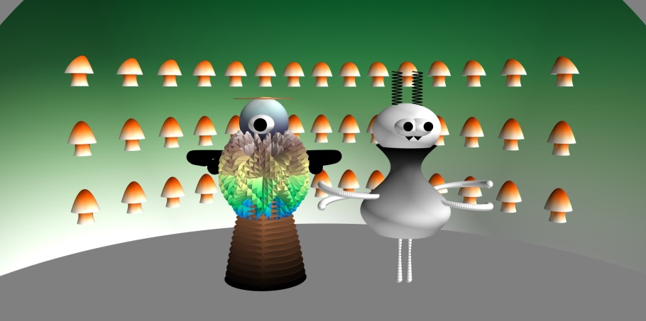

(a)

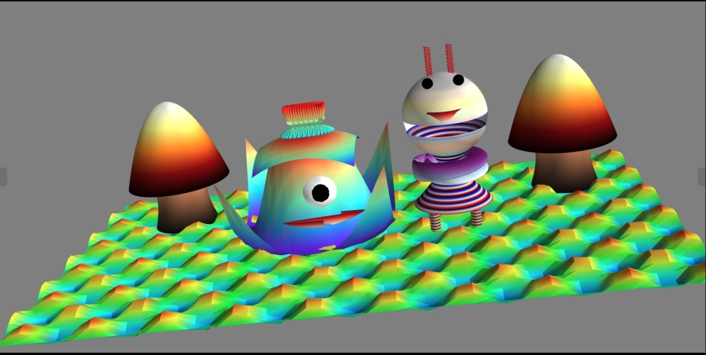

(b)

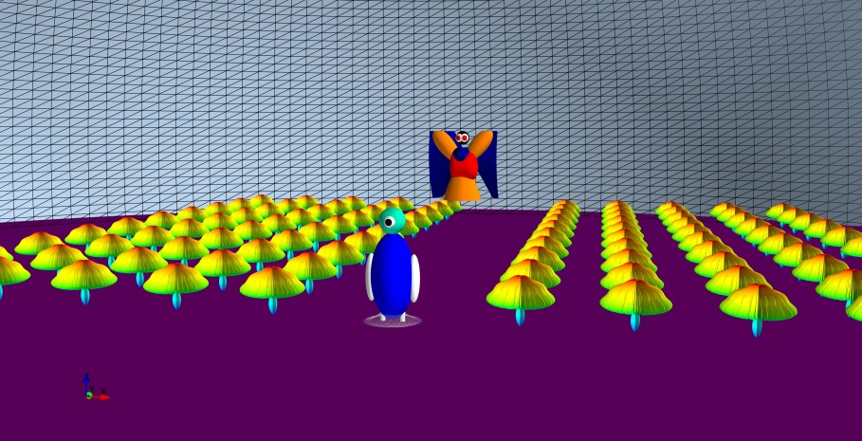

(c)

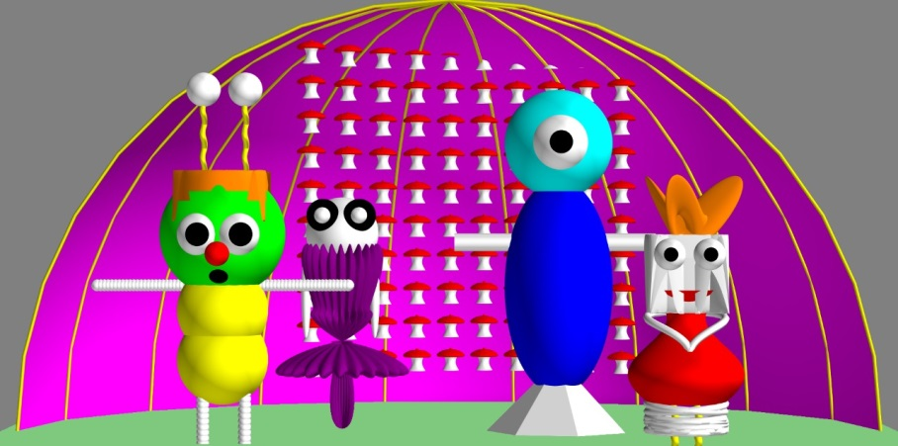

(d)

**Figure 1.** (a-d) Software cartoon character images created, using AIDesign commercial software, downloaded from [https://AIDesign.today](https://AIDesign.today/). AIDesign commercial software works with AI operating system terminal based operating system written in python language. The GNU of AIDesign commercial software is loaded from terminal command using AI Operating system and AIDesign commercial software also can be loaded directly clicking the .exe file to use only in Windows operating system.

3. Conclusions

Here we present for the first time a novel artificial intelligence technology use for the creation of story board and software feature film. Also, we illustrate AIDesign commercial software generates the story board and also predicts the new page in the story board, by extrapolating the existing story board pages. The main difference between the AIDesign commercial software with earlier international cinema studio industry using Celtx commercial software is that our AIDesign software creates the story board using trignometric operators, truncated Fourier series operators and creates/predicts the future new story board page in millisecond time that is four orders of magnitude faster than Celtx software. Another niche aspect discussed in this paper is that the art and design illustrated here, enables the manufacturing of the product design seen in the science of 2021. The rapid software feature film product creation in millisecond time makes the formidable difference from other international cinema studio industry like Disney and Pixar (Co-product) of Disney that have guild certification.

References

1. Animation, Walt Disney Animation Studios: The Archive Series #2, by Walt Disney Company, Published December 8th 2009 by Disney Editions.
2. Guide to New media- Writers Guild of America, (2015 book).
3. Art of Pixar Animation Studios Postcards (English, Postcard book or pack, Disney – Pixar).
4. The Art of Pixar, Volume II: 100 Collectible Postcards, from Chronicle Books includes stunning images from many iconic movies, from Ratatouille through Brave.
5. <https://www.celtx.com/index.html>
6. <https://en.wikipedia.org/wiki/Celtx>
7. <https://www.imdb.com/title/tt0114709/>
8. <https://www.wonderlandpark.com/>
9. <https://engineering.mit.edu/engage/ask-an-engineer/can-humans-fly-like-birds/>
10. <https://aidesign.today/>
11. V. Nandigana, Product work engine Design with AIDesign software, Intl. J. Sci. Res. in Phys. Appl. Sci. 2021.
12. V. Nandigana, Deep Learning and Generative, Interactive Design for Multiphase Multiphysics Technologies, Intl. J. Sci. Res. 10 (5), 673-675, 2021.
13. V. Nandigana, Deep Learning for real applications, Intl. J. Adv. Res. Ideas and Innovations in Tech., 7 (3), 236-238, 2021.
14. V. Nandigana, A. Dasari, D. Somasundaram, A. Anbarasu, Deep Learning for engineering applications, Intl. J. Adv. Res. Ideas and Innovations in Tech., 7 (3), 267-271, 2021.
15. V. Nandigana, Software Feature Film using AIDesign Software, Intl. J. Adv. Res. Ideas and Innovations in Tech., 2021 (accepted).
16. K. V. Mahendar and V. Nandigana, Real electrical signals to text, Intl. J. Adv. Res. Ideas and Innovations in Tech., 2021 (accepted).
17. V. Nandigana, Deep Learning and Generative, Interactive Design, Intl. J. Sci. Res. 10 (4), 679-680, 2021.
18. V. Nandigana, Deep Learning for Turbulence Modeling, Intl. J. Adv. Res. Ideas and Innovations in Tech., 7 (3), 260-262, 2021.
19. L. Dillard, V. Nandigana, J. Gore, Artificial Intelligence Application in Combustion Modeling, AIAA Scitech 2021 Forum, 2021.