Self Driving Cars Risk Free Software Management System

Vishal Nandigana¹
nandiga@iitm.ac.in
¹Indian Institute of Technology Madras (IITM)

Abstract

In this paper, an Artificial Intelligence based Deep Learning algorithms developed inside AIDesign software package available in the website https://aidesign.today over fee payment for download and use is used to develop a software methodology for the future of self driving cars on roads only with tight stringent software tight mangement millisecond response rates of the algorithms possibilities offered by the AIDesign software package for self driving cars on roads only and vehicles of present and future designs offered by the AIDesign software package for design and analysis for usage possibilities of the developed software methodology presented in the paper with the code structure and reduced lines of code structure compatible with the AIDesign software package for software management of self driving cars/vehicles on roads for nearly 80% safety assurance from the millisecond response rates of the code structure with the assurance of design and analysis of the millisecond approved response rates of the cars/vehicles design, analysis for steady and vibrations/kinematics/dynamics/road testing of laminar and turbulent wind conditions on cars, sedans, SUVs, with the mechnics also offering similar millisecond response rates over both the design and analysis together by the AIDesign software package confirmed results as published in the website https://aidesign.today launched in 2021.

Keywords: Self Driving cars, AIDesign, AI, Deep Learning, Software, Software Management, Human Welfare

Introduction

Self driving cars different from the technology offered by the another growing field of Autonomous cars on the engineering development of the automation fo the cars [1-2]. Self driving cars focuses on the implementation of the existing cars/vehicles and futuristic new designs developed from the manufacturing approved cars and vehicles running on road to drive self-driving using software methodology with the implementation of a tight yet not completed so far in the literature over the last twenty years of this growing and future of booming exciting field of reasearch and readiness to drive approvals on road with 100% safe approvals [1-2].

Deep Learning with the taking over the reims as the future of computing in mathematics and theories from PDEs and ODEs as AI is the future coined technology and developed by robust technologies with AIAA [3], legal approved feature film technology approvals from legal websites as new software feature film different from animation/motionpicture/videogames software feature films offer physical real human beings inside software feature film using only images and AI developed and approved as the future tool for theories and mathematics [4].

Deep Learning was initially introduced as an automatic feature extraction system, requiring minimum pre-processing effort by the user [5,6]. This is an old technique that has existed from 1940 and is known by different names such as - Cybernetics and Connectionism [5]. It was reintroduced as deep learning in 2007 [6]. The sudden increase in popularity of this field was due to the development of niche algorithms for training these networks. The most popular deep learning models are Convolutional neural network (CNN) and its next developed algorithms such as Recurrent Neural Network (RNN) and Reinforcement Learning (RL) [6], which uses images to identify similarities and patterns.

Software Code Structure and Schematic for Risk Free Management and Tight Code for 80% human welfare for self driving cars on roads and self driving vehicles on roads

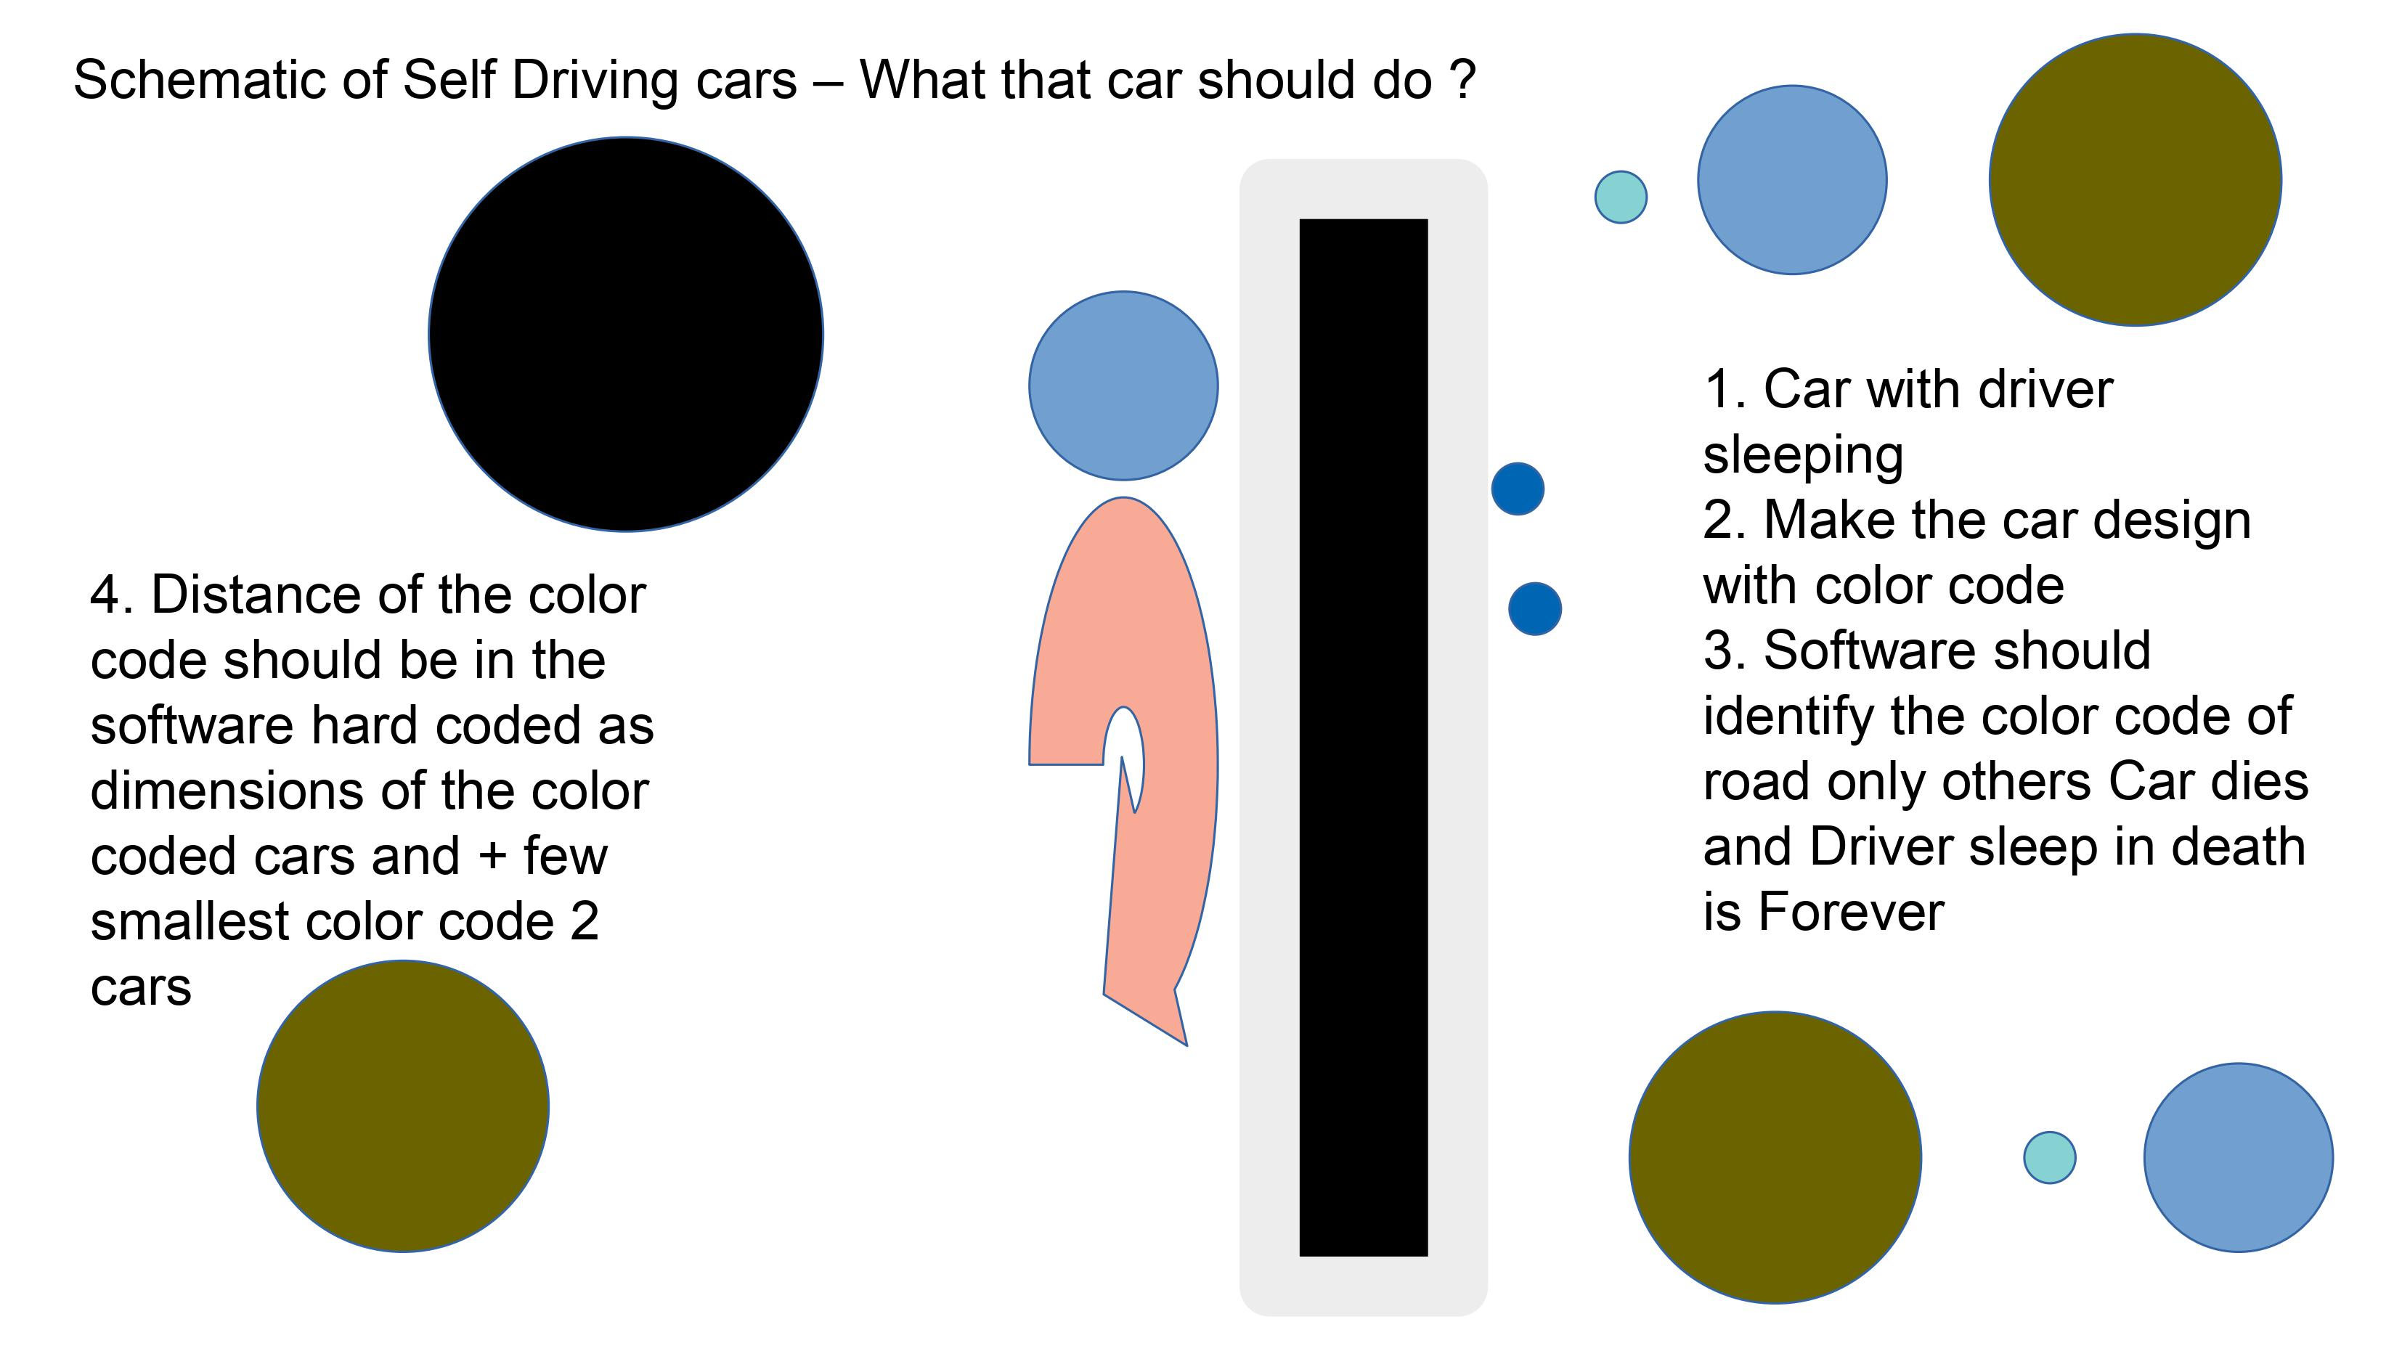

Figure 1. Self Driving Cars Schematic

Fig. 1 shows the software code schematics for risk free management and tight code for 80% human welfare for self driving cars on roads and self driving vehicles on roads. The schematic of self driving cars illustrates four points to ensure the code is small code with reduced lines of code to ensure millisecond response rates of the software package compatible with AIDesign software package and ensure the response rates make the self driving cars/vehicles risk free management as a real/true self driving cars/vehicles giving the driver/passengers assurance of the 100% software assurance with no trouble in the performance and workability of the software packages in the road and focusing on the plans of taking the car/vehicle from garage/parking lot for human life while driving the self-driving car with the software risk free management and human welfare approvals as usuage.

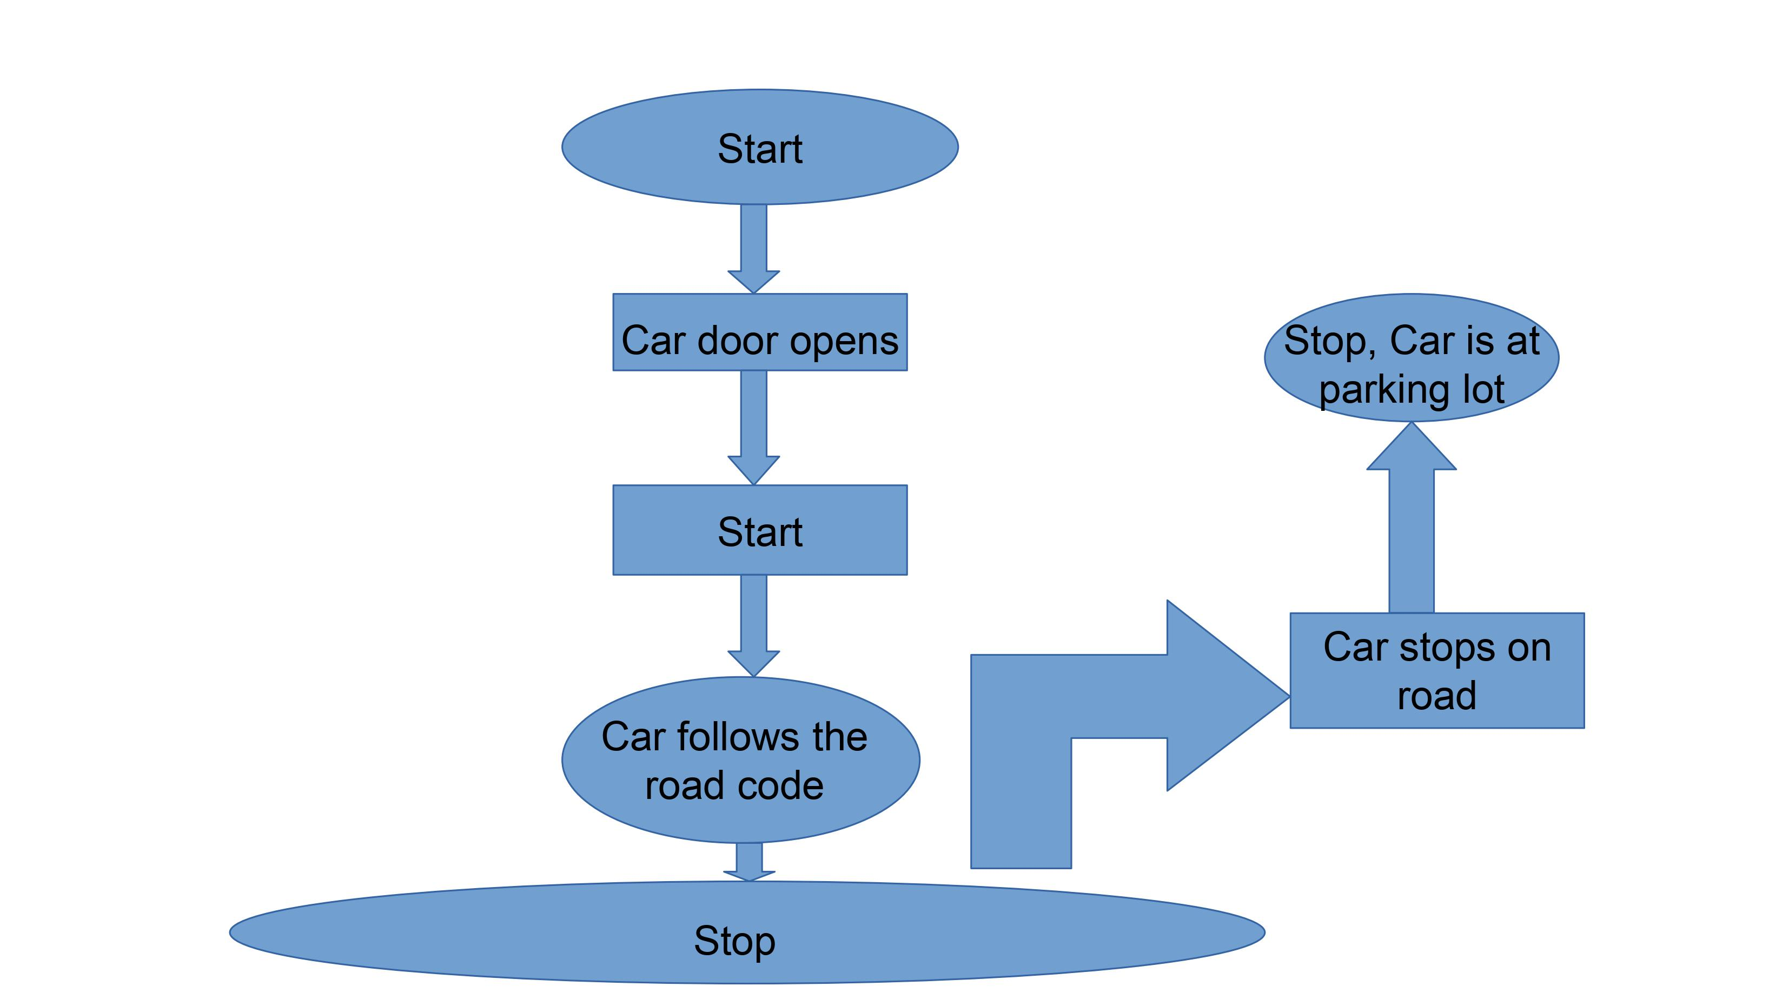

Figure 2. Self Driving Cars code structure

Fig. 2 shows the software code structure for risk free management and tight code for 80% human welfare for self driving cars on roads and self driving vehicles on roads. The code structure has 2 start buttons 2 stop buttons with 2 for loops only as small code with 25 lines of code compatible with python package developed AIDesign software package. The 2 for loops are hard coded as shown in schematics and 2 start buttons are software coded if needed 1 start button is hardware remote control for the driver/passenger but only if needed. The 2 stop buttons are software coded if needed 1 stop button is hardware remote control for the driver/passenger but only if needed.

Conclusion

Here, an AI based Deep Learning algorithms developed inside AIDesign software package available in the website https://aidesign.today over fee payment for download and use with tight stringent software tight mangement millisecond response rates of the algorithms possibilities offered by the AIDesign software package with the software methodology and tight millisecond small code compatible and reduced lines of code structure with the AIDesign software package for software management of self driving cars/vehicles on roads for nearly 80% safety assurance from the millisecond response rates of the code structure makes the future of self-driving cars with a confidence to enable human welfare and offer software assurance of 100% risk free usage with no too much service and management.

References

[1] Faisal, A., Yigitcanlar, T., Kamruzzaman, M., & Currie, G. Understanding autonomous vehicles: A systematic literature review on capability, impact, planning and policy. T J  T  L U, V. 12 N. 1 [2019] pp. 45–72.
[2] Jianfeng Zhao, Bodong Liang and Qiuxia Chen, The key technology toward the self-driving car, International Journal of Intelligent Unmanned Systems Vol. 6 No. 1, 2018 pp. 2-20, Emerald Publishing Limited.
[3] LN Dillard, V Nandigana, JP Gore, Artificial Intelligence Application in Combustion Modeling, AIAA Scitech 2021 Forum, 2021.
[4] AICartoon.Today for Software Feature Films Technology and International Studio, 2021. https://aicartoon.today
[5] J. Philip C. Jackson, Introduction to artificial intelligence, Dover Publications, 2013.
[6] G. B. Jon Krohn, A. Bassens, Deep Learning Illustrated: A Visual, Interactive Guide to Arti-ficial Intelligence, Addison-Wesley Professional, 2020.

