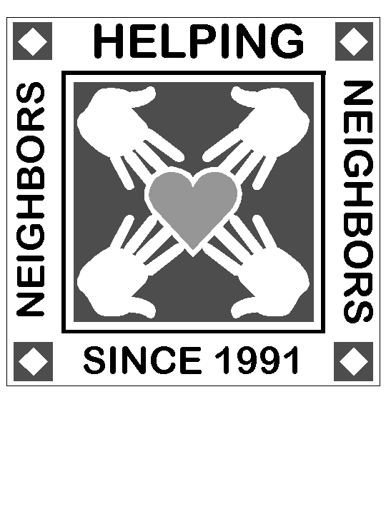 | WLWA Community Foundation 2022  Raises Over $20,000 to Benefit  Fulshear/Simonton Area

Thanks to generous donations from residents and businesses, the Weston Lakes Women’s Association Community Foundation, Inc. distributed $17,675 to these organizations in the Fulshear/Simonton communities:

Organization | Amount | Contribution Usage
WLWA College Scholarship Fund | $8,650 | To provide scholarships and grants for deserving 2023 graduating students in the Fulshear/Simonton area
Friends of the Bob Lutts Fulshear/Simonton Library | $2,000 | To fund the summer Reading program and cultural programs for our youth and adults in the community
Fulshear/Simonton Lions Club | $2,000 | To provide screening for vision and assistance for exam and eyeglasses to financially challenged students & seniors
Weston Lakers Swim Team | $2,000 | To provide much needed equipment for the Swim Team’s use at the new competition pool which should be finished in 2023
Family Hope | $1,350 | To provide financial assistance to landlords or service providers to qualifying residents of Fulshear
Fort Bend County Women’s Center | $1,675 | Memorial funds transferred at the request of Mrs. Frances Carr, widow of J. Carr

Thanks to the WLWA Community Foundation Board of Directors: Lisa Guerre, Mary Kanney, Dana Sarles, Cindy McNab, Terri Oliver, Erin Rapacki and Ida Wall.

Special thanks to: Anonymous, Rachele Adler, Gil & Vicki Ash, Kim & Carol Bennetts, Blackbaud Giving Fund, Sonya Boydston, Glenn & Eunice Buchanan, Bette Burton, Carol Clark, Sandra Clinard, Les & Patsy Coalson, Wendee Court, Kyle & Janet Cuellar, James & Mary Alice Daniel, Courtney Dodge, Elsa Gerber, Clint & Beth Greenwalt, Russell & Lisa Guerre, Fred & Margie Hall, Carol & Olin Hammer, Linda Harbers, Claire Hines, Chuck & Debbie Ingram, Mark & Anna Johnson/Apanel, Jerry & Mary Kanney, Betty Kiesler, Rhonda Kottke, Jerry & Karen Lea, Linda Lee, Keith & Sharon Leonard, Betsy Martin, Joel & Allison Mayhugh, Michael & Sherry Mays, Roger & Dana McCartney, Judith McCulloch, Cynthia McNab, Tim & Bridget McWilliams, Kathy Miller, Terry & Judy Miller, Mosswood Properties--Jason & Susan Hall, Gene & Paula Nordt, Rick & Barbara Oneto, Mary Peterson, Robert Pfaffenberger, Walter Pharris, Bob & Jane Poe, Suzanne Price, Roller Realty, Dan Riley, Joe Saltamachia, Julie & David Sawyer, Robert & Elizabeth Schaeffer, Jillian Schifferstein, Jay & Robin Schill, Kandi Schramm, Albert & Lari Secor, Susan Sessions CPA, Douglas & Lou Ann Simons, Kevin & Veronica Smith, JP Steel LLC, Morgan Stewart, James & Betty Thiele, James & Judith Thompson, Bruce & Cindy Turk/Henry, Steve & Linda Utterback, Mary Vaeth, Peggy Van Dyke, Clarence & Sharon Venables, Bob & Ida Wall, John & Willie Walton, Anthony & Lourdes White, Carl & Mary Whitlock, Michael & Lynne Wolf, Weston Lakes Garden Social Club, Weston Lakes Ladies Golf Association. Sponsors of the WLWA Fall Festival were: Weston Lakes Senior Golf Men’s Association, Pinnacle Energy Solutions, Wallis Bank, Weston Lakes Garden Social Club, Weston Lakes Men’s Golf Association, Jennifer Francois, Tricia Turner Properties, Surface Construction, Rex Jarrell, The Salons (Monica Krpec), Fulshear Dental, Mosswood Properties/Jason Hall, Pier 36, Milestone Windows & Doors, Keep Weston Lakes Beautiful, Terri Oliver, Jollery Eckerd, Papa Murphys Pizza, JJMJ Inc., Lari & Al Secor, Betty Burton, Mary & Jerry Kanney, Scott Thornton/Window World, Jay & Robin Schill, Cobble Stone Cottage, Kevin & Lisa Guerre, Gina Cornelius/GNA Inspections.

We have made every effort to accurately acknowledge all the businesses and people who contributed to our fundraiser in 2022. If we inadvertently missed someone or some business, we sincerely apologize.

