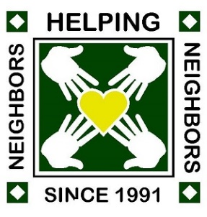 | Weston Lakes Women’s Association  Community Foundation, Inc.  Grant Application
The Weston Lakes Women’s Association Community Foundation welcomes your nonprofit to apply for a one-time monetary grant for 2026. The Foundation is a 501(c)(3) Corporation whose mission is to manage and disburse monies raised and collected by the Weston Lakes Women’s Association. Our philanthropic efforts provide monetary grants to nonprofit charities who must be a designated 501(c)(3) organization in the Fulshear-Simonton area. Please complete this form and

Email to: wlwafoundation@gmail.com | Or mail to: WLWA Community Foundation  PO Box 873, Fulshear, TX 77441

Date: | Contact Name:
501(c)(3) EIN: | Contact Title:
Nonprofit: | Contact Email:
Address: | Contact Phone:

Amount Requested: __________________

How would you use this grant? Please provide information about your organization. What is your mission? What is your priority? How does it benefit the community?

