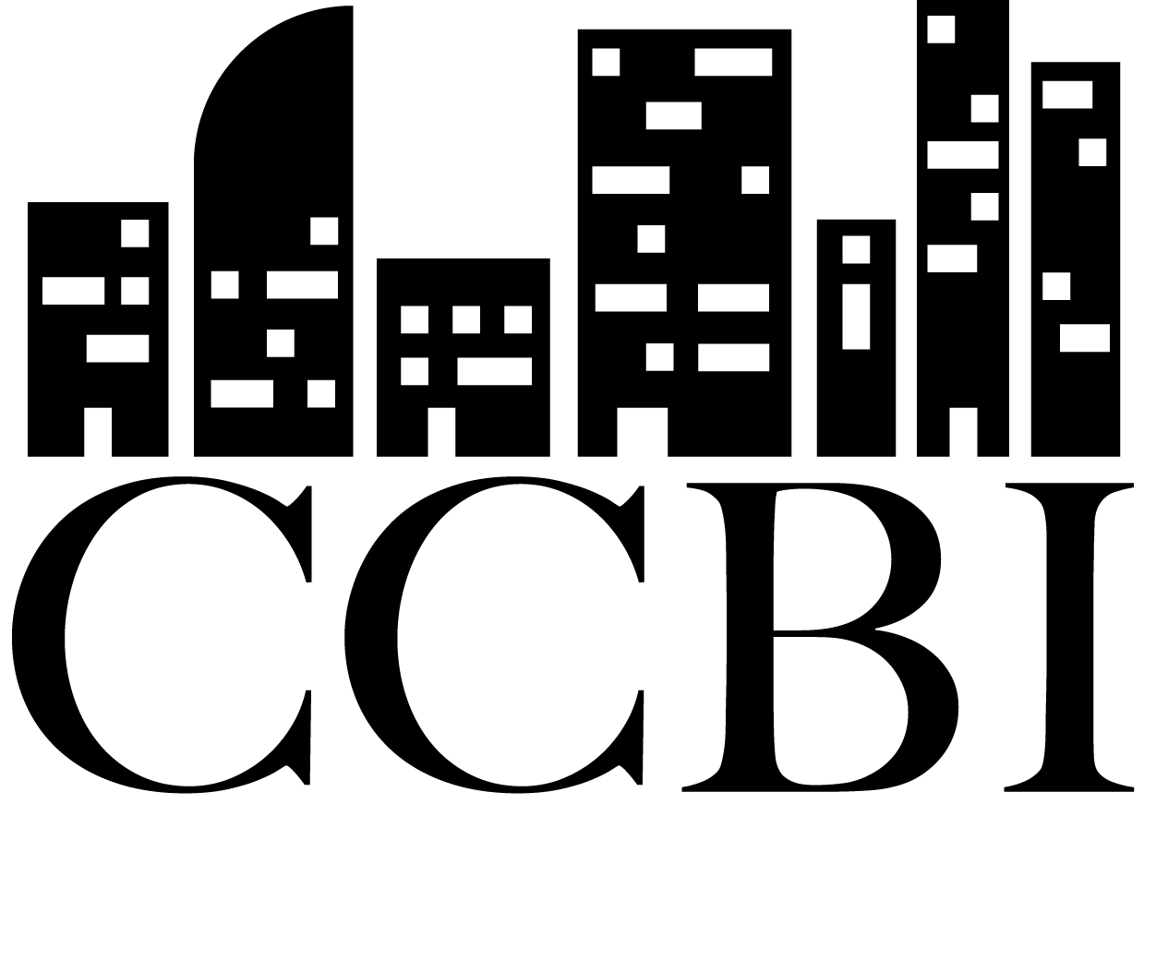
OFFICIAL NOTICE OF ANNUAL GENERAL MEETING

Community Capacity Building Initiative (CCBI)
Non-profit Social Enterprise
Date of Issue: October 25, 2025
Issued by: Jack Aude Pichette

MEETING DETAILS
Date: Tuesday, November 11, 2025
Time: 6:00 PM - 8:00 PM
Format: Hybrid (in-person and online)

In-Person Location:
1988, Rue Sainte-Catherine Est #201
Montréal, Quebec H2K 2H7
Accessibility:
- Wheelchair accessible with elevator
- Gender-neutral bathrooms available
- French/English interpretation provided
- Vegan catering by Coco Yam

Online Participation: Will be sent by email

VOTING ELIGIBILITY

To be eligible to vote, you must:
- Have been in active relationship with CCBI since August 1, 2024
- Register as an active member at latest November 2, 2025
- Be present at the AGM (in-person or online)

Active relationships include:
- Client
- Collaborator or partner
- Activity or program participant
- Employee or contract worker
- Volunteer or intern

Active membership registration:
Link: https://lnkd.in/eEHpV4NM
Deadline: November 2, 2025

AGENDA
The complete agenda is attached to this notice. Main items include:
- Welcome and land acknowledgment
- Approval of agenda
- Approval of 2024 AGM minutes
- Year in review and planning
- Financial report
- Policy updates
  - Intersectional framework
  - Bylaws
- Election of board members
- Other business
- Adjournment

Extraordinary board meeting
Immediately following AGM (board members only)

BOARD ELECTIONS

Available positions:
- 7-9 regular board seats
- 1 CPA advisory seat (non-voting)

Nominations:
Nominations are open until November 8, 2025, 5:00 PM

To submit a nomination: https://forms.gle/UScJaWDou9MhNUnaA

AVAILABLE DOCUMENTS
The following documents will be available on November 3, 2025:
- Annual report
- Financial statements
- Proposed budget
- Revised bylaws
- Intersectional governance framework
- Candidate information
- 2024 AGM minutes

How to access documents:
Documents will be emailed to all registered members and will be available on our website: https://ccbi.ca/agm-2025

REGISTRATION REQUIRED
Please register before November 3, 2025
To register:
- Complete your active membership
- Register for the AGM
- Indicate your participation mode (in-person/online)
- Nominate a board candidate!
Registration link: https://lnkd.in/eEHpV4NM
Board nomination link: https://forms.gle/UScJaWDou9MhNUnaA

ACCOMMODATIONS
If you require special accommodations (accessibility, additional interpretation, dietary restrictions, transportation, etc.), please contact us before November 1, 2025.
Contact: info@ccbi.ca

QUORUM
In accordance with our bylaws, quorum is established when more than 50% of present members vote in favor.

PROXIES
Proxy voting is not permitted. Members must be present (in-person or online) to vote.

RECORDING
The meeting will be recorded for minute-taking purposes. Individual votes will remain confidential.

QUESTIONS
For any questions regarding the AGM:
Community Capacity Building Initiative
1988, Rue Sainte-Catherine Est #201
Montréal, Quebec H2K 2H7
Website: ccbi.ca
Email: info@ccbi.ca

ATTACHED DOCUMENTS
- Complete agenda
- Hybrid voting procedures
In accordance with Quebec legal requirements, this notice is issued at least 10 days before the annual general meeting.
We look forward to seeing you on November 11th!
For the CCBI Board of Directors
Jack Aude Pichette
Board Member; General Administrator
Date: October 27, 2025

