**Reston & District Library Book Club**

Runs from September to June. Book club members meet the last Wednesday of everyone month at 5:30 pm for supper and discussion.

If you are interested in joining, please stop by the library, or call us at 204-877-3673. If you have book club suggestions, we’d love to hear from you.

# **Reston & District Library** hosts **Mom’s & Tots** every Wednesday from 10:00 – 11:00.

# Moms, come in and have coffee while the kids enjoy stories and playtime. Everyone Welcome!

**E-Books App Change**

To all our eBook users, there has been a change in Overdrive to the new App, Libby. Please contact the Reston District Library at 204-877-3673 and we can set you up with your 14-digit library number and password.

**TD Summer Reading Club 2018**

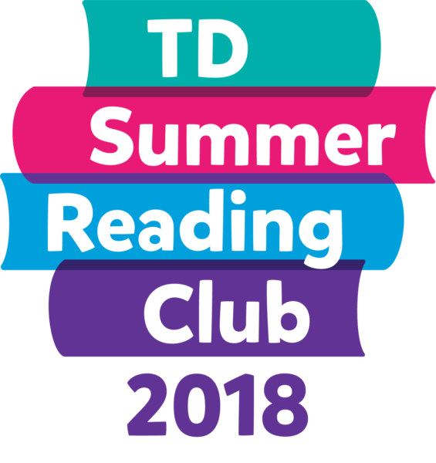

The Reston & District library is once again hosting the TD Summer Reading Club for kids aged 0 – 12. This year’s theme is innovation and imagination.

Kids are invited to sign up from July 3rd – August 29th 2018 to receive their passport book. For every book the kids take home to read and return they receive a sticker for their passport book and a chance to put their name in for a chance to win the book of their choice.

The Kids will also get to take part in our fun lego creation that will run from July to the end of August. Be Innovative, use your imagination to build something extraordinary with all the participants.

The TD Summer Reading Club wind-up party will be held on Wednesday August, 29th from 2:00 – 3:30 pm. Prize draws will be made at 3:00 pm. Join us for activities, refreshments and treats.

See you at the Library!