**E-Books App Change**

To all our eBook users, there has been a change in Overdrive to the new Libby App. Please contact the Reston District Library at 204-877-3673 and we can set you up with your 14-digit library number and password.

**Reston & District Library Book Club**

Runs from September to June. Book club members meet the last Wednesday of everyone month at 5:30 pm for supper and discussion.

If you are interested in joining, please stop by the library, or call us at 204-877-3673. If you have book club suggestions, we’d love to hear from you.

# **Reston & District Library** hosts **Mom’s & Tots** every Wednesday from 10:00 – 11:00 am. Moms, come in and have coffee while the kids enjoy stories and playtime. **Everyone Welcome!**

**Author Visit Thursday September 27, 2018 at 7 pm.** The Reston & District Library will host **Virden Author, Iris Munchinsky, Author of Bridge of Shadows**. Iris will be here to talk about her book. Please mark your calendars and plan to attend. Watch our Facebook page, website and posters around town and the Reston Recorder for notices of her visit. **See you there.**

**2018 TD Summer Reading Club**

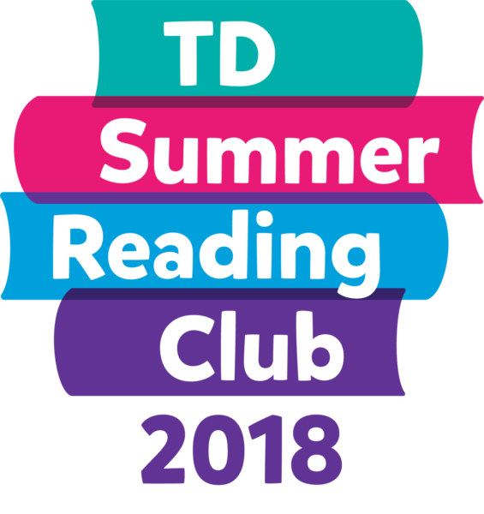

The **TD Summer Reading Club** at the Reston & District Library was a great success this summer for kids aged 0 – 12. We had 91 kids sign up. This year’s theme is innovation and imagination.

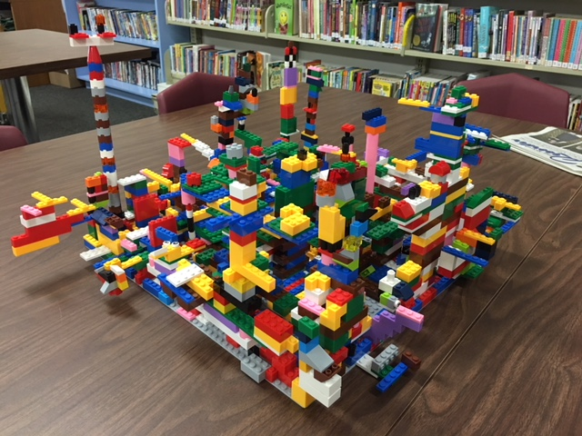

The Kids had a great time building the Lego creation. For every book they returned, they got 5 pieces of Lego to add to the creation plus they got a sticker for their passport books.

The TD Summer Reading Club wind-up party was held on Wednesday August 29th. The kids played games, had drinks and treats and everyone went home with a little prize. 8 lucky winners won the book of their choice.

**See you at the Library!**