 | East Oaks HOA - Automatic Payment  AUTHORIZATION FORM (Required Fields)  Effective Date of Authorization: _____ / _____ / __________
Type of Authorization: New Authorization Change Payment Amount Change Payment Date
Change Banking Information Discontinue Electronic Payment
Last Name |  |  | First Name
Street Address
City |  | State |  | Zip
Email Address
Payment Frequency ONE-TIME Recurring (select one) WEEKLY MONTHLY ANNUAL OTHER __________________
Date of One-Time Payment _____ / _____ / __________ Amount $ __________________
Date of First Payment _____ / _____ / __________ Amount of Recurring Payment: $363.75
Please debit payment from my (check one)  Savings Account  (contact your financial institution for your routing #)  Checking Account  (staple a voided check to bottom of page) |  |  | Routing Number:  __________________________________  Valid Routing # Must Start With 0, 1, 2 or 3  Account Number:  __________________________________  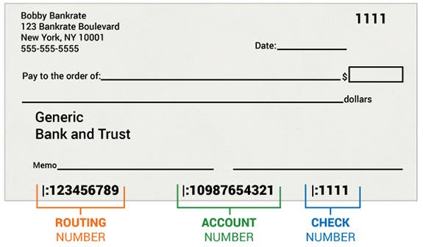
I authorize the above organization to process debit entries to my account. I understand that this authority will remain in effect until I provide reasonable notification to terminate the authorization.

Authorized Signature: _____________________________________________ Date: _________________________

