Mystic Beauty Iris |  |  | Bluebells
This gorgeous variety has purple-blue standards and pale lavender falls with golden blotches. | 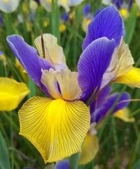 |  | This scented woodlands naturalizer has pendant, dark violet-blue flowers. Plant these and think of the Belles of WCCC! | 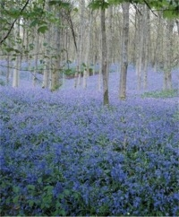
Blue Magic Iris |  |  | Hyacinth Fondant
This beautiful display and cutting flower has campanula-violet standards with deep heliotrope-blue falls and yellow blotches. | 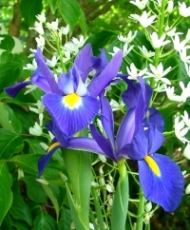 |  | Fondant has neyron-rose with phlox-pink highlights. You will need about 4 bulbs per square foot. | 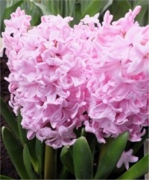
The Woman’s Club of Chevy Chase Bulb Sale
For a Deer Resistant Spring Garden
October 2020

Iris Rainbow Mix |  |  | Hyacinth Mixture
This stunning mixture includes purple, lavender, blue, yellow, and white varieties. | 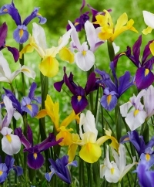 |  | This stunning mixture includes purple, lavender, blue, yellow, and white varieties. | 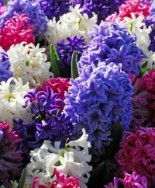
Collection K Daffodils |  |  | Collection Q
Late -flowering fragrant narcissi. Yearning for a late spring, fragrant narcissus show? | 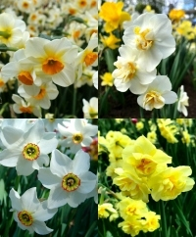 |  | Popularly regarded as NOT squirrel food, this hard-to-find spectrum of Species Crocus will festoon lawns with glistening gems of pale lilac to deep reddish-purple with every shade in between. | 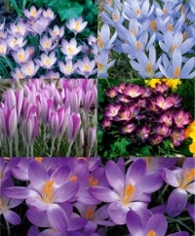

Collection M Daffodils |  |  | Collection R
A collection of perfect naturalizing mates. Large Cupped Narcissus Golden Salome is paired with its parent, Large Cupped Salome. They are perfect together. | 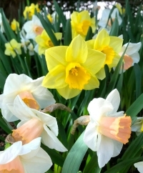 |  | The Bee-Loved Early Bird Garden. Early sightings of these diminutive flowers have a huge impact on the budding beauty of the environment. They bravely wake up the world, feed the bees, and brighten spirits as they herald spring's arrival. | 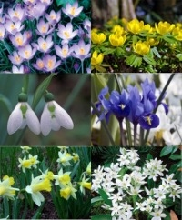
Collection N Daffodils |  |  | Amaryllis Gift Boxes
Fragrant narcissi. Plant drifts of these intoxicating beauties where you will be able to enjoy their delightful bouquets. | 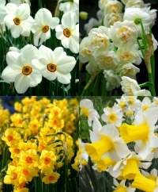 |  | Perfect holiday gift-giving, our Amaryllis gift boxes contain one bulb, a green plastic pot, lid and saucer, potting medium, and growing instructions. | 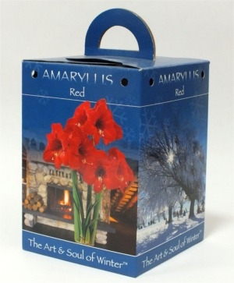

Muscari Magical Mixture |  |  | Paperwhite Gift Boxes
This long-lasting blend includes twinkling shades of periwinkle, sapphire, pale wisteria, and white. | 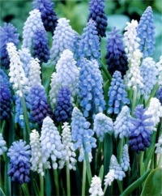 |  | Each attractive gift box contains 4 Paperwhite Ziva bulbs, a watertight, green plastic pot, special soil, marble chips, and instructions. | 