Montgomery College Music Program Donation Instructions
Task | Steps
- Visit Montgomery College’s Donation Website | Click on montgomerycollege.edu/onlinegiving
- Scroll down and confirm that you are on the right page | Note the heading on the page, “Emergency Support for Students”. You’re on the right page.
- Provide name and address
- Designate the donation for the Woman’s Club of Chevy Chase Music Program Scholarships | - Scroll down to the area where you can designate where your gift will go.  - In the center box, Select, “Give to a scholarship fund.”  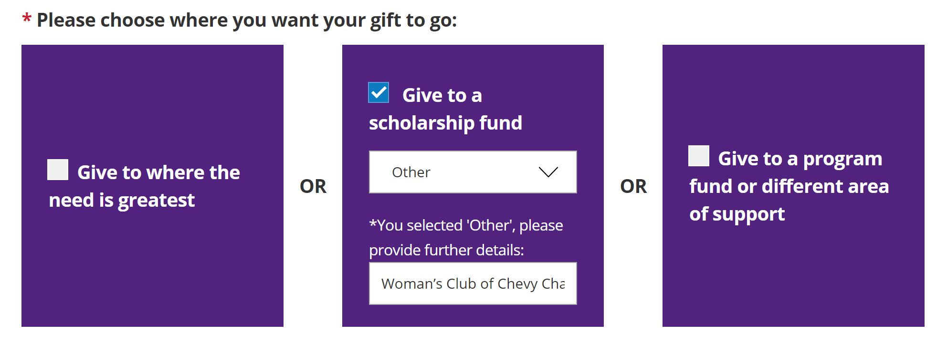  - Click on the drop down menu  - Scroll to the last item in the list, “Other”  - In the area provided, type in Woman’s Club of Chevy Chase Music Program Scholarships
- Complete the form | - Fill in the remaining fields as necessary, for such as whether it is a one-time donation; etc., in honor or memory of someone; and how you would like your name to appear on the donation list.  - Continue on to the credit card page to finalize

