Pentecost 7

Acts 2:1-4 REV (Revised English Version – used throughout unless otherwise noted)
And when the day of Pentecost arrived, they were all together in one place.
And suddenly a sound came from heaven like a strong rushing wind, and it filled the whole house where they were sitting.
And there appeared to them tongues as if of fire, which spreading out, came to rest upon each one of them.
And they were all filled with holy spirit, and began to speak in other tongues, as the Spirit was giving them utterance.

How

Having considered who, what, when, and where of Pentecost, let’s consider “how” beginning with the promise of the spirit before Pentecost.

Luke 11:9-13
And I say to you, keep asking, and it will be given to you; keep seeking, and you will find; keep knocking, and it will be opened to you.
For everyone who keeps asking receives, and the one who keeps seeking finds, and to the one who keeps knocking it will be opened.
And what father is there among you, if his son asks for a fish, will instead of a fish give him a snake?
Or if he asks for an egg, he will give him a scorpion?
If you then, being evil, know how to give good gifts to your children, how much more will your heavenly Father give holy spirit to those who ask him?”

Notice that “your heavenly Father give(s) holy spirit to those who ask him.” The holy spirit is not earned by works. It doesn’t come from a pilgrimage or a religious exploit. It is given by God through His grace to someone who… asks. And in the context, the asking indicates some persistent asking, seeking, and door knocking. In other words, the holy spirit does not knock you over with its presence or usually nudge you like a dog until you give in. It also is not automatic. You must ask for it. You don’t go to sleep and wake up and it’s in you. You must be mentally engaged with God to ask, seek, and knock.

Although the spirit doesn’t knock you down, in a manner of speaking, you must knock down the fear of getting a harmful impartation, like the verses above assert. I’ve seen this repeatedly with myself and others when it’s time to manifest the spirit in speaking in tongues. “What if I can’t do it? What if I say something disrespectful to God? What if nothing comes out? What if I open up and something spiritually harmful comes into me?” These are all good questions that are answered in these verses. The answer is that God is good and loving. He will not lead His children astray. They should ask for the spirit, trusting Him to give it as a loving Father would. He did that for me and many others.

Luke 24:49, 52, 53
And look!, I am going to send the promise of my Father upon you, but you, stay in the city until you are clothed with power from on high.”
And they, after paying homage to him, returned to Jerusalem with great joy, and were continually in the temple, blessing God.

Jesus told them to stay in Jerusalem until the spirit came. If they decided to go fishing on the sea of Galilee instead, who knows what would have happened? So obviously there is some simple obedience involved in receiving the spirit. Notice that they were continually in the temple during the interim, praying, and praising God. Were they there 24 hours a day? No, they were there during the three hours of prayer. The International Standard Bible Encyclopedia explains:

“The regular hours of prayer, as we may infer from Psalm 55:17 and Daniel 6:10, were three in number. The first coincided with the morning sacrifice, at the 3rd hour of the morning, at 9 AM therefore (Acts 2:15). The second was at the 6th hour, or at noon, and may have coincided with the thanksgiving for the chief meal of the day, a religious custom apparently universally observed (Matthew 15:36 Acts 27:35). The 3rd hour of prayer, 3 pm, coincided with the evening sacrifice, at the ninth hour (Acts 3:1; 10:30).”

The apostles waited in Jerusalem as Jesus instructed and prayed thrice daily in the temple – 9 am, noon, and 3 pm. When Pentecost came, where were they at 9 am for the first prayer time? They were in the temple ready to go. Perhaps they thought, “I wonder if it’s today?” It was! How would they know? They knew because Jesus had given them the divine cue.

John 20:19,22
Now when it was evening on that day, the first day of the week, and when the doors were shut where the disciples were for fear of the Jews, Jesus came and stood in the midst, and says to them, “Peace be to you.”
And when he had said this, he breathed on them, and says to them, “Receive holy spirit.”

The insight from the commentary on the REV regarding “breathed on” is terrific. “The Greek word for “breathed on” is emphusaō and it means to breathe on or to blow on. When understood as “blew on” we can see that Jesus was instructing his disciples about the Day of Pentecost, when the Temple was filled with the sound of a mighty wind. The beauty of the two meanings of emphusaō is that the Greek text is showing the two things Jesus is doing for his disciples. He is giving instruction for the Day of Pentecost when the Temple will be filled with the sound of a rushing, mighty wind, because he breathed on them, blew on them, and said, ‘Receive holy spirit.’ At the same time, Jesus is making a powerful association between what happened in Genesis, what is foretold in Ezekiel, and what will happen on the Day of Pentecost when he pours out the gift of holy spirit. The use of emphusaō here in John 20:22 takes us back to its use in Genesis 2:7 in the Septuagint, [the Greek Old Testament] where God formed Adam from the dust of the ground and “breathed” into him the breath of life, and he became a living soul. In Genesis, God breathed natural life into Adam, now Jesus foretells when spiritual life will be breathed into the disciples. Also, the Bible foretells that believers will receive resurrection life when the ruach (Hebrew for spirit, breath, wind) “breathes” on the dead bodies of Israel, and they come to life. “Then said he unto me, Prophesy to the wind [ruach], prophesy, son of man, and say to the wind [ruach], ‘Thus saith the Lord Yahweh: Come from the four winds [ruach], O breath [ruach], and breathe upon these slain, that they may live’” (Ezek. 37:9). REV Commentary

Jesus blew on them, making the sound of “a strong rushing wind” signaling the beginning of the coming Pentecost experience.

Acts 2:1-2
And when the day of Pentecost arrived, they were all [the 12 apostles] together in one place [the temple].
And suddenly a sound came from heaven like a strong rushing wind, and it filled the whole house where they were sitting.

What occurred on Pentecost morning was exactly what Jesus predicted would happen when the spirit would be received. When the wind noise appeared, the apostles knew it was time.

Let’s reinforce another critical point from Acts 2:2. About 20 years later the apostle Paul wrote his first epistle to the Corinthians correcting practical errors in that church. He addressed spiritual matters and manifestations in chapters 12 to 14. This section is summarized like this:

1 Cor. 14:40
But let all things be done decently and in an orderly way.

Some Christian churches do not operate spiritual matters “decently and in an orderly way”. My wife was at a public service recently where people gyrated and danced around, twirling scarfs and flags. This was not a practiced performance, but their regular worship practice. One man stood in a corner facing the wall and yelled for Jesus. I have been in services where participants were encouraged to “let go” and “let the spirit move them”, which is what happened. Most of the spirit movement was of the unholy kind. Participants fell over and shook on the floor. Some quaked standing up. The leaders of this church proudly proclaimed that they were interested in their member’s health and had nurses stationed there with medical transport gurneys in case “the spirit” got too intense! I saw a few people wheeled out. It was a spiritual circus! Is this what happened at the original Pentecost?

“And suddenly a sound came from heaven like a strong rushing wind, and it filled the whole house where they were…” Running around twirling flags? Standing up yelling for Jesus? Convulsing on the floor? No! “Where they were sitting”. They were acting “decently and in an orderly way”. Indecent and disorderly practices cast shade on the simple beautiful reality of receiving and manifesting God’s spirit. This causes fear in potential receivers who wonder “If I ask God for a fish, will He give me a snake? Will I lose control and act ridiculously?” These freakish practices repel hungry souls who want spiritual help, causing them to miss God’s blessings. The apostles were sitting in the temple with thousands of others peacefully praying on Pentecost. They were decent and orderly.

Also note that Acts 2:2 never says there was a strong rushing wind, only the sound of it. This indicated that God was breathing spiritual life into them, filling them with His spirit. Could this sound fill the temple? Easily. Remember this is God breathing, figuratively speaking! So, on Pentecost morning when the temple opened and all Jews were present, God cued the wind noise, and the apostles knew the wait was over - it was time. Then another sign occurred.

Acts 2:3
And there appeared to them tongues as if of fire, which spreading out, came to rest upon each one of them.

In Greek, the words “spreading out” are in the passive voice meaning that something or someone was “spreading out” the fire that came to rest on each of the apostles. This was not a random action but directed (obviously to the thousands of devout Jews in the temple) by God. These folks knew their history. Here’s more insight from the RSV commentary.

“Fire from heaven was always a sign of divine presence or action. God’s fire was used in judgment to consume his enemies, and it was also used as a sign of divine approval. For example, fire on Mt. Sinai signaled divine presence (Exod. 19:18). “A pillar of fire over the Tent of Meeting (Tabernacle) signaled God’s presence there (Exod. 40:38; Num. 9:16). God lit the Tabernacle altar with fire from heaven (Lev. 9:24), which is why the Levites were told to keep the fire going and never let it go out (Lev. 6:12, 13).
God accepted Gideon’s offering with divine fire (Judg. 6:21). Elijah’s sacrifice was accepted by fire from heaven (1 Kings 18:38), as was David’s (1 Chron. 21:26). God also lit the fire on the altar of the Temple with fire from heaven (2 Chron. 7:1-3). The Jewish audience assembled there at the Temple on the Day of Pentecost understood all this and had the opportunity to see that God (and His Messiah) accepted the Apostles.”
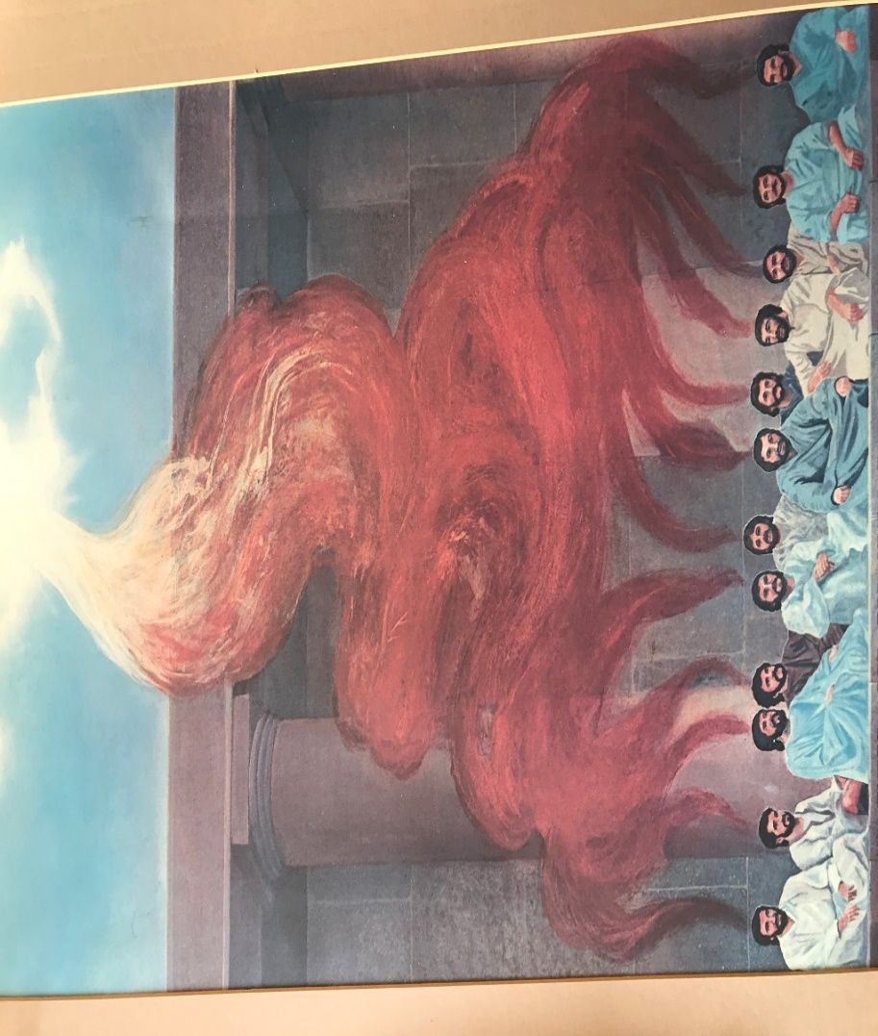
Acts 2:4
And they were all filled with holy spirit, and began to speak in other tongues, as the Spirit was giving them utterance.

After the sound of a strong rushing wind, signifying God giving the apostles spiritual life and the falling fire on each of them signifying God’s acceptance of the sacrifice of their lives and His presence in them, the apostles began to speak in tongues.

Speaking in Tongues

For some the word “tongues” is confusing. Some think speaking in tongues is a strange act including spasms of the tongue and mouth. This is not the case at all. In all the records about speaking in tongues, there is not one negative thing God inspired to be said - not one. On the contrary, there are many things mentioned about tongues glorifying God and beneficial to man. If this is the case, do you think Satan would cast the experience in a negative light? Absolutely. Minutes after the apostles manifested for the first time, some in the temple accused them of being drunk! The slanderer does not necessarily understand everything that God does, but he certainly can put it down. This was, and is, still true with tongues.

The word “tongue” was used in verse 3 as “tongues of fire”, figuratively comparing the shape of a tongue (big at the top and tapering toward the end) with the way the flames appeared to come down. “Tongue” is also used in verse 4 as “speaking in tongues”, figuratively mentioning a part of the body instead of what it helps generate, language. Today we still speak of “foreign tongues” using the same figurative expression. There’s nothing different about a physical “foreign tongue” from your tongue or mine. What’s different is the language. “Speaking in tongues” literally means “speaking in languages”, and in the context, “speaking in foreign languages”, as the word “other” tongues indicates.

Here are a few observations about this verse. “They were all filled with holy spirit”. No one got missed. This shows that if you ask, you get. Why? Because God is a loving Father. If you ask for some bread, He won’t give you air, figuratively speaking. He’ll come through. Remember, this experience was not dreamt up by man. It’s not my idea or yours. It was God’s idea and promised through Christ. We should trust that He’ll do what He promised. I’ve seen hundreds ask and receive. Nobody gets missed. God is faithful and bigger than our reluctance and uncertainty. His ability is bigger than our inability. “All receive” … that includes you and me.

A little research can open our understanding about this verse and how the spirit came. Greek verbs have three VOICES, the active, middle, and passive, indicating the origin and direction of the action described. The active voice is used when the subject of the sentence is the instigator of the action described by the verb. The middle voice denotes that the subject is both the instigator and the receiver of the action. The passive voice is used to show that the subject of the verb is acted on by an outsider.

John threw the ball to Pete. Active voice. John (the subject) initiated the action and “threw” to another.
John threw the ball to himself. Middle voice. John (the subject) initiated the action and “threw” to himself.
John was thrown the ball by Pete. Passive voice. John (the subject) was acted upon, not initiating the action, but receiving it.
In verse 4, the word “filled” is in the Greek passive voice. This means they (the subject – the twelve apostles) didn’t fill themselves, Jesus did. That may seem obvious to some, but not all of us. I stressed out thinking about my part in getting filled with the spirit. I worried needlessly because it’s a God-sized job, beyond my paygrade, as the saying goes. How did the filling happen? The apostles obeyed Jesus and were at the right place at the right time and Jesus did the rest – passive voice. They didn’t act – they were acted upon.
The next phrase is, “they were all filled with holy spirit, and began to speak in other tongues…”. Grammatically, the subject “they” carries over to the next phrase “and [they] began to speak in other tongues”. The word “began” is in the middle voice. So, although the first part of the verse is the passive voice (apostles acted upon), the second part of the verse says the apostles then initiated the action [speaking in other tongues]. Filling them with holy spirit was God’s job. Then, speaking in tongues was their job. How does this work?
The mechanics of speech were the same then as now. Speech begins with a thought. Someone wants to speak, usually because there is something they want to communicate. They then begin to move their lips, tongue, and mouth to form the appropriate words corresponding to their thoughts and move air up through their vocal cords, making sounds that others can hear. The mechanics of speaking in tongues are the same except for the predetermined idea of what you want to say. The speaker decides to speak, but they do not dictate the content of the speech. They still move their lips, tongue, and mouth to form the appropriate words, but it will be corresponding to the spirit’s thoughts, not theirs. They also move air up through their vocal cords, making sounds that others can hear. How do we know this distinction?
The third phrase in verse 4 is “as the Spirit was giving them utterance”. The words “was giving” is in the active voice. The means the subject [the Spirit] initiates and is responsible for the action of giving utterance to the one speaking in tongues. The speaker does not decide the utterance, or content, the Spirit does. This means:

THAT we speak is our business. WHAT we speak is God’s business.

This is why speaking in tongues is a manifestation of the spirit, not a manifestation of man’s mind. Decades after Pentecost Paul listed the nine manifestations of the spirit for the church.

1 Cor. 12:7-10
Now to each one the manifestation of the spirit is given for the common good.
For to one is given through the spirit a message of wisdom, and to another a message of knowledge by means of the same spirit,
to a different one trust by the same spirit, and to another gifts of healings by the one spirit,
and to another energizings of miracles, to another prophecy, to another discerning of spirits, to a different one various kinds of tongues, and to another the interpretation of tongues.

We will see these manifestations in Acts and the church epistles (and in our lives, I trust!).
Here’s a question for you, “Were the manifestations of the spirit new on Pentecost?” Here’s a follow-up question to answer the first one, “Was the idea of the spirit being given to man new on Pentecost?” The obvious answer to both questions is “No.” As we saw before God had given the spirit to man starting with Moses and continued through Jesus and the apostles. Therefore, there were manifestations of the spirit in the Old Testament – lots of ‘em.

Had the apostles manifested the spirit before Pentecost? The answer is, “Yes”. First, they watched Jesus do it, then he trained them to do the same.

Matt. 10:1, 8,
And he called to him his twelve disciples and gave them authority over unclean spirits, to cast them out, and to heal every kind of disease and every kind of sickness.
Heal the sick, raise the dead, cleanse those with skin diseases, and cast out demons. Freely you received, freely give.
Here are mentioned six of the manifestations of the spirit. To cast out spirits, you have to know they are there. That’s discerning of spirits. To cast them out, it takes trust or faith. To evict them is a miracle. To heal disease and sickness takes the word of knowledge and wisdom to know what God wants you to know about a person’s situation. Then you must command healing through trust. There are six manifestations right there.
Matt 10:18-20
and you will even be brought before governors and kings for my sake, as a testimony to them and to the Gentiles.
But when they deliver you up, do not be anxious how or what you are to say, for it will be given to you in that hour what you are to say,
for it is not you who speak, but the spirit of your Father that speaks in you.

In other words, THAT they would speak was the apostle’s business, but WHAT they would speak would be God’s business. Sound familiar? Sure. It’s similar to Pentecost, but what is different? Here in Matthew the manifestation was prophesy, bringing forth a message from God in the language of the speaker and those present – presumably governors and kings. On Pentecost, they didn’t bring forth a message at first in their language, Aramaic. Why was that? It was because that’s how the spirit gave them the utterance, the content.

Have you ever wondered how the apostles started speaking in tongues when this had never happened before or had even been foretold? ¹ Here is my private interpretation idea of how it happened. Is what I’m now sharing “the gospel”? No, it’s my conjecture…and worth as much as your ideas and warm spit!

When the spirit came on the elders with Moses, what did they do?

Num. 11:25
Yahweh came down in the cloud and spoke to him [Moses], and took some of the spirit that was on him and put it on the seventy elders. And it came to pass that when the spirit rested on them, they prophesied, but they did so no more.

They prophesied when the spirit came on them. What happened when King Saul received the spirit?

1 Sam. 10:10
When they came to Gibeah, behold, a group of prophets met him, and the spirit of God rushed upon him and he prophesied along with them.

Saul prophesied. What did Joel foretell when the spirit would be poured out in the last days?

Acts 2:17, 18
And it will be in the last days, says God, I will pour out a portion of my spirit upon all flesh, and your sons and your daughters will prophesy, and your young men will see visions, and your old men will dream dreams.
And even on my male servants and on my female servants I will pour out my spirit in those days, and they will prophesy.

The spirit coming and prophecy resulting was an established historical and scriptural pattern. I think that the apostles thought that it was “the last days” (Remember?) and when the spirit was poured out, there would be prophesying! So, when the day of Pentecost came, the mighty wind sound and flaming fingers appeared from heaven, they started doing the mechanics of prophecy. They decided to speak. They started moving their mouths, lips, tongue and making sounds, but the speech that came out was not in Aramaic, their language. They spoke in foreign languages (to them)! Why? Because “THAT they spoke was their business, but WHAT they spoke was God’s business.” God had something else in mind!

Acts 2:5-11
Now there were Jews staying in Jerusalem, deeply religious men from every nation under heaven.
And when this sound occurred, the multitude came together, and were bewildered, because each one was hearing them speaking in his own language.
And they were all amazed, and marveled, saying, “Look! Are not all these who are speaking Galileans?
And how is it that we are hearing them speaking, each of us, in our own language in which we were born?”
Parthians and Medes and Elamites, and those who live in Mesopotamia, in Judea and Cappadocia, in Pontus and the province of Asia,
in Phrygia and Pamphylia, in Egypt and the parts of Libya near Cyrene, and visitors from Rome (both Jews and proselytes),
Cretans and Arabians, we hear them speaking in our tongues the mighty works of God.

All the Jews who were in Jerusalem for Pentecost from all over the world had their minds blown. Here are twelve Galileans, as was obvious from their clothing. One-third of them, Peter, Andrew, James, and John were fisherman, with that ruddy windblown countenance and rough, fishnet-hauling hands. These Galileans are not soft men, spending their time indoors studying scrolls, like the scribes and Levites. They are common working men who are speaking languages perfectly they can’t have learned! In that time, there were no foreign exchange studies or language classes. People rarely went beyond 20 miles from their home. Yet these guys sounded like the United Nations amid the temple!

And what are they saying in the different tongues or languages? Are they jabbering like parakeets? Are they saying evil or foolish things? Not in any way! If they would have said something foolish or evil, verse seven would say, “And they [the hearers] were all disgusted and repelled”. Does it say that? No.

Acts 2:7
And they were all amazed, and marveled, saying, “Look! Are not all these who are speaking Galileans?

Those who heard the apostles speak in their home languages were “amazed and marveled”. Why?

Acts 2:11B
we hear them speaking in our tongues the mighty works of God.”

They were amazed that common men had the spirit and were able to speak in a language impossible for them to know, the mighty works of God. They were worshipping God perfectly, extolling His magnificent acts in the place and time perfectly appropriate. It was an awe-inspiring blessing and signified something earth-shattering was happening. It was the dawn of a new era and partial fulfillment of the ancient prophesy – a certain serpent’s head was getting crushed. And a new Head is beginning to reign in the church and soon on the earth, too. What an awe-inspiring and glorious day!

______________________________________________________________________________
¹ Footnote – Although Mark 16:17 seems to foretell speaking in tongues before Pentecost, there is ample evidence that the last part of Mark 16 was added after it was written. All the aspects of the Grace Administration were kept secret until revealed to Paul. See the REV Commentary Mark 16:9.

