Pentecost 5

Acts 2:1-4 REV (Revised English Version – used throughout unless otherwise noted)

And when the day of Pentecost arrived, they were all together in one place.

And suddenly a sound came from heaven like a strong rushing wind, and it filled the whole house where they were sitting.

And there appeared to them tongues as if of fire, which spreading out, came to rest upon each one of them.

And they were all filled with holy spirit, and began to speak in other tongues, as the Spirit was giving them utterance.

Who

Who were the first to receive the spirit on Pentecost? The traditional consensus is that about 120 disciples did. Here are some famous Christian artworks.

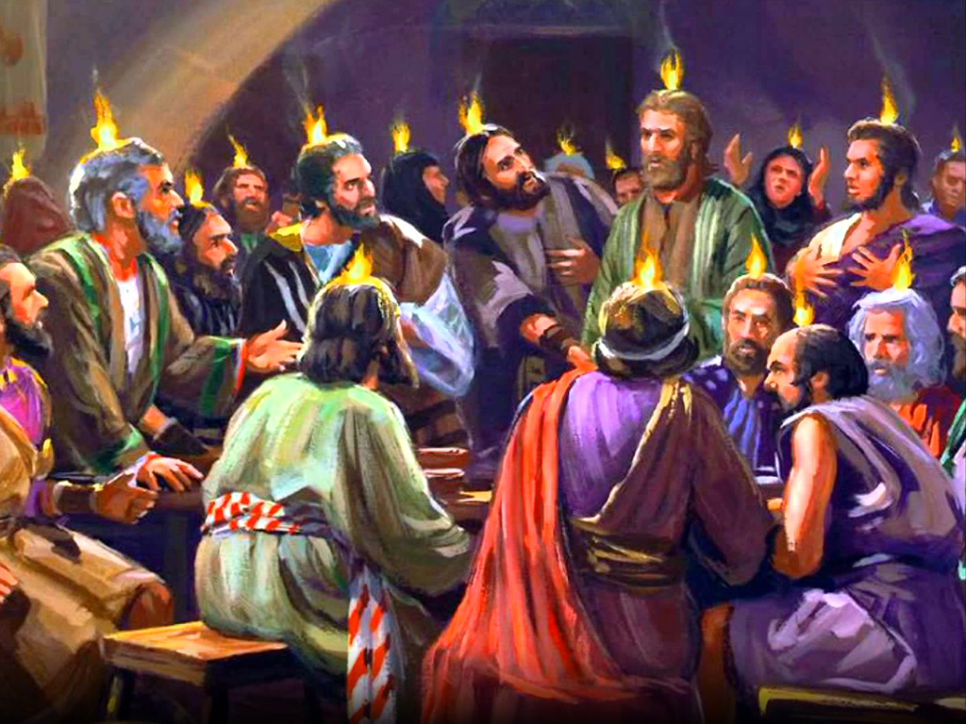

This shows about 20 disciples in the upper room with tongues of fire on their heads. Good thing they didn’t have smoke detectors in that imaginary hotel upper room!

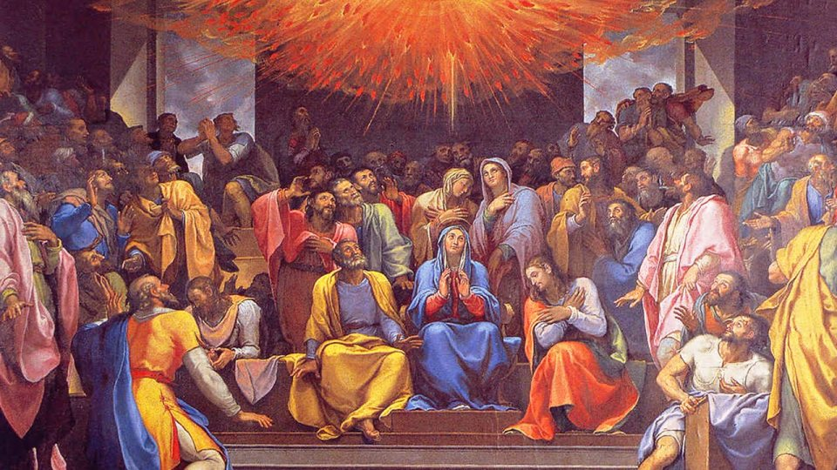

This one looks like about 60 disciples in a Roman Catholic church. Notice who is centered. It’s Mary, Jesus Mother! The Roman Catholic Church somehow or other decided she was central on Pentecost.

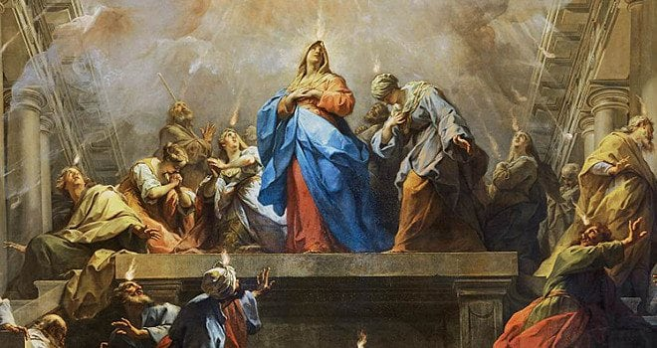

Here’s a wild one! Mary and a dozen disciples getting “zapped” in a temple. Great art, but is it accurate with the Bible? No. (Hint – they were all “sitting” Acts 2:2)

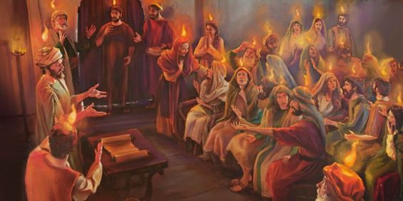

Here are 30 disciples getting tongues of fire on their heads in a meeting room at a Holiday Inn. Where are the other 90 disciples? And where are the men from all nations under heaven who hear them speak in their languages”? Once again, great art, but misguided.

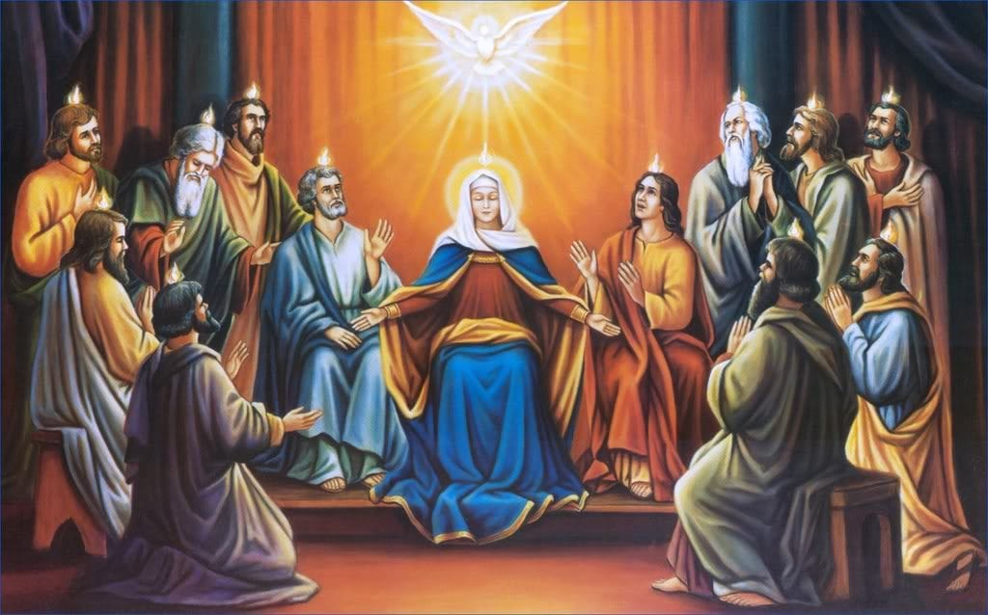

Nice of Mary to allow the apostles to be in the picture! Now some of you might be mad at me for denigrating Mary. I’m not denigrating Mary. I’m denigrating inaccurate art according to the Bible. Mary could be the greatest woman ever. Imagine God trusting someone to raise His son! I have no words to describe her character and inner beauty. She raised a son who never sinned and at least two others who became apostles. The spiritual pressure she endured was incalculable. But the Bible last mentions her in Acts 1:14 and if she was central to Pentecost, don’t you think the Bible would mention her specifically as it does with Peter and the apostles? Absolutely. Although not the center of the Pentecost story, she was probably there and received the spirit as one of the original 120 disciples and about 3000 souls. But the center of all this artwork? No. Is she special? Absolutely. She’s the only person to have Christ in her - twice! Once before the first Christmas and again on Pentecost! Beat that!

How did Christian inaccuracies begin and spread? One of the great ways was through art. In the 2000 years since Pentecost, many Christians couldn’t read. We are used to overwhelming literacy in the last 200 years, but before that illiteracy was common. Most Christians relied on the clergy to read the scriptures and tell them the gospel story. Another great way for them to learn Christian history was to view art and form a mental image of their spiritual heritage. In this way, Christmas, the crucifixion, Pentecost, and other events morphed from biblical language and certainty to fanciful. This occurred so often that over time the three wise men were thought to be present at Jesus' birth, only two criminals were crucified with Jesus, and many people were with Mary in an enormous upper room for Pentecost.

Now some may be thinking, “Steve, why are you making a big deal about these artworks?” The answer is, “What happens if you add a word to God’s word. Do you still have God’s word?” The answer is “No.” “How about if you subtract or change God’s word. Is it still God’s word?” The answer is obvious. The means of communication is irrelevant in which God’s word is manipulated, whether spoken, written, illustrated, or performed. It still will be inaccurate and lead inevitably to the same conclusion as the garden – away from God and truth. This is why it is important to recapture from the scriptures the history and doctrines of the Christian church, so that (as Luke 1:4 says) “you can come to fully know the certainty of the things about which you have been told.”

So, who was there in the temple at Pentecost? Let’s review what we learned from Acts 1.

Acts 1:1-2

The first account I made, O Theophilus, concerning all that Jesus began both to do and to teach

until the day he was taken up, after he, through holy spirit, had given commandments to the apostles whom he had chosen.

Jesus “had given commandment to the apostles he had chosen.” We know who they were from the gospels and they were relisted in verse 13 minus Judas. Jesus is speaking to the original apostles. Could there be others there also? Sure, but the focus is on the original 12 minus Judas. I will underline the pronouns referring to “the apostles whom he had chosen” throughout the context.

Acts 1:3-8

After his suffering he also showed himself alive to them by many convincing proofs, appearing to them over a period of forty days and speaking of the things concerning the Kingdom of God.

And being assembled together with them, he commanded them not to depart from Jerusalem but to wait for the promise of the Father, which, he said, “you heard about from me,

because John baptized with water, but you will be baptized in holy spirit not many days from now.”

Now when they had come together, they asked him, saying, “Lord, is it at this time you are going to restore the kingdom to Israel?”

And he said to them, “It is not for you to know times or dates that the Father has set within His own authority.

But you will receive power when the holy spirit has come upon you, and you will be my witnesses both in Jerusalem, and in all Judea, and Samaria, and to the uttermost part of the earth.”

To whom was the promise of the coming spirit specifically given? The answer is the original 12 apostles. A pronoun refers to its nearest antecedent noun in context, and in this instance, it refers to “the apostles whom he had chosen” in verse 2.

Acts 1:9-14

And when he had said these things, while they were watching, he was taken up and a cloud received him out of their sight.

And while they were looking into heaven as he was going, Look!, two men stood by them in white apparel,

who said, “Men of Galilee, why do you stand looking into heaven? This Jesus, who was taken up from you into heaven, will come in the same way as you saw him going into heaven.”

Then they returned to Jerusalem from the mount called Olivet, which is near Jerusalem (a Sabbath day’s journey away).

And when they had entered Jerusalem, they went up into the room upstairs, where they were staying; that is, Peter and John and James and Andrew, Philip and Thomas, Bartholomew and Matthew, James the son of Alphaeus, and Simon the Zealot, and Judas the son of James.

These all with one accord continued steadfastly in prayer, with the women, and Mary the mother of Jesus, and with his brothers.

At verse 14, the focus is widened to about 120 others to discuss the church business of replacing Judas.

Acts 1:15, 16a

And in those days Peter stood up in the midst of the brothers and said (and there was a multitude of names, about 120 people together at that one place),

“Men and brothers, it was necessary that the Scripture be fulfilled that the Holy Spirit spoke beforehand by the mouth of David concerning Judas,

This section ends with Matthias replacing Judas to complete the 12 apostles.

Acts 1:26

And they cast lots for them, and the lot fell on Matthias, and he was numbered with the eleven apostles.

Although the focus expanded to the about 120 disciples, it returns to the original apostles plus Matthias. Now check the context and pronouns.

Acts 1:26-2:4

And they cast lots for them, and the lot fell on Matthias, and he was numbered with the eleven apostles.

And when the day of Pentecost arrived, they were all together in one place.

And suddenly a sound came from heaven like a strong rushing wind, and it filled the whole house where they were sitting.

And there appeared to them tongues as if of fire, which spreading out, came to rest upon each one of them.

And they were all filled with holy spirit, and began to speak in other tongues, as the Spirit was giving them utterance.

The pronouns in Acts 2:1-4 refer back to “Matthias, and … the eleven apostles.” The scriptures clearly say that the original ones to receive the spirit on Pentecost were:

1. “the apostles whom he had chosen” verse 1:2.
2. “he commanded them not to depart from Jerusalem but to wait for the promise of the Father, which, he said, you heard about from me” 1:4.
3. “you will be baptized in holy spirit not many days from now.” 1:5.
4. “you will receive power when the holy spirit has come upon you” 1:8.
5. “Matthias, and … the eleven apostles.” 1:26.

We learn the identity of the first receivers from the narrative but also from clues later in the day.

Acts 2:6, 7

And when this sound occurred, the multitude came together, and were bewildered, because each one was hearing them speaking in his own language.

And they were all amazed, and marveled, saying, “Look! Are not all these who are speaking Galileans?

The apostles were Galileans, but not every one of the 120 disciples was. This distinction could be observed by clothing. The original spirit receivers were all Galileans.

Acts 2:12-14

And they were all amazed, and were perplexed, saying one to another, “What does this mean?”

But others mocking said, “They are filled with sweet new wine.”

But Peter, standing up with the eleven, lifted up his voice and spoke to them, saying, “Fellow Jews, and all you who are residing in Jerusalem, let this be known to you, and pay close attention to my words.

When some in the surrounding temple crowd mocked the apostles speaking in tongues, “Peter, standing up with the eleven, lifted up his voice”. Peter stood up with the eleven, not the 120. Perhaps the 120 was present, but they were not the original receivers and the target of the mocking - the apostles were. They were the original ones who spoke in tongues, just as Jesus promised.

When Peter finished his Pentecost preaching, the results were amazing – about 3000 souls added to the church! Where were the about 120 disciples? Where would you be if you were one of them? I’d be next to Peter or perhaps Thomas, the deductive reasoning research apostle! How about you? In other words, the 120 were probably right there becoming part of the 3000 souls! That could include Mary, Jesus’ mother and his brothers, Mary Madelene, Mary, the Mother of James, Salome, Joanna, and about 100 others. What an amazing day!

So, put the memo out to photoshop Mary out of the initial Pentecost art and also anyone else beyond the 12 Galilean apostles. Photoshop the Holiday inn upper room out of the event and put the 12 apostles in the Temple, surrounded with the 120 and thousands of Jews from all over the world who were there for the great one-day feast of First fruits, Pentecost. And spiritually photoshop in God’s ear-to-ear smile as He sees his “Family Plan” finally begin. All the love He had was starting to be poured out to the multitudes. He became a Father to thousands that day! … a day beginning with the twelve apostles Jesus had chosen in His house with all Israel invited and present.

Happy Birthday, Church of Grace!