20 - Speaking in Tongues
Acts 2:3
And there appeared to them tongues as if of fire, which spreading out, came to rest upon each one of them.

In Greek, the words “spreading out” are in the passive voice meaning that something or someone was “spreading out” the fire that came to rest on each apostle. This was not a random act but one directed (obviously to many devout Jews in the temple) by God.

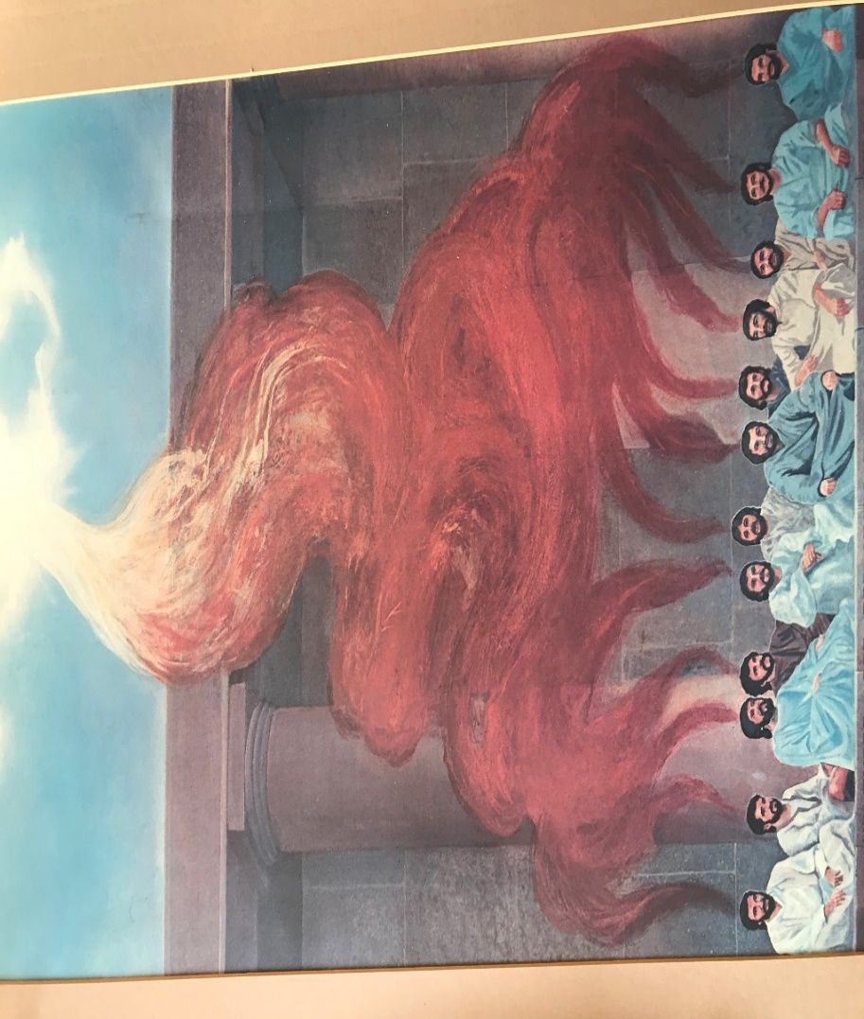

Acts 2:4
And they were all filled with holy spirit, and began to speak in other tongues, as the Spirit was giving them utterance.

After the sound of a strong rushing wind, signifying God giving the apostles spiritual life and the falling fire on each of them signifying God’s acceptance of the sacrifice of their lives and His presence in them, the apostles began to speak in tongues.

For some the word “tongues” is confusing. Some think speaking in tongues is a strange act including spasms of the tongue and mouth. This is not the case at all. In all the records about speaking in tongues, there is not one negative thing God inspired to be said. On the contrary, there are many things mentioned about tongues glorifying God and beneficial to man. If this is the case, do you think Satan would cast the experience in a negative light? Absolutely. Minutes after the apostles manifested for the first time, some in the temple accused them of being drunk! The slanderer does not necessarily understand everything that God does, but he certainly can put it down. This was (and is) still true with tongues.

The word “tongue” was used in verse 3 as “tongues of fire”, figuratively comparing the shape of a tongue (big at the top and tapering toward the end) with the way the flames appeared to come down. “Tongue” is also used in verse 4 as “speaking in tongues”, figuratively mentioning a part of the body instead of what it helps generate, language. Today we still speak of “foreign tongues” using the same figurative expression. There’s nothing different about a physical “foreign tongue” from your tongue or mine. What’s different is the language. “Speaking in tongues” literally means “speaking in languages”, and in the context, “speaking in foreign languages”, as the word “other” tongues indicates.

Here are a few observations about this verse. “They were all filled with holy spirit”. No one got missed. This shows that if you ask, you get. Why? Because God is a loving Father. If you ask for some bread, He won’t give you air, figuratively speaking. He’ll come through. Remember, this experience was not dreamt up by man. It’s not my idea or yours. It was God’s idea and promised through Christ. We should trust that He’ll do what He promised. I’ve seen hundreds ask and receive. Nobody gets missed. God is faithful and bigger than our reluctance and uncertainty. His ability is bigger than our inability. “All receive” … that includes you and me.

To review what we covered previously, in verse 4 the word “filled” is in the Greek passive voice. This means they (the subject – the twelve apostles) didn’t fill themselves, Jesus did.
The next phrase is, “they were all filled with holy spirit, and began to speak in other tongues…”. The word “began” is in the middle voice. So, although the first part of the verse is the passive voice (apostles acted upon), the second part of the verse says the apostles then initiated the action [speaking in other tongues]. Filling them with holy spirit was God’s job. Then, speaking in tongues was their job. How does this work?
The mechanics of speech were the same then as now. Speech begins with a thought. If someone wants to speak, it is usually because there is something they want to communicate. After the initial thought, they begin to move their lips, tongue, and mouth to form the appropriate words corresponding to their thought and move air up through their vocal cords, making sounds that others can hear. The mechanics of speaking in tongues are the same except for the predetermined idea of what you want to say. The speaker decides to speak, but they do not dictate the content of the speech. They still move their lips, tongue, and mouth to form the appropriate words, but it will correspond to the Spirit’s thoughts, not theirs. They also move air up through their vocal cords, making sounds that others can hear. How do we know this distinction?
The third phrase in verse 4 is “as the Spirit was giving them utterance”. The words “was giving” is in the active voice. The means the subject [the Spirit] initiates and is responsible for the action of giving utterance to the one speaking in tongues. The speaker does not decide the utterance, or content, the Spirit does. This means:

THAT we speak is our business. WHAT we speak is God’s business.

Please note this example and pattern of the Church’s first manifestation of the spirit event from which all others will follow.

- God initiates all spiritual gifts, ministries and manifestation by filling us with His spirit. If someone is saved, then they have already been filled with holy spirit.
- We activate the spirit within by doing what God says to do. It varies for each manifestation.
- God energizes the outcome, resulting in a manifestation of the spirit.

This is why speaking in tongues is a manifestation of the spirit, not a manifestation of man’s mind. We cannot speak in a language we’ve never learned. It’s physically impossible. Therefore, speaking in tongues and the rest of the manifestations of the spirit are supernatural. Once again, it’s a manifestation of the spirit, not my smarts, strength, personality, etc. It’s bigger than me. It’s way beyond me. It’s God sized! Why? Because it’s energized by God! This is why…the manifestations are a partnership between God and us. No one speaks in tongues unless they speak. No one also speaks in tongues unless God gives the content. It’s a partnership and a fellowship. (Sound familiar?)
“Speaking” (our job) + “in tongues” (God’s job) = speaking in tongues. We activate + He energizes = manifestation. Think of an automobile. The spirit is like the battery and the manifestations are like the different operations of the car – the horn, the radio, the turn indicators, AC, etc. Even if the car has a battery and it’s charged, the radio doesn’t work unless the driver turns it on and tunes it in. So it is with the manifestations, in this case speaking in tongues. A Christian doesn’t automatically speak in tongues unless they activate it, like turning on the radio. Now a non-Christian can turn the radio on all they want but it won’t work because they have no battery – and speaking in tongues is a manifestation of the spirit – and they have no spirit within to manifest. They need to get saved, born again of God’s spirit and then they can speak in tongues like Peter, Paul, you and me.

Tongues, interpretation and prophecy are different from the other manifestations in that they are “auto-energized”. You activate them and God energizes them automatically. The other six manifestations are not guaranteed to be energized by God just because we may want them to be. Even Jesus begged God saying, “take this cup away from me.” In the garden of Gethsemane. He wanted revelation saying something like, “Ok, Jesus, take off. I’ve got this.” But it never came. Jesus finally concluded, “Nevertheless, let not my will, but your will, be done.” If he couldn’t force desired revelation, do you think we can?

Tongues, interpretation, and prophecy are the beginning, or “training wheels” manifestations. Thet get us off our “physical legs”, sort to speak, and riding spiritually. Yet, although tongues is the first and most basic manifestation of the spirit in the Grace administration, it is our spiritual foundation and power base. We begin to see our spiritual self as able and powerful. We see ourselves as worshipers and sons of the Almighty.

Here’s a question for you, “Were the manifestations of the spirit new on Pentecost?” Here’s a follow-up question to answer the first one, “Was the idea of the spirit being given to man new on Pentecost?” The obvious answer to both questions is “No.” The Bible says God had given the spirit to man in the Old Testament and continued through Jesus and the apostles. Therefore, there were instances of manifestations of the spirit in the Old Testament. Had the apostles manifested the spirit before Pentecost? The answer is, “Yes”. First, they watched Jesus do it, then he trained them to do the same.

Matt. 10:1, 8,
And he called to him his twelve disciples and gave them authority over unclean spirits, to cast them out, and to heal every kind of disease and every kind of sickness.
Heal the sick, raise the dead, cleanse those with skin diseases, and cast out demons. Freely you received, freely give.
Here are mentioned six of the manifestations of the spirit. To cast out spirits, you must know they are there. That’s discerning of spirits. To cast them out, it takes trust. To evict them is a miracle. To heal disease and sickness takes the word of knowledge and wisdom to know what God wants you to know about a person’s situation. Then you must command healing through trust. There are six manifestations right there.
Matt 10:18-20
and you will even be brought before governors and kings for my sake, as a testimony to them and to the Gentiles.
But when they deliver you up, do not be anxious how or what you are to say, for it will be given to you in that hour what you are to say,
for it is not you who speak, but the spirit of your Father that speaks in you.

In other words, THAT they would speak was the apostle’s business, but WHAT they would speak would be God’s business. Sound familiar? Sure. It’s similar to Pentecost, but what is different? Here in Matthew the manifestation was prophesy, bringing forth a message from God in the language of the speaker and those present – presumably governors and kings. On Pentecost, they didn’t bring forth a message at first in their language, Aramaic. Why was that? It was because that’s how the spirit gave them the utterance, the content.

Have you ever wondered how the apostles started speaking in tongues when this had never happened before or had even been foretold? ¹ Here is my private interpretation idea of how it happened. Is what I’m now sharing “the gospel”? No, it’s my conjecture…and worth as much as your ideas and mine plus warm spit!

When the spirit came on the elders with Moses, what did they do?

Num. 11:25
Yahweh came down in the cloud and spoke to him [Moses], and took some of the spirit that was on him and put it on the seventy elders. And it came to pass that when the spirit rested on them, they prophesied, but they did so no more.

They prophesied when the spirit came on them. What happened when King Saul received the spirit?

1 Sam. 10:10
When they came to Gibeah, behold, a group of prophets met him, and the spirit of God rushed upon him and he prophesied along with them.

He prophesied. What did Joel foretell when the spirit will be poured out in the last days?

Acts 2:17, 18
And it will be in the last days, says God, I will pour out a portion of my spirit upon all flesh, and your sons and your daughters will prophesy, and your young men will see visions, and your old men will dream dreams.
And even on my male servants and on my female servants I will pour out my spirit in those days, and they will prophesy.

The spirit coming and prophecy resulting was an established historical and scriptural pattern. I think that the apostles thought that it was “the last days” and when the spirit was poured out, there would be prophesying! So, when the day of Pentecost came, the mighty wind sound and flaming fingers appeared from heaven, they started doing the mechanics of prophecy. They decided to speak. They started moving their mouths, lips, tongue and making sounds, but the speech that came out was not in Aramaic, their language. They spoke in foreign languages (to them)! Why? Because “THAT they spoke was their business, but WHAT they spoke was God’s business.” God had something else in mind!

Acts 2:5-11
Now there were Jews staying in Jerusalem, deeply religious men from every nation under heaven.
And when this sound occurred, the multitude came together, and were bewildered, because each one was hearing them speaking in his own language.
And they were all amazed, and marveled, saying, “Look! Are not all these who are speaking Galileans?
And how is it that we are hearing them speaking, each of us, in our own language in which we were born?”
Parthians and Medes and Elamites, and those who live in Mesopotamia, in Judea and Cappadocia, in Pontus and the province of Asia,
in Phrygia and Pamphylia, in Egypt and the parts of Libya near Cyrene, and visitors from Rome (both Jews and proselytes),
Cretans and Arabians, we hear them speaking in our tongues the mighty works of God.

All the Jews who were in Jerusalem for Pentecost from all over the world had their minds blown. Here are twelve Galileans, as was obvious from their clothing. One-third of them, Peter, Andrew, James, and John are fisherman, with that ruddy windblown countenance and rough, fishnet-hauling hands. These Galileans are not soft men, spending their time indoors studying scrolls, like the scribes. They are common working men who are speaking languages perfectly they can’t have learned! At that time, there were no foreign exchange studies or language classes. People rarely traveled far from their home. Yet these guys sounded like the United Nations amid the thousands in the temple!

And what are they saying in the different tongues or languages? Are they jabbering like parakeets? Are they saying evil or foolish things? Not in any way! If they would have said something foolish or evil, verse seven would say, “And they [the hearers] were all disgusted and repelled”. Does it say that? No.

Acts 2:7
And they were all amazed, and marveled, saying, “Look! Are not all these who are speaking Galileans?

Those who heard the apostles speak in their home languages were “amazed and marveled”. Why?

Acts 2:11B
we hear them speaking in our tongues the mighty works of God.”

They were inspired that common men had the spirit and were able to speak in a language impossible for them to know, the mighty works of God. They were worshipping God perfectly, extolling His magnificent acts in the place and time perfectly appropriate. It was an awe-inspiring blessing and signified something earth-shattering was happening. It was the dawn of a new era and partial fulfillment of the ancient prophesy – a certain serpent’s head was getting crushed. And a new Head is beginning to reign in the church and soon on the earth, too. What an awe-inspiring and glorious day!

