**Pentecost 2**

Acts 1:3 REV

After his suffering he also showed himself alive to them by many convincing proofs, appearing to them over a period of forty days and speaking of the things concerning the Kingdom of God.

One of the most mind-bending human experiences of all time had to be the forty days Jesus appeared to his disciples in his resurrected body. Can you imagine their minds? They knew he had been dead. The apostle John was there at the cross and watched him die with Mary, Jesus’ mother. This is after being beaten by Romans soldiers for hours, a crown of thorns hammered into his head, a spear piercing his side, a whipping (like the movie Passion of the Cross), and hours of crucifixion. He was buried by Nicodemus and Joseph of Arimathea. He was as dead as a fried feather.

1. Then he was resurrected by God and appeared to Mary Madelene. (John 20:14-16)
2. Then also Mary, the Mother of James, Salome, and Joanna. (Matthew 28:9).
3. Then he appeared to Peter (Luke 24:34).
4. And later, to two Disciples on the road to Emmaus. (Luke 24:13-16)
5. Later that night on Easter Sunday, Jesus somehow entered the room where the doors were shut for fear of the Jews and appeared to the disciples without Thomas. (John 20:19,20,24)
6. After eight days Jesus returned with Thomas present. (John 20:26-28)
7. Another appearance was to seven disciples on the Sea of Galilee. (John 21:1, 2).
8. He appeared to eleven disciples on a mountain in Galilee. (Matthew 28:16,17)
9. Jesus appeared to over five hundred people at one time. (1 Corinthians 15:6)
10. Then he appeared to James, then to all the apostles. (1 Corinthians 15:7)

The disciples had to be walking on air. They were spending time with an alive dead man! Who could appear and disappear at will… at any time! They could see the wounds in his hands and side. Yet they felt his vitality and power. Perhaps they thought, “It’s Jesus, but it can’t be! He was dead… but now he’s alive, instructing and encouraging us! Am I dreaming? Is he an apparition or a mirage? He can’t be, because he talks with us, answering questions and eating meals! What does this mean? Do we all get raised three days after we die? How does he zip in and out of our presence? What’s next? Will he now restore the kingdom to Israel?”

I think it was from that wide-eyed “anything can happen” mindset that they asked that question we discussed last time. Jesus answered:

Acts 1:7-9

And he said to them, “It is not for you to know times or dates that the Father has set within His own authority.

But you will receive power when the holy spirit has come upon you, and you will be my witnesses both in Jerusalem, and in all Judea, and Samaria, and to the uttermost part of the earth.”

And when he had said these things, while they were watching, he was taken up and a cloud received him out of their sight.

In essence, Jesus said, “Stay in Jerusalem, receive the spirit and be witnesses for me.” Then he was gone! Right in front of their eyes he ascended like he was on an elevator straight up! Until he was enveloped in a cloud! Perhaps they thought, “Wow, this is new! He’s coming right back, right?”

Acts 1:10,11

And while they were looking into heaven as he was going, Look!, two men stood by them in white apparel,

who said, “Men of Galilee, why do you stand looking into heaven? This Jesus, who was taken up from you into heaven, will come in the same way as you saw him going into heaven.”

Perhaps the apostles thought, “Ok, so now we know how he will return – a reverse of what we just saw. But when will he return?” How long do you think they stood there staring up into the clouds waiting for a reverse performance? 5 minutes? 5 Hours? Who knows? But at some point, they realized that what they expected and when he would return was unconnected and they fell back on Jesus’ instruction, “Stay in Jerusalem, receive the spirit and be witnesses for me.”

Acts 1:12

Then they returned to Jerusalem from the mount called Olivet, which is near Jerusalem (a Sabbath day’s journey away).

Let’s talk about the return of Christ. We just saw him leaving the earth and angels foretold his return, right? Is this the way Christ will come back for us, the Church of grace? That’s a good question and the answer should be easy, but it’s not. If you ask 10 Christians, you’ll get different answers. The majority answer will be “Yes, that’s how Jesus will come back.” Another possible answer is, “I don’t know.” And yet another answer might be, “Doesn’t he return with the Rapture?” What is scripturally accurate?

To whom did the angels foretell Christ’s return? The apostles, right? Were they Christians? The surprising answer is, “No – that was 10 days away at Pentecost, on the birthday of the Christian church.” The apostles and disciples were still only Jews. So, does the foretelling of Christ’s return by the angels in Acts 1 refer to Christians or Jews? The answer is “To the Jews”! Now some might say, “Steve, you’re splitting hairs here! What difference does it make if they were Jews or Christian?” The answer is the difference between an accurate word of God and human guesswork. The difference between a Bible you can stake your life on and man’s imagination that isn’t worth squat. Christianity has been plagued with man’s ideas masquerading as Christian doctrine for far too long. The illogic of human myths and interpretation cause well-meaning souls to shrink back from faith, fearing fraud. The Bible is very sensible when understood and completely worthy of our trust. It just needs logical and systematic consideration, which is the goal of these studies.

In the first study, we explored the Mystery of the Grace Administration. This is the time between Christ’s first and second coming that God kept secret until revealing it to the apostle Paul.

Eph. 3:1-5, 8, 9

For this reason, I Paul, the prisoner of Christ Jesus on behalf of you Gentiles—

Surely you have heard of the administration of the grace of God that was given to me for you,

and that the sacred secret was made known to me by revelation, as I have already written about briefly.

So when you read this, you will be able to understand my insight into the sacred secret of Christ,

which was not made known to people in other generations as it has now been revealed to his holy apostles and prophets by the spirit,

To me, who am less than the least of all the holy ones, this grace was given so that I could proclaim the good news to the Gentiles about the unsearchable riches of Christ,

and to bring to light for everyone what is the administration of the sacred secret, which for ages has been hidden in God who created all things.

God hid all information about the Mystery period in himself. Therefore, did the two angels who foretold Christ’s return immediately after the ascension, know the mystery? No. Therefore, they foretold the Jewish return, not the Christian return. “What??!!” Some of you are saying, “There are different returns for Christians and Jews?” The answer is, yes there are.

If it was the Jewish return the angels foretold, is there some other reference to it in the Old Testament? Yes.

Zech. 14:1-4a

Behold, a day of Yahweh is coming, when your spoil will be divided in your midst.

For I will gather all the nations against Jerusalem to battle, and the city will be captured, the houses plundered, and the women raped. Half of the city will go out into captivity, but the rest of the people will not be removed from the city.

When Yahweh will go out and fight against those nations as when he fights on a day of battle.

His feet will stand in that day on the Mount of Olives that is before Jerusalem on the east,

“His feet will stand that day on the Mount of Olives.” This was prophesied five hundred years before Christ and perhaps was the reason why Jesus led the disciples there for the ascension. Note the context when he returns in the future for Israel is for war and judgment, not exhortation as in Acts. It will be “the day of vengeance of our God” as stated in Is. 61:2. … and he’s not returning alone.

Rev. 19:11-13

And I saw the heavens opened, and Look!, a white horse, and he who was sitting on it is called Faithful and True, and in righteousness he judges and makes war.

And his eyes are a flame of fire, and on his head are many diadems, and he has a name written that no one knows but he himself.

And he is clothed in a robe sprinkled with blood, and his name is called The Word of God.

This is the Lord Jesus Christ returning to earth to set things right. And it may look like he is coming from heaven alone at first, but soon he’s followed by armies.

Rev. 19:14-16, 19-21

And the armies that are in heaven followed him on white horses, clothed in fine linen, white and clean.

And out of his mouth comes a sharp broadsword, so that with it he can strike down the nations (and he will shepherd them with a rod of iron), and he treads the winepress of the fury of the wrath of God, the Almighty.

And he has on his garment and on his thigh a name written, KING OF KINGS, AND LORD OF LORDS.

And I saw the beast, and the kings of the earth, and their armies, gathered together to make war against him who sat on the horse, and against his army.

And the beast was taken, and with him the false prophet who did the signs in his sight, with which he deceived those who had received the mark of the beast and those who worshipped his image. These two were thrown alive into the lake of fire that burns with sulfur,

and the rest were killed with the sword of him who sat on the horse, even the sword that came out of his mouth, and all the birds were filled with their flesh.

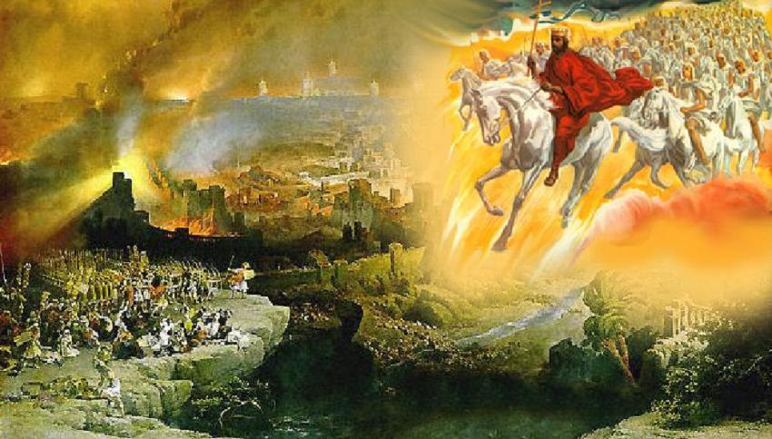

To use the phrase from Acts 1, this is Christ “restoring the kingdom to Israel”, wiping out the spiritual and physical opposition. He comes from the heavens down to the earth and “his feet stand on the Mount of Olives”. This is Christ’s second coming for Israel. There are numerous references to this in the Old Testament and Gospels. None in the Church epistles. Why? Because Christ comes back in an entirely different way for a different purpose for the Christian Church.

1 Thess. 4:13-17

Now, we do not want you to be ignorant, brothers and sisters, concerning those who are asleep, so that you do not grieve like the rest of humankind, who have no hope.

For since we believe that Jesus died and was raised, so also we believe that through Jesus, God will bring from the grave those who have fallen asleep so that they will be with him.

For this we say to you by the word of the Lord, that we who are alive, who are left until the coming of the Lord, will certainly not precede those who have fallen asleep.

For the Lord himself will descend from heaven with a loud command, with the voice of a ruling- angel, and with the sound of the trumpet of God, and the dead in Christ will rise first.

Then we who are alive, who are left, will be suddenly caught up together with them in the clouds, for a meeting with the Lord in the air, and so we will always be with the Lord.

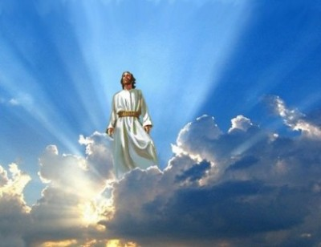

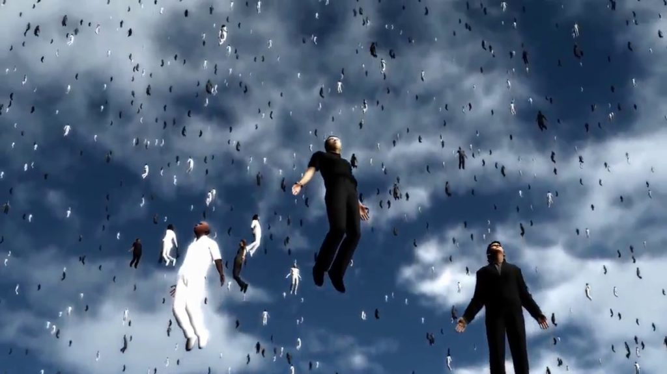

Notice that Christ doesn’t come down to the earth. He “descends from heaven” and meets the Christian church “in the clouds” and “in the air”. The Christian dead rise first then those alive will be caught up together with them “in the clouds”, from henceforth, “always with the Lord”. This means whenever you read about Christ, the raptured church is “always with the Lord”. So, in Rev. 19 when Christ comes back from heaven to fight for Israel and there are armies behind him, who do you think is also involved? The Christian Church is the answer because 1 Thess. 4 says, “we will always be with the Lord”.

So, if the church comes out of heaven with the Lord in Rev 19, where must we have gone after Christ meets us in the air at the Rapture? The answer is heaven. We all go up, up, up!

Phil. 3 :20,21

For our citizenship is in heaven, from which we also wait for the Savior, the Lord Jesus Christ,

who will transform our lowly body, so it will be in the same form as his glorious body, by the power that also enables him to subject all things to himself.

Today Christians wait for the Lord Jesus Christ to come from heaven and transform our mortal bodies into a glorious body like his. Alive and dead saints change when Christ returns for us at the Rapture. This will end the Church of Grace age because all the members of the Church will be gone out of the world and gathered to heaven with the Lord. This leaves only the unsaved and evil people in the world. That’s a recipe for disaster, which regrettably will happen, ushering in the Tribulation period.

That is the difference in the Acts 1 foretold return of Christ for Israel and the Rapture return for the Christian church detailed in 1 Thess. 4. Has it dawned on you yet? We get to be a part of both! We are gathered together and changed at the rapture. Then we return with Christ to “restore the kingdom to Israel”. If you ever wonder why they call the era we live in the “Grace Administration”, that’s a major reason right here. That former knuckleheads and sinners like us could be loved and objects of God’s mercy is amazing. That we get new bodies like Christ at his return is mind-numbing. And then that we get to assist Christ in battle and judgment is almost too insane to contemplate, except the Bible clearly teaches it.

1 Cor. 6:2,3

Or do you not know that the holy ones will judge and administer the world? And if the world is judged by you, are you incompetent to judge the trivial cases?

Do you not know that we will judge and administer angels? How much more, then, things that pertain to this life?

In all the annals of grace and glory, the unmatched and unequaled calling of the Church of Grace is the greatest thing God has ever done.

15 differences between the Rapture and the 2nd Coming.

|  |  |  |  |
| --- | --- | --- | --- |
|  | **Rapture** |  | **Second Coming** |
| 1 | Jesus coming **FOR** His Church. 1 Thess. 4:14-17 | 1 | Jesus coming **WITH** His Church Col 3:4, Zech. 14:5, Jude 14, Rev 19:14 |
| 2 | Caught up with Him in the air 1 Thess. 4:13-18 | 2 | Jesus' feet touch the earth Zech. 14:4, Rev:19:11-21 Acts 1:11. |
| 3 | Christians taken first, unbelievers are left behind. 1 Thess. 4:13-18 | 3 | Wicked are taken first, the righteous (Tribulation saints) are left behind. Matt. 13:28-30 |
| 4 | Purpose: To present the Church to Himself and to the Father 2 Cor 11:2. | 4 | Purpose: To execute judgment on earth and set up His Kingdom Jude 14-15, Rev. 19:11-21, Zech. 14:3-4 |
| 5 | Was a mystery, a sacred secret in the Old Testament. Eph. 3:1-9. | 5 | Was foretold Zech. 14:4, Ps. 2, Jude 14,15, Job 19:25. |
| 6 | Happens in a moment, in the twinkling of an eye (too fast for eyes to see) 1 Cor 15:52 | 6 | Slow coming, people will see Him come back. Zech. 12:10 Matt 24:30, Rev 1:7 |
| 7 | Only Christians will see Him 1 John 3:2, 1 Cor 15:52 | 7 | Every eye will see Him Rev. 1:7 |
| 8 | Jesus descends with a shout (for resurrection) 1 Thess. 4:16 | 8 | No shout mentioned Rev. 19:11-21 |
| 9 | A resurrection takes place 1 Thess. 4:13-18, 1 Cor 15:51-54 | 9 | No resurrection mentioned Rev 1:7, 19:11-21, Zech. 12:10, 14:4-5 |
| 10 | Can happen at any time 1 Thess. 5:4-6 | 10 | Occurs at end of 7 years of Tribulation Dan 9:24-27 Matt 24:29-30, 2 Thess. 2:3-8 |
| 11 | No angels are sent to gather (resurrected people don't need angels to help them) | 11 | Angels sent forth to gather people together for judgment Matt 13:39, 41, 49, 24:31, 25:31, 2 Thess. 1:7-10 |
| 12 | Dead in Christ arise with Jesus to receive their resurrected bodies 1 Thess. 4:14-16 | 12 | Christians return with Jesus in already resurrected bodies on white horses. Rev 19:11-21 |
| 13 | Jesus does not return on a white horse. | 13 | Jesus returns on a white horse Rev 19:11 |
| 14 | For the Church only (those in Christ) 1 Thess. 4:14-17 | 14 | For redeemed Israel & Gentiles Rom 11:25-27, Matt 25:31-46 |
| 15 | A message of hope and comfort 1 Thess. 4:18, Titus 2:13, 1 John 3:3 | 15 | A message of judgment Joel 3:12-16, Rev 19:11-21, Mal 4:5 |