Not Today!

In each Bible record there are gems of insight and visions of God’s heart that are treasures. Here’s one.

Luke 4:14-15 REV (Revised English Version)

And Jesus returned in the power of the spirit into Galilee, and news about him went out through all the surrounding area.

And he taught in their synagogues, being glorified by all.

Immediately after Jesus received the spirit and went into the wilderness for a 40 day “spiritual boot camp”, he went to Galilee and began his ministry. It must have been amazing because he came “in the power of the spirit” into Galilee. That means he was manifesting it – prophesy, discerning of spirits, word of knowledge and wisdom, faith, miracles, and healing. This exploded his reputation, getting invitations to teach in the synagogues, being glorified of all.

Can you imagine Jesus fresh with God’s spirit? I’ve heard that a great healer in the middle of last century would heal the first three people who came to him each night at a crusade no matter what their problems. After a while he would tire and the power to heal would dissipate as his physical and mental energy ebbed. Perhaps this was similar with Jesus. Can you imagine him at 100% and “fresh out the chute”? No disease or devil stood a chance. His ministry was the headline on the Galilean Gazette.

Luke 4:16-21 REV

And he came to Nazareth, where he had been brought up, and as his custom was he went into the synagogue on the Sabbath day, and stood up to read.

And he was given the scroll of the prophet Isaiah. And he unrolled the scroll and found the place where it was written:

The spirit of the Lord is upon me, because he anointed me to proclaim good news to the poor, he has sent me to declare liberty to the captives and recovering of sight to the blind, to set at liberty those who are bruised,

to proclaim the year of the Lord’s favor.

And he rolled up the scroll and gave it back to the attendant, and sat down, and the eyes of everyone in the synagogue were fastened on him.

And he began to say to them, “Today this scripture has been fulfilled in your ears.”

The scripture Jesus read is longer in the Old Testament. It reads:

Is. 61:1-2 REV

The spirit of the Lord Yahweh is upon me; because Yahweh has anointed me to preach good news to the humble. He has sent me to bind up the brokenhearted, to proclaim liberty to the captives and release to those who are bound,

to proclaim the year of Yahweh’s favor and the day of vengeance of our God; to comfort all who mourn;

Why did Jesus stop reading after the words “to proclaim the year of Yahweh’s favor”? Because it was not yet “the day of vengeance of our God”. Jesus came to minister, heal, and bless the first time. In the future he will come to judge. That’s why he stopped reading when and where he did. This is why Jesus was able to say, “Today this scripture has been fulfilled in your ears.” In essence he said, “First we read it and now you are experiencing its fulfillment.” The attendees were confronted with Jesus plainly stating that he was the realization of Isaiah’s 700-year-old prophesy. They had heard from other Galilean cities that he healed the blind, delivered the spiritual captives, and preached the gospel.

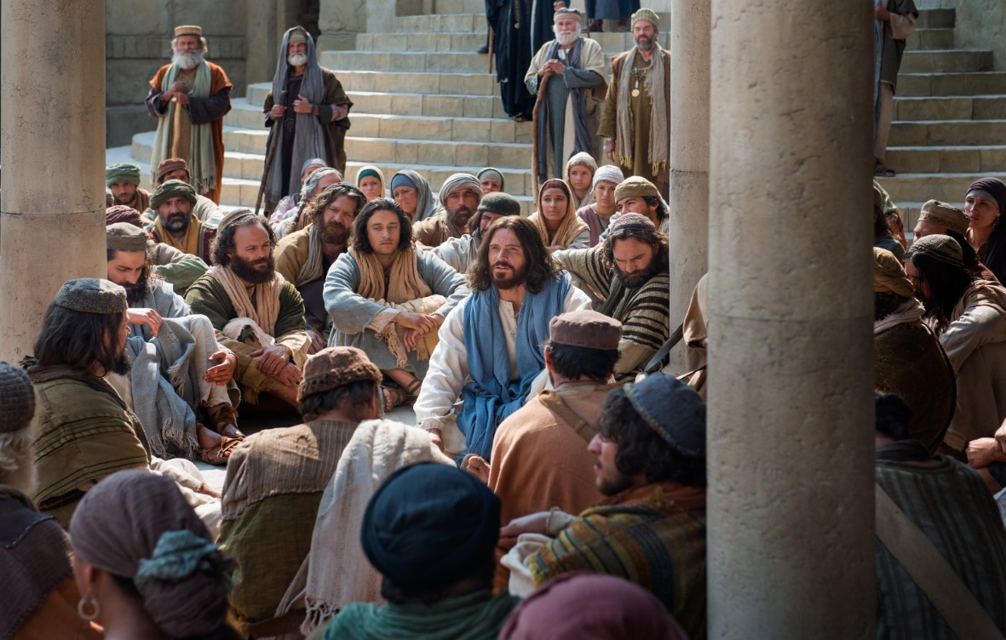

Luke 4:22 REV

And they all were giving a good testimony about him, and were amazed at the words of grace that proceeded out of his mouth, and they said, “Is not this Joseph’s son?”

The attendees said, “Is not this Joseph’s son?” Wait a minute. Could Joseph’s son do the miracles they heard about in the other Galilean cities? Could Joseph’s son speak such amazing words of grace? No, but the son of God could. And this is what in essence he is claiming to be right in front of them. They couldn’t see him as he was spiritually – the anointed Messiah of God, His only begotten son. They saw him as the grown kid they remembered. He played on the local baseball team as a youngster and struck out sometimes. They remember seeing him with his dad working on building projects. They remember the time he underestimated a roofing job and needed to go back to Hebrew Home Depot to get the needed materials. Perhaps they thought, “How could Jesus who went to school with our kids and took over his dad’s carpentry business, be the Messiah?” Mathew’s gospel adds:

Matthew 13:54-58 REV

And coming to his hometown, he taught them in their synagogue in such a way that they became astonished and said, “Where did this man get this wisdom and these mighty works?

Is not this the carpenter’s son? Is not his mother called Mary? And his brothers, James, and Joseph, and Simon, and Judas?

And his sisters, are they not all with us? Where then did this man get all these things?”

And they were offended by him. But Jesus said to them, “A prophet is not without honor, except in his hometown and in his own house.”

And he did not do many mighty works there because of their unbelief.

Everywhere else Jesus had been after the wilderness there was signs, miracles, and wonders. At Nazareth there were crickets. They rejected Jesus as the savior because of their prior experience with him and his family. This revealed that their heart was hard toward God and their familiarity with Jesus gave them an excuse to not expect God to work. This was not a healthy situation for them. They were closed off to God working in Jesus’ life and ministry.

Luke 4:23 REV

And he said to them, “Doubtless you will speak this parable to me: ‘Physician, heal yourself! Whatever we have heard done at Capernaum, do also here in your hometown.’”

Perhaps they were thinking, “Do some miracles, Jesus, and maybe we’ll believe. We heard some wild stories from the big city, Capernaum. Do some tricks for us and then perhaps we’ll be impressed.”

Luke 4:24-27 REV

And he said, “Truly I say to you, no prophet is acceptable in his hometown.

But of a truth I say to you, there were many widows in Israel in the days of Elijah, when the heavens were shut up three years and six months, when a great famine came over all the land,

and yet to none of them was Elijah sent, but only to Zarephath in the land of Sidon, to a woman who was a widow.

And there were many people with skin diseases in Israel in the time of Elisha the prophet, and none of them was cleansed, but only Naaman the Syrian.”

Jesus states that a prophet is unrecognized by those closest to him by giving two scriptural examples. Elijah, Israel’s great prophet, was sent by God to Zarephath, a gentile widow for deliverance. The same was true with his successor, the mighty prophet Elisha. He healed another gentile, Naaman the Syrian, instead of any in the family of Israel. This showed that “familiarity breeds contempt” – those comfortably knowledgeable with a prophet will tend to see the physical flaws and mundane flesh habits over their spiritual abilities. The physical distraction tempts them to miss God’s presence and possibilities. This quenches the spirit…God’s spirit. It regrettably can empower other spirits.

Luke 4:28,29

And when they heard these things, everyone in the synagogue was filled with rage,

and they got up and threw him out of the city. And they brought him to the brow of the hill that their city was built on in order to throw him down the cliff.

See the word, “filled”? In Greek it is in the passive voice. This means the subject of the sentence “everyone” is acted on (filled) by outside forces. What were they filled with by outside forces? “Rage”. This is a clear indication of what was happening in the spiritual realm, although unseen physically. The synagogue crowd’s rejection of Jesus as “God’s son” instead thinking of him only as “Joseph’s son” opened the door for them to become influenced by the spiritual opposition.

When Jesus passed Satan’s final exam at the end of 40 days in the wilderness, something was uniquely said about the spiritual battle.

Luke 3:13 REV

And when the Devil had completed every temptation, he departed from him for a season.

I don’t like this verse. I’d like this verse to say that Jesus’ overcoming the Devil’s attacks lasts forever. I want Jesus to be crowned spiritual champion for all time – therefore, no more temptations. But then it says 15 verses later that Satan is filling Jesus’ hometown neighbors with rage and a desire to kill him. It seems that it’s “open season” on Jesus again. Why is this?

Matt. 8:28,29 REV

And when he had come to the other side, into the region of the Gadarenes, two men who were afflicted by demons met him, who were coming out of the tombs. They were so exceedingly violent that no one could pass by that way.

And Look!, they cried out, saying, “What do you want with us, O Son of God? Have you come here to torment us before the time?”

The demons in the two Gadarene men, who obviously knew who Jesus was, asked him if he had come to “torment us before the time”. Let’s discuss aspects of this verse that will help us understand Luke 4. Firstly, just as people talk and word gets around about current events, the same is true with evil spirits. They had heard of Jesus as other scriptures testify such as Mark 1:24 and Acts 19:15. After Jesus didn’t succumb to Satan’s temptations in the wilderness, spiritual attacks paused while Satan looked for another opening. Then Jesus went on a godly tear, healing and delivering the spiritual captives in Galilee. Now “setting the captives free” means that you best the “jailers”, in other words, the captivating evil spirits. This was a rare spiritual phenomenon in Satan’s world – defeat. He was used to deceiving, stealing, killing, and destroying. The wilderness defeat was one thing, but this continued victory threatened his hold on the world. He put some spiritual “surveillance” on Jesus to look for weakness to be exploited to eliminate him and the threat to his kingdom. When the Nazarene synagogue rejected Jesus, the evil spirit scouts saw an opening and seized it.

Why are demons able to do this? Weren’t they defeated at the cross? Legally they were, but they still have rights. Steve, are you saying that demons have “civil rights”? Yes, I am. When God made angels and man, he endowed each with life and free will. It could be said that they were endowed by their Creator with “life, liberty, and the pursuit of happiness (and unhappiness, too)”. They have the right to be alive, same as us. They also have the right to make decisions and experience the results of those decisions. The angels who followed Satan’s rebellion against God changed their nature but have not forfeited their life and free will. In a manner of speaking, they went from the “pursuit of happiness” to the “pursuit of unhappiness” - ours and theirs. The Bible says that they will receive the consequences of their decision and life just as man will. And their end is sure and well known.

Rev. 20: 7-10, 14 REV

And when the 1,000 years are finished, the Adversary will be loosed out of his prison

and will come out to deceive the nations that are in the four corners of the earth, Gog and Magog, to gather them together to the war, the number of whom is as the sand of the sea.

And they went up over the breadth of the earth and surrounded the camp of the holy ones and the beloved city, and fire came down out of heaven and devoured them.

And the Devil, who deceived them, was thrown into the lake of fire and sulfur, where both the beast and the false prophet had been thrown, and they will be tormented day and night to the ages of the ages.

And death and the grave were thrown into the lake of fire. This is the second death, even the lake of fire.

There’s a specific time coming where the Devil and all his hosts will be “thrown into the lake of fire”. This is also called “the second death”. All evil spirits will be burnt up – gone forever. Not imprisoned but annihilated – no longer in existence. The spirits in the afflicted men of Gadarene knew about this future day. That’s why they asked Jesus if he was there “to torment us before the time”. When is that time? When Christ returns in judgement. So the Gadarene spirits knew that that day was a little time off, so they asked if Jesus was coming to beat them up a bit before the grand beat down and execution of Rev. 20. Until then, these spirits have a right to live, and if they choose to (and they have) steal, kill and destroy. It’s their “right”, if you’ll tolerate me to say it that way. God is just to all of his creatures, despite whatever each one does in spite of His original will for them to fellowship with Him.

Why did the demons inspire rage and murderous action against Jesus? Did Jesus attack the people? No, he was offering to bless them in fulfillment of Is. 61. That is a help to the people but a threat to the demons. It encroaches on their kingdom and is a reminder of their future “time”.

Let me point out that Rev. 20 says clearly that the Devil and all his hosts will be “thrown into the lake of fire”. It doesn’t say “they throw themselves into the lake.” Or accidently fall in. They get “thrown” in. Passive voice – acted on by an outside force. Who does that?

Gen. 3:15 REV

I will put hostility between you and the woman, and between your seed and her seed. He will bruise your head, and you will bruise his heel.”

A number of Bible versions translate “bruise” as “crush”. This first prophesy of the Messiah is not talking about a “subdural hematoma” but an execution, as a victorious general would have his foot on the conquered general’s head, showing complete victory and utter annihilation. Who does this? The seed of the woman, the only begotten son of God, our Lord Jesus Christ.

No wonder Satan sent spies to follow Jesus and took the opportunity to try and kill Jesus in Nazareth. He is trying to forestall his own execution. Makes sense in a preemptive way. But trying to preempt the God with foreknowledge is a waste of time.

Luke 4:29 REV

and they got up and threw him out of the city. And they brought him to the brow of the hill that their city was built on in order to throw him down the cliff.

This verse does not jibe with my theology. I feel that Jesus should immediately rise up and defend himself against the spirits and ignorantly inspired Nazarene neighbors. He should perhaps fry one or two to a crisp in a lesson to the others, “Don’t mess with the Redeemer!” Yet the Bible’s words defy my desired “action hero” scenario. He is “thrown out of the city”. That also assumes thrown out of the synagogue… and the neighborhood the synagogue was in. Here are some maps for perspective.



Here’s a current map of that area of Israel showing the city of Nazareth and what’s called Mt. Precipice today, the likely spot that the people wanted to launch Jesus.

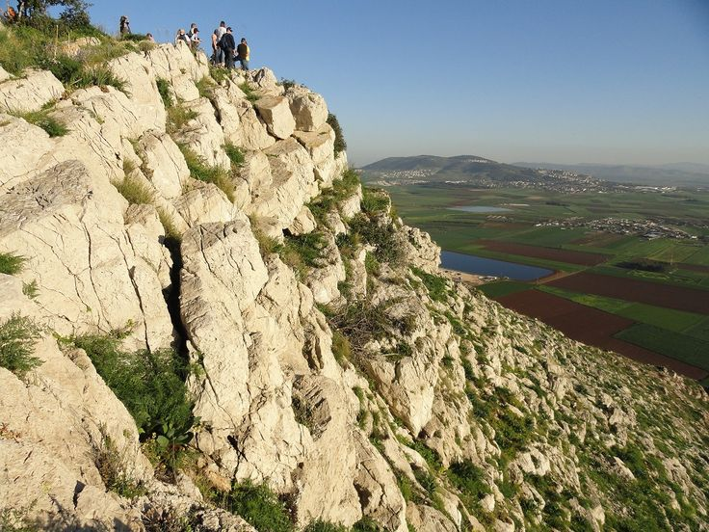

Mt Precipice is about 1100 feet above the valley floor. As you can see, there are no soft landing spots. The mob’s destination revealed their aim – kill Jesus.

The ancient town of Nazareth to Mt. Precipice is about a mile and a half. How long does it take to walk that far? In my experience a good pace gets 1 mile every 20 minutes or so. So, 30 minutes to walk 1 ½ miles, but I’d give it extra time because the path was not paved, they are corralling Jesus, and Mt. Precipice is at 150-foot elevation from the town. So, let’s figure a one hour walk that Jesus had as captive to those Nazarenes under murderous spiritual influence to get from the synagogue to the cliff.

My theology says that Jesus shouldn’t have to deal with a spiritually inspired riot for a one hour. I think God should have delivered him right after the spiritual tide turned in the synagogue – but He didn’t. How about when the first guy grabbed Jesus and then another one did as they dragged him out? No deliverance. How about when they were going toward Mt. Precipice and it was clear what their intentions were? Nope. How about when they passed his family home? How about when they “threw him out of the city”? How about when his old little league coach was telling him how disappointed he was in Jesus? What about when his old classmates jealously derided him about him thinking he was “better than they were”? What about the old electricians, plumbers, and material suppliers that he worked with for years denouncing him for going into the ministry instead of continuing the family construction business? What about his mother, brothers, and sisters, undoubtedly at the synagogue for his local ministry start, who stood by helplessly, or even complied with the execution march? My ideas of Jesus don’t allow for one hour of assault, battery, unlawful detention and excruciating mental torture from possessed neighbors who knew him most of his life. But there it is in biblical black and white.

I know we are promised and want victory in his life, but there are other forces out there that oppose us. Why is that? Jesus will not be alone in his future victory.

Romans 16:20a REV

And the God of peace will crush the Adversary, under your feet swiftly.

Got that? “Your feet” is our feet, the church of Grace, Christians – us! Look in the mirror. That is who will be helping fulfill the crushing of Satan prophesy of Gen 3:15. Am I quoting a verse out of context?

1 Cor. 6:2,3a KJV

Do ye not know that the saints shall judge the world? and if the world shall be judged by you, are ye unworthy to judge the smallest matters?

Know ye not that we shall judge angels?

There are two kinds of angels – good ones and bad ones. The good ones need no judging. The bad ones do… and who does it is us! The idea of Christians as mealy-mouthed future losers is certainly not the testimony of scripture. We help Christ “throw into the lake of fire” Satan and his hosts. Do they know this? Regrettably, yes. That’s why they did to Jesus what they did in Nazareth. Perhaps they wanted to throw him, before he threw them!

The same is true for us. Although we act as if we are seldom aware of it, the evil spirits are acutely aware of their end and who will bring it – Christ and his saints. This is why when each of us makes waves for God, persecution comes out of seeming nowhere, usually from sources we’ve trusted. Our jobs get threatened, our health is attacked, our loved ones are put at risk, or things we’ve spent a lifetime building are besieged. Where do the assaults originate? From the ones who we will be “ending” one day. Why can’t we “end” them today? Because they have a right to life, liberty, and the pursuit of unhappiness until their “time”. Until then we may get dragged down and tempted to be afraid, as Jesus was. We may be gang attacked by vile spirits bent on our death, as Jesus was – who want to take us out – but not on a date! Nonetheless, we will still be victorious, as promised.

Let me ask another question. Was Jesus out of fellowship with God so that Satan could have his way with him for an hour? That’s similar to what I’ve thought. I’ve thought that if I’m walking with God that I will be the master of every situation. To say it another way, If I’m not mastering the situation then I’m not walking with God, and I need to get back in harmony with Him. So, was Jesus mastering the situation when the mob went berserk and dragged him out of the synagogue and city? Hardly. Some might way he was “playing possum”, biding his time till the time was right. As we read the text we see he was not “playing possum”, but involved in a preview of his later crucifixion march.

Why didn’t God save him right when the synagogue got filled with rage and became a mob? We don’t know. Do you think Jesus did? Probably not. Here he was trained by God in the wilderness and starting his ministry in Galilee and the power of God’s spirit is nothing short of astounding. The sick healed, the possessed delivered, and the gospel preached and received with great gladness. Then he goes to Nazareth where he had been brought up, and they have no more expectation toward him than he can do a good “home makeover”. He tells them who he spiritually is, they scoff at his claims, the spirits see an opening for an attack, the mob grabs him, and all hell breaks loose. Do you think this turn of events confused Jesus? They would confuse me, that’s for sure. Jesus went from “the thrill of victory” in Galilee to the “agony of defeat” in Nazareth quickly. Before he knows it, he is dragged down the street by his neighbors, schoolmates, and co-workers while his family stood by helplessly. This isn’t “playing possum”, it’s more like “a lamb led to the slaughter”.

The idea that I and others have had that when you walk with God that you’re always on top of every situation is unrealistic and unscriptural. This record in Luke 4 demonstrates that. Jesus and God’s relationship was fine. The people and the spirits weren’t fine… and they get a vote in life. And sometimes that vote is coordinated and powerful, as it was here. And sometimes the attack on the righteous is an ambush like this was, from out of the blue. And sometimes it’s personal, like it was here, from the people he spent his formative years with. And sometimes it’s coordinated, with a number of spirits in a number of individuals. And sometimes it’s swift like a current, sweeping the unsuspecting away before they can get their balance. The idea that any human with limited knowledge and physical ability could be “on top” of every situation is silly.

I know that we want a formula that will make us victorious in every situation, but that idea is absurd too. If there was a formula like that don’t you think Jesus would have used it? There is ONLY one formula for success in this, or any situation – look to God. Christianity is not a formula – it’s a family. Christianity is not principles – it’s a relationship with God through Christ. Christianity is not even a set of scriptures, unless the scriptures tell you like Prov. 3:5,6 to trust God.

Prov. 3:5,6 KJV

Trust in the Lord with all thine heart; and lean not unto thine own understanding.

In all thy ways acknowledge him, and he shall direct thy paths.

Is there a verse that tells you what to do in the midst of a possessed mob? Can’t remember one. How about a principle? “A soft answer turneth away wrath”? Don’t think so.

So, what about 5 minutes into the “mob death march”? Do you think Jesus asked God what he should do? He probably did that in the midst of his old playmates telling him that he was a worthless piece of garbage. Any answer from God toward deliverance at that point? Doesn’t seem so. How about as they drug him past the city limits as his old next door neighbor was telling him what a disappointment he grew up to be? Doesn’t say so. So, what does Jesus do? Does he fight his neighbors? Try to run away from the mob? No, it seems the death march continues all the way to Mt. Precipice.

So, this is the end, when Jesus get’s launched, dies, and is defeated…right? Wrong. The promises of God are true. We are more than conquerors in the midst of whatever trials and tribulation occur. We just can’t quit trusting God. Do you think Jesus quit looking to God and trusting Him for the answer in this insane situation? No chance. He went all the way to the end of the death march to Mt. Precipice and this is what I think happened. (Note: This is my private interpretation.)

When you get to the end of that road this is what you see.



This valley south of Nazareth is the Jezreel valley, the breadbasket of Israel. Mt. Precipice is set on the southern edge of the plateau on which Nazareth sits. Here’s a satellite map.

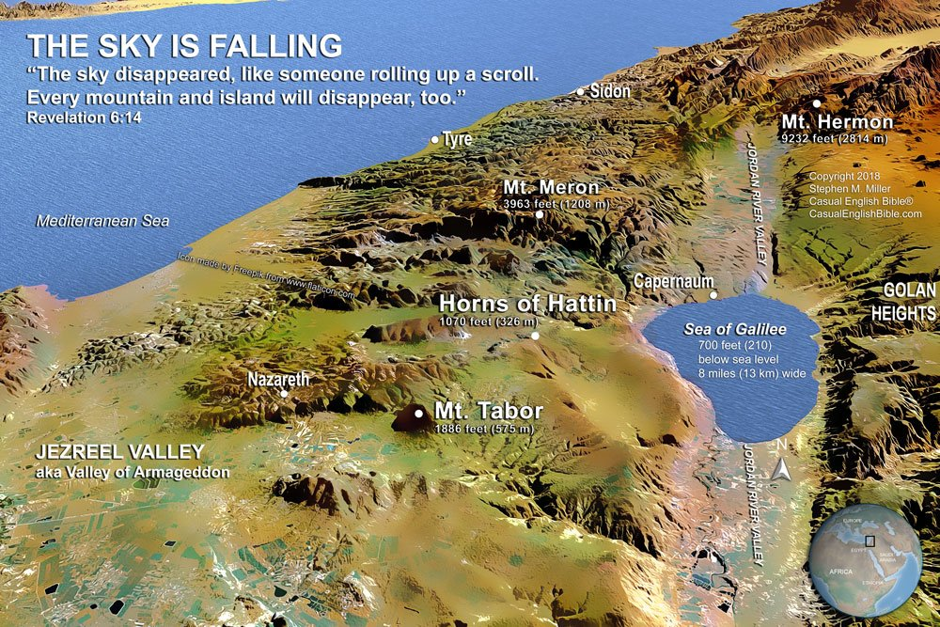

South and west of the plateau where Nazareth sits is the Jezreel valley, but it also has another name.



Look southwest across the valley and see the city of Megiddo. Rev.16:16 speaks about this place.

Rev. 16:14,16 REV

for they are spirits, (that is, demons), working signs, and they go out to the kings of the whole inhabited world, to gather them together to the war of the great day of God, the Almighty.

And they gathered them together into the place that is called in Hebrew, Har-magedon.

This will be the scene of a cataclysmic battle between Satan and his kingdoms and Christ and his followers.

Rev. 19:11-16

And I saw the heavens opened, and Look!, a white horse, and he who was sitting on it is called Faithful and True, and in righteousness he judges and makes war.

And his eyes are a flame of fire, and on his head are many diadems, and he has a name written that no one knows but he himself.

And he is clothed in a robe sprinkled with blood, and his name is called The Word of God.

And the armies that are in heaven followed him on white horses, clothed in fine linen, white and clean.

And out of his mouth comes a sharp broadsword, so that with it he can strike down the nations (and he will shepherd them with a rod of iron), and he treads the winepress of the fury of the wrath of God, the Almighty.

And he has on his garment and on his thigh a name written, KING OF KINGS, AND LORD OF LORDS.

Who is this on the white horse? It’s Jesus Christ leading the heavenly host – including us! – back for the great battle of Armageddon. Right there in that valley as you look out from Mt. Precipice you see...

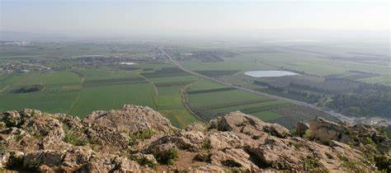

I wonder if God showed Jesus this when he got to Mt. Precipice.

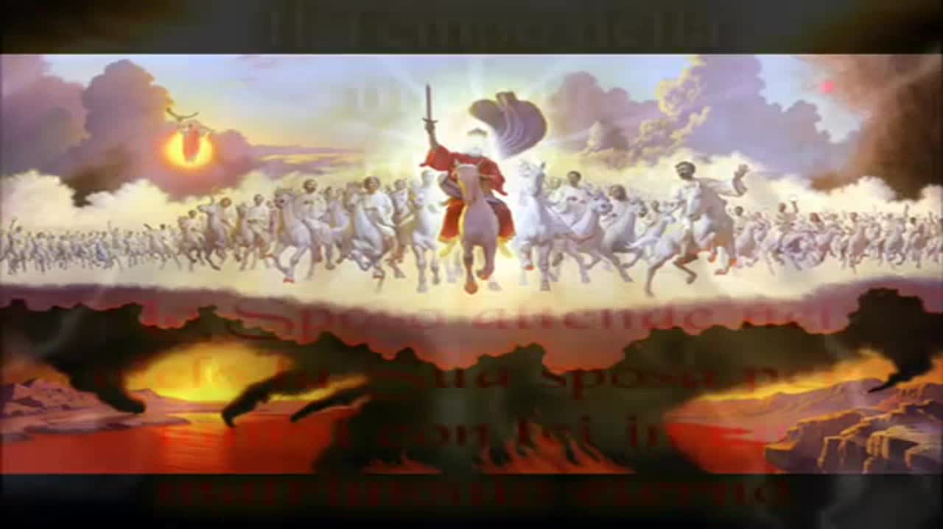

Wow! The greatest battle of all history. Who wins?

Rev. 19:17ff REV

And I saw an angel standing in the sun, and he cried with a loud voice, saying to all the birds that fly high overhead, “Come and be gathered together to the great banquet of God,

so that you may eat the flesh of kings, and the flesh of military commanders, and the flesh of the mighty, and the flesh of horses and of those who sit on them, and the flesh of all people, both free and slave, and small and great.”

And I saw the beast, and the kings of the earth, and their armies, gathered together to make war against him who sat on the horse, and against his army.

And the beast was taken, and with him the false prophet who did the signs in his sight, with which he deceived those who had received the mark of the beast and those who worshipped his image. These two were thrown alive into the lake of fire that burns with sulfur,

and the rest were killed with the sword of him who sat on the horse, even the sword that came out of his mouth, and all the birds were filled with their flesh.

These evil spirits in the Nazarenes led Jesus to the location of one of the greatest victories he would accomplish – Armageddon. Perhaps God answered his prayer for deliverance with a vision of the future at that place. And maybe God also added “At that time, ‘the day of vengeance of our God (Is. 61:2) shall be fulfilled in their midst!”

Wow! Can you imagine Jesus’ heart? The comfort, inspiration, and realization of what his future held?

Jesus may have thought after that vision, “I may die one day, but Not Today!” And then God may have said, “Walk away.” And he did.

Luke 4:30

But he, passing through the midst of them, went his way.

How did God do that? Don’t know. He could have “blinded” the spirits (like he did with Elisha) and then Jesus walked through the crowd. Or he could have walked right through their physical bodies. Or he could have gone faster than they could act and escaped their clutches and influence. Or… The God who made time, space, energy, and matter can do things like this many ways. Perhaps God doesn’t have it recorded because it wasn’t that important. What is important is that God was there for Jesus and rescued him, as He does for us too.

The idea that Jesus had to endure one hour of abuse doesn’t negate the fact that God fulfilled His promise to Jesus to protect and bless him. The same thing is true for us. At times we are also “ganged up on”. We can feel like we are being led to our ruin by those spouting hateful words. The cruelest wounds are from those we’ve known and felt cared for us. Their “gut punches” can leave us breathless as we ponder our self-worth in the eyes of those whom we thought respected us. We are tempted to give up, give in and go away – maybe even leave this life. This originates from the same kind of spiritual opposition that ambushed Jesus in Luke 4. Jesus never gave in or gave up. As he looked to God, He delivered him. Just as it was for Jesus, it is for us. There is no formula for deliverance, only a Father. There is no religious principle for escaping attack, only a looking to God and trusting in Him to fulfill His promises. Despite the opposition, “greater is He who is in us, than he that is in the world.”

So, although evil spirits have rights… Guess who else has rights? Us!

Rom. 8:31 REV

He who did not spare his own Son, but gave him up for us all, how will he not also, in addition to him, freely give us everything else?

We have been promised God’s protection, guidance, blessing, and favor – giving us the right to expect those things when we ask Him for them. We have been promised, “In all these things we are more than conquerors.” We have that right – to conquer! We may be at times surrounded by evil and confusion, mentally battered, emotionally assaulted, and even physically manhandled – feeling that we could, or even should, die. But by God’s mercy and grace we can say, “Not Today! I am more than a conqueror! What will God do for me today?”