1 Corinthians Intro – Bless This Mess

When God created everything, He made some of His creatures with free will - making it possible them to challenge His wonderful will and plan. When that happened, it made a mess! Although this rebellion occurred in the spiritual and physical realm, God promised a merciful redemption on earth. Jesus was the promised “seed of the woman” who bought a right standing with God for sinful man through his death and resurrection. Although man could now be redeemed and reconciled to God, he still has free which can be used to good or bad effect. When a Christian misuses their free will and chooses to think and live outside God’s direction, it still makes a mess! This study looks at the first attempt to correct the wrong use of free will in the Christian church and bless and clean up the mess.

The first epistle of Paul the apostle to the Corinthians (AKA 1 Corinthians, or 1 Cor.) is the largest church epistle with 40 more words than the next largest (but first listed) epistle, Romans. 1 Cor. is a reproof epistle, correcting the wrong practice of the gospel God introduced in Romans 12-16. In what ways were the Corinthians wrongly living the gospel? Not surprisingly, in similar ways we see today. In some ways, the epistle seems like it was written yesterday – with many of the challenges seen with newer Christians in the church now. The gospel, like human nature, are realities that transcend time and place.

Before we start reading the epistle, let’s read about the beginning of the Corinthian church. Paul, the itinerant Christian evangelist and a few companions were traveling across the upper northwestern Mediterranean about 50 AD. They had varying degrees of success (and travail) throughout Galatia and Asia, then in Philippi, Thessalonica, Berea, and finally Athens, where Paul addressed the Grecian elites at the Areopagus, where the ancient court of Athens met in the shadow of the Acropolis.

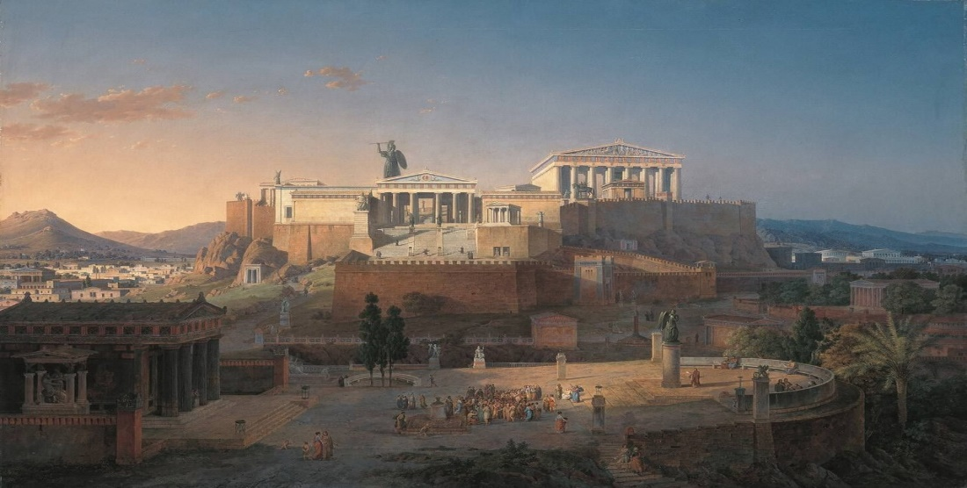

Acts 18:1 REV

After these things he [Paul] departed from Athens and came to Corinth.

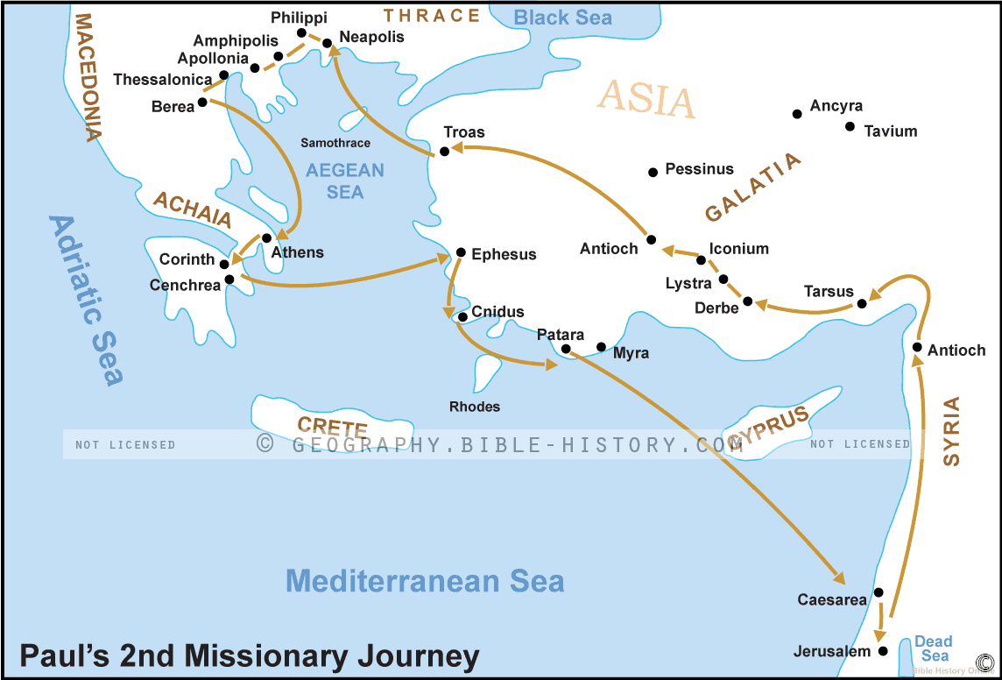

When did Paul visit Corinth? Toward the end of his second missionary journey, as recorded in Acts 15:36-18:22.

Acts 18:2ff REV

And he found a certain Jew named Aquila, a native of Pontus, having recently come from Italy with his wife Priscilla, because Claudius had commanded all the Jews to depart from Rome. And he came to them,

and because he was of the same trade, he stayed with them, and they were working together because they were tentmakers by trade.

And he reasoned in the synagogue every Sabbath, trying to persuade both Jews and Greeks.

But when Silas and Timothy came down from Macedonia, Paul was wholly occupied with the word, testifying to the Jews that Jesus was the Christ.

And when they opposed him and insulted him, he shook out his clothes and said to them, “Your blood be on your own heads. I am clean. From now on I will go to the Gentiles.”

And he departed from there, and went into the house of a certain man named Titius Justus, a God-fearing Greek, whose house was next to the synagogue.

And Crispus, the ruler of the synagogue, believed in the Lord together with his entire household. And many of the Corinthians, hearing, believed and were baptized.

And the Lord said to Paul by a vision at night, “Do not be afraid, but speak and do not be silent,

for I am with you and no one will attack you to harm you, for I have many people in this city.”

And he stayed there a year and six months, teaching the word of God among them.

While Gallio was proconsul of Achaia, the Jews rose up with one accord against Paul and brought him before the judgment seat,

saying, “This man is persuading the people to worship God contrary to the law.”

But when Paul was about to open his mouth, Gallio said to the Jews, “If indeed it were a matter of injury or evil crime, O you Jews, reason would dictate that I should put up with you,

but if there are questions about words and names and your own law, look to it yourselves. I do not intend to be a judge of these matters.”

And he drove them from the judgment seat.

And they all took hold of Sosthenes, the ruler of the synagogue, and beat him before the judgment seat. Yet none of these things were a concern for Gallio.

Now Paul, having still remained a considerable number of days after that, said goodbye to the brothers and sisters, and sailed from there to Syria, and Priscilla and Aquila were with him. In Cenchreae he shaved his head, for he had taken a vow.

Let’s recap the Corinthian history. Paul comes to Corinth and finds a fellow Jewish tent maker by trade, Aquilla, who either hired or partnered with Paul occupationally and invited him to the local synagogue. Paul, whose Jewish religious credentials were unmatched, was allowed to speak in the weekly gathering and he preached the living fulfillment of the Mosaic law, Jesus Christ. When opposition to the gospel reached critical mass, he exited the synagogue with those who believed, including Crispus the former synagogue leader and others. Paul announced that he would direct his message to the large Gentile population from the location of a Greek proselyte’s home next to the synagogue. He ministered at Corinth for an unpresented 18 months - an astounding investment of his time considering what God had revealed to him and his calling to the world.

Acts 18:8b,11 REV

+

.

And many of the Corinthians, hearing, believed and were baptized.

And he stayed there a year and six months, teaching the word of God among them.

This situation was unprecedented on this missionary journey. Paul’s preaching would usually be either rejected or bear some fruit with opposition soon forming and a quick exit. God announcing that Paul could stay and teach was a new development in two ways. First that he could not only preach (joyfully announce) the gospel but also teach the new converts systematically what Christ did for them, what he was in them, and how to live in that light. Secondly, no persecution for a while! A chance to grow a large fellowship.

So, what did he teach them for 18 months? That information is detailed in what we call “the epistle of Paul to the Romans” today. It was the foundational revelation in the first century church regarding salvation. Paul taught them (to the Jew first and also to the Greek – just as the Corinthian church also began) the gospel of Christ and its lifestyle. This was his first opportunity to start and disciple a church - the first time he was able to see the effect the gospel had on converts and the challenges Gentiles had in adopting its lifestyle. It was also the first time the Sacred Secret (or as it was sometimes called, the Great Mystery) was able to be taught and attempted to be lived. It was revolutionary and radical beyond anything imaginable at that time (and still is today).

As we go through 1 Cor., we won’t be looking at it through a microscope. Although there is research behind the sharing, I want to share “what time it is”, not how to build a watch. Original language words are included only when they illustrate meaning or clarify English concepts. There is much research on Corinthians available to those so inclined. Perhaps the commentary on the Revised English Version (the Bible version I prefer that is available online) is a good place to start for the research minded. The aspects I highlight are:

- Some figures of speech.

* Historical and geographical background info.
* First century AD Greek, Roman, and Corinthian culture.
* Biblical context, both near and far.
* Church epistle and Grace Administration logical thinking.

At first, we’ll go at a one Bible chapter per sharing pace until we get to 1 Cor. chapter 12. Because of today’s ignorance and wrong teaching on “spiritual matters” we will delve into this more carefully and deeply. Ready? Grab some spiritual diapers and wipes, because we have a few messes to clean up from the infant Corinthian Christians. Perhaps their (and our) favorite prayer should be:

“Lord, bless this mess!”