Israel Trip

“Should I bring 4 or 5 vials?” I wondered. The coming trip to Israel had me stepping up preparations a month ago. “I must bring home water from the Sea of Galilee, the Jordan River, The Dead Sea, and Hezekiah’s tunnel. But what about the falls at En Gedi and the springs at Dan? So that would make 6 vials that can seal and pass customs. And who knows what else might come up?” I wondered. So, I ordered 20 vials that could hold the water from various locations and return home. I also brought sealing plastic bags for soil or stone storage and transport. I packed a compass, flashlight, binoculars, trail shoes and notebooks.

This trip was a lifetime event for me. I have read the Bible for decades and now I would get to walk where Abraham, Joshua, Jesus, and the apostles walked. I anticipated and prepared for every eventuality and was ready. We flew into the airport in Tel Aviv and the first thing I realized is that the modern country of Israel does not resemble biblical Israel at all. Modern Tel Aviv is as modern as any US city with skyscrapers, freeways, and traffic.

The next thing I realized is that Israel is a lot smaller than I imagined it. I am used to US dimensions. For instance, the drive from where we live near Seattle to our daughter’s home in Spokane is a 4-hour drive – about 250 miles. The drive time from Egypt on the south of Israel to Lebanon in the north is the same - 4 hours! Israel at its most wide - east to west - is 75 miles! Are you kidding? The drive from Tel Aviv airport to our first stay in Galilee was 87 miles or a 1 hour 45 minutes through the mountainous terrain. I drive that for business appointments regularly.

When we got to the hotel we had a grand view of the “sea of Galilee”. You will notice that it’s hardly a “sea” according to most definitions, but a mid-sized lake. It’s 12 miles long and 7 miles wide at its widest. I grew up next to a 25-mile-wide lake so this was no “sea” to me.

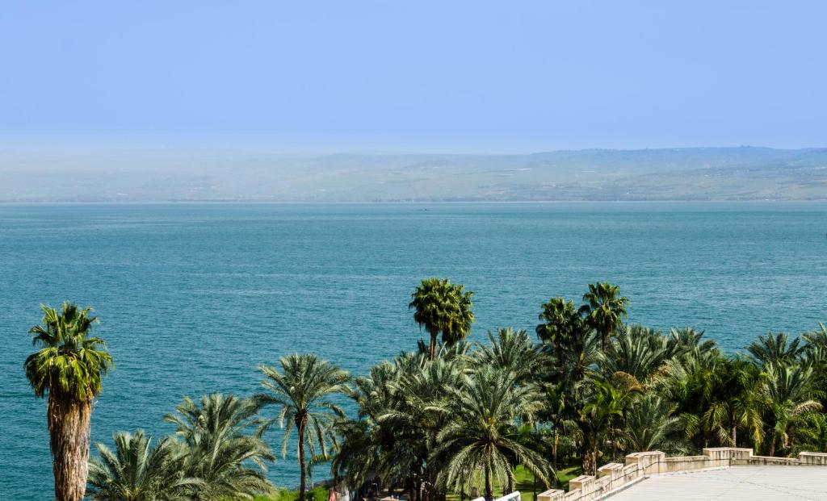

It turns out the translators of the King James had never been to Israel, so they translated the Greek word as “sea” because they assumed its large size. When we went out on a boat on the lake, the water didn’t seem so special to me. It was just a medium-sized lake.

We saw a house in Capernaum where perhaps Peter and Andrew lived and based their fishing operation. This was a house in the first century that was later expanded and perhaps used as a church meeting place. It was discovered by archeologist with 12 other homes by a first century synagogue in 1968 and soon after a 20th century church was built over it.

The house was made of stones, rock, and dirt… just like those lying all over the countryside. It didn’t seem so special to me.

We also went to the Valley of Elah where David slew Goliath with a sling and a stone. When I gathered stones from the brook there, they looked like… stones that I have skimmed on lakes since childhood. The stones didn’t look so special to me.

None of the things that I had prepared for – bottling “holy” water or storing significant soil – I did. I was thrilled to be in the locations where Jesus walked and sailed, and where David conquered, but I had mixed feelings about what made the locations in Israel special.

One night I missed my 35-person tour group at dinner at a Jerusalem hotel and sat in a huge dining room without them. I marveled at the diverse groups of Christians there. There were well dressed Africans from at least two different areas, noticeable by the difference in their dress and languages. There was a group of Scandinavians… and Slavs…and Italians…and many Spanish speaking groups… and some Australians…and Koreans… and many Americans and Canadians. It was surprisingly diverse like the United Nations but pleasantly alive with the fruit of the spirit.

And then it hit me. The water wasn’t special nor the locations or the rocks. Jesus was special! What made the water unique was that Jesus walked on it. What made the remnant of stones in Capernaum special was that Jesus healed Peter’s mother-in-law in that house and the first century church met there. What made the valley of Elah special is that one teenager got angry at the Philistines and at the cowardice of Israel’s army, so God helped a 5-footer kill a 9-footer in front of two armies. God and Jesus are special. Everything and everyone else basks in the reflection of their glory. If Jesus would have been born in Nevada and walked on Lake Mead, we would be going there. Wherever God and Jesus are – it’s special. All else is rocks and water.

I was amazed that so many thousands of people spent so much money (it isn’t cheap to fly to Israel, stay at hotels, and eat out 3 times a day). I was amazed that everyone there took time off work to visit the Bible lands and honor Jesus, our savior. There were Catholics, Baptists, Episcopalians, Mormons, Evangelicals, Methodists, Greek Orthodox and unorthodox saints (like me) who were united in one thing – Jesus had so impacted each life there that we spent much precious money and time honoring him. We were all pretty much floating on air because we were all following his steps and thinking of him.

For two weeks I never turned on the TV or answered business calls. I simply focused on many of the Bible believer’s lives and followed Jesus’s life and ministry. For two weeks I focused solely on what God and Jesus had done. “And the things of earth grew strangely dim in the light of his glory and grace.”

Now that I’m home, God and Jesus are here too. What makes home, work, fellowship special is God and Jesus. Without them, it’s just water, rocks, and stone. I have learned to focus more on what’s special – them. Perhaps that’s a good lesson for us all.