30 – Love in the Church

1 Cor. 13:1
If I speak with the tongues of men and of angels but do not have love, I have become a sounding bronze, or a clanging cymbal.

As mentioned before, “tongues” is said figuratively for “languages”. We still use the phrase “foreign tongues” today. Note that the word “tongues” is plural. This means that the speaker speaks in languages – at least two languages of men (could be more, but at least two). Here’s a surprising fact, according to ethnologue.com, there are and have been about 7000 human languages. Here is their breakdown by category:

  - Institutional - 485
  - Stable - 3481
  - Endangered - 3193
  - Extinct - 454

Note that there are as many languages that are either extinct or going extinct, as there are stable languages in common use. Perhaps this is because as modern media permeates a population and culture, the main media language slowly dominates the old one as it phases out. Sound recording was invented in the mid-19th century, so those languages that went extinct before then are unknown to us – like Canaanite or ancient Gaelic. Although scholars have secured written examples of many extinct languages, their pronunciation and sound remain unknown.

What this means is that when someone speaks in a tongue, they could be speaking in one of the 3481 languages used in the world today, or one of the 3193 endangered or 454 extinct languages. How can that be? How could we speak in an extinct language? The answer is the word “extinct” refers to our experience, not God’s. They aren’t extinct to Him! And Who is the one who provides the utterance – the content in speaking in a tongue? God, not us. Remember, we speak “as the Spirit gives utterance”.

Next question – why doesn’t each of us automatically speak in every language that has ever been if God knows them all? The answer is because we haven’t spoken in those languages. Let me explain. Have you ever learned a foreign language? There’s more involved than learning new vocabulary and word associations. We English speakers must learn to make new sounds and sound combinations particular to the new language. Here are some well-known examples. For modern Hebrew, we must learn to “clear our throat” to say the letter “n” (chet). For Spanish we learn to roll our “r”s. We learn to make clicking sounds to speak Khoisan and Bantu languages. Each language has unique pronunciations that demand us form our mouths and throats differently to make the new particular sounds.

The same is true when we learn to speak in a tongue. The beginner must make their mouth, tongue, lips and breathing perform differently than what they are familiar with to speak a new language. And although God is responsible for the content of the new language, He can’t make us say it. The verse says, “If I speak..” In the Greek, “I speak” is in first person active voice. That means - I speak. So, to speak in a different language, I must speak differently – move my mouth differently, form my lips in a new way, maneuver my tongue uncomfortably to me, and perhaps also make unfamiliar sounds.

So, the answer to the question – “Why doesn’t each of us automatically speak in every language if God knows them all?” is because we don’t form the foreign words necessary to speak them. As is usually the case in the spiritual realm, if we can’t do something, it’s usually because we’re limiting God – not because He’s limiting us. Once we have the spirit, we must trust God to speak differently than we have before to speak in an unknown tongue. Soon after, we should work on our ability to speak in the new tongue by expanding our vocabulary. I expanded my ability by starting to speak in a tongue beginning with the letter “a” for 10 seconds and soon many words/sounds came out of my mouth beginning with the letter “a”. Then I did all the rest of the letters with the same result. Then, when I spoke in tongues outside practice, the language flowed more fluidly with a greater word and sound diversity. This seemed to me like a baby learning to speak in English. They start out repeating one word/sound “mama” “dada”, etc., and gradually learn to do more with their mouth in different ways and patterns as they progress. The same is true with a tongue.

How many tongues do you want to speak in? It’s up to you. God knows them all and can provide for as many as you want. This seems like the situation with Paul. He spoke in tongues (plural) of men. This is what was referenced a few verses before in chapter 12:

1 Cor. 12:28
And God has set some in the church, first apostles, secondly prophets, thirdly teachers, then miracles, then gifts of healings, helps, governments, various kinds of tongues.

Notice it doesn’t say “a tongue (singular)”. It says “tongues” (plural). The “tongues” reference in this verse is not primarily about the manifestation, but the ability some have in the church to spiritually speak in more than one language, here called the “tongues of men”. When we speak in a tongue, all of us can speak in at least one foreign language, but some of us are adept at it, like a prophet is with prophecy. This verse (and section) highlights the spiritual long suites in the church, over the manifestations themselves.

Here's another question: “Should someone want to speak 5 languages instead of only one?” It’s up to the speaker. The primary importance of tongues is as a worship and prayer aspect in our relationship with God. If we speak in Swahili or ancient Akkadian, the content will still be praise or praying to our Father. The specific language will not affect the manifestation’s purpose. Perhaps multiple languages are a beneficial sign to the speaker and/or the hearer that God is at work. So, it’s the speaker’s choice as we learned in 12:11, “as he purposes”. This means the purpose of both God and the manifester.
Now let’s discuss “languages of angels”. Look at the structure of 1 Cor. 13:1-3 from the KJV.
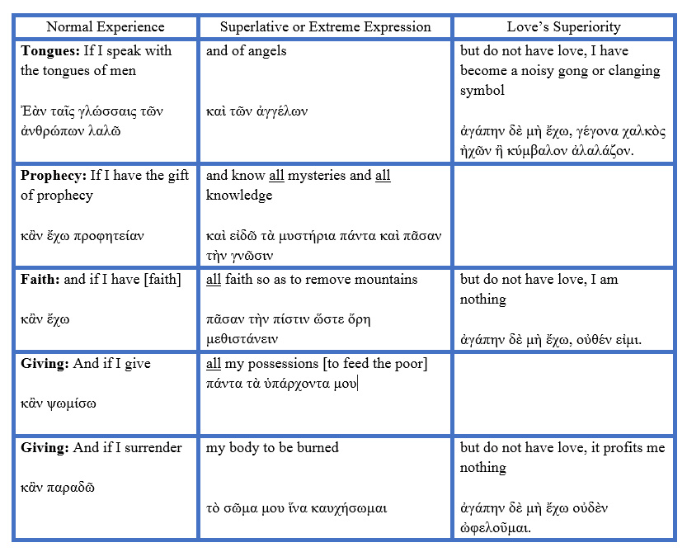
What’s the point of these verses? It’s to show the superiority or excellency of love in the spiritual manifestations and ministries in the church. The first verse in essence says:” Let’s say I can speak in multiple unknown languages – and even some languages of angels! But… if I don’t have love, I am functioning like a sounding bronze, or a clanging cymbal – making a lot of noise but signifying nothing. (I am only calling attention to myself, not benefitting God publicly or a human hearer.)

Note that God never corrects the manifestation of tongues, only the person doing it without love. In other words, when I speak in tongues aloud around others without interpreting, God is still being praised and my spirit is praying perfectly, but any hearers are not edified, and God’s reputation could get tarnished by a confusing public witness.

Here’s my amplified version of verse 2: “And let’s say that I have prophecy (it’s referring to someone skilled at prophecy as their long suite ministry in the church) and that I even know all sacred secrets and all knowledge (this means that they also have a long suite in the message of knowledge). Even if I have all trust (a long suite in trust) so that I could move mountains, but I don’t have love, I am nothing.”

Can We Mess up the Manifestations of the Spirit?

Once again, God doesn’t correct the manifestations, only the one operating them outside of His love. The question becomes, “Are you saying that I could operate the manifestations of the spirit incorrectly?” The answer is “Well, sort of.” For instance, I can speak in a tongue out loud to someone on the street and confuse them or silently pray in a tongue for them. In the first instance, the tongue is still genuine as I praise God and pray perfectly, but I could sow confusion and a bad witness to the one on the street. In the second instance, I could speak in tongues silently and lift the one on the street to God in prayer for their blessing. In scenario #2, everyone gets blessed, and no one gets missed. Perhaps the way to phrase the previous question would be, “Are you saying that I could manifest the spirit incompletely?” The answer would be, “Yes.” We can operate the manifestations correctly but still misuse them and miss the blessings that God intends. This is the excellence of love. It is how the manifestations benefit everyone involved, not just the one manifesting and not just God or another partially. He is love. He wants everyone to benefit in every way.

In Numbers 22-24 the prophet Balaam was hired by the evil king Balak to curse the Israelites. Instead of cursing, Balaam prophesied blessings on them with terrific words of knowledge, despite his initial willingness to curse them for a reward. Later Balaam used the revelation God gave him to lure the Israelites into idolatry (Num. 31:16), most probably for selfish "gain from wrongdoing" as 2 Pet. 2:15 says. So, here’s a guy who got revelation and prophesied correctly but later used it “unlovingly”, to say the least.

Free Will

Now the question becomes, why did God give Balaam revelation if it later could be used to attack His people? Ready to get rocked! Because of free will. Balaam asked God and trusted Him for revelation and got loads of it, speaking it out in prophecy. Once God gave Balaam revelation, who was responsible for it? Not God, Balaam was. Could Balaam have ignored the revelation, never speaking it out? Sure. God’s job is energizing the revelation, Balaam’s job was activating it and then speaking it out (in prophecy) or not speaking it out. After he spoke it out, it was still his responsibility what he did with it. He could have done three things – 1. Believe it. 2. Ignore it. 3. Misuse it. He chose #1 at first and then #3 later. God showed what He thought of that option by Balaam’s death. It’s never a good career move misusing God’s revelation to spiritually attack His people. That earned “early retirement”.

Today, few people alive believe in the manifestations of the spirit. On a narrower scale, few Christians even do. Of those who do, many have a skewed view of how they work. They believe that the spirit “takes you over”, as seen by the “slain in the spirit” adherents. Once I went to a church where the attendees “fell under the power” and acted so out of control and bizarrely that they had ambulance stretchers and attendants in scrubs ready to cart them out. What a disgrace! Is that what happened on Pentecost? No! How about other times when the spirit was manifested in the book of Acts? No, the only stretcher I remember was when some friends brought a cripple to Jesus to be healed, not to carry out someone out shaking uncontrollably. Remember that the true God doesn’t violate anyone’s free will. “I speak”, not the spirit. I activate and God energizes. It’s a partnership. I don’t do it all and neither does God.

Think about the silly idea of “The Sprit Controlled Life” as some call it. If the “Spirit controlled” when, where, and how we manifested it, there would have been no need for God to have Paul write 1 Cor. 12-14. He just would have said, “Would you folks just give in and do what the Spirit wants you to do?!” Did he? No. Instead, he had to instruct them because the gift of holy spirit is subject to their will, not the opposite. He had to teach them how, when, and where they were to manifest the spirit because they were responsible for the utilization and benefit from the spirit. The idea of “Let the Spirit have his way in you” is almost laughable if it wasn’t so spiritually dangerous. God’s spirit doesn’t act that way, but there are some spirits that do, and we certainly don’t need or want them.

The manifestations and ministries are subject to man’s will. I won’t manifest the spirit if I don’t want to. And I can manifest incompletely if I want to. I can speak in tongues in a church… in a park … in a car … in a bar! What?! How can that be? It can be because it’s my option to activate the spirit. And if I choose to do it in a bar, then God will honor that activation and energize the spirit – even if it’s in a bar… in a casino! Now, is this God’s will? Perhaps not, but if an out of fellowship saint found themselves there and had a moment of sanity, speaking in tongues would help “bring them home”! It did for me once in the 1970’s when I was drifting away from God and I found myself in a situation where two guys were hijacking my car. They had pistols at my head and were yelling at me to stop the car and give up my wallet. When I began to speak in tongues, I remembered that the worst thing that could happen to me was that I’d see Jesus sooner than expected, so a strange sort of “crisis peace” calmed me. I stopped the car, got out and gave them my wallet. I found the car after a few days and replenished the missing wallet items. And – most importantly – stopped drifting from God and moved back toward him! A little timely tongues did the trick!

This truth gives many Christians and even theologians headaches. They have a hard time with free will, as I do at times. (I really don’t like free will when my children or grandkids ignore my advice and I must watch them live the consequences. I bet it’s the same way God feels when we ignore His word and advice and get our lives (and cars) hijacked! Dooh!)

Remember, the spirit of God is a gift from God. And who is responsible for a gift after it’s been given? The giver? No, the receiver is, in this case - us. And this is the purpose of this scripture section about spiritual gifts, ministries and manifestation. God is instructing and
encouraging us in the proper use of the gift He gave us.

The Agape Love of God

1 Cor. 13:3
And if I give all my possessions to feed the poor, and if I give my body to be burned, but do not have love [Greek word – agape], it profits me nothing.

Can you imagine giving all your possessions away and even giving your body to be burned or “burned out”? That’s some extreme stuff! What’s it talking about? To answer, let’s discuss another very important thing that is misunderstood by most people (and even many Christians) – the true nature of love (the Greek word is agape). Most people have a feeling-oriented, fantasy-based understanding of love. They think love looks like this:


This is wonderful, but is this how God defines His love?

1 John 5:3a
For this is the love [agape] of God: that we keep his commandments.

God’s love is not primarily feelings based. It’s commitment to God, not just feelings toward God. Feelings come and go, but commitment endures. In the traditional marriage ceremony, the bridal couple usually vows, “In sickness and in health, for richer or for poorer, until death does us part”. True marital love in some ways mirrors agape love in that it’s not dependent on circumstances. A bad health diagnosis doesn’t nullify the vows, nor does bankruptcy or winning the lottery. A good definition of agape love is: “Selfless, unconditional love, often described as the highest form of love. It involves deep, sacrificial care for others, characterized by kindness, patience, and a commitment to their well-being. Unlike other forms of love, agape is not based on feelings or reciprocity, but rather on a deliberate choice to act in the best interest of the other person. Agape love is not motivated by personal gain or the worthiness of the recipient. It is freely given without expecting anything in return.” That is an amazing reality that we have been called to. It was also the opposite of the selfish Corinthian culture which they were being challenged to leave behind. Agape teaches the golden rule “Love others as you love yourself.” It teaches us that we are not the most important thing in the world. We are as important as our spiritual family, but not more so. In agape, we come to the end of ourselves – we are willing to give up our desires in light of God’s commandments and desires. We are also willing to give up our wants in light of other’s needs. As the saying goes, “God first, others second, I am willing to be third.” This is what God patterned to us.

John 3:16
For God so loved [agape] the world that he gave his only begotten Son, so that whoever believes in him will not perish, but have life in the age to come.

I would NEVER give up my son for any reason – period. I’m sorry, but I must have selfishness so embedded in me that I can’t even imagine a scenario where I would. Yet God and Jesus offered themselves for us, worthless, ungrateful wretches. This selfless act is probably the center point of creation and history. Its light separates the darkness and light for heaven and earth, good and evil, believer and unbeliever. It is the grace that pierces through the sin of man and reaches our hungry, hurting heart. It is the love that saves us, no matter how low we are. It is THE amazing grace!

