Pentecost 6
Acts 2:1-4 REV (Revised English Version – used throughout unless otherwise noted)
And when the day of Pentecost arrived, they were all together in one place.
And suddenly a sound came from heaven like a strong rushing wind, and it filled the whole house where they were sitting.
And there appeared to them tongues as if of fire, which spreading out, came to rest upon each one of them.
And they were all filled with holy spirit, and began to speak in other tongues, as the Spirit was giving them utterance.

What

What came on Pentecost? The answer is “the spirit”, but what exactly (or some might erroneously say “who”) is that? There are many explanations given over the years, few logical or satisfactory. Let’s catalog and examine the options, then compare them to scripture.

There are several meanings of “spirit”. One is a dead person’s life essence returning to the land of the living. We refer to this supposed phenomenon as a “ghost”. This term was common long ago from where the name “Holy Ghost” sprang. Today, we use the word “ghost” to refer to an imaginary dead person who inhabits haunted houses. This meaning is inconsistent with the use of spirit in Acts 2.

Another meaning of spirit is “evil spirit”. These entities fight against God and can demonize humans. Still another meaning of “spirit” refers to an attitude or mood, as in “He is filled with team spirit.” or, “Please take this comment in the spirit of fun.” Yet another meaning of “spirit” is alcoholic and/or distilled products as in “We don’t serve hard spirits here, only wine and beer.” or “mineral spirits”. These uses also bear no kinship with the use of “spirit” in Acts 2.

A better meaning of “spirit” is “an animating or vital principle held to give life to physical organisms”. This meaning is closer to relevance in Acts 2 except for the fact that the apostles already were “alive physical organisms” when the spirit came. This meaning of “spirit” is seen throughout the Bible and is sometimes translated “soul” or “life”, referring to man’s physical life evidenced by breath, movement, and thought. Although not the exact meaning in this context, it is related to the one that is.

“Spirit” can also mean “supernatural essence”. What is that? We do not and cannot know. It’s outside of the natural (super–natural) and therefore beyond the five senses we use to gather info and analyze.

1 Cor. 2:14 KJV
But the natural man receiveth not the things of the Spirit of God: for they are foolishness unto him: neither can he know them, because they are spiritually discerned.

The natural world can be known by man’s natural senses – seeing, hearing, smelling, tasting, and touching. The spiritual world must be ascertained by man from the spirit. Man’s natural mind can’t know the spiritual world with any great degree of clarity, but we can discern aspects of it from what God has revealed to us through the scripture and by the results of its interaction in the physical world. We also understand facets of the spiritual realm through the manifestation of discerning of spirits, but that discussion awaits another time. Is spirit important?

John 4:24
God is spirit, and those who worship him must worship in spirit and truth.

One of the ways Jesus described God was “spirit”. That means man can not know God intimately unless He comes into concretion in the senses world. This He has done numerous times throughout history, through the scriptures, and especially from Jesus making Him known. God has been known by the name “the Holy Spirit”, distinguishing Himself as the “Holy” or “pure” spirit, as opposed to the many “unholy” or “impure” spirits.

The Giver and the Gift

Now some have said that “The Holy Spirit” (God) came on Pentecost. How can that be? God has been around forever. The confusion stems from the biblical versions translating the same Greek words into the English “Holy Spirit” (God) and “holy spirit” (God’s gift). In the original Greek there were no capitalizations and lower-case distinctions. So, any capitalization distinctions in the English versions are the translator’s interpretation of when they think God, or His gift is mentioned. At times the translators are right, but sometimes they are wrong and cause confusion.

In the Old Testament times, God would take of His essence (spirit) and put it upon individuals to link the spiritual and natural worlds and produce supernatural results in the natural. It was almost like He took a little bit of Himself (the Spirit) and put it (the spirit, or God’s spirit) on certain people.

Num. 11:25-29
Yahweh came down in the cloud and spoke to him [Moses], and took some of the spirit that was on him and put it on the seventy elders. And it came to pass that when the spirit rested on them, they prophesied, but they did so no more.
But two men remained in the camp. The name of one was Eldad and the name of the other Medad, and the spirit rested on them. And they were of those who had been registered, but they had not gone out to the Tent; and they prophesied in the camp.
A young man ran and told Moses and said, “Eldad and Medad are prophesying in the camp!”
Joshua the son of Nun, the servant of Moses, one of his chosen men, answered, “My lord Moses, forbid them!”
Moses said to him, “Are you jealous for my sake? I wish that all Yahweh’s people were prophets, that Yahweh would put his spirit on them!”

When the seventy elders received God’s spirit, they began to prophesy, bringing forth a message from God to people in the natural world. It’s interesting to note that Moses’ exclamation also mirrored God’s desire “I wish that all Yahweh’s people were prophets, that Yahweh would put his spirit on them!” This shows some of God’s long-standing desire for everyone to have His spirit and be connected with Him.

Another point to make from this record. When the spirit of God came on the elders they prophesied. It doesn’t say that the spirit prophesied and they had to “allow it”. The spirit God gave them was subject to their will. That’s why it says, “they did so no more”. They started prophesying and they stopped prophesying. Each elder was in control, not the spirit. The spirits that control and force a man to act are not “from God” but are evil spirits. This is why Joshua asked Moses to tell Eldad and Medad to stop prophesying because he thought they were doing it improperly. Who was responsible that the prophecy was spoken? The answer is Eldad and Medad. Who was responsible for what the content of the prophesy was? The answer is God via His spirit. Free will is always a hallmark of the true God.

The Old Testament scripture records God putting His spirit on Joseph (Gen. 41:38), Moses (Num. 11:25) the seventy elders (above), Bezaleel (Ex. 35:30,31), Caleb (Num. 14:24), Balaam (Num.24:2), Joshua (Num. 27:18), Othniel (Jud. 3:9,10), Gideon (Jud. 6:34), Jephthah (Jud 11;29), Samson (Jud. 13:25), Saul (1 Sam. 10:6), David (1 Sam 16:13) and many more after them. It was not uncommon for someone to have God’s spirit in Israel and speak for God, get revelation, and perform mighty works. As you look in the context of each “spirit” usage, it shows that God gave his spirit to someone to use for a specific reason or reasons. God never put the spirit on man for him just to “have it”. He gave it for man to use.

One thing that should rivet our attention is that the person to whom God placed His spirit could drift away from God and lose the spirit!

Ps. 51:11
Do not cast me away from your presence and do not take your holy spirit from me.

This was written by King David! Oh boy, if he could lose the spirit then any spirit recipient was at risk because of bad attitude and behavior! The first king of Israel, Saul, lost God’s spirit in 1 Sam. 16:14, demonstrating that the standards of having and keeping God’s spirit must have been high because even an ordained king had no immunity from losing it.

Of course, Jesus had God’s spirit (Matt. 3:16) and the apostles received it also (Matt. 10:1) while learning under Jesus’ instruction. So, what was so different about the promised spirit from the one God had been giving in the Old Testament times? Let’s see how Jesus’ promise of the spirit unfolded.

Characteristics of the Promised Spirit

John 7:37-39
Now on the last day, the great day of the feast, Jesus stood and cried out, saying, “If anyone is thirsty—whoever believes in me—let him come to me and drink.
As the Scripture has said, out of his belly will flow rivers of living water.”
Now he said this about the spirit, which those who believed in him were going to receive, for as yet there was no spirit, because Jesus was not yet glorified.

Notice that Jesus said the coming spirit would be like “out of his belly will flow rivers of living water.” Certainly, that was the case on Pentecost as the apostles filled the temple with tongues and Peter’s message flowed like a salvation river to the multitude! Can’t wait to see the video!

Also notice John says, “for as yet there was no spirit, because Jesus was not yet glorified.” Wait a second. We saw lots of people get the spirit in the Old Testament. In fact, Jesus and the apostles had it then. So, what does “for as yet there was no spirit” mean? It means that the spirit is coming in a new measure (“rivers of living water”) and character so that it’s a whole new reality.

For those who think every use of “spirit” refers to God, these verses put an end to that idea. These uses of spirit refer to God’s gift of holy spirit, not God. God didn’t come after Jesus was glorified, the gift of a new kind of spirit did.

John 14:15-17
If you love me, you will keep my commandments,
and I will ask the Father, and he will give you another helper, which will be with you forever.
This helper is the spirit of truth, which the world is not able to receive, because it does not see it, neither knows it. You know it, for it is present with you, and will be in you.

Jesus reveals more info about the coming spirit. The spirit will be a “helper” - not a burden, or a distraction. Boy, do we need that! And he also says, “which will be with you forever”. Did Jesus just say that? Are you kidding? Forever? Wait a minute, the Old Testament spirit could get lost, right? Saul lost it and David almost did. But Jesus said that this spirit “will be with you forever”. Could that mean…?

Then Jesus reveals that they already have the spirit “present with you” but Jesus adds that when the promised spirit comes it “will be in you”. What a distinction! The Old Testament spirit was placed “with” or “upon” certain people, while Jesus said the new spirit “will be in you”. It’s almost as if God placed the Old Testament spirit “upon” condition, so that if the recipient became “unholy”, they lost the “holy” spirit – sometimes getting an “unholy” one, like king Saul. The new spirit will not be “with” or “upon” man, but “in” man.

Most people don’t consider themselves to “have a body with them”. They consider themselves to “have a body” or that “they are their body”. In other words, when they look in the mirror, they consider it looking at themselves when they view their body. They don’t feel disconnected from their body and feel it’s “with them”. Are you starting to see the distinction between the spirit being “with” the Old Testament believers and “in” the New Testament saints? The NT saints have the spirit “in” them, as a part of them. When they “look” at the spirit, they are looking at themselves. It’s a part of them – just as their body and soul is!

1 Thess 5:23
Now may the God of peace himself make you completely holy, and may your whole spirit and soul and body be preserved without blame at the coming of our Lord Jesus Christ.

Man began as a three-part being in the Garden, able to spiritually walk with God, who is spirit. Is God restoring and reequipping man to his “original equipment”? It seems so. Let’s keep reading.

John 15:26
But when the helper comes that I will send to you from the Father, the spirit of truth that comes from the Father, it will testify about me,
Who sent the spirit on Pentecost? The answer is Jesus. Where did the spirit come from originally? The answer is the Father, God. Notice how Jesus called it “the spirit of truth”. This is what comes from the promised spirit, the truth. Jesus knew he would be exiting the world for a while. How long? He didn’t know because it was still a mystery. But he knew that he would send the spirit that would act as a helper in his absence to reveal information “about me”. For instance, what was the meaning of his crucifixion and resurrection? What was the meaning of his ascension and ministry? The spirit “would testify about” Jesus and guide them into the truth about who he was and what he accomplished.

On a side note, the pronouns in many Bible versions confuse readers on this subject. The above verse is translated in many versions, “the spirit of truth that comes from the Father, he will testify about me.” They use the masculine personal pronoun “he” while the Revised English Version uses “it”. Why? The other versions translators believe the helper and the spirit to be a “person”, the Holy Spirit, the third person of the Trinity. For this to be the case, then “the Holy Spirit” must have never come around before Pentecost and also be subject to man’s will! Remember when the seventy elders prophesied, they prophesied – not “the Holy Spirit”. You can search this throughout the Bible and you’ll see that the spirit God gives man is subject to man. So, if the spirit is really “the Holy Spirit” then…
1 Cor. 14:32 KJV
And the spirits of the prophets are subject to the prophets.

God is subject to prophets? Don’t think so – but the gift God gives is. It is not a “person” or a conscious, willful being, but some of the essence of what God is. It’s also not a “he” or a “she”. It’s a supernatural imparting of some of God that we think of like our body or soul. We speak of our bodies as an “it”, as in “it hurts today”, not “he hurts today” or “she feels great today”. Therefore, it is consistent to translate the pronoun referring to the spirit God gives man as a neuter, “it”. (In Greek, pronouns are genderless and refer to the nearest related nouns and gain gender for translation from the context.)

John 16:12-15 REV
I still have many things to say to you, but you are not able to bear them now.
But when it, the spirit of truth, comes, it will guide you in all truth, for it will not speak on its own, but whatever it hears, it will speak, and it will declare to you the things that are to come.
It will glorify me, for it will take from what is mine, and will declare it to you.
All things, whatever the Father has, are mine, therefore I said that it will take from what is mine and will declare it to you.

“I still have many things to say to you, but you are not able to bear them now.” The apostles were understandably confused as to what exactly was going on at that time. Jesus said he would send the spirit and “guide you in all truth”, “for it will take from what is mine, and will declare it to you.” The spirit would explain the meaning of his crucifixion, resurrection, ascension, and “the things that are to come”. This was of course fulfilled with the New Testament starting with Romans through the book of Revelation, plus all the revelation given to so many saints since Pentecost.

Notice how Jesus describes the spirit’s function – “it will not speak on its own, but whatever it hears, it will speak, and it will declare to you the things that are to come.” This is not a “person” with original thought or will. The spirit acts as a conduit between the speaker - God or Jesus – and transmits that information to the one in whom the spirit is. The coming spirit will be the interface between the spirit world where God is and Jesus will be, to a man who will become body, soul, and spirit.
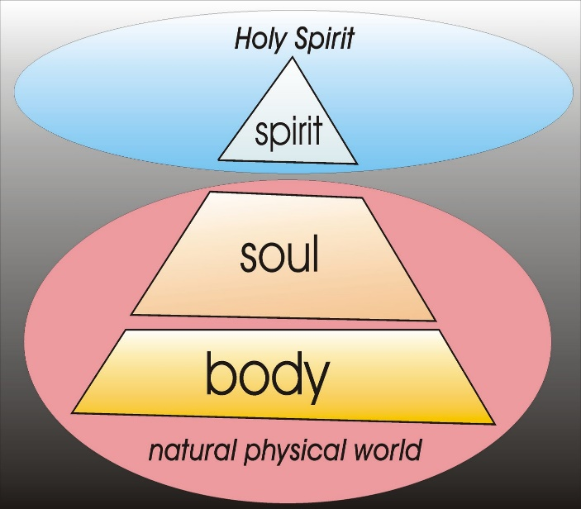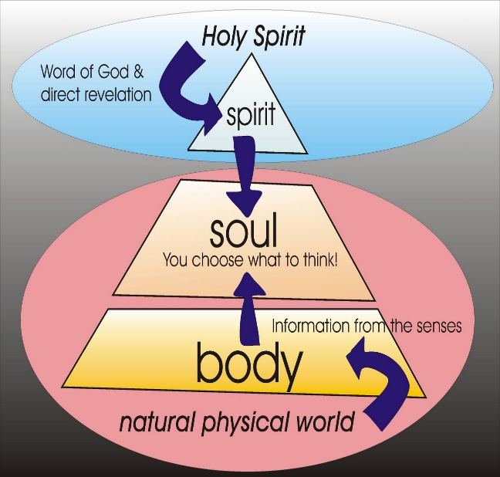

The Father

Did you notice a name that was repeated consistently in the context of the coming spirit? Let me highlight it for you.

John 14:15-16,
If you love me, you will keep my commandments,
and I will ask the Father, and he will give you another helper, which will be with you forever.

John 15:26
But when the helper comes that I will send to you from the Father, the spirit of truth that comes from the Father, it will testify about me,
John 16:15
All things, whatever the Father has, are mine, therefore I said that it will take from what is mine and will declare it to you.

God is called “the Father” in relation to the coming spirit. Perhaps this is why Acts also says…

Acts 1:4-8
And being assembled together with them, he commanded them not to depart from Jerusalem but to wait for the promise of the Father, which, he said, “you heard about from me,
because John baptized with water, but you will be baptized in holy spirit not many days from now.”
Now when they had come together, they asked him, saying, “Lord, is it at this time you are going to restore the kingdom to Israel?”
And he said to them, “It is not for you to know times or dates that the Father has set within His own authority.
But you will receive power when the holy spirit has come upon you, and you will be my witnesses both in Jerusalem, and in all Judea, and Samaria, and to the uttermost part of the earth.”

Jesus called God many different names in his time on earth – Lord, Most High, God of the living, God, etc. So, why does Jesus constantly call God “the Father” when speaking to the apostles about the coming spirit? Could it be…

John 3:3-8
Jesus answered and said to him, “Truly, truly, I say to you, unless someone is born from above, he is not able to see the Kingdom of God.”
Nicodemus says to him, “How is a person able to be born when he is old? Surely he is not able to enter a second time into his mother’s womb, and be born?”
Jesus answered, “Truly, truly, I say to you, unless one is born of water and of the Spirit, he is not able to enter into the Kingdom of God!
That which is born of the flesh is flesh, and that which is born of the Spirit is spirit.
Do not be amazed that I said to you, you must all be born from above.
The Spirit breathes where it wants to, and you hear its voice, but do not know where it comes from and where it goes; this is how it is with everyone who is born by the Spirit.”

“That which is born of the flesh is flesh, and that which is born of the Spirit is spirit.” The first time we’re born were born of our fleshly parents and are flesh. The next time a person is born, it’s from above by the Spirit (God) and they are made spiritually. The first birth is body and soul (flesh), the second birth is body, soul, and spirit. What came on Pentecost? The new birth! New Creations! People were homo sapiens up until then. On Pentecost it became available to be a new species, “Holy Sapiens”! A three-part being. Children of…God. By birth! Not just servants, like the Old Testament believers thought of themselves, but children of God with God’s seed – spirit – in us, as a part of us! Sons of God! It’s so wonderful, it’s hard to stop talking about it!

1 John 3:1,2a
See what kind of love the Father has given to us, that we should be called children of God, and that is what we are! On account of this, the world does not know us because it did not know him.
Beloved, we are children of God now,

Before Pentecost, the called of God were at best servants, carrying out the Mosaic law and striving for righteousness. After Pentecost, the called of God are children of God, given Christ’s righteousness. You see, all that Christ achieved - sonship, righteousness, justification, redemption, etc. - he gave to the Church of Grace. On Pentecost this began to be available to whosoever believed.

1 Pet. 1:23
for you have been born again, not from corruptible seed but from incorruptible, through the living and enduring word of God.

When humans are born, they are made by corruptible parents from corruptible seed and inherit a corruptible body and soul. When a human is born again, they have an incorruptible parent (God, the Father, The Holy Spirit) who infuses them with incorruptible seed (holy spirit, the spirit, the gift) “which will be with you forever” according to John 14:15.

“What” is the spirit that came on Pentecost? The church epistles and other places in the New Testament explore and detail some of the answers. Also, God's spirit itself teaches each of us born again ones a lifetime of insight for the church overall and us specifically. It’s bigger than the human brain can handle. Discovering what Christ gave us and living it is the adventure of a lifetime. So, what came on Pentecost? The incorruptible sonship spirit!

Happy New Birth - day Church of Grace!

Congratulations God! You’re a Father!

(And by the end of the day, about 3000 times! A spiritual baby boom!)

