**18 - Discerning of Spirits**

A definition of the manifestation of Discerning of Spirits from the Holy Spirit book is “God or the Lord Jesus Christ revealing to you information about the presence or non-presence of spirits (including both holy spirit or demons), and sometimes including the identity of demons present, whether or not you may cast them out, and providing the power to do it.”

**The Spiritual Landscape**

**The Kingdom of God** **The Kingdom of the Devil (Luke 11:14-20)**

God created everything and is spirit. (No corresponding entity.)

God made angels, cherubin, seraphim - Satan (originally created by God) is spirit.

Spiritual creatures. Free will decisions.

(Originally “sons of God”- Job 38:7, then Gen. 6 - some in chains)

Principalities, powers, dominions, etc.

Demons, evil spirits

Children of God in OT ‘spirit upon’ Children of the devil (filled w/ unholy

In NT, filled with ‘spirit inside’ - BA spirit. “Your seed” Gen. 3:15, Cain, etc.

The Future:

God

Jesus

Us

First Resurrectionists

Angels

Creation (Physical stuff)

Where will the Devil, his angels, his principalities, and his children be? Toast!

Matt. 25:41 Rev. 20:10

Spirits we may discern.

1. God – it’s revelation. He usually delegates His actions – angels, us. The CEO.
2. Angels – Usually in concretion. Don’t usually need DS.
3. Holy spirit – we can “see” the manifestations. Can spiritually ‘sense’ family.
4. Satan himself. Nah. Think of the wizard of OZ – behind the scenes pulling strings.
5. Satan’s seed. Rare but possible. Soros, etc. Behind the scenes guys like their dad.
   1. Recall that the Pharisees had a BA from Serpent U. Cain, Eli’s sons, etc. Not redeemable – it’s seed.
6. Principalities, powers, dominions, etc. Rare but possible. Usually it’s a spiritual leadership function (angels and church) to fight these guys.
7. Demons – this is usually what we deal with.

Characteristics and information about demons.

1. John 4:4

You are from God, little children, and have overcome them, because greater is he who is in you than he who is in the world.

We must understand that we have nothing to fear. The Christ that is in us is greater than demons in the world. Once Jesus understood the epileptic boy’s trust history, then he commanded the demons to go, and they did. They didn’t say, “No!”. Why?

Phil. 2:9,10

And therefore God raised him to the highest place of honor and gave him the name that is above every name,

so that at the name of Jesus every knee will bow—in heaven and on earth and under the earth—

Every knee bows – even the spiritual ‘knees’!

Eph. 1:19-22

and what is the immeasurable greatness of his power for us who believe, which is the same working of his mighty strength

that he worked in Christ when he raised him from among the dead and seated him at his right hand in the heavenly places,

far above every ruler and authority and power and dominion and every name that is named, not only in this age but also in the one to come;

and he put all things in subjection under his feet and appointed him as the head over all things related to the church,

If God put all things in subjection under Christ’s feet and we are members of his body, then everything is under our feet too. No need to be afraid. The only way they beat us is with special effects. They mask who they are. It’s like Anthony Hopkins acting like Hanibal Lector. They are good at acting to trick you into being afraid or obeying them. It’s special effects – not real. Muffy and Sam. Check the end credits at the end of the movie of eternity:

Is. 14:14-21

I [Satan] will ascend above the heights of the clouds! I will make myself like the Most High!”

Yet you will be brought down to Sheol, to the depths of the pit.

Those who see you will stare at you. They will ponder you, saying, “Is this the man who made the earth to tremble, who shook kingdoms,

who made the world like a wilderness and overthrew its cities, who didn’t release his prisoners to their home?”

All the kings of the nations, sleep in glory, everyone in his own house.

But you are cast away from your tomb like an abominable branch, clothed with the slain who are thrust through with the sword, who go down to the stones of the pit; like a dead body trampled underfoot.

You will not join them in burial, because you have destroyed your land. You have killed your people. The seed of evildoers will not be named forever.

Prepare for slaughter of his children because of the iniquity of their fathers, that they not rise up and possess the earth and fill the surface of the world with cities.

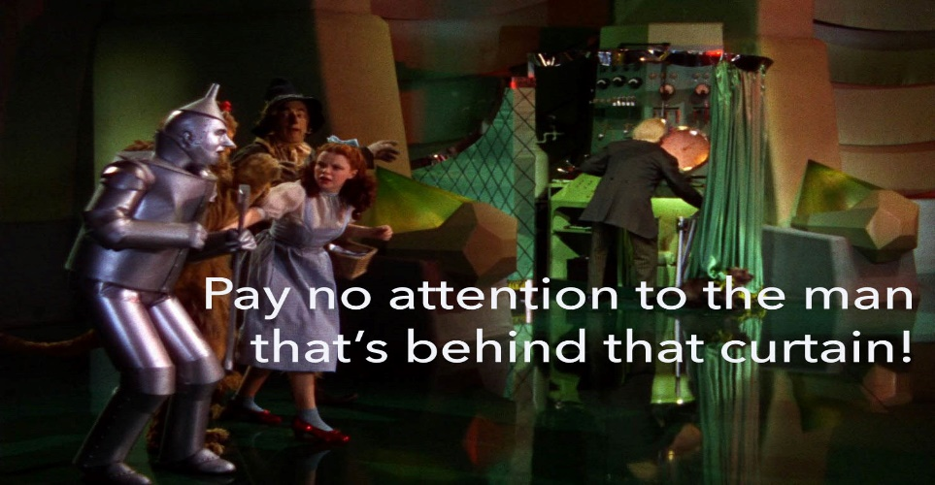

It’s all special effects! One day – not so special and no more effects. A reject.

1. Demons have various degrees of wickedness, boldness and intelligence. They are not like rocks or plants. They have sentience, will and individuality. They are not robots. They have chosen their future already and it’s not rosy. Gen. 3:15

Matt. 8:28,29 REV

And when he had come to the other side, into the region of the Gadarenes, two men who were afflicted by demons met him as they were coming from the tombs. They were extremely violent, so much so that no one could pass by that way.

And look! They cried out, saying, “What do you want with us, O Son of God? Have you come here to torment us before the appointed time?”

They know already that they have “an appointed time” in the future. They wonder if there will be some “testing” [rubbing of a coin against a touchstone] beforehand. They know the Bible and who will be judging them – Christ and us. Forget about making friends with them or coexisting with them. They want to get their licks in on us before we get them. Some Christians are afraid of them. The truth is they are afraid of us. They have a better idea of who we are than most Christians have of themselves! We will be their executioners.

1. Some folks learn about demons and get ‘devil vision’, seeing them everywhere! These folks need to calm down. We are Christ centered, never devil-centered. This is the reason for discerning of spirits. We live life walking with God and when we need to know about the presence of spirits, He informs us. This is a manifestation of the spirit, not a “spiritual zoo tour”. If you need some personal instruction, ask God. He’ll do it if you need to know - but put your mental seat belt on! It’s a weird world.
2. Don’t get ‘on their radar’ for no good reason. They steal, kill, and destroy. Rarely play. Instead of direct confrontation, they prefer to do guerrilla warfare with us, indirect camouflaged attacks.
3. They will speak at times. Usually partial-truths through people to distract.
4. The phrase “demon possession” can be misleading. One definition of “possession” is “property”, as in “My favorite possession is my car.” This meaning when lent to spiritual matters suggests ownership and control. That’s not accurate.

Matt. 8:28a New King James Version

When He had come to the other side, to the country of the Gergesenes, there met Him two demon-possessed men, coming out of the tombs, exceedingly fierce,

Demons cannot totally control a human. They can affect, inflict, influence, partially occupy, induce, and/or shut down parts of humans, but never totally control or own. If they could totally control someone, there could be no deliverance, right? But like dogs which occupy a vacant house, if someone comes in and evicts them, they go. They don’t own the home. They just occupy it unopposed. They can affect and inflict damage on the home, but the damage could be reversed when the dogs (spirits) leave.

1. Can Christians get demonized before they are saved? Yes. The Bible has examples of demons cast out of those called. Can Christians get demonized after they are saved? Regretfully, the answer is yes. *Pneuma hagion* is our spirit, but our minds and bodies can still get afflicted and occupied if we allow it. 2 Tim. 2:26.
2. They inhabit certain places preferred to others. Mark 5:13.
3. They tend to live in groups like humans. Luke 8:2,30. They can also work in groups too. Like a football ‘play”.

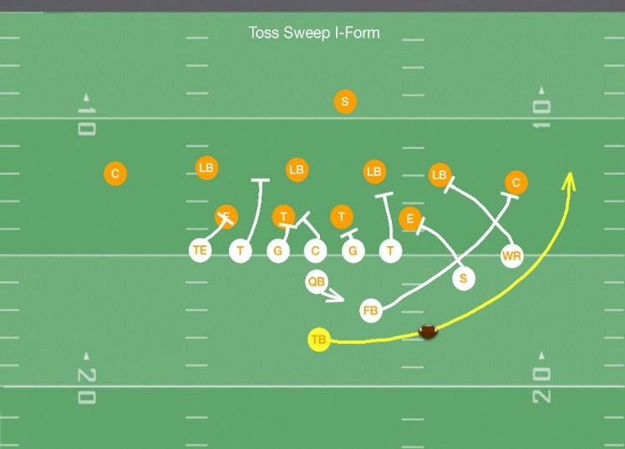

Note that each player does something different, but it all contributes to their team goal.

Typical spiritual “play”.

* 1. Start with an undisciplined, unforgiving mind of a hurt person.
  2. Get’s tempted by anger. Feels good releasing anger at a target who they think deserves it.
  3. Regularly gets angry, develops anger habit – action without thought. Automatic – but not really. “No thought” allows a spirit in and it starts helping with the anger - speaking and action.
  4. Violent spirit – host feels justified because of past offenses. I hurt – you hurt.
  5. Hurts someone. Ends relationship. Loses love. More hurt to the person.
  6. Spirit withdraws from influence.
  7. Person condemns themselves for unbalanced behavior and results.
  8. Self-directed anger leads to more outbursts and more disastrous results.
  9. More condemnation leads to depression, more anger. More acting out.
  10. Alcohol / drugs numb the pain. Open the spiritual door wider.
  11. Depression leads to despair.
  12. Despair leads to suicide to ‘end’ the pain.

Anger, violence, condemnation, depression, despair, and suicide can be spirits. Like humans, spirits develop expertise in certain categories. They’ve been at their ‘professions’ for millennia. That’s why we only engage with them by revelation – with God’s help. We are stronger, but they are more wily. They were involved with these “plays” when Columbus was discovering America, in the Middle Ages, during the Roman empire, in Egypt, and in Babel. We generally avoid them, but when we encounter them, we proceed by revelation and win, short circuiting their plays.

1. We can’t kill them now. That will happen in the future at the end. We just want them out of our lives and the lives of those with whom we fellowship and serve. We evict dogs out of an unoccupied house and then block the entrances so that there’s no re-entry. We don’t shoot the dogs, just evict them. Demons have free will and can do what they want. They will however, stir up their “allies” like in Ephesus when “the Word mightily grew and prevailed” and evil was made to retreat and abandon long held people, places and things. Persecution can and does usually result.
2. There is no peaceful co-existence with these spirits, even if someone wants it.

Ephesians 6:10-13

Finally, be empowered by the Lord, that is, by his mighty strength.

Put on the whole armor of God so that you will be able to stand against the schemes of the Devil.

For we do not wrestle against flesh and blood, but against the rulers, against the authorities, against the world-rulers of this present darkness, that is, against all the spiritual forces of evil in the heavenly places.

Because of this, take up the whole armor of God so that you will be able to stand your ground in this time of evil, and when you have done everything, you will be able to stand.

We are empowered by the Lord, in his mighty strength. The devil has schemes (plays) that we must withstand. It’s not optional. Either we withstand or we ‘go with the flow’ and the direction of their flow is always down the tubes. In the ancient world, wrestling was a universal athletic competition. Neither side died, but one side was victorious. This is the physical picture Paul paints, but it is not physical, but spiritual. We wrestle with spirits. They try to trip us up. They try to pin us. We take up the armor of God to stand – at the end of the competition and at the awards ceremony. The wrestling with spirits is a part of this life. The only question is, “Will we stand or fall?”

1. We wrestle with sin and sins and win and that keeps the spirits at ‘arm’s length’. If we wrestle with anger, we won’t have to wrestle with anger spirits. If we give in habitually to anger, we probably will be dealing with anger spirits soon.

Rom. 8:13

For if you live according to the flesh, you will certainly die, but if by the spirit you put to death the practices of the body, you will live.

We kill (put to death) the practices (habits) of the body by walking by the spirit – having spiritual practices. This gives us holy spirit life in our physical lives and excludes unholy spirit in our physical lives.

1. They will even demonize animals. Luke 11:24.
2. The “black arts” were forbidden in the Old Testament and should always be avoided and repulsed in our hearts even after we’re saved.
   1. Familiar spirits – fortune tellers
   2. Wizards and witches deal with the dead and wielding spirit ‘power’.
   3. Divination
   4. Enchantment
   5. Charmer
   6. Necromancer
   7. Soothsayer – future predictor
   8. Spiritual healer
   9. Exorcists that are really witches.
   10. Conjurer (of the dead). Spirits masquerading as the dead.
   11. Snake charmer.

It is healthy to have an attitude of despising nausea toward these spiritual fronts.

1. Types of spirits. Name a sin and a spirit can inhabit it and animate it.
   1. Spirit of fear – *phobos – delia* – timidity. Spiritual leadership sin. 2 Tim. 1:7
   2. Spirit of bondage Romans 8:15
   3. Spirit of slumber Romans 11:8
   4. Spirit of envy James 4:5
   5. Spirit of infirmity Luke 13:11 Infirmity could be spirit, physical or behavioral.
   6. Lying spirit 1 Kings 22:22
2. Discerning of spirits is revelation, and as such we can activate, but it’s God’s option to energize. All spiritual knowledge comes by grace. (Sometimes it takes a little mental work and trusting God to understand the revelation.)
3. DS is hard for an undisciplined mind to operate. Revelation comes from outside our mind. Let’s say a believer has not disciplined their mind to think loving thoughts of others and God tells them that the person sitting next to them has a lying spirit.

1 Cor. 13:5 NKJV

does not behave rudely, does not seek its own, is not provoked, thinks no evil;

If the person getting the revelation has not disciplined themselves to “think no evil” about others, then the DS message that a person has a lying spirit will probably be ignored as just another random evil thought among others about someone. On the other hand, if the person has learned to think positive, loving thoughts of others and a “lying” thought enters their mind about someone, they are much more likely to recognize that thought as revelation and act accordingly. Most probably in scenario one, God will not even give the revelation because it will be wasted. Discerning of spirits regarding demons, by its very nature, is negative and evil. People with disciplined minds are able to recognize DS while undisciplined ones usually are not.

We have the adage, “We separate the sin from the sinner.” To operate DS effectively we must take that a step further and “separate the spirit from the person”. We speak to the person much differently than we speak to the spirit. We are loving to the person in attitude, word and action, but not with the evil spirit. We don’t get into a shouting match or some silly “chest thumping” ego exercise. We speak “matter of fact-ly” (or matter of truth-ly, if you prefer). The power of God is the revelation and inspired words we speak to do the job. Volume and attitude are incidental. We express ourselves as we’re inspired. We love the potential ‘deliveree’ and see them delivered. The only way we see the spirit is “out”!

1. Can we cast out demons?

Mark 16: 17

And these signs will accompany those who believe: they will cast out demons in my name, they will speak in new tongues,

The answer is “Abso -freakin’-lutely!”



