36 – The New Heavenly Body

1Cor. 15:29
Otherwise, what will those do who are being baptized for the sake of those who are dead? If the dead are not raised at all, why then are they baptized for them?

To me, this is one of the top ten weirdest verses in the Bible. The REV Commentary says: “The exact way to translate this verse has been debated for centuries. … The most likely explanation for the custom is that living Christians were being baptized for people in the congregation who were known to be faithful and believers but had not as yet received the rite of baptism. In the early centuries of the Church, especially once the Roman persecutions had started, it was often the case that a person had to be faithful to the Church for some probationary period before he or she was allowed to be baptized, which granted them the full status of membership in the congregation. It seems probable from this passage of Scripture that at some point in the early Church, a new custom started such that if a person in the probationary period died, someone else was then baptized in his or her place, most likely as a demonstration that the person really was a believer and would be in the resurrection, and that was being practiced at Corinth.”

This verse contradicts so many other verses about free will and personal responsibility that it sticks out like a sore thumb. Paul didn’t assign a high priority on baptism as the first chapter of 1 Corinthians showed. Perhaps some members did this as an outward show of salvation, just like they did with other outward demonstrations (like no head coverings) because of their concern for external appearances. In truth, God’s spirit in us is salvation – not baptism, or head coverings or any other outward displays.

Paul brings this up while answering the question, “Is there life after death?” He shows that some are getting baptized for the dead because they thought it benefited their afterlife. Did it? No. Did Paul endorse this? No, he merely mentions that people were doing it and their thinking bolstered his point that others besides him believed in life after death.

1 Cor.15:30-32
Why are we in danger every hour?
I die every day! I swear this, brothers and sisters, by your reason to boast, that is, Christ Jesus our Lord.
If for merely human motives I fought with wild beasts at Ephesus, what does it profit me if the dead are not raised? Let us eat and drink, for tomorrow we die.

One figure of speech we are familiar with today is Hyperbole, or Exaggeration. It overstates something to emphasize its ‘bigness’. Was Paul literally in danger “every hour”? No, but he was regularly in danger as 2 Corinthians 11:24-28 details. Did he “die every day”? No, but he avoided death regularly and once had to be raised from the dead. Did he fight with wild animals in Ephesus? Probably not because there is no record of ancient gladiatorial games there. He did however contend with thousands of irate idol makers (figuratively called ‘wild beasts’) who were having their incomes threatened as worshipers converted to the true God and stopped patronizing the “great” Diana temple, which was one of the wonders of the ancient world.
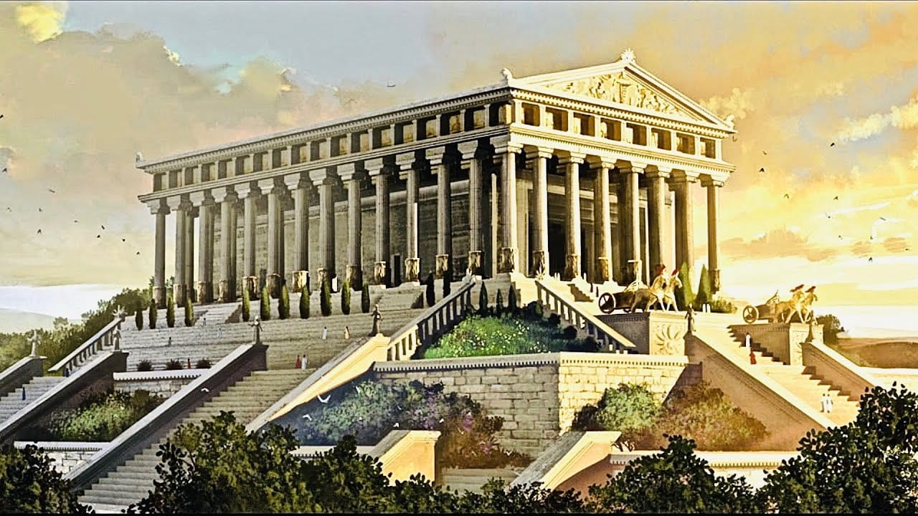
Paul’s point is, “Why am I promoting the gospel and being regularly attacked for it if there’s no reward after death?” “I should quit preaching and get my ‘reward’ now - eat, drink and avoid strife.” An unearthed Roman tombstone to Tiberius Secundus summed up this idea.

“Bathing, wine, sex ruin our bodies,
but bathing, wine and love make life worth living”.

This was the overall thinking of the common man then and it’s still popular today. It makes sense… IF … there is no afterlife… and IF there is no God rewarding good behavior and loving acts. But… IF God rewards goodness after death, then eating, drinking, and sexing to the exclusion of eternally rewardable acts is shortsighted and foolish.

1 Cor. 15:33-34
Do not be deceived: “Bad company corrupts good morals.”
Start thinking clearly, as is right, and stop sinning, for some have no knowledge of God. I say this to move you to shame.

Some of the Corinthian saints were hanging out with worldly knuckleheads and reverting to thinking and talking like them. As the saying goes, “When you lay down with dogs, you get fleas.” The “No life after death” ideas Paul addressed was probably introduced into the church by saints associating with “flesh-heads”. Sure, we must interact with “flesh-heads” in our work and social settings, but we shouldn’t hang out with them and let down our guard. We should get socially intimate with those who “have the knowledge of God” so we get built up, not corrupted. This is tough for some saints. They have old friends or co-workers whom they like and “let down their guard” around these “flesh heads”. Soon the flesh starts looking better to them. Soon they start talking and act like them. And they forget that this life is only ‘Act 1’, which lasts for 50-100 years. ‘Act 2’ lasts forever.

There is nothing wrong with eating, drinking and sex. (As long as you don’t try all three at once!) Or watching TV, or playing cards, etc. The problem becomes making these things the center of your life as Tiberius Secundus did, putting it on his tombstone. We want to please God in all that we do, just as He wanted to please us in all that He gave us. The priority is doing things that please Him that He will reward. Eating, drinking and sex are great now but will not be rewarded in eternity – unless He tells you to do it. (Single guys, don’t hold your breath waiting for that revelation!) We don’t want to let things in the physical realm distract us from doing things that are good now and great for eternity, instead of only good now. This life is short. We carried nothing into this world, and we will carry nothing out – except for the rewards we earned for Christ. And eternity never ends.

1 Cor. 15:35
But someone will say, “How are the dead raised? And with what kind of body do they come?”

These were probably typical cynical questions asked by the “Eat, drink and be merry” crowd when confronted by the gospel’s claim of resurrection. They might have said something like, “The dead are raised? Really? I’ve never seen that. So, how will it happen? And what kind of body will they supposedly get? What if they were blown up in an explosion? How do you get a body from vaporized molecules? And what about those aborted in the womb? Will they be raised and if so, what body do they get? Are they fetuses forever?” Good questions. The rest of chapter 15 answers these questions.

1 Cor. 15:36,37
You senseless one, that which you sow does not come to life unless it dies.
And that which you sow, you do not sow the body that will be, but a bare grain, perhaps of wheat, or of something else.

9 Characteristics of the Resurrected Body

1 – Our resurrected body will be like our previous body, but much more superior.
(On this topic. I will borrow from and quote Robert J. Morgan, noted Bible writer.) Paul begins to answer the questions by using an agricultural analogy. Take for instance a pumpkin seed. It looks nothing like a developed pumpkin yet has the same genes within. The difference is that the seed needs to “die”, be planted in the ground, begin to decompose, and then a miraculous transformation takes place. It’s transformed from a small seed to a plant with huge, beautiful vegetables. Same genes, just a different developmental stage. All that was needed was for the seed to ‘die’ and resurrect.

1 Cor. 15:38
But God gives it a body just as it pleased him, and to each of the seeds he gives a body of its own.

When an acorn germinates it issues a body different than what a pumpkin seed produces. This principle holds true throughout the plant and animal world.

1 Cor. 15:39
All flesh is not the same flesh, but there is one flesh of humans, and another flesh of animals, and another flesh of birds, and another of fish.

The seeds of pumpkins and acorns produce different results, as do the seeds of humans, sheep, eagles, and trout. This leads us to the first principle in this section, which is, when we plant an acorn, we’ll get an oak tree, not a human or a trout. The seed and that which it produces will have the same basic nature, but the end result will be superior. We die a human and we’ll be raised up a human, but much better. We won’t be a dandelion or a bull or a ball of light. Those are totally unrelated to humans – before or after being raised. So, reincarnation is a “no go”. Reincarnation teaches that your ‘spirit’ (your essence) is reborn into a different body. Resurrection teaches that you (and your essence) will be raised from the dead to a similarly related better body but with a new animating spirit. So, those who say that we will be transformed into a brahma are ‘full of bull!’ The point is that we will be figuratively sowing (planting) our bodies in the ground, but what will be coming up will be related, but a little different and better. (More on this later.)

1 Cor. 15:40-41
There are also heavenly bodies and earthly bodies, but the glory of the heavenly is one kind, and the glory of the earthly is another.
There is one glory of the sun, and another glory of the moon, and another glory of the stars, for star differs from star in glory.

2 - Our Resurrection Bodies Will Be Patterned After Christ’s. The body that dies is Adamic. It is like the body of the first man, Adam, who died. But when we are resurrected, our bodies will be glorified like that of Jesus, the Second Adam.

1 Cor. 15:45-47
So also it is written, the first man, Adam, became a living soul. The last Adam has become a life-giving spirit.
But the spiritual is not first, on the contrary, the soul body is; after that is the spiritual.
The first man is of the earth, made of dust; the second man is of heaven.

Jesus died too. He was put to death. His body was sown in dishonor, weakness and sorrow. But at that moment when He was resurrected, a bolt of transforming power stuck Him and when He rose again His body was changed, transformed, glorified, and equipped for eternal life. And He set the pattern for us.

1 Cor. 15:48,49
Like the one made of dust, so too are those who are of the dust; and like the heavenly man, so too will be the heavenly ones.
And just as we have borne the image of the man made of dust, we will also bear the image of the heavenly man.

On this planet, we bear the ‘dusty’ bodies of Adam. We have genetic damage, illness, disease, sickness, and death. But at the resurrection, our bodies will bear the image of Christ – life, righteousness and wholeness. This is a consistent teaching of Scripture.

Phil. 3:20,21
But our citizenship is in heaven, from which we also wait for the Savior, the Lord Jesus Christ,
who will transform our lowly body so it will have the same form as his glorious body, by the power that also enables him to subject all things to himself.

1 John 3:2
Beloved, we are children of God now, and it has not yet been revealed what we will be. We know that when it is revealed, we will be like him because we will see him just as he is.

3 - Our resurrection bodies will be incapable of corruption and dying. Right now, we’re corrupting and subject to death at any moment. Our bodies are perishing, then they die. But after the resurrection our glorified and transformed bodies will be incapable of dying. In verses 50-54 notice the seven times ‘incorruption’, ‘imperishable’, and ‘immortality’ occur. ‘Incorruption’ means incapable of corruption or degrading. ‘Imperishable’ means it cannot perish or be annihilated forever. ‘Immortal’ means not subject to death.

1 Cor. 15:50-54 (Bold face and underlining added)
Now I say this, brothers and sisters: flesh and blood is not able to inherit the Kingdom of God; neither does corruption inherit incorruption.
Look! I tell you a sacred secret: we will not all sleep, but we will all be changed.
In a moment, in the blink of an eye, at the last trumpet, for the trumpet will sound, and the dead will be raised imperishable, and we will be changed.
For this corruptible must put on incorruption, and this mortal must put on immortality.
Now when this corruptible puts on incorruptibility, and this mortal puts on immortality, then the word that has been written will be brought to pass: Death has been swallowed up in victory.

Here’s another related scripture.

Rom. 6:8-11 (Boldface added)
Now since we have died with Christ, we believe that we will also live with him,
because we know that Christ, having been raised from among the dead, will never die again; death no longer has dominion over him.
For the death that he died, he died once and for all with respect to the power of sin, but the life that he lives, he lives in relation to God.
So you also must consider yourselves to be dead with respect to the power of sin, but in union with Christ Jesus, alive in relation to God.

Notice the words about Jesus, he ‘will never die again’. What was the one thing Jesus could do during HIs earthly life that He can never do again? What capacity did He have before the cross that He lost afterward? The capacity of dying. Before the crucifixion he was capable of dying. After resurrecting that capability was gone forever. When his entombed body was struck by the Resurrection Bolt of the Holy Spirit, a surge of glorification instantly transformed Him. He rose imperishable. The Bible says, “Since Christ was raised from the dead, He cannot die again.” And He also said, “Because I live, you will live also.”

4 – Our resurrected bodies will be incapable of pain and tears. Right now, we’re subject to terrible pain. Some of our pain is from diseases, injuries, and illnesses. Some people experience terrible pain inflicted by others. Some are even tortured. But our resurrection bodies will be incapable of pain.

Rev. 21:4
and he will wipe away every tear from their eyes, and death will be no more, nor will there be mourning, nor crying, nor pain, anymore; the former things have passed away.”

5 - Our resurrection bodies will be physical, real, corporal, and recognizable.

Luke 24:36-43
And as they spoke these things, he [the resurrected Christ] himself stood in the midst of them, and said to them, “Peace be to you.”
But they were terrified and frightened, and thought they were seeing a spirit.
And he said to them, “Why are you troubled? And why do doubts arise in your hearts?
Look at my hands and my feet, and see that it is I myself. Touch me and see, because a spirit does not have flesh and bones as you can see that I have.”
And when he had said this, he showed them his hands and his feet.
And while they still did not believe for joy, and were amazed, he said to them, “Have you anything here to eat?”
And they gave him a piece of a broiled fish.
And he took it and ate it in their presence.

In his book about the believer’s afterlife, Randy Alcorn said, “We’ll stand on the New Earth and see it, feel it, smell it, taste its fruits, and hear its sounds. Not figuratively. Literally. We know this because we’re promised resurrection bodies like Christ’s. He saw and was seen. He heard and spoke. He was felt by others and held and ate fish. He presumably smelled and tasted it. We will too.”

6 – Our resurrected bodies may have extra-dimensional qualities.

Luke 24:30,31
And it came to pass, when he [the resurrected Christ] had reclined to eat with them, he took the bread and blessed it, and breaking it, he began giving it to them.
And their eyes were opened, and they recognized him, and he vanished out of their sight.

He had the ability to disappear, and we see Him later that evening in Jerusalem, as though he traveled there by being instantly transported. Also look at…

John 20:19-20
Now when it was evening on that day, the first day of the week, and when the doors were shut where the disciples were because of their fear of the Jews, Jesus came and stood in the midst, and said to them, “Peace be to you.”
And when he had said this, he showed them his hands and his side. So the disciples were overjoyed when they saw the Lord.

Jesus seemed to have been able to pass right through locked doors. Also we read …

Acts 1:9
And when he had said these things, while they were watching, he was taken up and a cloud received him out of their sight.

The glorified body of Christ had and has extra-dimensional abilities. It can appear and disappear; it can travel, it seems, by transport; it can pass through locked doors; it can fly or ascend into the sky. Now, when we’re told that our resurrection bodies will be like our Lord’s, it is speaking in terms of immortality. Just because He could do those things doesn’t guarantee we will be able to. But, why not? Angels seem to have these same abilities, and we know that our resurrection bodies are going to be far superior to our current ones.

7 - Our resurrection bodies will be in the prime of life. Many theologians have taught that in terms of the spectrum of apparent age, we’ll all appear to be perhaps somewhere around 28-33 years old at the Rapture, for that’s the age Jesus was at the moment of His resurrection. That’s an age that seems to express the prime of life. And when we think of Adam and Eve, they were created in the prime of life. They weren’t created as babies, nor were they elderly. We will be raised and transformed at our peak – for eternity!

It seems that our new bodies will retain some of our old body’s characteristics like Jesus who could still display his wounds from the crucifixion in John 20:27. Yet his new body’s appearance was not easily or initially recognizable as Mary Magdeline, the apostles, and the two Emmaus Road disciples proved. Perhaps Jesus was able to change his appearance from old body to new body to accommodate those familiar with the old. That would mean that he could show the scars of the old body or change to wholeness. That would mean those of us missing body parts could be ‘transformers’, alternating between old and new body appearances at will. It seems Jesus’ old wounds didn’t disable him in any way, so neither will ours.

8 - Our racial and gender identities will probably continue into heaven. If you’re a man or a woman on earth, you’ll be that in heaven. If you’re Caucasian or Asian or Black or Jewish or whatever, that’s what you’ll be in heaven. Here are two verses from Revelation that seem to suggest this.

Rev. 5:9, 7:9
And they were singing a new song, saying, “You are worthy to take the scroll and to open its seals, for you were slain, and with your blood you purchased for God people from every tribe, and language, and people, and nation,
After these things, look, I saw a great multitude from every nation, and tribe and people and language, which no one could count, standing before the throne and before the Lamb, clothed in long white robes and with palm branches in their hands,

9 - We may have a luminescent quality to us. Do you remember what Paul said in 1 Corinthians 15 about the glory of the heavenly bodies being different from those of earth? What was the major difference? Their glow and their glory.

In Exodus 34, Moses spent time with the Lord and something unusual happened to him. When Moses came down from Mount Sinai with the two tablets of the covenant law in his hands, he was not aware that his face was radiant because he had spoken to the Lord. When Aaron and all the Israelites saw Moses, his face was radiant, and they were afraid to come near Him.

In Luke 9:28-30, Jesus took Peter, John, and James and went up onto a mountain to pray. As He was praying, the appearance of His face changed and His clothes became as bright as a flash of lightening. Moses and Elijah, appeared in glorious splendor, talking with Jesus.

When we see Jesus after His ascension, His face is as brilliant as the sunshine. In Acts 9, Saul of Tarsus saw him and was blinded by the experience. In Revelation 1, John saw a vision of the enthroned Christ and He was splendorous. And in Revelation 21, we’re told that the entire city of New Jerusalem will be luminescent and illumined by the light that radiates from the resurrected Christ.

Will our new bodies glow after the Rapture? If Jesus’s did and we will be getting a body like his, why not?



