Food Offered to Idols

1 Cor. 8:1-4a

Now concerning things sacrificed to idols, we know that we all have knowledge. Knowledge puffs up, but love builds up.

If anyone thinks that he has come to know something, he does not yet know as he ought to know.

But if anyone loves God, that one is known by him.

Therefore, concerning the eating of things sacrificed to idols,

What is this “eating of things sacrificed to idols” all about? In Corinth, idol worship usually included burnt offerings, eating some of them, wine, and sex. There were also two other ways to eat things offered to idols outside an idol “worship” setting. The first was at a social temple event. From Stuart T. Rochester, Regent College, Vancouver:

“The Greco-Roman culture was thoroughly imbued with the worship of many deities, and consequently there were large numbers of temples at which a variety of social and religious activities took place. It is known that, apart from the formal worship of deities, involving ritual animal sacrifice, pagan temples provided a venue for social gatherings of fraternal associations, and also served as ‘restaurants’ for the general public.”

What do you do with all the leftover Aphrodite Angus? You sell it! And that’s what they did, offering catering and hospitality services to the “Corinthian Canvas Cutters, Local 104”. They also provided food through “Aphrodite’s Annex”, a walk-in public restaurant serving the left-over sacrificial beef to the public. The second way people got this food was from the marketplace which we’ll discuss when it comes up in chapter 10. This situation at the beginning of chapter 8 is not addressing someone worshiping Aphrodite and eating the meat just sacrificed. That would have been considered idolatry and condemned outright. This refers to someone eating at a temple “convention center” or at the annex restaurant.

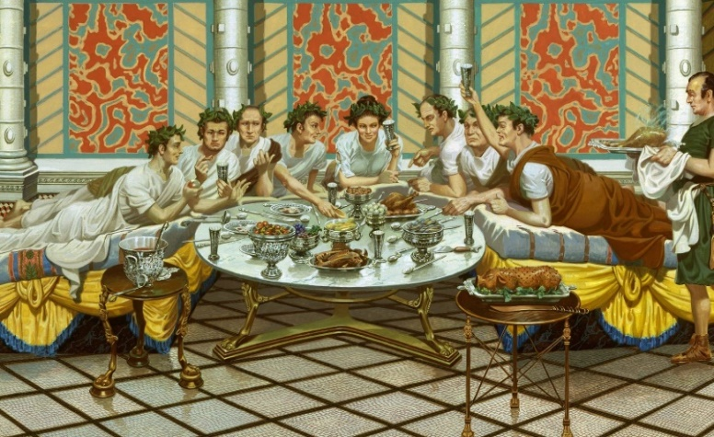

1 Cor. 8:1-7a

Now concerning things sacrificed to idols, we know that we all have knowledge. Knowledge puffs up, but love builds up.

If anyone thinks that he has come to know something, he does not yet know as he ought to know.

But if anyone loves God, that one is known by him.

Therefore, concerning the eating of things sacrificed to idols, we know that “no idol in the world really exists,” and that “there is no God but one.”

For even if there are so-called gods, whether in heaven or on earth (as indeed there are many “gods” and many “lords”),

yet for us there is one God, the Father, from whom are all things, and we are for him; and one Lord, Jesus Christ, through whom are all things, and we are through him.

But not everyone has this knowledge.

What kind of knowledge is being referred to? The answer is the knowledge that idols are not real. This insight was new to Corinth which was steeped in idolatry for centuries. Its economy was built on idol temples and “worship”. Paul’s preaching included the realization that Aphrodite, the supposed goddess of love, was not a real person. Neither was Poseidon, the beneficent and furious god of the ocean and earth, to whom the Corinthian games were dedicated every four years. Paul announced that the gods were only inventions of demons, whose power was eclipsed by the risen savior, Jesus Christ.

This must have come as a shock to the Corinthians. They were used to worshiping and praying to Poseidon for his favor for plenteous harvests and favorable seas. They saw the disastrous results when he was “angry”, “answering” with famines and furious storms.

Once the Corinthians got saved, they prayed to the one true God and followed His son, Jesus Christ. Nonetheless, the old habits die hard. They could see Poseidon’s statue and murals at the temple, from which they heard the songs sung to him. They could still feel the tug on their hearts when they ignored him as the Christian church regularly did, instead imploring their new God for favor and blessing. Although this perhaps seems strange, this is typical young, immature believer growing pains and behavior.

Let me explain. Have you seen the movie, “Silence of the Lambs”? It has a great villain portrayal by actor Anthony Hopkins of a psychotic killer, Hanibal Lector.



The character is amazingly fearing-inducing. Some viewers can’t get to sleep after seeing the movie, concerned that Dr. Lector will somehow “get them”! This continues until the scared viewer realizes that Hanibal Lector is not real, but only a character invented by the writer and actor, neither of which will ever “get them”! This is why we restrict certain movies to young people who have not yet developed the ability to distinguish fact from fiction and will certainly be terrorized by a fabricated villain. This is like Paul’s revelation about Aphrodite and Poseidon in Corinth. He announced that they weren’t real but only inventions of demonic spirits with physical representations in stone, wood or murals. And, most importantly, Jesus was the one true God’s son, vastly superior to the demons who have been made subject to him, and now, subject to us!

Now at first glance, accepting the gospel seems simple – salvation is a clean break with the past – new God, new Lord, new spirit, new family, new guidelines, etc. But with fallen humanity, nothing is simple as we’ve seen so far in this epistle (and our own lives!). Years of devotion and habits die hard. Deep in the new saint’s memory is the time they prayed and sacrificed to Aphrodite, and they got some love. And the time they didn’t sacrifice to Poseidon and the results were baaad! So, some still had some tentative lingering deference for their past idols because of their past track record. From God’s perspective and their benefit, they should avoid the old idols while they seek to building a track record of trust in Christ that eclipses their past with idols.

Someone asked me recently what I would do if the world went crazy, electricity died and all money evaporated. I thought that sounded exciting and told them so. They said I was nuts. The fact is I’m confident – in God! Three times in my life I had nothing, and God helped me put things together. I was a minister for 15 years and it fell apart. I started in the car business with nothing and did well, although about 20 years later, that fell apart too. Then I started insurance in my mid 50’s and 15 years later retired with no debt. Not much brains either, but at least - no debt! Three times God got me from zero to victory in big ways. That’s why if the zombie apocalypse happens, I’m looking forward to what God has in store. Why? I’ve 50 years of experiencing God’s faithfulness to His promises and to little old me.

The new converts/immature believers at Corinth didn’t have that background yet. Nor did I at first but I learned over time who God was and what He could do. As I trusted Him, He came through, and my trust grew. It takes time to grow a baby to an adult and to grow up spiritually, too. God wants us to avoid “arrested development”. “How?” you might ask.

1 Cor. 8:7

But not everyone has this knowledge. Some are still so accustomed to idols that they eat as if it were food offered to an idol, and their conscience, being weak, is defiled.

When a young believer does any old idol worship activities, this smacks of disloyalty to their new lord and fidelity to their old. Their confidence in Christ dissolves and conscience toward God is injured. That should never happen. Why? Because they consider their “sin” to separate them from God. Why? Because they have not yet learned…

1 Cor. 8:8

But food will not bring us close to God, for neither, if we do not eat are we left behind, nor if we eat, do we have an overflow of credit.

Eating food related to an idol will not result in us being “left behind” from God’s viewpoint. Why? We are His children, born again of His spirit. We have been graced with eternal life by Christ’s sacrifice on our behalf. “Eating doesn’t bring us close to God” or give us an “overflow of credit” with Him. It takes a while for new Christians to realize that nothing we can do, can add to, or subtract from, what Christ has done on our behalf. We will never be more, or less righteous than what God has made us. What Christ accomplished and gave us is way bigger than food! But… it’s all spiritual. And if you’re still tuned in to the big, scary Poseidon images or if the memory of Aphrodite gives you a warm tingle, then avoiding physical associations with these idols, - even though they are imaginary personages - is wise if you want to build a track record of trust with Christ.

1 Cor. 8:7

But not everyone has this knowledge. Some are still so accustomed to idols that they eat as if it were food offered to an idol, and their conscience, being weak, is defiled.

This could become a problem in two ways. #1. For those saints who know Christ is bigger than food and the fake idols and, #2. For those saints that don’t really know that yet.

1 Cor. 8:9,10

But take care lest by any means this liberty of yours becomes a stumbling block to the weak.

For if someone sees you who have knowledge reclining to eat in an idol’s temple, will not his conscience, if he is weak, be emboldened to eat things sacrificed to idols?

Once again, this refers to someone at a Corinthian convention center or at the Poseidon restaurant annex eating (reclining – that’s how they ate).

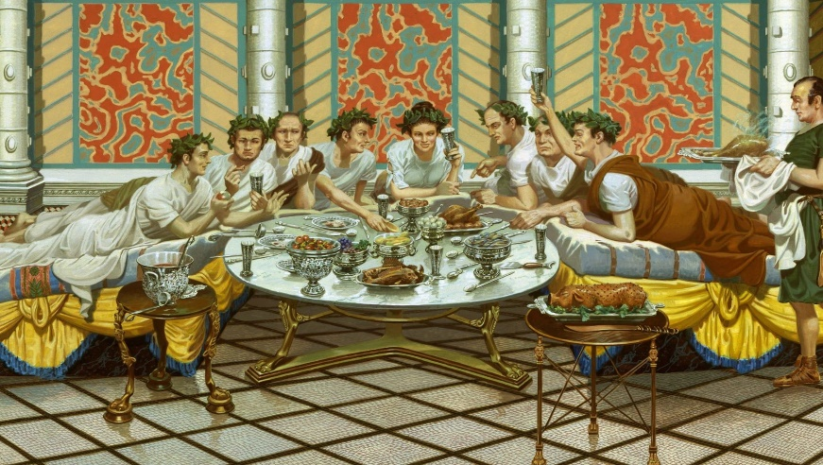

Imagine if the server on the right, a newer Christian, a lower-class guy named Gus, sees an upper class elder Christian guy in red, munching on Aphrodite Angus. What does he think? Perhaps he thinks, “Hey, that’s Fred, an elder at church. He’s eating leftover idol meat! That was offered to Aphrodite in a temple sacrificial service! I thought he was dedicated to Christ! It looks like he’s a hypocrite. Or maybe Jesus isn’t really interested in our commitment to him, because that’s how Fred’s acting. I’ve been praying to Yahweh for a spouse and haven’t got one yet. Maybe I should go back to Aphrodite because I’m lonely.”

Fred knows that Aphrodite is a demon-inspired illusion. Fred also knows that food was made by God for our benefit and enjoyment and that it has nothing to do with our value to God. Regrettably, Gus knows none of that yet. And maybe he never will if he follows through on his thoughts and veers back toward Aphrodite.

1 Cor. 8:11 -13

And so by your knowledge, the one who is weak is ruined—this brother for whose sake Christ died.

And when you sin against the brothers or sisters in this way, and when you wound their conscience when it is weak, you sin against Christ.

Therefore, if food causes my brother to fall away, I will never eat meat, lest I cause my brother or sister to fall away.

To Fred, eating the food is nothing (no big deal), but God says that hurting others when you do it, is. The first point and exhortation from God is - Don't eat idol meat (in a place associated with a pagan temple) because someone will be scandalized. 1 Cor. 8:1-13. (Fred says, “Wait! What about my freedom in Christ and rights as a believer?” God will answer this question in 1 Cor. 9:1-10:22.) The second point and exhortation from God is - Eat idol meat (anywhere else) unless someone will be scandalized. 1 Cor. 10:23-11:1

Let’s stay with the “food offered to idols” topic which resumes 1 Cor. 10:23 and concludes at the beginning of chapter 11. We’ll discuss the problem of supposed “loss of freedom” next installment beginning in chapter 9.

1 Cor. 10:23

“All things are lawful” but not all things are beneficial. “All things are lawful,” but not all things build people up.

The probable Corinthian Christian church slogan re-emerges, “All things are lawful”. Again, the point is made that just because you can do something doesn’t mean you should. What’s the Christian lens through which we should view our decisions and actions? “Is my choice beneficial to build up?” Also, once again, it’s not talking about building up a bank account, or muscles. The context is spiritual edification. “Do my decisions and actions build up my trust in what Christ did for me and what he is in me? And what do my decisions and actions do for others? Do they spiritually build up or tear down?” These are the spiritual and ethical “glasses” we use to see ourselves, the Christian family, and the world.

1 Cor. 10:24

No one should seek his own good, but the good of the other person.

It is assumed and understood that the verse has the thrust “No one should seek his own good [only], but the good of the other person [also].” God is not asking us to ignore or punish ourselves, but to consider the effect of our actions on others too.

1 Cor. 10:25

Eat anything that is sold in the meat market without asking questions for conscience’ sake,

for the earth is the Lord’s, and everything in it.

Another way a Corinthian could eat “meat with a bad history” was by purchasing it at the marketplace, where leftover non-restaurant meat was off-loaded from the temple. Why should they eat it? Because food is a gift from the Creator – despite any sordid past.

1 Cor. 10:27

If one of those who does not believe invites you to a feast, and you want to go, eat whatever is set before you, asking no question for conscience’ sake.

But if anyone says to you, “This has been offered in a sacrifice to idols,” do not eat for the sake of the one who informed you, and for conscience’ sake.

Now I say “conscience,” not meaning your own, but the other person’s, for why is my freedom subject to the judgment of another’s conscience?

If I partake with thankfulness, why am I slandered for that for which I give thanks?

So, if some unbeliever neighbor invites you to their house for a barbecue, and no mention is made of the source of the pork chop, eat it. But if the host boasts, “These chops were only $2/pound because they are last week’s Poseidon pork!” then don’t eat it. Why? Because it will dirty your witness to the unsaved and those new in the faith, as was discussed in chapter 8. We Christians must stand for the ONE true God and keep Him separate from all the idols, even though we know that they’re pretenders, not contenders. To the senses-oriented person, idols are a big deal. To us, God is the big deal and we keep ourselves at arm’s length from all the imposters once they’re mentioned.

1 Cor. 10:31

Therefore, whether you eat, or drink, or whatever you do, do everything to the glory of God.

Here’s the positive answer to the question, “What should I do?” The question we should ask before answering is, “Does it glorify God?” Whatever situation Christians find themselves in, this is the question they should ask and answer for questions like: “Do I eat this meat? Do I attend this banquet? Do I take this job? Do I date this girl? Do I move to this neighborhood? Do I pay taxes that seem unfair?” Wait! Did I just say that out loud? Yes, in the state in which we live the elected representatives have decided to raise our taxes significantly (without promising to increase government services accordingly). This is what is known colloquially as a “rip off”. A majority of my witless fellow citizens repeatedly vote for a social theory that has never, nor will ever, work – socialism. So, do I move to a more tax friendly state from an increasingly “tax unfriendly” state now that I’m retired and making less money? What’s the right question to ask? Is it a Ben Franklin pro-con list? Should we ask an accountant? Should I ask AI? No, how about asking God? What’s He say? What will glorify Him and bless others? Perhaps living in a “state of confusion” and standing and speaking for God will be better than running off and keeping a few more acorns in the tree to leave for the kids, should Christ tarry. Back to 1 Corinthians.

My private ruminations illustrate the positive conclusion to this whole discussion of “eating food offered to idols”. Here’s the negative aspect to consider.

1 Cor. 10:32-33

Give no offense to Jews, or to Greeks, or to the church of God,

just as I also please everyone in all things, not seeking my own benefit, but the benefit of the many who do not believe, so that they might be saved.

To illustrate the negative perspective of our dilemma, will us staying in the state be a stumbling block for other’s salvation or a benefit? The answer is clear – staying and witnessing will be a benefit for others. Therefore, I should stay and witness to the witless and pay more for the privilege because God says He’ll pay us back later! Make sense? It does if you think spiritually, but financially and politically, it’s stupid. Oh, well!

1 Cor. 11:1

Be imitators of me, just as I also am of Christ.

Jesus once said he could command 12 legions of angels. That’s 72,000. Imagine that power! (Perhaps you can, but I can’t!) He raised the dead and healed the blind. His speaking and presence were so charismatic that he could attract crowds of thousands, without advanced advertising or TV. He could have been rich beyond Solomon or started an empire beyond Babylon. Instead, he chose to ask the questions “What will glorify God?” and “What will benefit others?” He spent his short earthly life living the answers.

The apostle Paul came from blue blood stock. He was accepted and attended the instruction by the most outstanding rabbi of his time, Gamaliel. He was part of the Sanhedrin, the 70-member ruling council of Israel, similar to the US Senate. His future had no limit. Instead, he answered Jesus’ call and chose to be a leader of the Christian church, despised and persecuted by the Sanhedrin and the Gentile authorities. He went around as an itinerate preacher, supporting himself by tent making and preaching when and where he could. The book of Acts describes some of the hardships he endured, when instead he could have been in Jerusalem, adored by the temple goers and respected by his peers. Why forgo the fame for the struggle? He asked and answered the same questions Jesus did, “What will glorify God?” and “What will benefit others?” and chose to live the answers.

1 Cor. 11:1

Be imitators of me, just as I also am of Christ.

Now it’s our turn to ask and answer these questions and then, live the answers God gives us with His help.