Dysphemism #1

Let’s look at Dysphemism, the use of a derogatory term in place of an inoffensive term. Dysphemism is the opposite of the better-known figure of speech, Euphemism. In a Euphemism, “a woman of the night” is said instead of “prostitute” and “rest room” is said instead of “excrement disposal site”. Euphemism puts a “good face” on an ugly reality. In contrast, dysphemism puts an “ugly face” on something that is usually neutral. A Dysphemism calls the postal service “snail mail”, highlighting the slowness of postal delivery compared to email’s immediacy. Dysphemism is an implication that is a “put down”, while Euphemism is an implication that is a “put up”. The Bible has many examples of both figures, although Euphemism is usually recognized while Dysphemism isn’t. Let’s discuss two Dysphemisms and learn valuable insights.

Herod

Luke 13:31,32 REV

At that time certain Pharisees came, saying to him [Jesus], “Go off and get away from here, for Herod wants to kill you.”

And he said to them, “Go and say to that fox, ‘Look! I will keep on casting out demons and performing healings today and tomorrow, and on the third day I will be finished.’

A confusing subject for some in the New Testament is “King Herod”. Some wonder, “Who was he and why did he reign so long in different places?” Here is a 2014 blog by Professor Kenneth Berding of Biola University answering these questions.

“In my last post I wrote about Herod Antipas. As I was writing, I realized that a lot of people get confused about who “Herod” is in the Bible. This isn’t surprising since there are actually six different (!) “Herods” in the New Testament, and they are all somehow related to each other. Here are thumbnail sketches to help you keep track of who’s who:

1. **Herod the Great** (ruled 37-4 B.C.) He’s the guy in the Christmas story. Super powerful client king answerable to Rome. Tried to trick the wise men. Killed the babies in Bethlehem (not to mention some of his own sons and wives). Not cuddly at all. Actually, you wouldn’t invite any of these Herods to become your “bosom friend,” but especially not “the Great.”

2. **Herod Archelaus** (ruled 4 B.C.-A.D. 6) He was one of Herod the Great’s three sons mentioned in the Bible. He received one-half of his father’s territory, the area surrounding and near Jerusalem (Judea and Samaria). Joseph was unwilling to move Mary and young Jesus to Bethlehem after fleeing to Egypt because Bethlehem was in this Herod’s territory and, like his father “the Great,” Herod Archelaus wasn’t known to be very cuddly either. He got replaced by a Roman procurator less than ten years into his reign; that’s why Pontius Pilate is the man in charge at Jesus’ crucifixion rather than one of the “Herods.”

3. **Herod Antipas** (ruled 4 B.C.-A.D. 39) Jesus called him “the Fox” (Luke 13:32). Received a quarter of his father’s territory (Galilee and Perea). Divorced his first wife and married Herodias, the wife of his brother (who was yet a different “Herod”). Killed John the Baptist. Pontius Pilate sent Jesus to see this Herod as part of Jesus’ trial, since this Herod was visiting Jerusalem at the time Jesus was sentenced to death.

4. **Herod Philip the Tetrarch** (ruled 4 B.C.-A.D. 34) Got the remaining quarter of his father’s territory (north and east of Galilee—mostly ruled over Syrians and Greeks).

5. **Herod Agrippa I** (ruled A.D. 37-44 [41-44 in Judea]) Grandson of Herod the Great and nephew of Herodias, Herod Antipas’s wife. In the book of Acts he is known as the one who put Peter in prison (Acts 12:1–5 and was struck by an angel and “eaten by worms” (Acts 12:20–23).

6. **Herod Agrippa II** (ruled A.D. 50s until around A.D. 93) He interviewed Paul along with the Roman procurator Porcius Festus when Paul was imprisoned in Caesarea after Paul’s third missionary journey (Acts 25–26). Agrippa exclaimed to Paul, “In a short time you will persuade me to become a Christian?” (Acts 26:28).”

Jesus dealt with Herod #3 in Luke 13 - the same guy who be-headed his kinsman, John the Baptist, of whom he declared. “Among those who are born of women there has not arisen anyone greater than John the Baptist”. This Herod was the latest in a series of murderous tyrants. The only time the Bible records Jesus saying his name is Mark 8:15.

Mark 8:15

And he [Jesus] ordered them, saying, “Watch out! Beware of the leaven of the Pharisees and the leaven of Herod.”

Jesus says Herod’s name only to clarify the type of doctrine (figuratively spoken of as leaven) of which he warned his disciples. There are a few Greek texts that substitute ‘Herodians” for “Herod”, thus even possibly further diluting Jesus’ use of the current dominant political leader’s name. It could be argued that Jesus never uttered his name directly. This is unusual as we would expect all subjects to mention the king by name, yet Jesus doesn’t. As we will see, God has a habit of not naming those who obstinately oppose Him. He may mention them in a dysphemism but otherwise He sometimes erases their “given name” entirely. This could be a harbinger of their ultimate disposition – oblivion.

When “warned” of Herod’s possible attack by the religious leaders, Jesus refers to Herod as “that fox”. This is an obvious figure of Implication, comparing Herod to a fox. It could be thought that an ancient king would be compared to a lion, “the king of beasts”. It would be assumed that their absolute power would ensure boldness and decisive action. The negative implication that Jesus emphasized calling Herod “fox”, was slyness, sneakiness and menace. Herod had no regal bearing like a lion but like that of a furry weasel. Instead of Herod being and acting regal, Jesus, the “King of the Jews”, had that bearing. When allegedly threatened by the supposedly ruthless tyrant, Jesus answers back with the boldness of a lion…

Luke 13:32

And he said to them, “Go and say to that fox, ‘Look! I will keep on casting out demons and performing healings today and tomorrow, and on the third day I will be finished.’

Who was the “fox” and who was the “lion”? The answer is obvious. Jesus was the king and Herod was a subject although he seemed to fight this reality. At one of Jesus’ “trials”…

Luke 23:8-11

Now when Herod saw Jesus, he was exceedingly glad, for he had wanted to see him for a long time, because he had heard about him, and he hoped to see some miracle done by him.

And he questioned him at considerable length, but he [Jesus] did not answer him.

And the chief priests and the experts in the law stood, vehemently accusing him.

And Herod with his soldiers treated him with contempt, and mocked him, and dressing him in a magnificent robe, sent him back to Pilate.

When standing in judgement before Herod, Jesus said nothing. Herod questioned and then mocked Jesus. Mind blowing! What would a lion say when questioned by a fox? He would probably act as Jesus did – ignoring the insignificant sneaky animal. Jesus’s description of Herod as a “fox” is a figure of implication and dysphemism, showing inconsequential distain. Let’s look at another dysphemism describing another spiritual rebel.

Nimrod

Gen. 10:8-12

Cush fathered Nimrod. He was the first to be a mighty one in the earth.

He was a mighty hunter before Yahweh. That is why it is said, “Like Nimrod, a mighty hunter before Yahweh.”

The beginning of his kingdom was Babel, Erech, Accad, and Calneh, in the land of Shinar.

Out of that land he went into Assyria and built Nineveh, Rehoboth Ir, Calah,

and built Resen between Nineveh and Calah (which is the great city).

Although Nimrod is focused upon after the great post-flood reset of humanity, he is spoken of very sparingly. What do we learn of him from this historic record? He was “first [after the flood – the context] to be a mighty one in the earth”. Here is some insight on this text from the commentary of the REV.

“Nimrod did not live in Yahweh’s favor. In fact, the name “Nimrod” was almost certainly not his birth name, it was given to him because of his lifestyle of rebelling against authority and against God. “The Hebrew name Nimrod means ‘let us rebel,’ given by his contemporaries to Nimrod as one who ever had in his mouth such words to stir up his band to rebellion. Nimrod subverted the existing patriarchal order of society by setting up a chieftainship based on personal valor and maintained by aggression.” Given that, the Hebrew phrase “before Yahweh” has been understood by many scholars to have the sense of “in defiance of” Yahweh; or “against” Yahweh. Some scholars disagree with that and think that it means more like “a mighty hunter in the eyes of God”.

What did Nimrod hunt? Did he put on camouflage and sit in a duck blind with a shotgun? Or wear hunter orange and sit in a tree stand with a cross bow? Check the context.

Gen. 9:1,5-7

God blessed Noah and his sons and said to them, “Be fruitful and multiply and fill the earth.

` Surely I will require a reckoning for your lifeblood—from the hand of every animal I will require it, and from the hand of every man. From the hand of a brother human I will require a reckoning for the life of a human.

“Whoever sheds the blood of man, by man his blood is to be shed, for God made man in his own image.

Be fruitful and multiply. Increase abundantly on the earth and multiply on it.”

Nimrod’s sin (among others) was that he didn’t “Increase abundantly on the earth and multiply on it.” He started the first “one world government” after the flood. How did he do that? By destroying and replacing the previous governments of all the conquered areas mentioned in verses 10-12. He “destroyed abundantly on the earth and subtracted from it”. He hunted people – lots of people. He certainly lived up to the name “Let us rebel”. He did the opposite of what God had originally commanded Adam and then recommissioned Noah after the flood in the great human “re-start”.

It's interesting to realize that nothing else significant is revealed about Nimrod in the Bible. It is also interesting to realize that the secular world mocks the historical validity of Nimrod because nothing with that name has ever been found by archeologists. Wikipedia says:

“There is no evidence that Nimrod was an actual historical person in any of the non-biblical historic records, registers, or king lists (including any of the Mesopotamian ones, which are considerably older and more comprehensive than the biblical texts**).**

So, because they haven’t found any documentation of an ancient man named Nimrod, the Bible is supposedly unreliable, myths, etc.. Really? Dr. Randall Price, well-known author, world-renowned archaeologist, and president of World of the Bible Ministries, writes:

“Archaeological excavations in ancient Mesopotamia reveal striking parallels between the Bible’s King Nimrod and the ancient Semitic ruler Sargon the Great, thus confirming the biblical king’s historicity.

The Old Testament mentions Nimrod four times, calling him “a mighty one on the earth” (Gen. 10:8; 1 Chr. 1:10); “a mighty hunter before the LORD” (Gen. 10:9); and the founder of the Assyrian Empire (Mic. 5:6). But who was he?

The ancient Jewish writers Philo of Alexandria and Flavius Josephus suggested Nimrod was a giant who opposed God and the tyrant behind the construction of the Tower of Babel (respectively). Genesis 10:10–12 includes within Nimrod’s kingdom the Sumerian cities of Babel and Uruk (Erech); the city of Akkad (Accad) in “the land of Shinar” (southern Mesopotamia/Babylonia); and the Assyrian cities of Nineveh, Resen, and Calah. Archaeologists have uncovered the remains of some of these cities, which have helped them identify Nimrod.

Nimrod built his extensive empire from south to north, indicating a third-millennium BC setting (3000–2000 BC). Therefore, he must have ruled in this region during this period. Egyptologist Douglas Petrovich argues that Sargon the Great, who built the first cities of Sumer and Akkad, best fits the historical data for five reasons:

First, both Nimrod and Sargon came from the same region. Nimrod’s origin in Cush matches Sargon’s origin in Sumerian Kish. Both peoples and territories were named after Cush (Kish), Noah’s grandson. The Sumerian King List names Kish as the first city on which “kingship was [again] lowered from heaven” after the flood and says it became the leading city of Sumer, facts later confirmed by archaeological excavations.

Second, both Nimrod and Sargon made Akkad a prominent city. Although scholars don’t know the exact location of Akkad, ancient texts place it in Babylon and Kish and suggest it became prominent once Sargon made it his capital and restored Kish. From Akkad, Sargon conquered Mari, Ebla, and Assyria.

The archaeological record fits with the biblical record of Nimrod’s location in Sumer and his conquests of Uruk—the center of power in Mesopotamia—and Akkad, from which he extended his rule north (Gen. 10:10–11).

Third, both Nimrod and Sargon initiated building projects in Assyria. The Bible reveals Nimrod built the principal cities of Assyria (vv. 11–12). Archaeological discoveries in Nippur (an ancient city in Mesopotamia) credit the same feat to Sargon.

Archaeologists have discovered inscriptions of Sargon’s rule on monuments of native governors in the Assyrian cities of Ashur and Nineveh. They also found the remains of a statue dating to the reign of Manishtushu, Sargon’s second son and successor. Since history records Manishtushu as a less powerful figure, his attaining such stature strongly implies his father had seized power in Ashur. Additional excavations also support the fact of Sargon’s mastery in Assyria.

Fourth, both Nimrod and Sargon created a lasting influence on Assyria. The Bible indicates Nimrod’s exploits indelibly impacted the Israelites, since the prophet Micah equated the “land of Assyria” with “the land of Nimrod” (Mic. 5:6). In like manner, Sargon left an abiding influence on Assyrian culture by introducing the Eponym dating system, used throughout the history of Assyria.

Fifth, both Nimrod and Sargon were legendary for their military exploits. Genesis 10:9 calls Nimrod a “mighty hunter before the LORD,” indicating God observed—not approved of—his military exploits. “Therefore it is said, ‘Like Nimrod, the mighty hunter before the LORD.’” His reputation may have extended to successive generations (v. 9). Palace reliefs discovered in ancient Nineveh display the hunting exploits and military conquests of Assyrian kings.

Ancient steles reveal Sargon also was renowned for his military conquests, such as those recorded in his Stele of Ishtar, his Victory Stele, and the Manishtushu Obelisk. These steles, which embody only a small part of the mass of archaeological evidence concerning Akkadian military brutality, sufficiently show Sargon’s reputation in this regard.

Overall, archaeological excavations in ancient Mesopotamia provide historical evidence for Nimrod’s identity as Sargon, once again confirming the Bible rests on a solid, historical foundation.

ENDNOTES

Philo of Alexandria Quaestiones et Solutiones in Genesim (QG) 2.82.

Josephus Antiquities of the Jews 1.113–114. “

Nimrod the Empire Builder – Architect of Shock and Awe - Douglas Petrovich 2023

You may ask, “Ok, Steve. Thanks for the scholarly journey through ancient history and archaeology. What’s the point?” The point is, Sargon “the great” of Akkad was Nimrod. The next question is, “Why didn’t God call him by his given name?” The answer is that God only referred to him by dysphemism. Just a Jesus referred to Herod as “that fox”, God only referred to Sargon as “that rebel”, i.e., “Nimrod”. It seems that there are some folks God won’t directly name. Let me explain.

I have recently retired from being a Medicare health insurance agent. I’ve spoken to some retired people who, when their children are brought up, choke up with grief or gripping pain because of an untimely death of their child or the crushing disappointment of their bad decisions. Many times, these “suffering parents” sit mute in their pain, still unable to process the horror of the children’s situation. They usually don’t mention their child’s given name, using instead their family position title, in other words, “my son” or “my daughter”. Their “given name”, John, or Sandy, etc., is a reminder of what they were like at birth and before a calamitous change occurred. It’s as if their given name is too painful for them to say now. I think this is some of the logic behind God’s dysphemistic use for Sargon. Yes, he rebelled. But from whom did he rebel? Sargon rebelled against the loving God who told Noah and his family “Whoever sheds the blood of man, by man his blood is to be shed, for God made man in his own image. Be fruitful and multiply. Increase abundantly on the earth and multiply on it.” He did neither. Remember, Noah’s immediate family was still very much alive during Nimrod’s time and assuredly repeated the epic transformational experience of the flood, which had only just occurred a few decades before. Astounding!

Adam and Eve disobeyed God in a sort of rebellion and rejection. Nevertheless God gave Adam’s progeny a mercifully life in the fallen world even after their ancestor’s sin and expulsion from the garden. Regretfully some of them together with some mutinous “sons of God” also rebelled against their Creator. This necessitated Noah’s flood. God started humanity anew after erasing the spiritually poisoned DNA of Nephilim. Within a few generations after the flood, God was stiff-armed again, led by the mighty rebel, Sargon. It was probably heartbreaking to God – having loved and invested so much and being repeatedly rejected for centuries.

God chose not to say Sargon’s name but simply refer to him by the moniker “Rebel”, in other words, Nimrod. He may have been important to history, but he was a heartbreak to God – both in his rebellion to his Creator and furthermore in the slaughter of so many made in God’s image. By dysphemism, God made Sargon/Nimrod an unnamed “speed bump” on the way to His redemption of mankind and creation.

Dysphemism #2

We are studying Dysphemism, the use of a derogatory term in place of an inoffensive term. Dysphemism is the opposite of the better-known figure of speech, Euphemism. In a Euphemism, “a woman of the night” is said instead of “prostitute” and “rest room” is said instead of “excrement disposal site”. Euphemism puts a “good face” on an ugly reality. In contrast, dysphemism puts an “ugly face” on something that is usually neutral. A Dysphemism calls the postal service “snail mail”, highlighting the slowness of postal delivery compared to email’s immediacy. Dysphemism is an implication that is a “put down”, while Euphemism is an implication that is a “put up”. The Bible has many examples of both figures, although Euphemism is usually recognized while Dysphemism isn’t. Let’s discuss another Dysphemism and learn valuable insights.

Babel

Surprisingly, the city where Nimrod’s empire began, Babel, is referred to in a dysphemism.

Gen. 11:1-2

The whole earth had one language and one set of words.

And as they traveled east, they found a plain in the land of Shinar and they settled there.

Allow me to use the words of scripture to craft a **possible (not guaranteed)** scenario for verse 2 of chapter 11. Let’s say that Noah, his wife, his three sons and their wives landed “on the mountains of Ararat” as Gen.8:4 says. Notice that it doesn’t say on “Mount Ararat”, a 17,000-foot volcanic mountain, but on one of the mountains associated with it.

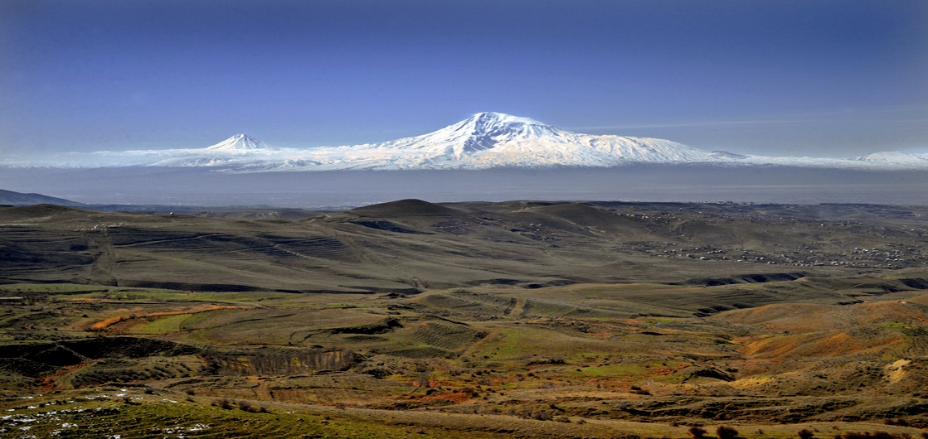

*We see Mount Ararat in modern-day Turkey and how impractical it would have been to land the ark on it.*

It makes sense that Noah wouldn’t land his ship – which held all their food, tools, fire fuel, and building supplies (wood and tar) – on the top of an inaccessible and precarious mountain. Here is a possible theory of the ark’s location from an article by Robert Bowie Johnson, titled “Evidence that Noah’s Ark Landed on a Mountain 17 Miles South of Ararat”.

*We see the mountain seventeen miles south of Mount Ararat where the ark first came to rest (arrow), and the impression it left when it slid down the mountain about 100 years later. At the top of the mountain, we see the escarpment cliffs which the “Epic of Gilgamesh” refers to as the “wall of heaven”.*

“The ark first came to rest on the mountain south of Ararat in a welcoming and accessible spot at an elevation of 7,400 feet, supposed location indicated by the arrow in the illustration, above. The hull of the ark provided basic raw materials for the occupants of the first post-Flood city, Mesha-Naxuan. They stripped its planks and beams to build roofs, and used the melted down kapar or bi-tumen (tar) to seal the roofs from rain. They most likely used the wood for furnishings as well as for fires.

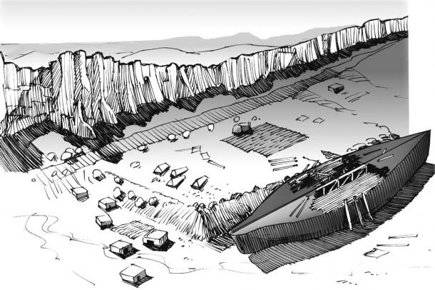

*Sketch of the landing site on Mashu or Mesha Mountain as the survivors began to construct the first post-Flood city—Mesha. (David Allen Deal).*

When the ark slid downhill after an earthquake and rains provided the impetus, perhaps after 100 years, the Mesha-Naxuan lumber yard moved a mile across the mountain, and 1,200 feet lower. Two ark impressions remain on the mountain: one where it landed, and the other where it descended to the lower elevation. Evidence on site indicates that the ark slid down the mountain, away from Mesha-Naxuan, after about 1,000 dwellings had been built there.

**Etymological (Language) Evidence**

Mesha means “to be drawn out of water,” the name most likely given to it by Noah. Nax-xuan is a Greek interpretation for the Hebrew, *noach tsywn*, “Noah’s Zion,” or “Noah’s capital,” a name given to the city by later generations. Mesha is a variation of Moshe meaning “saved through water” as Moses (Moshe in Hebrew) was saved from the Nile. In the ancient [***Epic of Gilgamesh,***](https://www.ancient-origins.net/myths-legends-asia/epic-gilgamesh-unveiled-0011927) Gilgamesh (Nimrod/Herakles) traveled to the mountains of *Mashu* to find *Utnapishtim* (Noah/Nereus), the man who had brought humanity through [**the Flood.**](https://www.ancient-origins.net/history-important-events/great-flood-00263) Gilgamesh (Gl-Gm-Mesh) means “the man who revealed Mesha.”

The city of Mesha-Naxuan was the first “city” built by the Flood survivors and their descendants. Then from an earthquake and rain, the ark slid down 1,200 feet (365m) to its second and final resting place, leaving what is now a one-acre elliptical 538-foot-long (164 m) ship’s hull impression at 6,200 feet (1890 m).

While mountain adventurers still climb Ararat, David Deal and a small unconnected group of other explorers began to realize the implications of this site at Mashur Dag, having seen the evidence for what it is. The ark mold impression is compelling as a stand-alone feature.

The remnants of many ancient habitations discovered by Deal in 1996-1997 at the upper landing site (Mesha-Naxuan) and the “wall of heaven” written of in the Epic of Gilgamesh convincingly add to the evidence. Furthermore, the connected meanings of the various place-names on the mountain provide us with a unifying clarity. As the entire mountain location is now becoming known and understood, it is impossible to conceive of the ark landing anywhere else, especially on a massive volcano.”

Once again, you may ask, “Steve, why do you take us on these historic rabbit trails?” My answer is to make real and logical what the scriptures describes 4400 years ago. Yes, that’s right. Noah’s flood occurred about 2400 years before Christ. Abraham was 300-400 years later. How in the world can Babel and Nimrod get so crazy evil a hundred years after ALMOST EVERYONE ON EARTH DIES? ... and Noah lives another 350 years and can tell everyone firsthand how insanely evil the world was before the flood and that obeying God is the only sensible thing to do!? … and there are piles of carcasses (human, animal and Nephilim) all over the place!? … and there is a BOAT 500 feet long (almost two football fields) and 80 feet wide and 50 feet tall (five stories!) that is inescapable and undeniable!? Yet in a few generations they went nuts again!? How did that happen?

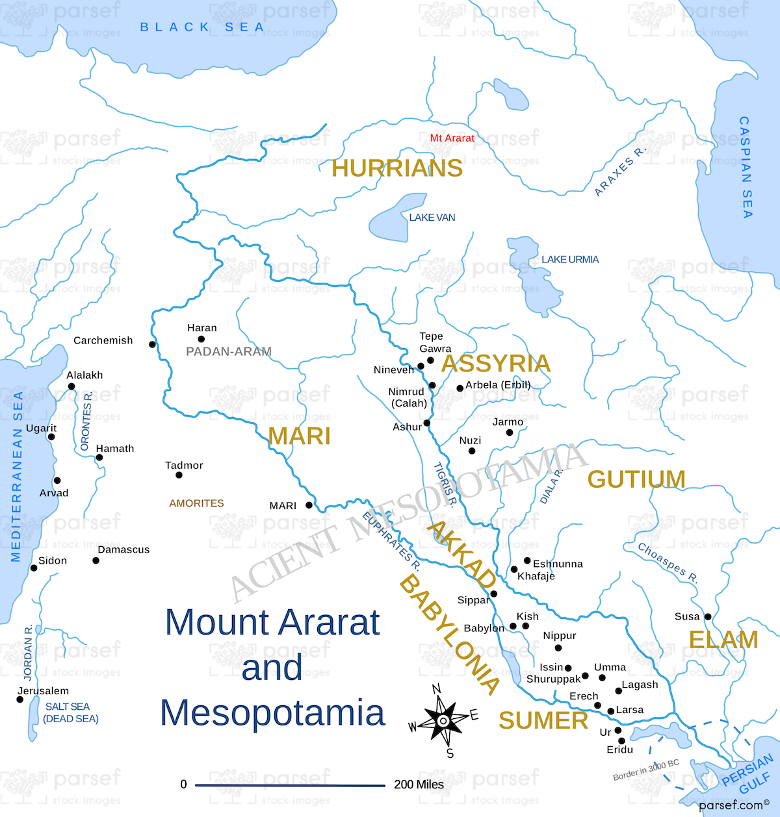

(This is more of my imagined scenario.) Let’s say that Noah and family lived near the ark after the flood by Ararat for about 50 years. They told their children and grandchildren about the pre-flood world with its evils and eventual judgement. Then in the second and third generation many people began migrating southwest down the Euphrates River. They followed the river down the valley to its end by Eridu, near what we call the Persian Gulf. (See bottom right of the map.) Though we would consider this a southern journey, the ancients considered this a “travel (to the) east”. Look at the map. Eridu is due east from Jerusalem and Israel - in God’s and Moses’s perspective - the center of the world. This is important because at that time geography was usually oriented toward the east, just as we are currently oriented toward the north. In ancient times, all cultures realized the importance of the eastern sunrise beginning the day, so east began their orientation. Did you know that the Jerusalem temple and most Hebrew homes were oriented east? The ark refugees didn’t travel “east from Ararat”. They traveled from Ararat “to the east” and found the broad plain in Shinar. Did they “continued on to fill the earth and image God everywhere”? Regretfully, no…

Gen. 11:2

And as they traveled east, they found a plain in the land of Shinar and they settled there.

Instead of filling the earth as God commanded Noah and his sons in Gen.9:1, they filled the lower part of the Mesopotamian valley and “settled there”. Why? Because it was a relatively lush area with abundant year-round water making the agricultural possibilities plentiful and easy. It was certainly preferable to the mountainous, mile-high region they came from in terms of ease of food production. Nonetheless, God had directed…

Genesis 9 :1

God blessed Noah and his sons and said to them, “Be fruitful and multiply and fill the earth.

God was big enough to feed everyone as they trusted Him. But who needs to trust God when you’ve got huge rivers and oodles of airable acres next to them? What could go wrong with a multitude living in close proximity? Was there any precedent for “city living”?

Gen.4:17

Cain knew his wife, and she conceived and gave birth to Enoch. He built a city and called the name of the city after the name of his son, Enoch.

Holy urbanization! Cain built the first city! The first murderer and rebel was the mayor of Enochville! What does that tell you about people living too close together? It is not a godly idea. Soon after people settled in the plain, formed cities, and couldn’t see the ark, they began to forget the flood lessons and rebellion against God re-emerged.

Gen. 11:3-4

They said to one another, “Come, let’s make bricks, and burn them with fire.” They had brick for stone, and they had bitumen for mortar.

They said, “Come, let’s build ourselves a city and a tower whose top is in the heavens, and let’s make ourselves a name, lest we become spread out over the face of the whole earth.”

They came up with a mass production plan for building. There was no stone around there but there was a lot of dirt, water, and tar, so they decided to make bricks – lots of them. They built a city, which in ancient times was defined as a community with walls - to keep the enemy out and protect their lives and wealth. But here’s a question. Who was the enemy? Weren’t they all family? They were only a few generations from the flood, so who was the enemy from whom they needed protection? Did they need protection from their own cousins, aunts and uncles? Yes, just as Cain’s sick mind saw Able as his enemy rather than his brother, the evil influence on man’s fallen nature after the flood inspired paranoia to protect the plain dweller’s riches. Each city of the plain built walls and rivalry ensued.

Here are some ancient bricks unearthed at the ancient tower of Eridu site. Notice the plain of Shinar.

One city sought preeminence over the others and formulated a plan to “build a tower whose top in in the heavens”. Why was that important? Perhaps it was important to some because a few decades before a flood had wiped out “everything under heaven” and they didn’t trust God’s promise of no more floods. Perhaps they wanted a “stairway to heaven”. The REV commentary on Gen.11:9 says:

“In the Babylonian literature the name bab-ili meant “the gate of God,” but in Hebrew it sounds like the word for “confusion,” and so retained that connotation.”

Being that Gen. 11:9 is the only time “Babel” is mentioned in scripture, a reasonable way to define its meaning is by comparing its use to contemporary Babylonian use found in ancient Archeological texts. It seems they wanted “a gate of God (elohim)”, a portal to enter the spiritual realm by their own “magnificent” works. I’m sure that at the time, the huge tower was awesome and “inspiring”.

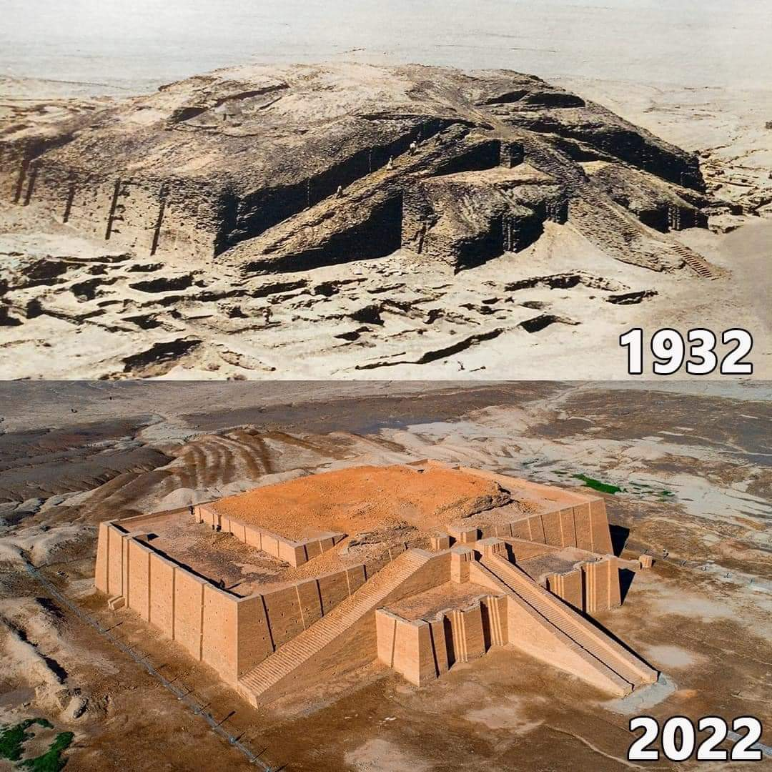

Here are overhead pictures of the ruins (1932) and the rebuilt tower foundation (2022), or ziggurat, from the ancient town of Ur, next to Eridu.

Archeologists say that the tower of Eridu (since destroyed) was the largest in the region - much larger than the 210ft long x 148ft wide x 100 feet tall ziggurat foundation pictured above at Ur. Think of it… the foundation of the smaller structure at Ur was 10 stories tall! How tall was the tower at Eridu planned to be? No one knows because it was never finished. Here’s a possible archeological sketch.

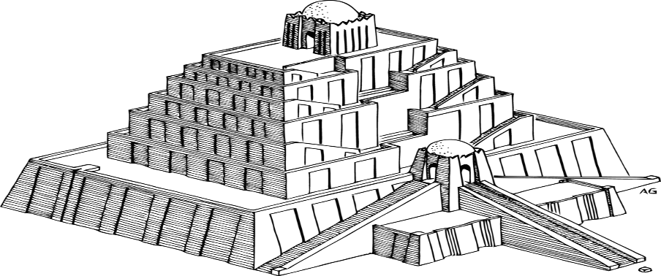

These ancient towers were called “Ziggurats”. Do you see the small structure on the top? It was called “the gate of the gods”. In the ancient logic, this was not for man to ascend to heaven, but for the “gods” to descend to the earth. It was a “portal” for the “sons of God” to once again visit the earth and do as they had done in the pre-flood era – make gigantic spiritual/physical hybrids. The top structure was stocked with food for the gods and even a bed for obvious reasons. This was a revival of the evil on the earth that necessitated the flood. And Nimrod and the nearby regional cities were all participating. Perhaps they wanted the toughest Nephilim army to protect their city (and probably to attack others). They built the ziggurat because they wanted the heavenly powers to “come down” to them.

Bethel

How does God define “the gate of heaven”?

Gen. 28:10-17

When Jacob went out from Beer-sheba and went toward Haran,

he arrived at a certain place and spent the night there because the sun had set. He took of the stones of the place, and put it near his head and lay down in that place to sleep.

And he dreamed. And behold, a stairway was sitting on the earth, and its top reached to heaven. And behold, the angels of God were ascending and descending on it.

Behold, Yahweh stood at the top of it and said, “I am Yahweh, the God of Abraham your father and the God of Isaac. The land on which you are lying, to you I will give it and to your seed.

Your seed will be like the dust of the earth, and you will spread out to the west and to the east and to the north and to the south. By you and by your seed all the clans of the earth will be blessed.

Behold, I am with you and will watch over you wherever you go, and will bring you again into this land, for I will not leave you until I have done what I have promised to you.”

Then Jacob woke up from his sleep and said, “Surely Yahweh is in this place and I, I did not know it.”

And he was afraid and said, “How awe-inspiring is this place! This is none other than the house of God [in Hebrew – Bethel], and this is the gate of heaven.”

Notice that Jacob never decided to build a city or a tower that would entice the divine down. He simply was carrying on normal life and ‘camping out’ when God ‘came down’ to him where decades before, his grandfather Abraham worshiped Him. God initiated this divine encounter. Jacob was sleeping – recalling the covenant God made with Abraham while he, too, slept! God chooses His entrance and exit ‘gates’, not man. No amount of man-made ziggurat grandeur can entice Yahweh, the Creator of galaxies, to grace a pile of mud bricks. Although, one day, an unexpected visitor did come down to Babel …

Gen 11:5-7 (Underlining added)

And Yahweh came down to see the city and the tower that the children of men built.

Yahweh said, “Behold, they are one people and they have all one language, and this is what they are beginning to do. Now all the things that they intend to do will not be withheld from them.

Come, let’s go down there and confuse their language, so that they do not understand each other’s language.”

When it says “let’s go down” it is plural in the original language, just as it was in Gen. 1:26

Gen 1:26 (Underlining added)

And God said, “Let us make humankind in our image, after our likeness; and let them have dominion over the fish of the sea and over the birds of the heavens and over the livestock and over all the earth and over every creeping thing that creeps on the earth.”

Just as in Gen.3:20

Gen. 3:22a (Underlining added)

Yahweh God said, “Behold, the man has become like one of us,

This is not God having split personalities or a conversation between the Trinity members. It’s a revealed discussion between God and His ruling council of spirit beings that help Him administer the earth. This subject is covered briefly in the REV commentary on Gen 1:26 and more completely in Unseen Realm by Dr. Michael Heiser. The ziggurat builders wanted spirit beings to “come down” through their gate and repeat what they had done in Gen. 6.

Gen. 6: 2,4

the sons of God saw the daughters of man, that they were desirable, and they took for themselves wives of all that they chose.

The Nephilim were on the earth in those days (and also after this) when the sons of God came in to the daughters of men and they bore children to them. Those were the mighty men who were of old, the famous men.

This is what happened that precipitated the flood. The biblical term “sons of God” refers to those whom God makes directly. In the Bible, this includes God’s spiritual ruling council, Adam, angels, Jesus and the Church of Grace. The only logical meaning of ‘sons of God” in this context are the members of God’s divine council who rebelled against God, entered the world on their own, and impregnated human women. This may sound bizarre to some (as it did to me) but this explanation best explains the many biblical references to this spiritual/physical reality. Let me quote from the “Unseen Realm” regarding Gen. 11.

“You’ll notice right away that there’s the same sort of ‘plural exhortation’ going on in verse 7 that we saw in Gen. 1:26. The verse has Yahweh proclaiming, ”Let’s go down there and confuse their language”. As was the case in Gen. 1:26, the plural announcement is follower by the actions of only one being, ‘So Yahweh spread them out…’. 11:8.

It’s at this point that most Bible readers presume that there’s nothing more to think about. That’s because other Old Testament passages that speak of this event tend to be omitted from the discussion. The most important of these is:

Duet. 32:8-9

When the Most High gave to the nations their inheritance, when he divided the children of men, he set the boundaries of the peoples according to the number of the sons of God.

Indeed, Yahweh’s portion is his people. Jacob is the lot of his inheritance.

Duet. 32:8-9 describe how Yahweh’s dispersal of the nations at Babel resulted in His disinheriting those nations as His people. This is the Old Testament equivalent of Rom. 1:18-25, a familiar passage where God ‘gave humankind over’ to their persistent rebellion.

The statement in Duet. 32:9 that ‘Yahweh’s portion is his people. Jacob is the lot of his inheritance’, tips us off that a contrast in ownership and affection is intended. Yahweh decided in effect that the people of the world’s nations were no longer going to be in relationship to Him. He would begin anew. He would enter into a covenant relationship to a people who did not yet exist: Israel.

Most English Bibles do not read ‘according to the number of the sons of God’ in Duet. 32:9.

Rather they read ‘according to the sons of Israel’. The difference derives from disagreements of Old Testaments manuscripts. ‘Sons of God’ is the correct reading as is known from the Dead Sea scrolls. …

So what happened to the other nations? What does it mean that they were apportioned as an inheritance according to the number of the sons of God? As odd as it sounds, the rest of the nations were placed under the authority of members of God’s divine council. The other nations were assigned to lesser elohim [lesser spiritual entities] as a judgement from the Most High, Yahweh. That this interpretation is sound is made clear by an explicit parallel passage, Duet 4:19-20. There Moses says to the Israelites:

Duet. 4:19-20

and lest you lift up your eyes to heaven, and when you see the sun and the moon and the stars, all the army of heaven, you are drawn away and bow down to them and serve them, which Yahweh your God has allotted to all the peoples under the whole heavens.

But Yahweh has taken you and brought you forth out of the iron furnace, out of Egypt, to be to him a people of his own inheritance even this very day.

Duet. 4:19-20 is the other side of God’s punitive coin. Whereas in Duet 32:8-9 God apportioned or handed out the nations to the sons of God, here we are told God ‘allotted’ the gods to those nations. God decreed, in the wake of Babel, that the other nations He had forsaken would have other gods beside Himself to worship. It is as if God is saying, ‘If you don’t want to obey me, I’m not interested in being your god – I’ll match you up with some other god.’ Ps. 82, where we started our divine council discussion, echoes this decision. That Psalm has Yahweh judging other elohim, sons of the Most High, for their corruption in administering the nations. The psalm ends with the psalmist pleading, ‘Rise up, O God, judge the earth, because you shall inherit all the nations.’…

After the flood God had commanded humanity “to be fruitful and multiply and fill the earth” Gen.9:1. These words reiterated the original Edenic intention. But instead of obeying and Yahweh being their god, the people gathered to build a tower. The theological messaging of the story is clear. Humanity [and many sons of God] had shunned Yahweh and His plan to restore Eden through them, so he would shun them and start over…

God said that all the nations would be blessed through Abraham, through his descendants Gen. 12:1-3. The covenant language reveals that it was God’s intention, right on the heels of his decision to punish the nations, that Israel would serve as a conduit for their return to the true God. Israel would be in covenant with ‘the God of gods’ and ‘the Lord of lords’ Duet 10;17. The disinherited would be in bondage to the corrupt sons of God. But Israel would be a conduit, a mediator. Yahweh would leave a spiritual bread crumb trail back to Himself. That path would wind through Israel, and ultimately, Israel’s messiah.’

Holy ziggurat! I thought Babel was about a tower and a confusion of languages! What a mess!... in every way imaginable – physically and spiritually. Can you imagine God’s heartbreak at disinheriting mankind again so soon after their near extinction with the flood? Can you also imagine the pain of losing at least 70 of His “sons”, spiritual beings that He had created, who had rejoiced at creation, and had helped him administer His grace and order to creation? He assigned them to the nations to administer and they grew corrupt and began accepting worship themselves, afflicting and enslaving their charges.

Babel was one of the most catastrophic events of all time. Yet, there is no record in archaeology of a city called Babel. Of course, there is an ancient city called Babylon so many historians attribute the record of Gen. 11 to the city of Babylon. But there are major problem in considering Babel and Babylon the same city (and tower) - the biblical record, geography and common sense. Nimrod, aka, Sargon, built his empire like this:

Gen. 10:10-11

The beginning of his kingdom was Babel, Erech, Accad, and Calneh, in the land of Shinar.

Out of that land he went into Assyria and built Nineveh, Rehoboth Ir, Calah,

Geologists say that the Persian Gulf was extended further northwest at that time so that Eridu was basically on its coast. The Bible says that Nimrod (and archeology agrees that Sargon) began his empire in the south of Mesopotamia. The first few cities conquered were in Shinar, the “south land”. Then Nimrod/Sargon marched north and went to Assyria.

Notice on the expanded map that Nimrod/Sargon marched right through the Babylonia area and followed the rivers northwest to Assyria. Babylon eventually became a center of civilization from about 1800 BC until 539 BC when it fell to the Persians. Nimrod/Sargon lived about 500 years before that began in 1800 BC. Babylon was probably a back water then, not even earning a mention in Genesis, although some Bible translations say, “Babylon” instead of “Babel” in Gen. 10. Why? Because they confuse the two cities. Look again two maps up. Is Babylon in the land of Shinar? No. Would Nimrod/Sargon conquer Babylon in the middle of the Mesopotamian valley then go south and conquer Erech, etc, in the land of Shinar. Then turn round and go far north past Babylon to Assyria? It makes no sense. Nonetheless, about half of English Bibles say in essence:

Gen. 10:10 New International Version

The first centers of his kingdom were Babylon, Uruk, Akkad and Kalneh, in Shinar.

Many scholars agree that Sargon began at Eridu - not Babylon - and then conquered Shinar, then moved north. So, if Babel wasn’t actually Babylon and it was really Eridu, what’s the big deal? The big deal is that Eridu is where Nimrod began conquering, built a tower to get the “sons of God” to descend and restart a Nephilim army to conquer the world. It was at Eridu that God “came down” and ended the attempted unified Nephilim empire. He did this by putting supposedly trusted “sons of God” over the divided nations to stop the earth from becoming “Nephilim world” and short circuiting the promised redemption. In short order the spiritual entities placed over the nations rebelled against God too. What a mess and kick in the gut to God’s plan to have a family!

So, why didn’t God/Moses call the city Eridu where these events centered? He called it Babel instead, because it was similar to the local language meaning “gate of the gods” and the Hebrew word meaning “confusion”. It was a dysphemism. God never said its true name because it was so cataclysmically bad and painful. It was “confusion central” for humans and spiritual beings, too.

Perhaps you’re thinking that this is the most depressing sharing ever. Try looking at it differently. This is a testimony to the incredible love of God, which…

1 Cor. 13:7,8a

bears all things, believes all things, hopes all things, endures all things.

Love never ends

God walked away from all the rejection from humanity – repeatedly. He also walked away from all the rejection of those spiritual sons that He created – repeatedly. If God blew up creation and began again, who could blame Him? If He decided that being alone and never suffering rejection was preferable to making creatures with free will who spurn Him… If He decided to forget about creating others and live alone forever, who could blame Him? Yet,

John 3:16

For God so loved the world that he gave his only begotten Son, so that whoever believes in him will not perish, but have life in the age to come.

God is love. It’s His very essence. He doesn’t love because someone earns it, but because that’s who He is. He “bears all things, believes all things, hopes all things, endures all things.” His “Love never ends.” In contrast, what does “perishing” look like?

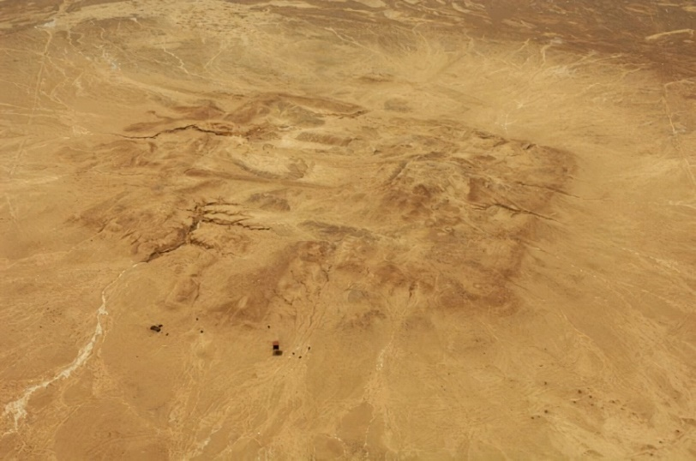

An overhead of the ruins of the ancient tower of Eridu. A cautionary image of spiritual rebellion – oblivion

What does “life in the age to come” look like? Like Jesus after the resurrection! Can’t wait!

Dysphemism #3

We are studying Dysphemism, the use of a derogatory term in place of an inoffensive term. It is the opposite of the better-known figure of speech, euphemism. In a euphemism, “a woman of the night” is said instead of “prostitute” and “rest room” is said instead of “excrement disposal site”. Euphemism puts a “good face” on an ugly reality. In contrast, dysphemism puts an “ugly face” on something that is usually neutral. A dysphemism calls the postal service “snail mail”, highlighting the slowness of postal delivery compared to email’s immediacy. Dysphemism is an implication that is a “put down”, while euphemism is an implication that is a “put up”. The Bible has many examples of both figures, although euphemism is usually recognized while dysphemism isn’t. Let’s discuss another dysphemism and learn valuable insights.

Satan

One of the most misunderstood and ‘spookiest’ subjects in the Bible is Satan. What is Satan’s given name? You know, the one God gave him when he was created? No one knows because God never tell us. He uses figurative language (implication and dysphemism – like Nimrod) to refer to him, but never reveals his given name. Here’s some shocking (for many folks) and insightful commentary from the REV on Genesis 3:1.

Gen.3:1a

Now the serpent was more crafty than any animal of the field that Yahweh God had made.

The “serpent” is the Devil, Satan. Here in Genesis 3, the Devil is called the “serpent” (snake) by the figure of speech hypocatastasis (comparison by implication). Calling the Devil a serpent is similar to calling a sloppy person “pig,” or calling an overly cautious person “chicken” (for more on simile, metaphor, and hypocatastasis, the three main figures of comparison, see commentary on Rev. 20:2). Calling the Devil a “serpent” compares him with a serpent (snake), and assigns the characteristics of a serpent onto him, implying that he is an ambush killer who is sneaky, crafty, and deadly. We can correctly identify the “serpent” as the Devil here in Genesis 3 from 2 Corinthians 11:3 and Revelation 20:2.

Also, however, as we will see later in this study, the Hebrew vocabulary allows for the Devil to have actually appeared to Eve and Adam as a glorious “Shining One,” a glorious and powerful angel, yet still be called “the serpent” to portray his crafty characteristics.

The Bible never gives us the actual personal name of the Devil; the name he was given when God created him. We know the names of important angels such as Michael or Gabriel, but when it comes to the Devil, all the Bible gives us are appellatives and descriptions that let us know about his evil nature and his power. Many of the names in the Bible are given as “mini-portraits” of the person, and that is the case with the Devil. The “names” of the Devil portray him very well, names such as “Slanderer,” “Adversary,” “Opposer,” “Wicked One,” and “Dragon.”

Many are shocked to realize that the name of the Devil is never revealed by God.

Duet. 29:29

The secret things belong to Yahweh our God; but the things that are revealed belong to us and to our children forever, that we may do all the words of this law.”

If God doesn’t reveal his name, then the only way to know it is if Satan or an associate does, and why would any sound minded person believe anything revealed by them? Perhaps the reason why God never utters his name is the same reason why he didn’t name Nimrod or Eridu – heartbreaking disappointment in their choices and results. Perhaps it was because of God’s disappointment in the difference in his potential and his self-chosen destiny.

Ez. 28:12-19

“Son of man, take up a lamentation over the king of Tyre, and tell him: This is what the Lord Yahweh says: You were the seal of perfection, full of wisdom and perfect in beauty.

You were in Eden, the garden of God; every precious stone adorned you: carnelian, peridot, and moonstone, topaz, onyx, and jasper, lapis lazuli, turquoise, and emerald. Gold work of tambourines and of pipes was in you. In the day that you were created they were prepared.

You were the anointed guardian cherub, and I placed you there. You were on the holy mountain of God. You have walked up and down in the midst of the stones of fire.

You were blameless in your ways from the day that you were created until unrighteousness was found in you.

By the abundance of your trade you were filled to the core with violence, and you sinned; therefore I cast you out of the mountain of God as a defiled thing; and I expelled you, O guardian cherub, from the midst of the stones of fire.

Your heart was lifted up because of your beauty. You corrupted your wisdom for the sake of your splendor. I cast you to the ground; I laid you before kings, that they may see you.

By the multitude of your iniquities in your unrighteous trade, you have defiled your holy places; therefore I will bring a fire out of the midst of you; it will devour you, and I will turn you to ashes on the earth in the sight of all those who see you.

All those who know you among the peoples will be astonished at you: you have become a terror, and you will be no more forever.”

Most scholars think this scripture section refers to Satan. The one spoken of is well beyond the “king of Tyre” whom had similar character traits but was never “in Eden, the garden of God” nor had been a “guardian cherub”. This is a rare look into the spiritual realm that God gave Ezekiel (and, in turn, to us also). This obvious spiritual entity was “the seal of perfection, full of wisdom and perfect in beauty.” Amazing! What a beginning he had! He was adorned with every precious stone and had music in his essence. He was the anointed one – the one specially called out and equipped by God to protect creation. He was on “the holy mountain of God”. In ancient times, the common man pictured God on lofty mountaintops, separated from the earth and man. This means that Satan was with God in what we could consider “the throne room”. He had a special residence and access to God as a member of God’s spiritual council. The REV commentary adds:

What “the stones of fire” are is unknown. They may have been stones that actually burned with perpetual fire, or they may have been red/yellow/orange stones that gleamed and glistened like fire. Although they could have been for decoration, like the stones worn by Satan before he fell (although those may have had specific meaning too), it seems unlikely that they were “just decoration” with no other meaning. There is a strong relationship between fire and judgment throughout the Bible (e.g.. Lev. 10:1-2; 2 Kings 1:9-12; Dan. 7:9-10; Matt. 3:11; Rev. 20:14). Given that, it seems likely that these stones were a reminder of the seriousness of what took place on the Mountain of God. God’s divine council that met on this “Mount of Assembly” did serious work in ruling the earth. We see an example of that serious work in ruling in Genesis 11 when the people in the land of Shinar decided to build a tower into the heavens. God saw their sinful desire and said to His council, “Come, let’s go down there and confuse their language” (Gen. 11:7), which they did.

That Satan had “walked up and down” (we would say “back and forth”) among those stones of fire shows the authority he had as an anointed cherub. He was one of the spirit beings whose voice was heard in determining what happened in the universe. Amazingly, he was not content with that and wanted to be like the Most High God, meaning he wanted to be the Most High on the mountain.

The rest of the passage describes Satan’s fall and the consequences of his inexplicably prideful decision. Is. 14 adds more insight.

Is. 14:12-17

How you have fallen from heaven, Shining One, son of Dawn! How you are cut down to the ground, you who laid the nations low!

You said in your heart, “I will scale the heavens! I will raise my throne high above the stars of God! I will sit enthroned on the Mountain of Assembly; on the heights of Mount Zaphon!

I will ascend above the heights of the clouds! I will make myself like the Most High!”

Yet you will be brought down to Sheol, to the depths of the pit.

Those who see you will stare at you. They will ponder you, saying, “Is this the man [the one] who made the earth to tremble, who shook kingdoms,

who made the world like a wilderness and overthrew its cities, who didn’t release his prisoners to their home?”

The Devil began as a “shining one”. Perhaps light was part of his original created function. The description, “son of Dawn” uses the same term as Venus, the morning star, in ancient language to refer to him. He was not the “Dawn” the beginning of light and life, but the ”son of Dawn”, a creation of the “Dawn” figuratively speaking. Yet he wanted to sit on the throne atop God’s mountain, like his Father did! What a catastrophe! What a loss for God! One of His main creations, leaders and responsible administrators rebelliously committed insurrection against his Father and Creator! What a gut punch to God!

Perhaps we think that fore knowledge means no surprise or pain to God, but just because you know the person you love will betray you doesn’t erase the pain. In some ways it intensifies it because of the painful anticipation. How do you get over one of your favorite creations stabbing you in the back and then leading others in doing the same? And then killing millions, billions, trillions (when animals are considered) of your creations? What a mind-boggling cesspool of pain and suffering God endured (and still does). Perhaps this is the reason he never utters Satan’s name and only refers to him as “accuser” (devil), “adversary” (Satan), and other implications and dysphemisms. You will notice the positive descriptions of Satan before his calamitous decisions – “anointed cherub”, “shining one”, and “son of the dawn. After the rebellion, there is nothing but dysphemism – depictions of his evil character, habits, and actions instead of his name.

The church we are part of is much different.

Eph. 3:14

For this reason I kneel before the Father, from whom every family in heaven and on earth derives its name.

God names everyone in heaven and earth. He is proud of those who have decided to be part of His family.

Heb. 12:23

to the church of the firstborn, whose names are written in heaven. You have come to God, the Judge of all, to the spirits of the righteous made perfect,

Our names are written in heaven, far from anyone’s, or anything’s ability to erase them.

Rev. 2:17

Whoever has ears, let them hear what the Spirit says to the churches. To the one who is victorious, I will give some of the hidden manna. I will also give that person a white stone with a new name written on it, known only to the one who receives it.

It may be surprising to some, that God knows each of our names – our essences, our strengths and weaknesses, our calling, our lives. He knows our secrets known only to Him and us. And…. HE STILL LOVES US!

Rev 3:5

The one who is victorious will, like them, be dressed in white. I will never blot out the name of that person from the book of life, but will acknowledge that name before my Father and his angels.

Once someone’s name is in the book of life, Jesus says that he won’t blot them out. That’s definitely where you want your name to be, because if not…

Rev 20:15

Anyone whose name was not found written in the book of life was thrown into the lake of fire.

Herod, Nimrod, Babel, and Satan are not in the book of life. They were not even on God’s “lips” when He inspired the Bible. Notice that the “nameless ones” will be “thrown into the lake of fire”. Someone has to throw them in, they don’t volunteer. Who will do that? Only those whose names are written in the book of life.

Rev 21:27

Nothing impure will ever enter it [the new Jerusalem], nor will anyone who does what is shameful or deceitful, but only those whose names are written in the Lamb’s book of life.

Those given names will judge and destroy those whose names are unmentionable.

Ez. 28:18b-19

I will bring a fire out of the midst of you; it will devour you, and I will turn you to ashes on the earth in the sight of all those who see you.

All those who know you among the peoples will be astonished at you: you have become a terror, and you will be no more forever.”

Pinch yourself. This is part of our destiny. “Terror”-ist neutralization and “ash” removal. Most importantly, Jesus knows our eternal name… and loves us!