39 – Blessed are the Flexible Planners
1 Cor. 16:5-9
Now I will come to you when I pass through Macedonia (for I intend to pass through Macedonia)
and perhaps I will stay with you, or even spend the winter there, so that you can set me forward on my journey wherever I go.
For I do not want to see you now just in passing. I hope to stay a while with you if the Lord permits.
But I will stay at Ephesus until Pentecost,
for a wide door, even an effective work, has opened to me, and there are many opposing it.

The apostle Paul was never accused of being a wall flower. He did everything 100% - right or wrong. He was a “type A” personality – take charge and expect everyone else to follow. He knew what he wanted and said so twice - to pass through Macedonia. He also intended to spend extended time with the Corinthian saints. Paul planned - he was not a careless operator. Imagine intending to travel hundreds of miles by land at that time. That meant walking – not with Merrel’s hiking boots or Hoka walking shoes, but with leather sandals on roads and trails unpaved, unregulated and unprotected. Later he wrote:

2 Cor. 11:26,27
in frequent journeys, in danger from rivers, in danger from robbers, in danger from my own people, in danger from the Gentiles, in danger in the city, in danger in the open country, in danger at sea, in danger among false brothers;
in labors and struggles, in many sleepless nights, in hunger and thirst, often without food, in cold and without adequate clothing.

Can you imagine the courage it took to travel in the first century? There was no state patrol, no police, no FBI, and no call boxes at the side of the road. No 911, no ambulances, no search and rescue helicopters, no emergency rooms. Just danger and peril – and that’s if you planned well and had God’s help! Those journeys took serious guts, folks! Why did he do it? Because Jesus asked him to and people needed saving, as Jesus told him:

Acts 26:15-18
And I [Paul} said, ‘Who are you, Lord?’ And the Lord said, ‘I am Jesus, whom you are persecuting.
But get up and stand on your feet, for I have appeared to you for this purpose—to appoint you a minister and a witness both of the things that you have seen, and of the things about which I will appear to you.
I will deliver you from the People, and from the Gentiles to whom I send you,
to open their eyes, so that they turn from darkness to light and from the power of the Adversary to God, so that they receive forgiveness of sins and an inheritance among those who are made holy by their trust in me.’

Planning

This calling guided Paul to spread the gospel throughout the world despite steep obstacles. This scripture section highlights two important and related lessons for us. The first is that planning is good. Regretfully, some Christians rarely plan. That’s not good because as the saying goes, “Those who fail to plan, plan to fail.” Christianity is spiritual, but it’s not just spiritual. Jesus taught us to love God with our whole heart, soul, strength and mind.” Some folks get so heavenly minded that they are become no earthly good. They use their head only for a hat rack! They read in the Bible that we are to walk by the spirit, so they turn off their minds. Let me ask you, how can you love God with all your mind if you turn it off? You can’t. Is this how Paul operated? Did he go thoughtlessly wherever he felt the spirit wanted him to go? In other words, did he wake up daily without a plan and ask God, “What should I do today?” Of course not. Look at the verses we just saw. He planned and intended to go to Macedonia and Corinth. He thought ahead. How else could someone have a successful journey and walk hundreds of miles in the first century? Trying to do that without a plan would have been suicidal, although it almost reached that even with planning!

The Christians who rarely plan may think, “I hope something good results from what I do!” I agree that ‘hope’ is essential to long term stamina, but ‘hope’ is a lousy strategy to produce “godly results”. God want us to think – about our goals – and about their cost – and about the strategy to achieve them. He wants us to love Him with our mind. That means planning, logic, focus, coordination, etc. The secular world is well acquainted with the idea of planning. Even Jesus portrayed it as a strategy to be successful.

Luke 14:28-30
“For which of you, wanting to build a tower, does not first sit down and count the cost and see if he has enough to complete it?
Otherwise, when he has laid a foundation and is not able to finish, all who see it begin to mock him,
saying, ‘This man began to build, and could not finish.’

Remember that Jesus was a carpenter and builder himself. He knew to estimate the concrete, wood, excavation, labor, financing, etc. before starting so that he could finish the job he promised to do, get paid and not look foolish.

Because we’re made in the image and likeness of God, we have the inherent ability to plan as He plans. Obviously, God is perfect in His planning, organization and ability to execute those plans. The problem with us is that our planning abilities are impaired by sin. As someone has said, “Most organization and administration is nothing short of hard work!” Although we don’t have anything approaching God’s abilities, we don’t need to; planning simply takes work; physically, mentally, and spiritually! Check this out:

Proverbs 6:6-11
Go to the ant, O lazy one, watch its ways and become wise.
Because it has no leader, overseer, or ruler,
yet it prepares its bread in summer; it gathers its food in the harvest.
How long, O lazy one, will you lie there? When will you rise up from your sleep?
“Just a little more sleep, a little more slumber, a little more folding of the arms to lie here,” and your poverty will come like a thief, and your needs like an armed man.

Even ants plan! They somehow know that they should store up provisions for the winter, so they prepare in summer, collecting and storing food during harvest so that there is enough later. If ants didn’t plan, they would starve. This is also true for humans, which is probably why God had Solomon write this warning. Those who never plan usually have an empty storehouse and life. You get what you aim at… and if you aim at nothing – you get nothing.

Now planning is not the be-all, end-all of our lives, even though many successful secular leaders swear by planning and visualizing techniques. They say, “Anything the mind of man can plan, conceive and believe, he can achieve.” Really? How about speaking in tongues, the proof of eternal life? How about revelation – hearing from God in the here and now?
How about peace in the midst of a storm, or joy in the midst of misery? Or love in the middle of a crazy selfish world? You get the point. Planning is useful with physical things, but only partially useful with spiritual things. So how do we Christians live and plan?

Fellowship with God

Prov. 16:9 NKJV
The mind of a person plans his way, But the LORD directs his steps.

For believers, life is a partnership with God. God wants us to plan our way, not just be an aimless space cadet, void of goals or strategy. Once we have goals and a godly plan, God can and does direct our steps to achieve it. A famous saying is “God can’t steer a parked car.” Too many Christians do little because they are afraid of sinning or failure. How sad. God wants us living – moving – the opposite of a parked car. As we move forward on what we think is the best plan or strategy to achieve our goals, God can (and does) make course corrections. He wants us to achieve the desires of our heart. Why? Because most likely those desires come from Him.

Ps. 37:4 NKJV
Delight yourself also in the LORD, And He shall give you the desires of your heart.

Where do our heart’s desires originate? Could they have come from God? Could He be the one to set our sights on the future so that we know where we’re going? In the scriptures we read of God setting a person’s desires in their heart well before they come to pass. This was true with Abram, Joseph, Moses, Samual, David, Paul, etc. etc. Their heart’s desires were set there by God and He certainly “directed their steps” all the way until they achieved those desires.

Now some might say, “What if a desire of someone’s heart is to be a billionaire, a king, and have 1000 wives?” If I remember correctly, Solomon wanted those things and it went badly for him. The verse says, “Delight yourself also in the LORD, and He shall give you the desires of your heart.” My question is, “Does the hypothetical billionaire king’s desire spring from “delighting in God’ or delighting in himself?” I think we know the answer to that question. I ask you, would a billion dollars be a blessing or a distracting burden for you?

Eccl. 4:6 NKJV
Better a handful with quietness Than both hands full, together with toil and grasping for the wind.

A billion dollars is many, many handfuls! There will be a lot of toil and frustration to manage and keep it. How about being a king? Shakespeare said, "Heavy is the head that wears the crown". Great privileges, yes, but also tremendous responsibility, 24/7, serving everyone in your kingdom. How about 1000 wives? Can you imagine living anywhere near hundreds of women in a harem who have their menstrual cycles synchronized? I’d go on a missionary journey without planning - hoping for death! These desires may look good from afar, but God wants us blessed, not burdened or overwhelmed.

Some of the greatest most productive time we ever spend is our prayer time with God. I don’t know how your prayer time works out, but I not only speak to God, but He also communicates to me. This is one of the ways we realize the desires God has put on our heart and those He hasn’t. He ‘steers’ us to them. Other believers can also confirm the information that God has told us through counsel or prophecy. Once we get a general sense of where we can go with God, we start thinking, planning and strategizing. Once we’re moving, God can, and will, ‘steer us’ further. He’s guided me at times from what I originally thought was important to something entirely different that ultimately proved way more vital to realize the original desire He gave me.

Flexible

We see two things with Paul’s example. Firstly, that he intentionally planned and strategized, and secondly that He was flexible.

1 Cor. 16:7 (Underlining added for emphasis)
For I do not want to see you now just in passing. I hope to stay a while with you if the Lord permits.

In essence Paul is saying, “The mind of a person plans his way, but the LORD directs his steps.” Although Paul carefully planned, he gave God veto power over His plans. He wanted and planned for an extended visit with the Corinthians, but his game plan was always subject to “revision at half time from the Coach”. Paul didn’t sit on his hands. He was ready, willing and able to preach the gospel. He was moving forward in that vein yet still partnering with God for Him to direct his steps.

Too many Christians want God to give them a formula, a road map, a checklist for their life. They want to know everything about their journey, not just the destination. In other words, they want “Today, we do A. Tomorrow, we do B. The next day we do C.” etc. That will NEVER happen. Why not? Because… God made the universe for the earth, the earth for man, and man to fellowship with Him. God is our “formula”. The Lord is our “road map”. The spirit is our “checklist”. He not only gives us the desires and goals, but partners with us to bring them to pass. Life is to be lived with God – not with formulas, road maps, or checklists. If God gave us road maps or checklist, we wouldn’t need Him, right? We would just need the “To Do List”. We would do what the list said and after we had arrived at the end, we would boast about what we accomplished! True life is an exciting (thrilling, scary, fulfilling, roller-coaster) journey with God. Each of us with God charts a unique odyssey to fulfill the desires God has put in our heart. It is not safe or predictable. It is not easy or comfortable. Even the roller coaster analogy falls short because the roller coaster rides on rails, insuring a safe, predictable ride for the passengers. There are no rails when we walk with God, except for His love and promises. Sometimes we “walk through the valley of the shadow of death”, but we “fear no evil, for you are with me.” The Lord is our safety rails.

If we stay in fellowship with Him and do as he leads us, we will be blessed and ultimately arrive at our goals. Some try to imitate other’s spiritual journey, because as the world says, “Nothing succeeds like success.” In other words, imitate someone else’s road to success and you’ll be guaranteed to get their success. That may sound good, but it misses the spiritual point. True spiritual success is not due to what someone does, but Whom they trust. We can duplicate that, but it will look different according to how God guides each of us. In short, success is trusting God every day and that will look different for each of us.

You want safety and predictability? Do the seven sacraments in Sacramento. Do the four-fold path in Fort Worth. Do the 5 pillars of Islam at the Pentagon. You want your heart’s desires fulfilled? Get with God and pour yourself into Him and then go as He leads. The journey is the ride of our lives. And we’re never too young to start or too old to return to it.

Paul originally wanted to 1. sail from Ephesus to Corinth, then 2. travel overland to Macedonia and then 3. return for an extended stay in Corinth and then 4. sail for Judea.

2 Cor. 1:15,16
And with this confidence, I planned at first to come to you, so that you could have a second experience of grace,
and travel by way of you into Macedonia, and back again from Macedonia to come to you, and have you send me on my way to Judea.

Did something change? Yes, God’s guidance did so Paul’s plans and actions did too. Blessed are the flexible! Look at the map of Paul’s second missionary journey below. Paul wrote 1st and 2nd Corinthians when he was Ephesus on his second journey. Ay that time He intended to sail to Corinth to revisit and strengthen the church, but God changed the timing and manner or the visit.

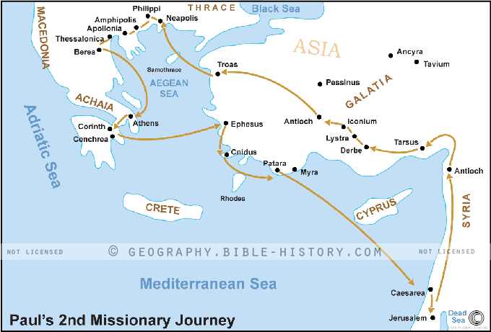
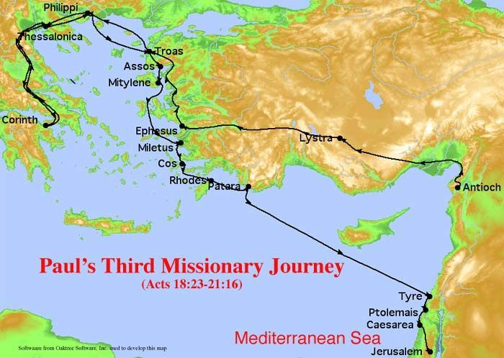
Paul never returned to Corinth on his second missionary journey as he initially intended. From Ephesus he traveled south on Turkish coast until sailing to Judea. A while later, he began his third journey from Antioch and traveled overland to Ephesus and then into Macedonia, where Philippi and Thessalonia are located. Then he went south to Corinth finally and then retraced his steps back to Judea.

Blessed are the flexible! There’s an old adage that says, “Man plans and God laughs!” I say, “Man plans and the world laughs! But God directs us and we get the last laugh!” We win!

Now sometimes we have big desires that God has shown us. Our fleshly impatience wants it all now. But that’s not how it usually works. The saying goes, “How do you eat an elephant? The answer is “One bite at a time.” Each day, each year brings us closer to the realization of the desires of our heart. Each completed task is one brick that will comprise the walls in which our dreams will live. Trusting, faithfulness, and focus gets the job done.

1 Cor. 16:10-13
Now if Timothy comes, see that he is with you without cause to be afraid, for he works the work of the Lord, as I also do.
Therefore let no one treat him with contempt, but set him forward on his journey in peace so that he can come to me, for I expect him with the brothers.
Now concerning our brother Apollos, I greatly exhorted him to come to you with the brothers, but it was not at all his will to come now, but he will come when he has an opportunity.
Be watchful, stand firm in the faith, be courageous, be strong.

There are times when it takes courage to be a Christian. Like when your boss tells you to lie or steal. Or your government tells you to stop fellowshipping because of a bogus virus. Or your neighbor wants to protect violent felons despite the harm they pose to themselves and others. Speaking and doing the truth can be quite unpopular at times, sometimes resulting in garnering unwanted legal attention or losing your job. Some of the Corinthian saints may have been subject to more intense persecution, such as imprisonment and death, as Paul almost experienced when he first evangelized there. If we want to escape evil attacks, we can be spineless flesh heads and go with the flow – the world’s flow. And we know where that leads – the spiritual desert. Or we can stand courageously for God and the truth. He will provide, as He did with Paul and so many other times in scripture.

1 Cor. 16:14
Let everything that you do be done in love.

This is one of the greatest and most challenging exhortations in the Bible. This means that in the interactions with our boss who wants us to lie or steal, we love. We stand for the truth and love him, not show contempt for him. We love the bankers who comb our financial details to entrap us. We love and pray for the governmental leaders that seek to extort increasing amounts of taxes from us to do wasteful and immoral things. We love our neighbors and family members who think that men can be women and berate us for not “following science”. We love everybody, no matter what. Not necessarily what they do or say, but we love them – just as God does. Anger, bitterness and resentment have no place in us. We love. This is about the toughest thing God asks us to do. And we can only do it as we remember how much God forgave us for and what vile butt-heads we were!

Like 7:47
For this reason I say to you, her sins, which are many, have been forgiven, for she loved much. But the one who is forgiven little, loves little.”

I think the opposite of, “the one who is forgiven little, loves little.” is true, too. “He that is forgiven much, loves much.” When we grasp how much we’ve been forgiven, we love much. When we forget God’s mercy on our lives, we look down on others and love little.

1 Cor. 16:15-24
Brothers and sisters, you know the house of Stephanas, that it is the firstfruits of Achaia, and that they have committed themselves to minister to the holy ones. Now I urge you
to submit yourselves to people like them, and to every fellow worker and laborer.
And I rejoice that Stephanas and Fortunatus and Achaicus are here, because they provided what you were not able to;
for they refreshed my spirit and yours. Therefore you must give recognition to people like them.
The churches of the province of Asia greet you. Aquila and Prisca greet you warmly in the Lord, along with the church that is in their house.
All the brothers and sisters greet you. Greet one another with a holy kiss.
I, Paul, write this greeting in my own hand.
If anyone is not a friend with the Lord, let him be accursed. Our Lord comes!
The grace of the Lord Jesus Christ be with you all.
My love be with you all in Christ Jesus. Amen.

We’ve had quite the journey through this epistle. I hope that some of its large and mid-sized themes have become understandable and part of your life. I exhort you to spend time daily with the Lord in prayer and the Word to connect with Him. And continue to plan your journey while preparing to be flexible on this blessed adventure… and…

1 Cor. 16:14
Let everything that you do be done in love.

God Bless You!

