Low Born – High Called

Let’s glean some insight from the first chapter of 1 Corinthians.

1 Cor. 1:1-12 REV (Boldface for Emphasis)

Paul, called to be an apostle of **Jesus Christ** by the will of God, and Sosthenes, our brother,

to the church of God that is at Corinth, to those who have been made holy in **Christ Jesus**, called ones, holy ones, with all those in every place who call on the name of our **Lord Jesus Christ**—theirs and ours:

Grace to you and peace from God our Father and the **Lord Jesus Christ**.

I thank my God always for you because of the grace of God that was given to you in union with **Christ Jesus**,

because in union with him you were enriched in everything, in all speech and all knowledge,

(just as the testimony about the **Christ** was confirmed in you),

so that you are not trailing behind the others in any gift, as you are eagerly awaiting the appearing of our **Lord Jesus Christ**,

who will also confirm you to the end, blameless in the day of our **Lord Jesus Christ**.

God is faithful, by whom you were called into the fellowship of his Son, **Jesus Christ our Lord**.

Now I urge you, brothers and sisters, by the name of our **Lord Jesus Christ**, that you all speak the same thing, and that there be no divisions among you, but that you be made complete by having the same mind and by the same judgment.

For I have been informed about you, my brothers and sisters, by Chloe’s followers, that there are quarrels among you.

What I mean is this: that each one of you says, “I am of Paul,” “But I of Apollos,” “But I of Cephas,” “But I of Christ.”

The Corinthian church developed problems when Paul left after founding it. He began the epistle by addressing one of them - the division reported by saints from Chloe’s fellowship. Notice (**boldface print**) that Jesus is named 10 times in the first 10 verses! Why was that?

Romans 1:1-3

Paul, a servant of Jesus Christ, called to be an apostle, appointed for the good news of God,

which he promised beforehand through his prophets in the holy scriptures

concerning his Son, who was born from the seed of David according to the flesh,

In the first epistle addressed to the Church of Grace, we learn a foundational truth. The word “concerning” comes from the Greek preposition peri, meaning “around”, “surrounding” or “encircling”. When the ancient Greeks gave geometric shapes to their prepositions they described “peri” as a circle equidistant from a central point.



The Good News of God is “all about” His son, Jesus Christ our Lord. He is the center and focus. Christianity is “all about” Christ. You might say, “Of course! Christianity is named after him!” My response is that I wish that Christ being the focus was so obvious. Within a short time, the Corinthian saints were distracted from this simple truth. This is why Jesus was mentioned 10 times in the first 10 verses of the epistle – to refocus them.

A Little Background

Let’s discuss why they could have lost focus. At that time, Corinth was the second most important city in the Roman empire. It had vast wealth stemming from its location as a travel crossroads. All roads from northern Greece to the important Peloponnesian peninsula ran through it. Much shipping also passed through it owing to its unique location as a 5-mile land bridge between the Aegean and Adriatic seas.

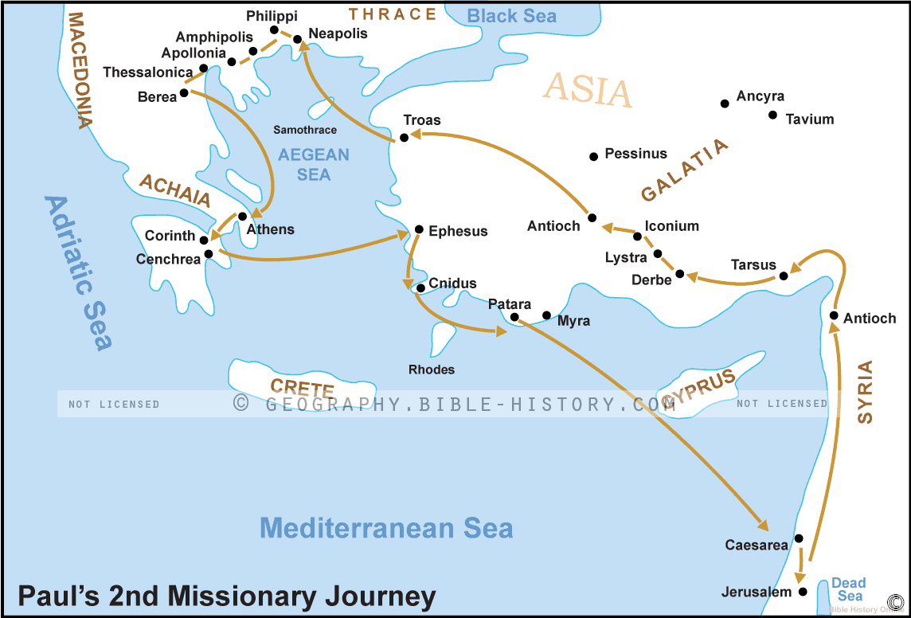

For shipping to avoid the long dangerous journey around southern Greece, an ingenious system of transport was used. 5 miles of paving stones were placed from “sea to sea” allowing boats and their cargo to be transported across the land bridge.

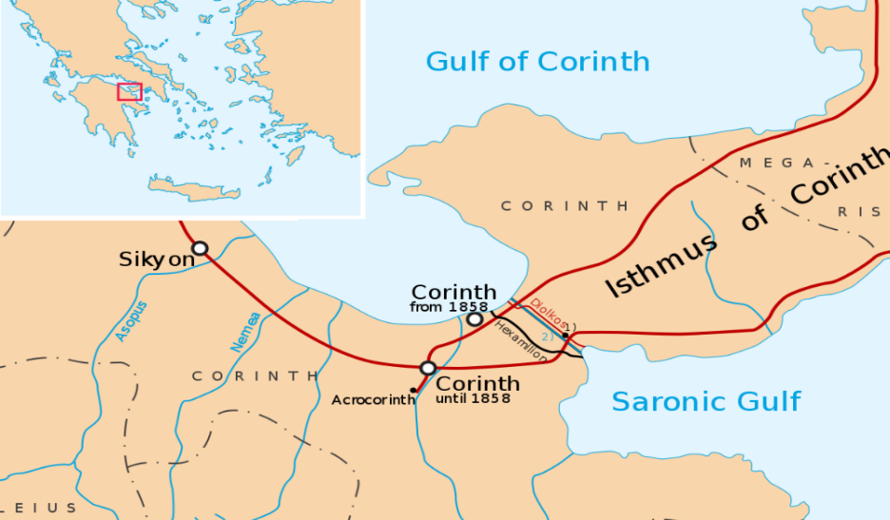





Corinth had a population of about 200,000 citizens and 500,000 slaves plus many freed slaves. Why so many people? When the sailors came to port, they had little to do while their boat was on land or in line to be transported, so they did what many sailors do away from home, they worshipped. “What?!” you say, “Worshipped?” Yes, they ‘worshipped’ Aphrodite at the temple above the city at the Acro Corinth, or at many satellite locations where hundreds of temple prostitutes would “help”. The roads in all directions were stacked with traveler friendly food, drink, and other considerations. Corinth had the reputation of Las Vegas or Bangkok. Misbehavior was expected and excused.

The constant flow of outside money brought the Corinthian citizens riches as well as religious and moral corruption. The phrase, a “Corinthian” girl, or boy, or something else was shorthand for depravity throughout the empire. The abundant wealth made it a cultural power center of the Roman empire and was directed by wealthy, dominant men who shunned physical work and engaged in the Greek aristocratic habit of listening to and dialoguing about news and ‘wisdom’.

Acts 17:21

(Now all the Athenians and the foreigners who lived there spent their time doing nothing else, but either telling or hearing something new.)

The moneyed class had little to do themselves, so they spent their time doing what we today call “surfing the web” or at that time, hanging around the marketplace where they could hear someone or something new and interesting. Perhaps this is how Apollos got his start in Corinth (Acts 18:27,28, 19:1) and Paul was allowed to speak in the Corinthian synagogue and later to the Gentiles after he was ousted. This makes sense because they had no TV, internet, newspapers, movies, or other forms of entertainment or information. Public speakers were both, so the Corinthians flocked to them. Perhaps this custom also helped spread the gospel so rapidly.

It is amazing to think that God had Paul spend 1 ½ years in Corinth, teaching and shepherding the new believers according to Acts 18. What a huge investment of the apostle’s ministry! Although it should be assumed that he hammered the centrality of Christ into their thinking and action, it wasn’t long before some saints there were dividing the church by siding with their favorite leaders.

1 Cor. 1:12

What I mean is this: that each one of you says, “I am of Paul,” “But I of Apollos,” “But I of Cephas,” “But I of Christ.”

How could some say that they were “of” these leaders? Had any of them even met Peter? Sure, they had heard of him – the leader of the apostles, the one who walked on water – but how can you side with someone you’ve haven’t met? What’s going on? The above verse will tell you as you look closely at it. The word “I” is repeated 5 times. The first time it’s used it refers to Paul, the writer. The next 4 times it refers to the saints who were choosing favorite leaders. What’s the emphasis with the repetition? “I”, obviously. The choices of leader affiliation were being made according to how it benefited “I”, in other words, the chooser.

Whenever saints get their focus off Christ it always shifts to something or someone else. Was it “Paul,” “Apollos,” or “Cephas”? No, it was themselves - “I”. The leader mentioned is incidental. Our natural man is naturally tuned in to the world’s favorite radio channel – WIIFM – **W**hat’s **I**n **I**t **F**or **M**e. When we tune out Jesus, we usually tune in our own thoughts and desires. We look at everything from a ‘what’s in it for me’ perspective. Was that how we were saved? No, we confessed Jesus as lord, the master of our lives, not ourselves. We agreed to put our thoughts and desires below his, making our will subject to his. Recently during a discussion on why marrying non-Christians is unwise, those of us married (by God’s grace) shared that to be successful we must put our own desires often to the side and subject our will to our spouse’s. Christians already know how to subject our will and do it regularly as we walk with the Lord. Non-Christians may do it for a short while but usually quit when they fear getting short changed, not getting what they want despite their yielding. Christians are blessed for their yielding to God and Jesus, but with married folks, getting rewarded is hit and miss. Sometime a yielding spouse is rewarded and sometimes not. With unbelievers in marriage, when push comes to shove, an unreciprocating spouse usually gets pushed and shoved. Why? Because unbelievers are tuned in to WIIFM. Their assessment of their situation is self-centric, not Christ-centric. On the “self-centric metric” if someone is considered a debit to your wellbeing, they’re expendable. If someone is considered a plus to you, they’re valuable. The more pluses, the more affection is attached to the person who benefits them. This is why some claimed to be “of Paul”. They thought their association with Paul enhanced them in some way more than being affiliated with Apollos, Peter or Christ. Whenever Christians get distracted from Christ, they devolve into selfish thinking. Soon, we’ll see one reason why that could have been.

1 Cor. 1:13-18

Has the Christ been divided up? Was Paul crucified for you? Or were you baptized in the name of Paul?

I thank God that I baptized none of you except Crispus and Gaius,

so that no one can say that you were baptized in my name.

(But I also baptized the household of Stephanas. Beyond that, I do not know whether I baptized any other).

For Christ did not send me to baptize, but to proclaim the good news—not with clever words, lest the cross of Christ should be emptied of its power.

For the message of the cross is foolishness to those who are perishing, but to us who are being saved it is the power of God.

For those with a hungry and meek heart, the good news about Christ is the power of God. For those who are self-satisfied and unmeek, it’s foolishness. The crucial points are the gospel being presented and the hearer’s heart, not our clever technique. What a relief!

1 Cor. 1:19-21

For it is written, I will destroy the wisdom of the wise, and the discernment of the discerning I will bring to nothing.

Where is the one who is wise? Where is the expert in the law? Where is the debater of this age? Hasn’t God made foolish the wisdom of the world?

For since, in the wisdom of God, the world did not know God by its wisdom, it pleased God by the foolishness of preaching to save those who believe.

Here’s a figure of speech, Sarcasm, where the opposite of what’s said is meant for contrast and persuasion. If the statement was literal (“I will destroy the wisdom of the wise”), the question would be implied, “If the ‘wisdom of the wise’ is so wise, why will God destroy it?” The answer is that it’s not really wisdom and those who hold it aren’t really wise. God says it that way for emphasis, much like we use air quotes when speaking, or real quotation marks when writing. God has made foolish the “wisdom” of this world. The Corinthian saints were being distracted by worldly “wisdom” when, in truth, it was not wisdom at all.

Why was God inspiring Paul to write this? It was because the Corinthians were fans of “wisdom” as were most Greeks because of their great philosophers like Plato, Socrates, and Aristotle. (By the way, “philosophy” means “love of wisdom” in Greek.) So, where were all these great philosophers? Having lived centuries before, they were fertilizing olive trees. Where were Paul, Apollos and Peter? On their way to joining the ‘fertilizing fraternity’. Where was Jesus? Raised from the dead – alive forever! Why center your life or focus on anyone else? The gospel, although simplistic and “foolish” as far as the world thinks, is the power or God to save us from eternally joining the same ‘fatal fraternity’ when we believe.

1 Cor. 1:22-24

For Jews demand signs and Greeks seek wisdom,

but we preach Christ crucified, which is a stumbling block to Jews and foolishness to Gentiles,

but to the called ones (both Jews and Greeks), Christ is God’s power and God’s wisdom.

According to the Greek/Roman worldview, the gospel was foolish - dying on a cross was an act of weakness. Humility, suffering, and servanthood were thought to be attitudes of the ‘unwise’. The Jews were looking for a mighty, miracle-working, kingdom-conquering Savior (Acts 1:6). They forgot the Old Testament prophecies of a Messiah who would suffer and die (Ps. 22; Is. 53). Because of their forgetfulness, Jesus called them foolish (Luke 24:25).

1 Cor.1:25

Because the foolishness of God is wiser than human wisdom, and the weakness of God is stronger than human strength.

My favorite instance of “the foolishness of God is wiser than human wisdom” is the first time the gospel was proclaimed (although in an abbreviated form). Remarkably it was foretold not to a believer, but to a former favorite who became an evil rebel.

Gen. 3:15

I will put hostility between you and the woman, and between your seed and her seed. He will strike your head, and you will strike his heel.”

Imagine Satan’s pride and boastful heart. He thought he had bested God by causing man to sin, which would bring about God’s promised consequence of death on the sinners, ending humanity and increasing Satan’s role in creation. From this time of seeming defeat, God prophesies this. It had to make Satan’s head spin. Here’s some possible thoughts:

**God Says** **Satan Thinks**

I will put hostility between you and the woman. The woman? Really? She’s the one I easily deceived. She’s smaller and weaker than the man. Her hostility to me is no threat.

Hostility between your seed and her seed. I can have a seed? How will that work?

She can have a seed? How will that work?

I thought the man had the seed. I beat the woman before, and I’ll beat her again. The same is true for our seeds, whatever that means.

He will strike your head, you will strike his heel. What sense does this make? It seems

foolish and weak, like humanity.

What happened soon after this conversation? Satan destroyed Cain, the first possible “woman’s seed” relatively quickly, making him the first of Satan’s seeds to “strike his heel”.

I assume that Satan thought God’s prophesy was “foolishness”. After Cain he inspired more “spiritual seeding” on the earth and almost succeeded in human genocide again before the flood. After the flood he again began ‘seeding’ humanity in order to end them until God intervened again at Babel. From there God pivoted from all humanity to one meek man whom He promised a “seed”, Abraham. For the next 2000 years, it’s almost as if Satan played “whack a mole” trying to exterminate any possible threat to him. When Jesus began walking and talking like the son of God, he targeted him through the religious establishment. When he succeeded in getting the secular government to kill Jesus, Satan thought he had won again. But, au contraire! Jesus was the seed of the woman! Although he had “struck” Jesus’s heel, Jesus had struck Satan’s head – his plans and desires. The “foolish” plan of Gen. 3:15 was wise beyond Satan’s or anyone’s comprehension. Foolish? Only for Satan and the unbeliever, as we will see in the second chapter.

1 Cor. 1:26-28

For consider your calling, brothers and sisters, that not many wise according to the flesh, not many powerful, not many of noble birth, are called,

but God chose the no-good things of the world to put to shame those who are wise, and God chose the weak things of the world to put to shame the things that are strong,

and the low-born things of the world, and the things that are treated with contempt—God has chosen these—and the things that are not, to bring to nothing the things that are,

The phrase “the things that are not … the things that are” is sometimes misunderstood. At first it seems to be talking about things that exist and don’t exist, but a familiar idiom adds light. Think of the movie, “On the Waterfront” where Marlon Brando’s character exclaims, “I could have been a contender! I could have been somebody!” Did Brando want to be “somebody” or more accurately “somebody important” or “somebody valuable”? This is the same idiom in the phrase above. In context it means “the things that are not [‘wise, good, strong, noble-born, important, valuable’, etc.] … to bring to nothing the things that are” [‘wise, good, strong, noble-born, important, valuable’, said in sarcasm]. Doesn’t that make more sense?

Let’s add another aspect from the context. In today’s American culture, there is no structured class system, but in that day there was. There was a small population of royalty, upper class, and middle class, then a large population of lower class and slaves. A person’s class was determined by birth, with rare exceptions. If they were noble-born, they were considered upper class all their life. If a person was low-born, they were deemed lower class forever. Slaves could only hope to buy or be granted their freedom and in time, ascend to the lower class. Here's a short discussion of one aspect of the low-born childhood experience in the Roman Empire by historian Moshe Rideout.

In Ancient Rome, newborn children had a much different experience from those in the modern world. The mortality rate for babies was much higher than today, and the social structure had much lower expectations for the safety of children. In Ancient Rome, there was a practice known as the ‘dawning of infants’. On the fifth or ninth day after a child was born, a ceremony would be conducted in which the child would be exposed to the gods. The parents would place the baby in a secluded area, usually a public place outside. If it was not taken by a passerby within the next few days, the child would be taken back home by the parents.

In some cases, the parents made the decision not to take a newborn child home, for instance if the child was severely ill, had deformities, or the family could not afford to take the infant home, such as with slave parents. In addition to the practice of exposing newborns, ancient Roman culture also placed little value on the safety or wellbeing of infants. There was no expectation that all children would survive, and there was no social or religious pressure placed on protecting newborns.” This may be because of the high mortality rate for children in ancient times – about 25% to 30% of infants not surviving their first year and perhaps half of all children dying before reaching adulthood. This is why Roman mothers hoped to produce 6-12 children, with a net brood of 3-6 survivors.

Yow! Certainly, a different world than the one we grew up in, right? OK, now hold on to your hat. Let’s go inside the possible mind set of the Corinthian saints. Some were former Jews because the church began in the Corinthian synagogue as Acts 18 says, but a lot were former gentiles - a few noble-born but mostly low-born and slaves. That meant that many experienced the ‘dawning of infants’ abandonment early in their lives. How traumatic was that? To be abandoned at a week old for a few days, exposed to the elements? Of course, babies felt abandoned because just days before they were next to their mother’s heart all their life and then, they were … totally, completely, terrifyingly … alone! Can you imagine crying till you can’t cry anymore and no one helps! Laying in your own filth, shivering with fear, desperate for a touch of warmth, adrift from any security. How unthinkably cruel!

Yes, at that time most gentile low-born babies were abused as infants – assuming – that they survived childbirth. Then, how attentive do you think the parents were to them as they grew up? Remember, there’s a 50/50 chance they could die of measles or infection or get trampled by a horse before adulthood. Do you think these parents looked at the kids as a blessing or a burden? I think too often they considered children the latter. How about childcare growing up? There was no ‘Kindercare’. Mom and dad worked and kids were watched by an older sibling (if there was one) or a relative or at 8-9 years old the kids went to work with the parents and learned a trade. They learned how to build a stone pathway to transport cargo, or make wheels for carts, or make bread, or host sailors. Yuck! PTSD was common for all children. What was the self-esteem for the low-born? What do you think? When you’re abandoned at a week old and treated regularly with contempt, you grow up insecure and seriously question your value and self-worth. As you age, you see the cheapness of human life when you lose siblings and relatives regularly. You wonder about the value and meaning of your life… until… you hear the good news of Jesus Christ!

Everything changes when the gospel enters! The hearer learns of God’s love for them and the sacrifice His sinless son did on their behalf, paying for all their sins and shortcomings. They learn of God raising Jesus from the dead, giving him new life as He promises the same for believers. They experience that new life as they see people speaking in languages they couldn’t know and interpreting it – messages of love, comfort, and praise to God. They see former vicious slaves beaming with peace and former temple prostitutes bubbling with joy. Gone is the striving to prove that they are worthy of being treated with respect and not contempt as they were by their parents and society. God’s love and grace fills the gaping chasm of insecurity their childhood left. They are somebody important and valuable which God proved by calling them and making them His own. He’s not abandoning them for a few days, or hours. Jesus will never, ever leave us nor forsake us!

During his 18-month ministry in Corinth, Paul taught the new believer about redemption and righteousness. He taught them to speak in tongues and all the other spiritual abilities they’d been given. The new saints walked in power, love, and a sound mind.

Until … after Paul leaves, then perhaps an upper-class person in the church listens to Apollos in the marketplace when he swings through town in Acts 18:27-28 and he decides that Apollos is a better speaker and leader than Paul. Other saints disagree and retain allegiance to Paul, while some claim Peter is whom Jesus left in charge, while others remember what Paul told them and remain loyal to Christ. Messy divisions develop.

In my imagined scenario, the Corinthian church’s thinking could have gone from being in Christ back to pre-Christ – colored by class, security and honor concerns.

Noble-born Thinking Low-Born and Slave Thinking

“Secure” Insecure

“Superior” Inferior

“Honorable” Contemptable

“Wise” Unwise

“Strong” Weak

“Important” Insignificant

“Valuable” Worthless

When we get distracted from Christ as the center of the gospel and our life, there is usually a mad scramble – like when the music stops in musical chairs – to fill the space in our hearts caused by our “de-throning” Christ. We fill up that hole with all kinds of things and people. After the noble-born guy declared his allegiance to Apollos, many others chose a leader to identify with so that they wouldn’t be thought of as foolish. In the world’s systems, there will always arise reasons for us to feel foolish, insignificant, weak, or contemptable when the devil picks the scabs on our past, reminding us of who we were. When we have our thinking in Christ, we never need to feel second rate. Why?

Romans 16:20

And the God of peace will crush the Adversary under your feet swiftly. The grace of our Lord Jesus be with you all.

Our past may be low-born, but we were born again from on high and in the future we’ll have the high hand… and upper foot! Do you remember how I pictured Satan (“who was also originally noble-born, wise and strong”) thinking God’s prophesy was foolish? Well, in the future he will get beat not only by the “seed of the woman” but by the low-born, unwise, insignificant, and weak ones who love the “seed of the woman” – us! Why?

1 Cor. 1:27,28

but God chose the no-good things of the world [us] to put to shame those who are wise [said sarcasticly], and God chose the weak things of the world [us] to put to shame the things that are strong [said sarcasticly],

and the low-born things of the world [us], and the things that are treated with contempt [us]—God has chosen these [us]—and the things that are not [important or valuable – us], to bring to nothing the things that are [in the world’s estimation, supposedly “important” and “valuable”].

We were “chosen of God” to be who we are and to do what we’ll do with Christ.

Talk about grace!



“He will strike your head”.