Spiritual Matters

1 Cor. 12:1

Now concerning spiritual matters, brothers and sisters, I do not want you to be ignorant.

Some versions read “spiritual gifts” but the Greek says, ‘spiritual matters’. This is important because all spiritual gifts are spiritual matters but not all spiritual matters are gifts.

The spiritual insight I’m about to share with you is a minority position in Christian theology. The vast majority of Christian theologians, past and present, believe otherwise – and therefore most bishops, ministers and priests mirror their view. “How can so many people be wrong?” you might ask. To explain, this takes us into some research areas that I usually avoid to keep these sharings simple and clear. So, before we start reading chapter 12, we must reclaim some lost understanding of these spiritual matters from the haze which Satan has obscured them. Let’s handle a few foundational misunderstandings by quoting from the excellent book, “The Gift of Holy Spirit” by Mark H. Graeser, John A. Lynn and John W. Schoenheit. These misunderstandings of spiritual matters began with bad Bible translating long ago according to preconceived ideas.

“The student of scripture needs to know that the Bible was originally written in [Greek] “uncial” text, that is, in only capital letters with no spaces between the words.

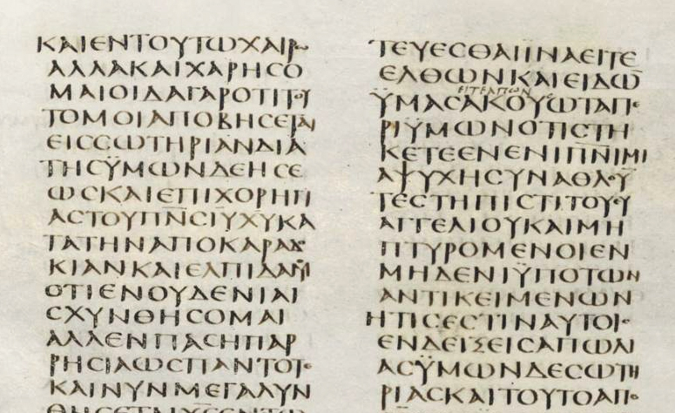

“Thankfully scholars have now separated the modern Greek and Hebrew texts into individual words and, of course, all English translations are in standard English, using both capital and lower-case letters.”

“Let’s introduce the Greek words for “spirit” and “holy”. We do this because it’s impossible to write the words “holy spirit” in English, without making them either God (if the “H’ and the “S” are upper case) or God’s gift (if the “h” or the “s” are lower case). By using the Greek, we can write about holy spirit without assigning a specific meaning to the words.”

“The word “spirit” has many definitions in both English and Greek. In English we call God a “Spirit”, that is, an invisible being. We also call both good and evil invisible beings “spirits”. Also, we use “spirit” as a disposition of the mind, an attitude, as in the sentence, “She was in good spirits today.” We also use “spirit” to refer to the general intention or real meaning of something, as in “the spirit of the law”. We even call alcohol beverages “spirits”.

“The Greek word for “spirit” is *pneuma*, and just as English has many definitions of “spirit” Greek has many definitions of *pneuma*. The Greek noun *pneuma* comes from the verb *pneo*, “to blow or breathe.” Thus, to the ancient Greeks, *pneuma* was a “breath”, and it came to be associated with invisible things that exerted a force or power. A good Greek Lexicon will show that besides breath, *pneuma* also was the Greek word for wind. Our English word “pneumatic” (air powered) comes from the Greek word *pneuma*, and so does our word “pneumonia” a disease of the lungs. *Pneuma* may be invisible, but it has power. Breathe on your hand. Can you feel it? Sure, you can. You can feel the breath, but you cannot see it. *Pneum*a is used in the Greek language, and thus in the Bible, of an invisible force or substance, as when the Bible says, “God is spirit [*pneuma*]”. (John 4:24a) Many things are called *pneuma* in the Greek New Testament. A partial list includes:

1. God (the “Spirit” in John 3:8b).
2. The gift of God known as holy spirit (Acts 2:38).
3. Angels, who are “ministering spirits” (Heb. 1:14)
4. Demons (Matt. 8:16; Luke 9:39)
5. “Breath” or “life”. The girl’s *pneuma*, (breath or life) returned when Jesus raised her from the dead, (Luke 8:55a)
6. “Wind” John 3:8a says, “The wind blows wherever it pleases…”.
7. “Attitude” or “thoughts”. “The spirit is willing, but the body is weak” (Matt. 26:41b).

“Since *pneum*a can refer to so many different things, how do we know which of them is referred to in any specific verse? We know the same way we do in English – by reading the context. The context must be used to determine whether *pneuma* means “Spirit” or “spirit”, and there are times when the translators do not agree about what the context is saying, which is why versions sometime differ. For example, in Matthew 12:18, the KJV reads “spirit”, but the NIV reads “Spirit”. The difference is because the translators cannot tell from the Greek text whether “spirit” should be capitalized, so they make a judgment call based on their understanding of the context.”

“There are times when the word “spirit” refers to God and thus should be capitalized. There are times when “spirit” refers to an angel, a demon, the gift that is given by God, etc., and should not be capitalized. For example:”

John 3:6 KJV

That which is born of the flesh is flesh; and that which is born of the Spirit is spirit.

“Translators realize from the context of this chapter that the one who gives birth is the Spirit with a capital “S” – God, and the thing that is born is also spirit, but should have a lower case “s”. As we said, the early Greek texts of John 3:6 had the word for “spirit” in all capital letters both times e.g. *PNEUMA.* Thus, whether the New Testament says “Spirit” with a capital “S” (such as Matt, 4:1 or Luke 2:27), or “spirit” with a lower case “s” (such as Matt. 26:41 or Luke 1:80), the Greek text reads *PNEUMA*. Translators must pay close attention to the context to determine whether “Spirit” or “spirit” is correct, not an easy task.”

“The Greek word for “holy” is *hagion*… When the words *pneuma hagion* refer to God, translating them as “the Holy Spirit” is correct, because [in English] we capitalize proper nouns and personal titles. When “the Holy Spirit” is used as a designation for God, it emphasizes His power at work. That is why, though the Bible often calls God the father of Jesus Christ (e.g., Rom. 15:6), in the Four Gospels it is not “God” who impregnates Mary, but rather His power in operation, “the Holy Spirit”.

Luke 1:35

And the angel answered and said to her, “The Holy Spirit will come upon you, and the power of the Most High will overshadow you, and for that reason the holy one to be born will be called the Son of God.

“Three things have contributed greatly to people’s misunderstanding and ignorance concerning God’s gift of holy spirit. The first is when the translators capitalize the “H” and “S” and translate *pneuma hagion* as “Holy Spirit” when there is no reason in the Greek text to do so, and even when the context indicate the gift of God, holy spirit, is the subject being discussed. The second is the translators, not being aware *pneuma hagion* can refer to the gift of God, added the definite article “the,” making the Bible read “the Holy Spirit” when there is no word “the” in the Greek text. When the article “the” is absent in the text, it is usually an indication the text is referring to the gift of holy spirit, and not “the Holy Spirit”.

The third is translating pronouns associated with *pneuma hagion* as masculine, “he” instead of “it”.

“The reason the translators have been so insensitive to the subject of the gift of holy spirit is the doctrine of the Trinity, which says “The Holy Spirit” is the “Third Person” in the Trinity and for the most part fails to also recognize that *pneuma hagion* can refer to the gift of God. It is due to the doctrine of the Trinity that translators capitalize the “H” and “S” when the context is clearly referring to the gift God gives, add a “the” when none is in the Greek text, and translate the pronouns associated with *pneuma hagion* as masculine, even when the context is clearly referring to the gift of God and neuter pronouns are called for.”

What Came on Pentecost?

This is an important and telling question that demands an accurate answer. The traditional position answers, “The Holy Spirit” (God, the third person of the Trinity). The question then becomes, “Hasn’t God been here already? How can He ‘come’ where He is already present?” Tradition responds, “Not God totally, just the third person – the Holy Spirit – came on Pentecost.” “Wait,” I ask, “Didn’t the Holy Spirit conceive Jesus in Mary? So, the ‘third person of the Trinity’ was already here too, right?” The conversation ends inevitably, “Well, it’s a mystery! We can’t understand it because it’s too big for human understanding. Stop trying to understand God and conform to what everybody else thinks.” My experience is that discussions involving traditional “spirit” logic usually end with the exhortation to shut off my brain and fall in line with established doctrine (or else). But, what about …?

Duet. 29:29

The secret things belong to Yahweh our God; but the things that are revealed belong to us and to our children forever, that we may do all the words of this law.”

God revealed lots of information to us that “belongs to us”. We have every right (and in fact, a responsibility) to understand it. Remember, trust/faith is persuasion of information to the end of acting on it. There are things that God keeps secret, but what info God gave us, He expects us to understand and do. I don’t think “Shut your brain down and blindly believe ancient confusing man-made doctrines”, agrees in any way with the above verse.

Did you know that the word “Trinity” is not in the Bible? It is a man-made theological concept adopted into the church in the 4th century after Christ. Did God hint at being a ‘three in one’ entity before? No, just the opposite.

Duet 6:4 KJV

Hear, O Israel: The Lord our God is one Lord:

This verse is the first one every Jewish child learned. The Gentile nations around them had many gods, some even compounded like the Trinity concept. Israel has always been identified as monotheistic – having only one God. To suddenly change to a ‘three in one’ concept would have been earth shattering. Where is the clear notification and announcement of this sea-change? In contrast, the idea that God had a son was another monumental shift in understanding God. Was that change subtle or hidden? No, Jesus is referred to as ‘the son of God’ 50 times in the New Testament. There is no confusion about that. In contrast, the arguments for the ‘three in one’ concept of God are strained and obscure. Look at this…

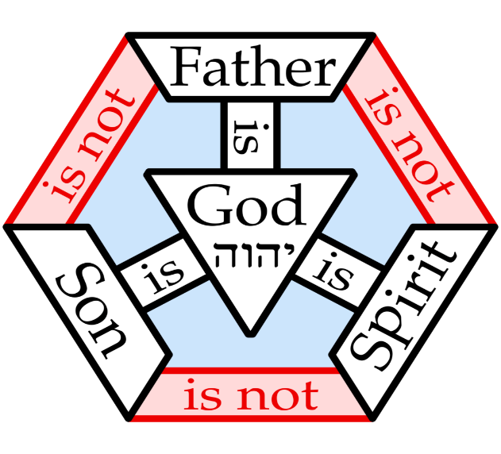

Better get some CBD oil for your temples if you try to understand this. I’m sorry for bringing this contentious stuff up, but in this category of ‘spiritual matters” it’s crucial to be clear on what the word ‘spirit’ means. The reason I quote from the research in the “Gift of Holy Spirit” book is so that you can see that the idea that “the Holy Spirit (God) came on Pentecost” is injected into the Bible, not the opposite. Honest students want to see what the text says of itself, not project in their pre-decided ideas. The proponents of “the Holy Spirit came on Pentecost” idea can point to Bible verses to back up their ideas which can be confusing to those of us who hold a different view. It’s important for us to realize that the ”God came on Pentecost” view comes from inaccurately translated English Bible versions. The original text said no such thing. We are not inserting our ideas into Christianity as they did. The original text and overall context leads us to our position.

So, once again, what (or who) came on Pentecost? The traditional position is that the third person of the trinity came. Is this what the Bible says?

Acts 2:4 REV

And they were all filled with holy spirit and began to speak in other tongues, as the Spirit was giving them utterance.

The Greek text says that they were filled with *pneuma hagion*, with no definite article. Were they filled with the third person of the Trinity? Not according to the Greek texts. Those who say so import that idea into the Bible. God gave His gift, holy spirit, to the disciples who spoke in tongues as the Spirit, God – the Giver - gave them utterance. What were they filled with – the Giver or the gift?

Acts 2:38

And Peter said to them, “Repent and be baptized, every one of you, in the name of Jesus Christ for the forgiveness of your sins, and you will receive the gift of the holy spirit.

On Pentecost, they were filled with the gift, not the Giver. Once you leave the confusing traditional ideas out, the discussion of spiritual matters makes logical and spiritual sense.

John 3:6,7 REV

That which is born of the flesh is flesh, and that which is born of the Spirit is spirit.

Do not be amazed that I said to you, you must all be born from above.

When a person is conceived, the father doesn’t give himself 100% in the action. He gives a part of himself, his “seed” to begin the birth process. This is true with the new birth. God, the “Spirit”, doesn’t give Himself totally in the saint’s new birth, but only a part of Himself. The Spirit gives the spirit, the gift. It is easy to distinguish the difference between the giver and the gift by designating the Giver with the capital “S” and the gift with the lower case “s”.

On Pentecost it was the first time someone could get born again. What happened? The Spirit (God, the *Pneuma* – with the definite article) made a person His child by creating *pneuma* (no article – the gift) in them. What ‘came’ on Pentecost was *pneuma hagion,* God’s gift of holy spirit. It was the original day someone could get born from above of “incorruptible seed”, 1 Pet. 1:23. *Pneuma hagion* (holy spirit) had been around in the Old Testament and Gospel periods, but not as a permanent birth. It could now be part of man.

Let’s talk pronouns. (Do we have to?) Traditional doctrine says you must address “the Holy Spirit” as “Him”. Most folks don’t understand that Greek pronouns are flexible when translated to English. They should agree with the noun to which they refer. So, is God’s gift a “he”? Is it a separate person with a gender? That’s what traditional ideas envision. Let me ask you, do you call your body a “he”? Or how about your soul, it is a “she”? I know this is silly but see the point. We call those parts of us an “it”, as in “My knee hurts today and it needs to rest.” Our knee is part of us and is referred to accordingly. This is true with the spirit God gives us. It’s not a separate sentient person who acts independently of us. It’s part of us. It is us! The idea that we ‘get the Holy Ghost’ and ‘He’ guides us and empowers us is not biblical. This idea is akin to having a spirit guide, like some spiritualist or cult practice, where an outside, conscious entity interacts with a person informing and compelling them to act. A spirit guide pretends to have a name, a history and the right to commandeer someone’s life. In reality, this is really an unholy spirit, *pneuma “barf-ion”*. (Just kidding!) Perhaps a gender designation might be considered appropriate for the spirit guide pretending to be “the queen of Bravaria”, but certainly not for our *pneuma hagion*.

John 16:12-15 REV

“I still have many things to say to you, but you are not able to bear them now.

But when it, the spirit of truth, comes, it will guide you in all the truth, for it will not speak on its own, but whatever it hears, it will speak, and it will declare to you the things that are to come.

It will glorify me, for it will take from what is mine, and will declare it to you.

All things, whatever the Father has, are mine, therefore I said that it will take from what is mine and will declare it to you.

(One of the reasons I use the REV is its clear, modern, and accurate translation like that above. So many of the old versions (like the KJV) will say, “when he, the spirit of truth, comes, he will guide you in all the truth, for he will not speak on his own…” The REV allows us to spend more time learning and less time dealing with faulty translations.)

I’m sorry to bring up this traditional controversy which for some is a fellowship breaker. My job is to teach the Bible. Having studied it for decades and helped others understand and live it, this doctrine is a stumbling block for many people to understand this section of scripture. There are great books that handle this controversy. I’ll include a list at the end of this discussion for those who want to study more, but guess what? If you want to still believe in the traditional doctrine, it’s fine by me! You can still operate the manifestations of the spirit well and effectively minister. Billy Graham was a traditionalist and an OK evangelist, right? Pentecostals and Charismatics speak in tongues and are traditional, right? Just as God made receiving the new birth as easy as breathing, He made spiritual things easy-peasy too. He had too because humans are duller than rusted butter knives!

2 Cor. 4:7

But we have this treasure in earthen vessels [our bodies], so that the exceeding greatness of the power will be of God, and not from ourselves.

He made it simple so we could be involved. We simply trust God. I’ll point out any doctrinal or practical “spiritual matter killers” when they come up in the text or from my experience. The Trinity isn’t one of them (as long as some aspects of its teaching are ignored, such as, “the Holy Ghost overpowers you” and other things as we’ll discuss.)

Back to spiritual matters. Jesus spoke of the coming “spirit of truth” not as a conscious, independent thinking entity but as a relater of information. “It will not speak on its own, but whatever it hears, it will speak.” God’s spirit doesn’t originate information, it conveys it. “It will declare to you the things that are to come.” Perhaps we can think of it as a spiritual “router”. It connects us with God’s and Jesus’s channel, allowing both parties access to each other. It also transfers future info to us and from what source does that come? “It will take from what is mine and will declare it to you.” Ah-ha! God tells Jesus and Jesus lets us know via the spirit what’s coming. Having the spirit is almost like having the ability to be ‘online’ spiritually with God and Jesus!

John 14:16,17

and I will ask the Father, and he will give you another helper, which will be with you forever.

This helper is the spirit of truth, which the world is not able to receive, because it does not see it or know it. You know it, for it is present with you, and will be in you.

Jesus told the disciples that the promised spirit would be with them forever. This was not the case in Old Testament times. It could be lost because of sin. He further stated that it was (present tense) “with them” but would be (future tense) “in them”. The difference in old and new spiritual realities was remarkable. Pentecost began a new epoch spiritually.

John 14:25,26

“These things I have spoken to you while I am still with you.

And the helper, the holy spirit, which the Father will send in my name, it will teach you all things and bring to your remembrance all that I said to you.

Once again, the promised spirit would not instigate a new order. It would teach and remind us of Jesus. It was a conveyor of information, not a separate personality. It would be a part of us like our body and soul, except it would also connect us to Christ and help us.

1 Cor. 12:3

Therefore I make known to you that no one speaking in union with the spirit of God says, “Jesus is accursed,” and no one is able to say, “Jesus is Lord,” unless in union with the holy spirit.

So now we can think logically about the meaning of “speaking in union with the spirit of God” and “saying Jesus is Lord in union with the holy spirit”. Is this use of *pneuma* talking about God, the giver? No. Is it talking about angels, demons or human emotions? No. It’s talking about God’s gift of holy spirit, the incorruptible seed given in the new birth that everyone born from above has. This is what this section of chapters 12-14 deals with – spiritual matters relating to the spirit God gave us in the new birth. What ‘matters’?

1 Cor. 12:4 spiritual gifts

12:5 spiritual ministries

12:6 spiritual energizing

12:7-11 Spiritual manifestations

12:12ff Spiritual body of Christ

13:1ff The Spiritual “how”

14:1ff Spiritual gifts, energizing, ministries, and manifestations in the spiritual body - done in love.

Congratulations! We have made it to the happy hunting ground of Christian spirituality, that (regrettably) became pretty much ignored over time after it was written. Why was that? For the same reason the Sacred Secret has been intentionally re-hidden and ignored – Satan. He doesn’t want us to operate spiritually. He likes to have that realm to himself. Too late! Christians are body, soul, and spirit. Satan would like us operating with body and soul only, avoiding thinking and acting spiritually. Therefore, he influences us to focus on the flesh and get us thinking that we are just “like everybody else”, when that’s far from the truth. We are a whole new species of humans – holy sapiens – body, soul, and spirit!

More on non-Trinitarian studies:

The Doctrine of the Trinity – Christianity’s Self-Inflicted Wound, 1994 by Anthony F Buzzard

One God and One Lord, 2010 by Mark Graeser, John A Lynn, John Schoenheit