35 – Made Alive
1 Cor. 15:22-24
For just as in Adam all die, so also in Christ all will be made alive.
But each in his own order: Christ the firstfruits, then those who are Christ’s, at his coming.
Then comes the end, when he delivers the kingdom to his God and Father, after he brings to an end every ruler and every authority and power.

The Bible seems clear to me about the overall big picture of resurrection events.
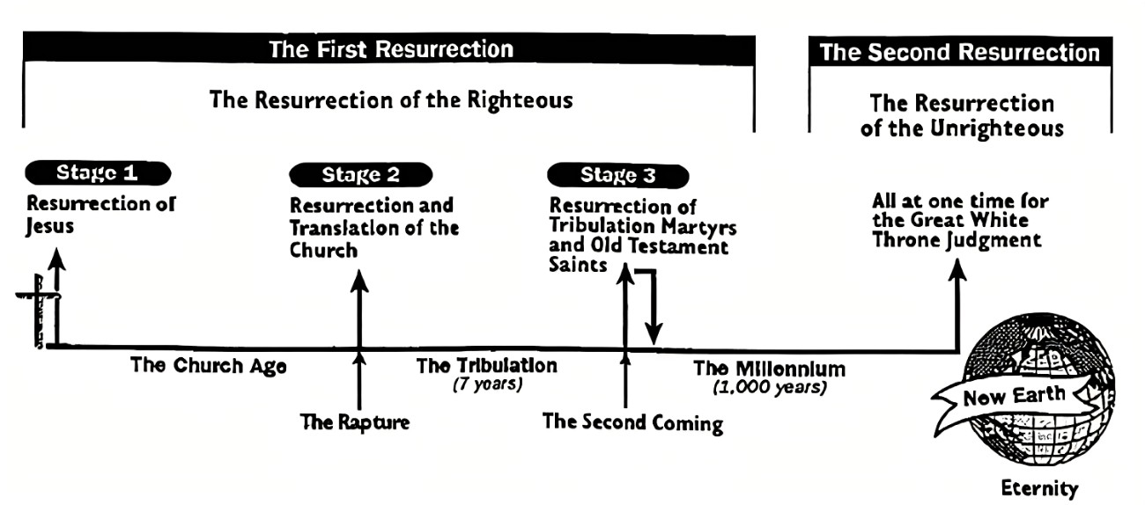
- Christ began the resurrection trend. He was the ‘firstfruits’. (More ‘fruits’ to come!)
- Christ comes back for those of us who choose him from Pentecost until the Rapture. He meets the dead and alive in Christ in the air, not on earth. 1 Thess. 4:13ff. More info on this event in a few verses. (“Second fruits”?)
- Christ comes back to the earth as foretold in the Old and New Testament. The tribulation martyrs and Old Testament saints are resurrected, judged and rewarded. (“Third fruits”?) Rev. 20:4,5. The Resurrection of the Just. (References to both remaining resurrections - John 5:28,29. Luke 14:14. Dan. 12:2. Acts 24:15.)
- Christ rules the earth with his resurrected saints for 1000 years and “brings to an end every ruler, authority, and power and delivers the kingdom to his God”.
- The Resurrection of the Unrighteous happens at this point. All remaining dead humans are “made alive” and judged as Rev. 20 says. (“Last fruits”?)

Rev. 20:11-15
And I saw a great white throne, and him who sat on it, from whose face the earth and the heavens fled away, and there was no place found for them.
And I saw the dead, the great and the small, standing before the throne, and books were opened, and another book was opened, which is the book of life, and the dead were judged out of the things that were written in the books, according to their works.
And the sea gave up the dead who were in it, and death and the grave gave up the dead who were in them, and they were judged, each one, according to their works.
And death and the grave were thrown into the lake of fire. This is the second death—the lake of fire.
And anyone whose name was not found written in the book of life was thrown into the lake of fire.

Everyone who has ever lived will be made alive at one of the three “raising” events:

- The New Testament Christians at the Rapture
- The Old Testament saints and Tribulation saints in the Resurrection of the Just.
- All the rest of humanity (Pre- and Post-Pentecost humanity, Tribulation humanity, and Post-Tribulation humanity) will be raised up at the Resurrection of the Un-Just, judged and passed through to life or judged and punished with the second death.

It will be just as God has said – all die in Adam, all are made alive in Christ. Those who are born again automatically inherit eternal life – no judgement required because Christ took that on our behalf. Praise God! Those who aren’t born again must stand through judgement – a terrifying prospect considering it’ll done by a God who is all-knowing and everywhere. The alternative is clear – believe in Jesus now and get born again. As the saying goes, “Born twice – die once. Born once – die twice.” Everyone gets a chance at life, despite the convoluted circumstances into which they’re born – without God, without hope, into this broken world. These are the inescapable consequences of Adam’s sin and the resultant turmoil. What each person does with that dilemma – accept God’s love in Christ or not - determines if they get “Act Two”. If they don’t get a second life, at least they had a life – an incalculably gracious gift. Any ungrateful attitude from anyone considering this astounding grace is stupefying and, frankly, reflective of the judgement they’ll receive.

1 Cor. 15:25-28
For it is necessary for him to reign until he has put all his enemies under his feet.
The last enemy that will be brought to an end is death.
For He has put all things in subjection under his feet. But when it says, “all things” have been put in subjection, it is clear that the One who subjected all things to him is not included.
And when all things have been put in subjection to him, then the Son will subject himself to Him who put all things in subjection to him, so that God is all in all.

The first Adam was given the charge, “Be fruitful, multiply, fill the earth and subdue it” in Gen. 1:28. Adam fell short on the “subdue” part of the command while Christ is now fulfilling it. A common question has been, “If the Bible says Christ has defeated Satan, why is evil still currently happening?” The answer is that the Bible sometimes uses figurative language to emphasize future events by stating them in the present or past tense to highlight their sure future fulfillment.¹ In today’s speech, we call something a “done deal”, despite it not yet being completed to emphasize its future certainty. I ask you, “Has Christ already defeated Satan?” The answer is “No”. Confused? Watch or read the news. The answer becomes “Definitely no!” This will happen in the future – once and for all – as 1 Cor. 15:28 says and…

Rev. 20:7-10
And when the 1,000 years are finished, the Adversary will be loosed out of his prison
and will come out to deceive the nations that are in the four corners of the earth, Gog and Magog, to gather them together to the war, the number of whom is as the sand of the sea.
And they went up over the width of the earth and surrounded the camp of the holy ones and the beloved city, and fire came down out of heaven and devoured them.
And the Devil, who deceived them, was thrown into the lake of fire and sulfur, where both the beast and the false prophet had been thrown, and they will be tormented day and night for ages and ages.

Has this happened yet? No, this is a future event. The Lord Jesus has (past tense), is (present tense), and will (future tense) battle all opposition to him with his saints and present the victory to God. Then he will usher in a new Heaven and Earth, where “God is all in all”. We are living in the era when Christ is subduing all things to himself, just as Adam was charged. This takes time because a lot of stuff became messed up from Adam’s sin. What stuff? The Human race – in many aspects. Plants and animals. The earth and its systems. Even physical laws are contrary to God will. Take for instance the second law of thermodynamics and the law of entropy. It states, “The total disorder (entropy) in a system (like the universe) naturally increases over time, moving from ordered states to more probable, disordered states where energy is dispersed and less useful for work.” This is a scientific way to say that the entire physical world has become inclined to go from order to disorder, from precision to randomness, from high energy to low energy, in other words, from life to death. Our environment, our bodies, even the molecules of which we consist, conspire to kill us. Adam’s sin brought death – and it’s everywhere.

Flip This Planet

As this catastrophic degradation spread after Adam’s sin, so does its ‘renovation’ after Christ’s resurrection. As it is 2000 years after Christ’s resurrection, we are either in the middle or toward the end of Christ’s mission to subject creation to himself and God. In a whimsical way, I image that we are in the midst a cosmic TV show called, “Renovate this Creation”. (By the way, this is our future. After the Rapture, we will be “with the Lord” helping with creation’s restoration. Where else would the “body” be but with the “Head”? So, get ready to grab your overalls, crowbars, and hammers!)

Now some of you are thinking, “Steve, thy meager learning hath made thee mad!” “Renovate creation? Fix the animal and plant kingdom? Subdue the world’s order? Overhaul the laws of physics? Is that what you’re saying?” Yes, that’s exactly what I’m saying! The first clue as to the extreme changes coming is in the first event foretold when Christ comes for us.

1 Thess. 4:16,17
For the Lord himself will descend from heaven with a loud command, with the voice of a ruling angel, and with the sound of the trumpet of God, and the dead in Christ will rise first.
Then we who are alive, who are left, will be suddenly caught up together with them in the clouds, for a meeting with the Lord in the air, and so we will always be with the Lord.

Remember the law of gravity? It’s out the window (or up in the air) when he returns. We’ll rise up to him in direct contradiction to gravity. To paraphrase Dorothy in the wizard of Oz, “We’re not (going to be) in Kansas anymore!” Get ready for radical jaw dropping change.

Romans 8:19,21
For creation waits with eager anticipation for the children of God to be revealed,
that the creation itself will also be freed from its slavery to corruption and delivered into the glorious freedom of the children of God.

Who will liberate creation from its corruption and death spiral? Look in the mirror. Ever wonder why our Church of Grace period has lasted 2000 years so far? Perhaps God is recruiting children who will work to bring His vision to pass – a loving family that will also make creation wonderful and evil extinct. Creation isn’t going to renovate itself, right? Satan does not “jump” into the lake of fire, he is “cast” – passive voice, acted on by an outside force – Us! God is recruiting lots of loving children, workers and warriors. Perhaps when He has enough, He’ll have an angel blow a trumpet and awaaay we go!

Maybe you’ll get an area on earth to renovate and I get to play work music for you. Maybe we’ll get a planet to subdue and bless. The universe is HUGE, right? Does it make sense that all created beings made in God’s image live on one planet when there could be hundreds or thousands more in the universe? Forget the idea that we will be floating around in heaven eating ice cream. We will be exploring and discovering new worlds and realms with perfect bodies and minds, powered by the spirit that raised up Jesus from the dead! We can only imagine what waits for us. And some of those opportunities will be rewards granted for doing God’s will in this life.

We Don’t Deserve It

Now some of you are quietly freaking out, saying to yourself, “Steve is nuts and misinterpreting scripture. I’m not going to, nor do I deserve to ‘renovate a planet’!” Ok then, where am I misinterpreting scripture? And I never said we “deserve” to renovate creation - I just said that we would. Let’s talk a bit about the whole “deserve” aspect of Christianity. A whole lot of people believe that “We get what we deserve” in this life and the next. Where is that saying in scripture? Probability in the same chapter as “Cleanliness is next to godliness.” and “Walk softly and carry a big stick”. Did you know that the phrase “We get what we deserve” is not in the Bible? In fact, it mirrors the idea of ‘karma’, a Hindu concept. What does the Bible teach?

1 Cor. 15:22
For just as in Adam all die, so also in Christ all will be made alive.

Do you deserve to die for Adam’s sin? Of course not - but you will. Sin and death were ‘baked into’ the human condition, whether we like it or not, or deserve it or not. Ever seen someone who’s escaped this? Of course not. No one gets out of here alive. Period. The only question about our death is “When?”. Deserving it has nothing to do with it. We got it by birth. It was part of the package. Adam’s sin earned him and each of us a death sentence. And it doesn’t matter whether you like it or not - or agree with it or not – or even believe it or not. Adam earned it and we all get it. Do we deserve that from what he did? No, but it’s still a reality.

Now, the same certainty is true with the new, second birth.

Romans 5:17-19
For if by the transgression of one man, death reigned through that one man, we can be much more certain that those who receive the overflow of grace and the gift of righteousness will reign in life through the one man—Jesus Christ.
So then, just as through one transgression the result was condemnation for all people, so also through one righteous act the result was righteousness that brings life for all people.
For just as through one man’s disobedience the many were made sinners, so also through one man’s obedience the many will be made righteous.

Do we deserve righteousness? In other words, have we earned the right to stand before God through our works? No – quite the opposite. Yet we still have it from “the overflow of grace and the gift of righteousness” through the one man – Jesus Christ. Praaaaise God! What does any of this have to do with deserving it? Nothing. It was achieved by Adam and Jesus, and we get it by virtue of birth – the first one – body and soul, and the second one – God’s spirit.

Look at verse 19. We were made sinners by Adam’s sin. We were “accidents looking to happen”, and we all know this experientially. Now we are made righteous in the new birth. God’s spirit has made us “righteousness looking to happen”. It’s how we’re made. We were made to speak tongues, interpret and prophesy. We were made to get revelation and carry it out in miracles and healing. We were made to love and bless others. We were made to witness and help others join the family. We were made to pray and get our prayers answered. We were made to reign in life – this life and especially the next. We are made to restore creation to its original perfection. It’s how we’re made. It’s who we are now!

It has nothing to do with how we feel or what we think. This is way, way, outside of “my truth” or “your truth”. It’s how we’re made. Whether we like it or not, or believe it or not, is irrelevant. It’s how we’re made. Once I absent-mindedly walked into a woman’s restroom and was ushered out by members of the fairer sex. They didn’t have a problem with my thinking or beliefs. They had a problem with how I was made!

The same is true spiritually about the future. We are made for restoring creation. We are made to reign … in a region, an area, a planet … who knows? We were made to subdue all the collateral damage from Adam’s sin and make our Father’s creation the way He wanted it – a blessing to all. Do we ‘deserve’ to do any of this? Of course not. Perhaps that’s why Christ is the ‘firstfruits’ so that he could get the ‘second fruits’ (us) together and we can partner with the Head and MCGA - Make Creation Great Again!

Footnote ¹ Dr. E.W. Bullinger calls this figure “Heterosis”, an exchange. In this case it is an exchange of the past or present tense for the future tense. He explains on page 518 in Figures of Speech Used in the Bible, “This is put when the speaker views the action as being as good as done. This is very common in the Divine prophetic utterances; where, through the tense is literally future, it is regarded and spoken of as thought it was already accomplished in the Divine purpose and determination. The figure is to show the absolute certainty of the things spoken of.” Other commentators have called it the “Prophetic perfect” among other names.

